NAME ____________________________________ INDEX NO. _______________
SCHOOL ____________________________________ SIGNATURE _______________ DATE _______________

443/1
AGRICULTURE
PAPER 1
JULY/AUGUST, 2015
TIME: 2 HOURS

443/1
AGRICULTURE
PAPER 1
TIME: 2 HOURS

INSTRUCTIONS TO CANDIDATES
- Write your name, school and index number in the spaces provided above.
- Sign and write the date of the examination in the spaces provided above.
- This paper consists of three sections: A, B and C.
- Answer all the questions in section A and B and any two questions from section C.
- All answers must be written in the spaces provided in this booklet.
- This paper consists of 12 printed pages.
- Candidates should check the question paper to ascertain that all pages are printed as indicated and that no questions are missing

For OFFICIAL use only
Section | Questions | Maximum score | Candidate’s score
A | 1 − 21 | 30
B | 22− 25 | 20
C |  | 20
 |  | 20
 | Total score | 90

SECTION A (30 MARKS)
Answer ALL the questions in this section in the spaces provided.
- Give two reasons why farmers are encouraged to practice organic farming. (1 mark)
________________________________________________________________________________________________________________________________________________________________________
- State three advantages of shifting cultivation. (1½ marks)
____________________________________________________________________________________________________________________________________________________________________________________________________________________________________________________________
- List four methods of farming. (2 marks)
________________________________________________________________________________________________________________________________________________________________________________________________________________________________________________________________________________________________________________________________________________
- Outline three effects of soil organisms which benefit crop growth. (1½ marks)
____________________________________________________________________________________________________________________________________________________________________________________________________________________________________________________________
- State two harmful effects of strong wind on crop production. (1 mark)
________________________________________________________________________________________________________________________________________________________________________
- State three advantages of adding organic matter to sandy soil. (1½ marks)
____________________________________________________________________________________________________________________________________________________________________________________________________________________________________________________________
- State three ways by which biological agents can enhance the process of soil formation. (1½ marks)
________________________________________________________________________________________________________________________________________________________________________________________________________________________________________________________________________________________________________________________________________________________________________________________________________________________________________________________________________________________________________________________
- Give three reasons for early seed bed preparation. (1½ marks)
________________________________________________________________________________________________________________________________________________________________________________________________________________________________________________________________________________________________________________________________________________
- Outline four main reasons for secondary tillage. (2 marks)
________________________________________________________________________________________________________________________________________________________________________________________________________________________________________________________________________________________________________________________________________________
- Name four types of water pumps which can be used on a farm. (2 marks)
________________________________________________________________________________________________________________________________________________________________________________________________________________________________________________________________________________________________________________________________________________
- State two features that should be considered when choosing water pipes for use on the farm. (1 mark)
________________________________________________________________________________________________________________________________________________________________________
- How does leaching lead to loss of fertility? (½ mark)
________________________________________________________________________________________________________________________________________________________________________
- Give four ways by which soil loses its fertility. (2 marks)
________________________________________________________________________________________________________________________________________________________________________________________________________________________________________________________________________________________________________________________________________________
- Give two reasons for imposing quarantine on imported planting materials. (1 mark)
________________________________________________________________________________________________________________________________________________________________________________________________________________________________________________________________________________________________________________________________________________
- State two advantages of earthing up in crop production. (1 mark)
________________________________________________________________________________________________________________________________________________________________________
- Give a reason for carrying out each of the following practices in a tomato nursery. (2 marks)
- Pricking out
________________________________________________________________________________________________________________________________________________________________________
- Hardening off
________________________________________________________________________________________________________________________________________________________________________

- Give two reasons for drying grains before storage. (1 mark)
________________________________________________________________________________________________________________________________________________________________________
- State two ways in which crop rotation controls weeds. (1 mark)
________________________________________________________________________________________________________________________________________________________________________________________________________________________________________________________________________________________________________________________________________________
- State two conditions under which the opportunity cost is zero in farming enterprise. (1 mark)
________________________________________________________________________________________________________________________________________________________________________________________________________________________________________________________________________________________________________________________________________________
- State four ways of harvesting water on the farm. (2 marks)
________________________________________________________________________________________________________________________________________________________________________________________________________________________________________________________________________________________________________________________________________________
- Name two classes of weeds on the basis of each of the following: (2 marks)
- Growth cycle
________________________________________________________________________________________________________________________________________________________________________
- Plant morphology
________________________________________________________________________________________________________________________________________________________________________

SECTION B (20 MARKS)
Answer ALL the questions in this section in the spaces provided.
- The diagrams labelled A₁, A₂, A₃ and B below illustrates materials and methods of vegetative
propagation. Study them and answer the questions that follow.
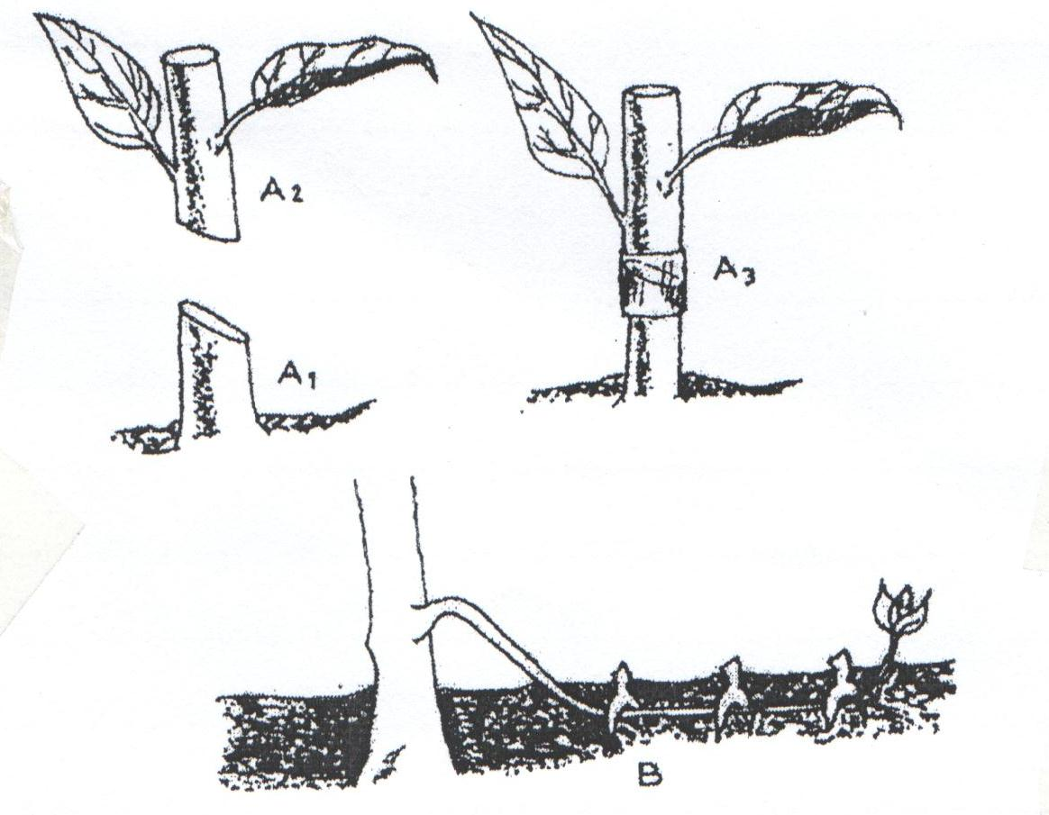
B
A₃
A₁
A₂
- Name the parts labelled A₁, and A_{2.} (2 marks)
A₁ ________________________________________________________________________________________________________________
A₂ ________________________________________________________________________________________________________________
- Name the methods of propagation illustrated in diagrams A₃ and B. (2 marks)
A₃ ________________________________________________________________________________________________________________
B ________________________________________________________________________________________________________________
- Name two methods of budding that are used in propagation of plant (2 marks)
________________________________________________________________________________________________________________________________________________________________________

- The diagram below illustrates a field management practice in tomatoes.
Study it carefully and answer the questions that follow.

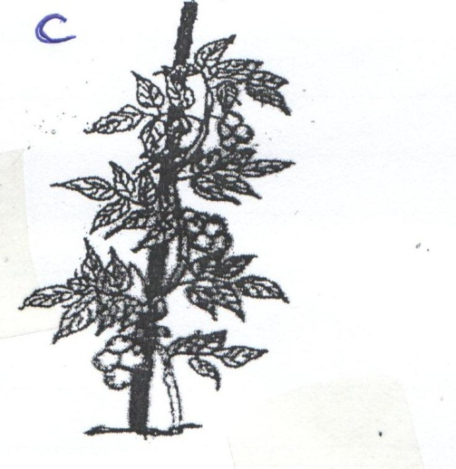
C

- Identify the field practice. (1 mark)
____________________________________________________________________________________
- State three reasons for carrying out the practice. (3 marks)
____________________________________________________________________________________________________________________________________________________________________________________________________________________________________________________________________________________________________________________________________________________________________________________________________________________________________

- a) The diagrams below represent two ways in which a crop was pruned.
Study them carefully and answer the questions that follow.
E
D
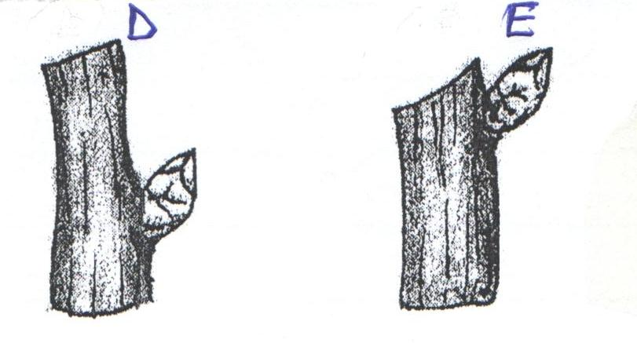
- Which diagram represents the correct way of pruning? (1 mark)
____________________________________________________________________________________
- Give a reason for your answer in (i) above. (1 mark)
________________________________________________________________________________________________________________________________________________________________________
b) State two ways in which pruning assists in controlling crop diseases. (2 marks)
________________________________________________________________________________________________________________________________________________________________________________________________________________________________________________________________________________________________________________________________________________
c) Outline three reasons for pruning coffee (3 marks)
________________________________________________________________________________________________________________________________________________________________________________________________________________________________________________________________________________________________________________________________________________________________________________________________________________________________________________________________________________________________________________________

- The illustration below shows a structure used for controlling soil erosion.
Study it carefully and answer the questions that follow.
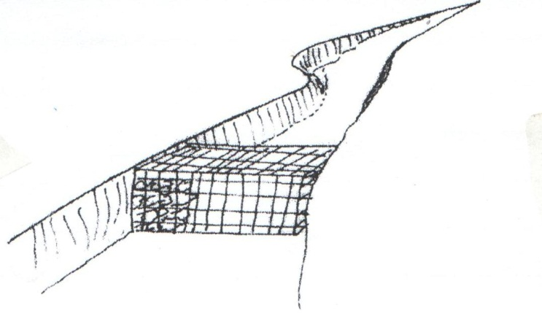
- Identify the structure. (1 mark)
____________________________________________________________________________________
- Explain two ways in which the structure helps to control soil erosion. (2 marks)
________________________________________________________________________________________________________________________________________________________________________________________________________________________________________________________________________________________________________________________________________________

SECTION C (40 MARKS)
Answer ANY TWO questions from this section in the spaces provided.
- a) Explain why settlement schemes were established in Kenya soon after independence. (10 marks)
b) State and explain the various land tenure systems practiced in Kenya. (10 marks)

- a) Explain the various ways by which a farmer can adjust to risks and uncertainties. (8 marks)
b) The inventory of Kembo farm as at 31st Dec, 2013 was as follows:

Cash at hand | 7,000
Layers | 25,000
Dairy cattle | 130,000
Cassava in store | 5,000
Calves | 19,000
Buildings | 80,000
Land | 180,000
Machinery | 85,000

On the same day, the following information was obtained from the farmers’ records.

Bank loan | 210,000
Egg sale on credit | 10,000
Vegetable sales on credit | 5,000
Farm input purchased on credit | 20,000
Wages payable | 6,200
Interest payable | 2500
Taxes payable | 800
Milk sales on credit | 15,000

Prepare a balance sheet (12 marks)

- a) Explain seven cultural methods of controlling crop diseases. (7 marks)
b) Describe precautions taken during the harvesting of coffee. (4 marks)
c) Given that a crop of cabbage is planted at a spacing of 60cm × 60cm, calculate the plant
population in a plot of land measuring 4m × 3m. (show your working). (4 marks)
d) Give five factors that determine spacing of cabbages in the field. (5 marks)

____________________________________________________________________________________________________________________________________________________________________________________________________________________________________________________________________________________________________________________________________________________________________________________________________________________________________________________________________________________________________________________________________________________________________________________________________________________________________________________________________________________________________________________________________________________________________________________________________________________________________________________________________________________________________________________________________________________________________________________________________________________________________________________________________________________________________________________________________________________________________________________________________________________________________________________________________________________________________________________________________________________________________________________________________________________________________________________________________________________________________________________________________________________________________________________________________________________________________________________________________________________________________________________________________________________________________________________________________________________________________________________________________________________________________________________________________________________________________________________________________________________________________________________________________________________________________________________________________________________________________________________________________________________________________________________________________________________________________________________________________________________________________________________________________________________________________________________________________________________________________________________________________________________________________________________________________________________________________________________________________________________________________________________________________________________________________________________________________________________________________________________________________________________________________________________________________________________________________________________________________________________________________________________________________________________________________________________________________________________________________________________________________________________________________________________________________________________________________________________________________________________________________________________________________________________________________________________________________________________________________________________________________________________________________________________________________________________________________________________________________________________________________________________________________________________________________________________________________________________________________________________________________________________________________________________________________________________________________________________________________________________________________________________________________________________________________________________________________________________________________________________________________________________________________________________________________________________________________________________________________________________________________________________________________________________________________________________________________________________________________________________________________________________________________________________________________________________________________________________________________________________________________________________________________________________________________________________________________________________________________________________________________________________________________________________________________________________________________________________________________________________________________________________________________________________________________________________________________________________________________________________________________________________________________________________________________________________________________________________________________________________________________________________________________________________________________________________________________________________________________________________________________________________________________________________________________________________________________________________________________________________________________________________________________________________________________________________________________________________________________________________________________________________________________________________________________________________________________________________________________________________________________________________________________________________________________________________________________________________________________________________________________________________________________________________________________________________________________________________________________________________________________________________________________________________________________________________________________________________________________________________________________________________________________________________________________________________________________________________________________________________________________________________________________________________________________________________________________________________________________________________________________________________________________________________________________________________________________________________________________________________________________________________________________________________________________________________________________________________________________________________________________________________________________________________________________________________________________________________________________________________________________________________________________________________________________________________________________________________________________________________________________________________________________________________________________________________________________________________________________________________________________________________________________________________________________________________________________________________________________________________________________________________________________________________________________________________________________________________________________________________________________________________________________________________________________________________________________________________________________________________________________________________________________________________________________________________________________________________________________________________________________________________________________________________________________________________________________________________________________________________________________________________________________________________________________________________________________________________________________________________________________________________________________________________________________________________________________________________________________________________________________________________________________________________________________________________________________________________________________________________________________________________________________________________________________________________________________________________________________________________________________________________________________________________________________________________________________________________________________________________________________________________________________________________________________________________________________________________________________________________________________________________________________________________________________________________________________________________________________________________________________________________________________________________________________________________________________________________________________________________________________________________________________________________________________________________________________________________________________________________________________________________________________________________________________________________________________________________________________________________________________________________________________________________________________________________________________________________________________________________________________________________________________________________________________________________________________________________________________________________________________________________________________________________________________________________________________________________________________________________________________________________________________________________________________________________________________________________________________________________________________________________________________________________________________________________________________________________________________________________________________________________________________________________________________________________________________________________________________________________________________________________________________________________________________________________________________________________________________________________________________________________________________________________________________________________________________________________________________________________________________________________________________________________________________________________________________________________________________________________________________________________________________________________________________________________________________________________________________________________________________________________________________________________________________________________________________________________________________________________________________________________________________________________________________________________________________________________________________________________________________________________________________________________________________________________________________________________________________________________________________________________________________________________________________________________________________________________________________________________________________________________________________________________________________________________________________________________________________________________________________________________________________________________________________________________________________________________________________________________________________________________________________________________________________________________________________________________________________________________________________________________________________________________________________________________________________________________________________________________________________________________________________________________________________________________________________________________________________________________________________________________________________________

