NAME ---------------------------------------------------------------------INDEXNO-------------------------
DATE--------------------------
CANDIDATE SIGNATURE--------------

GATUNDU SOUTH SUB-COUNTY FORM FOUR 2015 EVALUATION EXAM
231/2
BIOLOGY
PAPER 2
(THEORY)
JULY /AUGUST 2015
2HRS
GATUNDU EVALUATION TEST
Instruction to candidates
- Write your name index number in the space provided above.
- This paper consist two sections ,A and B
- Answer all the questions in section A n the space provided.
- In section B answer question 6(compulsory) and either question 7or 8.
For examiner’s use only.
SECTION | QUESTION | MAXIMUM SCORE | CANDIDATES SCORE
A | 1  2  3  4  5 | 8  8  8  8  8
B | 6  7  8 | 20  20  20

1. The genetic disorder hemophilia is due to a recessive sex linked gene .A man who is hemophilia maries a woman who is carrier for the condition .
a)Using letter H to represent the normal condition and letter h for the hemophiliac condition .
i)What is the genotype for the man and the woman ?(2mrks)
Man
Woman
ii) Work out a cross between the man and woman (3mrks)

b) What is the chance that both the first and second sons will be hemophiliac?(2mrks)
................................................................................................................................................................................................................................................................................................................................................
c) Hemophiliac is more common in males than in female human .Explain (1mrk)
................................................................................................................................................................................................................................................................................................................................................
2. Study the diagram below and answer the questions that follow.
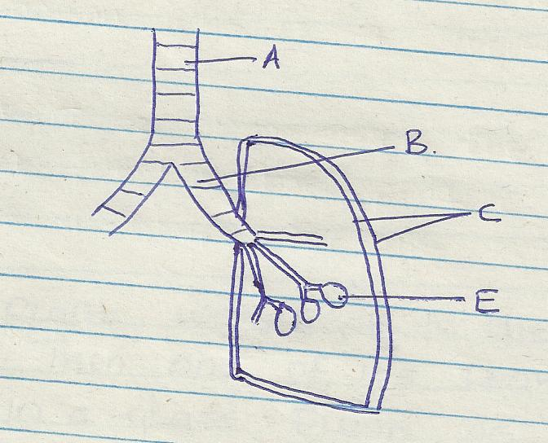
a)Name the part labeled A and B (2mrks)
A------
B-----
b) State the function of the part labeled C (2mrks)
................................................................................................................................................................................................................................................................................................................................................
c) How is he part labeled E adapted to its function (2mrks)
................................................................................................................................................................................................................................................................................................................................................
........................................................................................................................................................................
d) Indentify the structure that perform the same function as one illustrated above in(2marks)
i) Amoeba ---
ii) Fish ----
3. A health plant was kept in the dark for 48 hrs .Then one of its leaves (x) was enclosed in a glass flask as down below .The whole plant was then returned to light
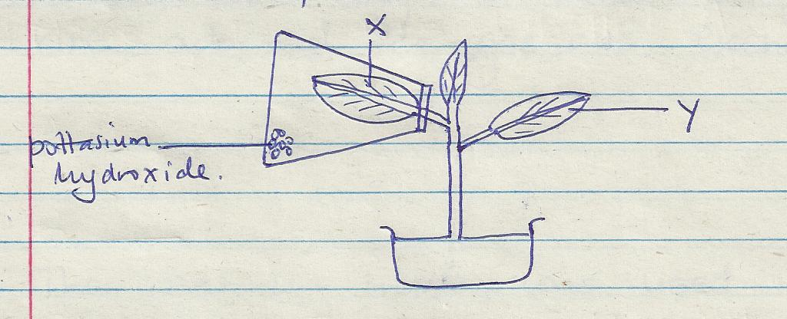
- After 48 hrs the leaves were tested for starch .What observations do you expect .(2mrks)
........................................................................................................................................................................................................................................................................................................................
bi) What conclusions can you draw from this observation (1mrk ....................................................................................................................................................................................................................................................................................................................................

ii) Explain your conclusion in b(i) above (2mrks)
................................................................................................................................................................................................................................................................................................................................................
- Why was the plant kept in the dark for 48 hrs (1mrk?)
................................................................................................................................................................................................................................................................................................................................................
- State two ways in which the green leaves are adapted for gaseous exchange ((2mrks)
................................................................................................................................................................................................................................................................................................................................................
................................................................................................................................................................................................................................................................................................................................................
4) The set up below was used to demonstrate a certain behavior of termites
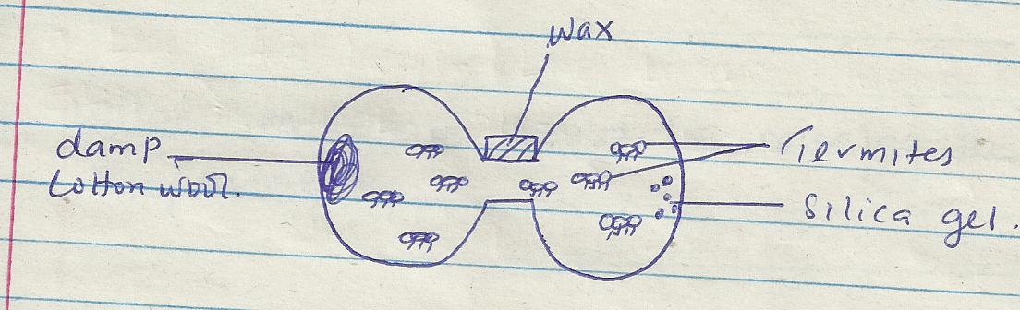
a) State the function of the following in this experiment
i) Damp cotton wool (1mrk)
................................................................................................................................................................................................................................................................................................................................................
ii) Silica gel (1mrk)
................................................................................................................................................................................................................................................................................................................................................
Iii) Wax (1mrk)
................................................................................................................................................................................................................................................................................................................................................

b) What result were obtained from this experiment after 12 hrs (1mrk)
................................................................................................................................................................................................................................................................................................................................................
- Account for the results in (b) above (1mrk)
................................................................................................................................................................................................................................................................................................................................................
- Name the type of response shown by termites (1mrk)
................................................................................................................................................................................................................................................................................................................................................
- What material wound is missing in a control experiment (2mrks)
................................................................................................................................................................................................................................................................................................................................................
5 Below is a diagram of a structure found in plants
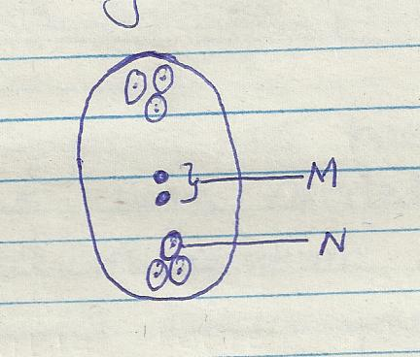
a (i) Indentify the structure (1mrk)
................................................................................................................................................................................................................................................................................................................................................
(ii)Name the parts labeled M and N(2mrks)
M---
N----
b) Explain why cross pollination is more advantageous to a plant species than self –pollination (2mrks)
................................................................................................................................................................................................................................................................................................................................................
................................................................................................................................................................................................................................................................................................................................................
c) Explain how double fertilization takes place in the above structure.(3mrks)
................................................................................................................................................................................................................................................................................................................................................
................................................................................................................................................................................................................................................................................................................................................
SECTION B;(40 MRKS)
Answer question 6(compulsory )and either question 7 or 8
in the space provide after question 8 .
6 An investigation of haemolysis of human red blood cell was carried out .Red blood cells were placed in sodium chloride solution and percentage of haemolysed cell established.
Sodium chloride conce .g/cm³(%) | 0.33 | 0.36 | 0.38 | 0.39 | 0.42 | 0.44 | 0.48
Haemolysed red blood cells (%) | 100 | 91 | 82 | 69 | 30 | 15 | 0
A (i) Using the data above, plot a graph of haemolysed red blood cell against salt concentration (6mrks)
(ii) At what percentage of sodium chloride was the number of haemolysed cells equal to those that are
not haemolysed. ( 1mrk)
(iii) What is the percentage of cells haemolysed at salt concentration of 0.45 percent. (1 mark)
b) Account for the result obtained at
(i)0.33% salt concentration (2mrks)
................................................................................................................................................................................................................................................................................................................................................
...............................................................................................................................................................................................................................................................................................................................................
(ii) 0.48% salt concentration (2mrks)
................................................................................................................................................................................................................................................................................................................................................
................................................................................................................................................................................................................................................................................................................................................
iii) Suppose the red blood cells were placed in 0.50%salt concentration .Explain what would happen (2mrks)
................................................................................................................................................................................................................................................................................................................................................
................................................................................................................................................................................................................................................................................................................................................
c (i)Distinguish between lymphocytes and phagocytes (2mrks)
................................................................................................................................................................................................................................................................................................................................................
................................................................................................................................................................................................................................................................................................................................................
(ii) State two ways in which white blood cells defend the body against infections. (2 marks)
................................................................................................................................................................................................................................................................................................................................................
................................................................................................................................................................................................................................................................................................................................................
d) State two adaption of red blood (2mrks)
................................................................................................................................................................................................................................................................................................................................................
................................................................................................................................................................................................................................................................................................................................................
7 a) Explain the role of the following hormones in growth and development of plants.
- Auxins (4mrks)
............................................................................................................................................................................................................................................................................................................
............................................................................................................................................................................................................................................................................................................
............................................................................................................................................................................................................................................................................................................
- (ii)Gibberellins (4mrks)
............................................................................................................................................................................................................................................................................................................
............................................................................................................................................................................................................................................................................................................
............................................................................................................................................................................................................................................................................................................
8 Explain the adaptation of the small intestine to their functions.(20mrks)
................................................................................................................................................................................................................................................................................................................................................
................................................................................................................................................................................................................................................................................................................................................
................................................................................................................................................................................................................................................................................................................................................
................................................................................................................................................................................................................................................................................................................................................
................................................................................................................................................................................................................................................................................................................................................
................................................................................................................................................................................................................................................................................................................................................
................................................................................................................................................................................................................................................................................................................................................
................................................................................................................................................................................................................................................................................................................................................
................................................................................................................................................................................................................................................................................................................................................
................................................................................................................................................................................................................................................................................................................................................
................................................................................................................................................................................................................................................................................................................................................
................................................................................................................................................................................................................................................................................................................................................
................................................................................................................................................................................................................................................................................................................................................
................................................................................................................................................................................................................................................................................................................................................
................................................................................................................................................................................................................................................................................................................................................
................................................................................................................................................................................................................................................................................................................................................
................................................................................................................................................................................................................................................................................................................................................
................................................................................................................................................................................................................................................................................................................................................
................................................................................................................................................................................................................................................................................................................................................
................................................................................................................................................................................................................................................................................................................................................
................................................................................................................................................................................................................................................................................................................................................
................................................................................................................................................................................................................................................................................................................................................
................................................................................................................................................................................................................................................................................................................................................
................................................................................................................................................................................................................................................................................................................................................
................................................................................................................................................................................................................................................................................................................................................
................................................................................................................................................................................................................................................................................................................................................

