STAREHE GIRLS CENTRE
MOCK EXAMINATION
Name:................................................................IndexNo…………....Class…… Candidate’s Signature: ……………................Date: ................................................
231/3
BIOLOGY PRACTICAL
JULY 2015
Time: 1³/₄ hours
INSTRUCTIONS TO CANDIDATES:
- Write your name and index number and Class in the spaces provided above.
- Sign and write date of examination and sign in the spaces provided above
- Answer all the questions
- You are required to spend the first 15 minutes of the 1 ¾ hours allowed for this paper reading the whole paper carefully.

FOR EXAMINER’S USE ONLY:

QUESTIONS | MAXIMUM SCORE | CANDIDATES SCORE
1 | 15
2 | 13
3 | 12
TOTAL | 40

This paper consists of 8 printed pages. Candidates should check to ascertain that all papers are printed as indicated and that no questions are missing
1.You are provided with liquid X and substance Q
(a) Place three drops of liquid X onto a white tile. Add four drops of iodine solution and record your observation. (lmk)
................................................................................................................................................................................................................................................................................................................................................................................................................................................................................................................................................................................................................................................................................................................................................................................................................................................
(b) Pour 2ml of liquid X into a test-tube. Add equal amounts of Benedict’s solution boil the mixture Record your observation. (lmk)
................................................................................................................................................................................................................................................................................................................................................................................................................................................................................................................................................................................................................................................................................................................................................................................................................................................
(c) Label three boiling tubes as set-ups A, B, and C. Place 3ml of liquid X into each of the set-ups.
Divide substance Q into three equal portions.
    - To set-up A, add one portion of substance Q and shake.
Place the second portion of substance Q into a test tube B. Add 1ml of water to it, shake the mixture and boil for four minutes..
    - To set —up C, add the third portion of substance Q. Add 8 drops of 2M
hydrochloric acid and shake.
Place the three set-ups in a warm water bath maintained at 37°C for 30 minutes.
Cool the set-ups by dipping the boiling tubes in cold water
Place 2ml of the contents of each set-up into three separate test tubes. Add equal amount of Benedict’s solution to each of the three test-tubes and boil.
Record your observations.
Set-up A (1mk)
....................................................................................................................................................................................................................................................................................................................
.............................................................................................................................................................................................................................................................................................................................................................................................................................................................................
Set-up B (1mk)
....................................................................................................................................................................................................................................................................................................................
..............................................................................................................................................................................................................................................................................................................................................................................................................................................................................
Set-up C (1mk)
....................................................................................................................................................................................................................................................................................................................
............................................................................................................................................................................................................................................................................................................................................................................................................................................................................
(d) Account for your observations in each of the set-ups above.
Set-up A (2mks)
.............................................................................................................................................................................................................................................................................................................................................................................................................................................................................
....................................................................................................................................................................................................................................................................................................................
Set-up B (2mks)
..............................................................................................................................................................................................................................................................................................................................................................................................................................................................................
..................................................................................................................................................................................................................................................................................................................
Set-up C (2mks)
...............................................................................................................................................................................................................................................................................................................................................................................................................................................................................................................................................................................................................................................................................................................................................................................................................................
(e) Give the most likely identity of substance Q. (1mk)
…………………………………………………………………………………………………………
f) Why was the water bath maintained at 37oC (1 marks)
…………………………………………………………………………………………………………………………………………………………………………………………………………………………………………………………………................................................................................……..
.
g) What is the fate of the product of set up A in an organism? (1mark)
……………………………………………………………………………………………………………………………………………………………………………………………………………………………………………………………...............................................................………
h) Name a part in a seed where the process you have named in (g) above occurs. (1mark)

…………………………………………………………………………………………………

2.You are provided with a photograph of a chloroplast and animal cell as seen under the
electron microscope. Examine them and use them to answer the questions that follow.

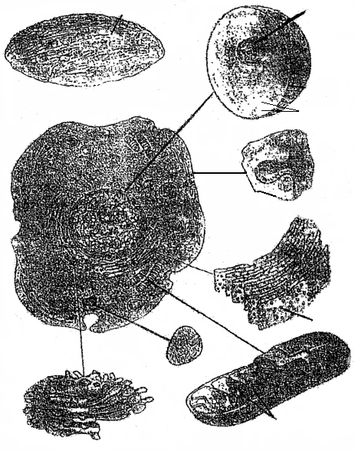
W
Y
B
A
X
C
Z
D
Plasma membrane
Chloroplast from a plant cell
Nucleussssss
Nuclear membrane
Chromosomes

Name the organelles labeled A,B,C and D (4mks)
A ___________________________________________________________________

B ___________________________________________________________________

C ___________________________________________________________________

D ___________________________________________________________________

(b) State the functions of the structures labeled W, X, Y and Z. (4mks)

W _______________________________________________________________________

X _______________________________________________________________________

Y _______________________________________________________________________

Z _______________________________________________________________________

(c) In the photograph, label the following structures: (2mks)
(i) Vacuole.
(ii) Pinocytic vesicle.

(d) Relate the structure of the organelle labeled C to its function. (1mk)

_____________________________________________________________________

_____________________________________________________________________

_____________________________________________________________________
(e) State the functions of the structure labeled D. (2mks)

_____________________________________________________________________

_____________________________________________________________________

_____________________________________________________________________

_____________________________________________________________________

3. Examine the photographs below and answer the questions that follow
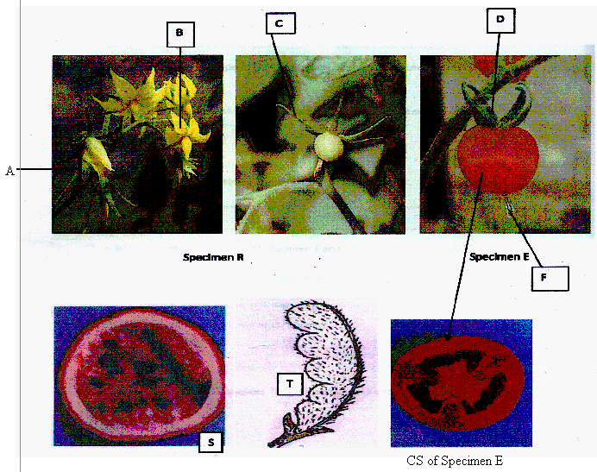

a) Specimen R was obtained from fruit development of a tomato fruit

i) Name the parts labeled A,B,C,D,E (5 marks)
A…………………………………………...........................................
B………………………………………...........................................…
C…………………………………………........................................…
D…………………………………………..................................…….
E………………………………………….................................…….

ii) State the type of fruit represented by E. (1 mark)

……………………………………………………………………………………
iii) Give reason for your answer in (ii) above. (1 mark)
………………………………………………………………………………………………………………………………………………………………………………………………………………………………………………………………................................................................…….

b) State the type of placentation shown by the specimen S and T. (1 marks)
S…………………………………................................................…………….......................……
T……………………………………………................................................……........................….
c) i) State the agent of dispersal of specimen T and E (1 marks)
T……………………………………………...........................................………........................…
E…………………………………………......................................................................………….
ii) Give reason for your answer in (c) i above. (2 marks)
………………………………………………………………………………………………………………………………………………………………………………………………………………………................................................................................................................................................................................................................................................................................................
d) List two observation differences between specimen E and T. (2 marks)
…………………………………………………………………………………………………………………………………………………………………………………………………………………………………………………………………………………………………………………………………………………………………………………………………………………………………………………………………………………………………………………………………………………………………………………………………………………………………………………………………………………………………………………………………………………………………………

BIO P3 SET 3 MARKING SCHEME
1. 1
a) Blue black/black colour1 is formed
b) Colour of Benedict’s solution remains1
c) Set up A -Colour changes from 1 blue to green to yellow
Set up B- Colour of Benedicts remains (reject no change)
Set up C-Colour of Benedicts 1 is retained
d) Set up A-Enzyme amylase/diastaseinvertasehydrolyse starch to reducing sugar.
Set up B- Boiling denatures/destroy enzymes hence starch is not converted to reducing sugar
Set up C- HCl provides unfavourable pH for enzyme Amylase, hence 1 starch not converted to reducing sugar.
- Q- Enzyme Amylase/diastase/invertase
- 37ºC provide optimum temperature for reaction of enzyme Amylase/diastase
- Oxidized to provide energy/ATP stored as glycogen.1
- Cotyledon1

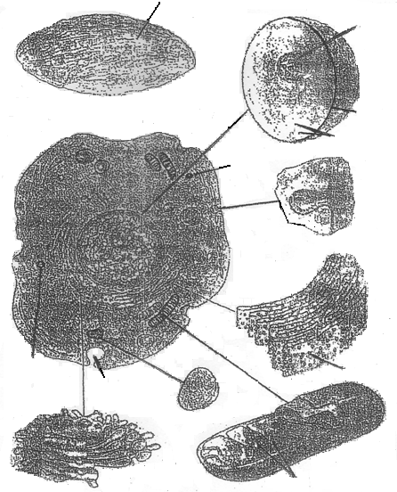2.
Pinocytic vestile
Vacuole
Plasma membrane
Vacuole
Nuclear membrane
Nucleus
Chloroplast from a plant cell
Chromosomes
W
Y
A
X
X
C
Z
B
D

3.2 (a) A – Rough endoplasmic reticulum;
B – Lysosome; Rej. lysosomes.
C - Mitochondrion; Rej. Mitochondria.
D – Golgi bodies/apparatus ;
- W – Site of photosynthesis;
X – Site of protein synthesis; Acc. Protein synthesis.
Y – Containing hereditary materials/chromosomes/genetic material/manufacture
of ribosome’s;
Z – Site of attachment of respiratory enzymes;
(c) NB: Labeling must be on the diagram.
Award 0 if otherwise.
(d) Inner membrane folded into cristae; to increase the surface area of respiration;
(e) (i) Packaging of proteins/lipids;
(ii) Manufacture of lysosomes;
(iii) Secretion of substances outside the cell; (Max 2mks)
3.A-Flower stalk;
B-Petal;
C-Sepal
D-Fruit stalk
F-Persistent style/remains
ii) Beg;
iii) Mesocarp and endocarp fleshy;/Sacculent; (any correct one)
- Many seeds embedded in the endocarp;
- Divided into may loculi
b) S-Parietal;
T-Marginal placentation;
c)
i) T-Self explosive mechanism/mechanical;
E-Animal;
ii) Reasons- T has two lines of weakness/satures along which dehisces on drying;
E-Brightly coloured to attract the animals/juicy/succulent;

