Name: ................................................................................................................... Class.................

Index No.: ………………………………… Sign………………… Date……………………

233/2
CHEMISTRY.
Theory
Paper 2
Time: 2 Hours

STAREHE BOYS’ CENTRE & SCHOOL
Kenya Certificate of Secondary Education
MOCK EXAMINATION, JUNE/JULY 2015

INSTRUCTIONS
- Answer ALL questions in the spaces provided.
- Mathematical tables and electronic calculators may be used.
- All working MUST be clearly shown where necessary.

For examiners’ use only.

Questions | Max-score | Candidates score
1 | 10
2 | 8
3 | 6
4 | 13
5 | 17
6 | 14
7 | 7
8 | 5
Total score = 80

NB: This paper consists of 13 printed pages. Students should check the question paper to ensure that all pages are printed as indicated and that no questions are missing.
Turn over
1(a) When 45 g of ethane gas were completely burnt in air 4680 kJ of heat energy was evolved.
i) Calculate the molar enthalpy of combustion of ethane. (C = 12, H = 1) {2 marks}

ii) Write the thermochemical equation for the combustion of ethane. {1 mark}

iii) Draw the energy level diagram showing the combustion of one mole of ethane. {2 marks}

b) Changes of state are either exothermic or endothermic. Name a change of state that is: {1 mark}
i) exothermic

ii) endothermic

c) Use the equations below to answer the questions that follow.
K⁺_{(g)} + Cl⁻_{(g)} KCl_{(s)} ∆H₁ = -701 kJ mol⁻¹

KCl_{(s)} K⁺_{(aq)} + Cl_{(aq)} ∆H₂ = +15 kJ mol⁻¹

i) What is the name of ∆H₁. {1 mark}

ii) Draw an energy cycle and use it to calculate the heat change for the process.
K⁺_{(g)} + Cl⁻_{(g)} K⁺_{(aq)} + Cl⁻_{(aq)} {3 marks}

2. Study the flow chart below and answer the questions that follow.
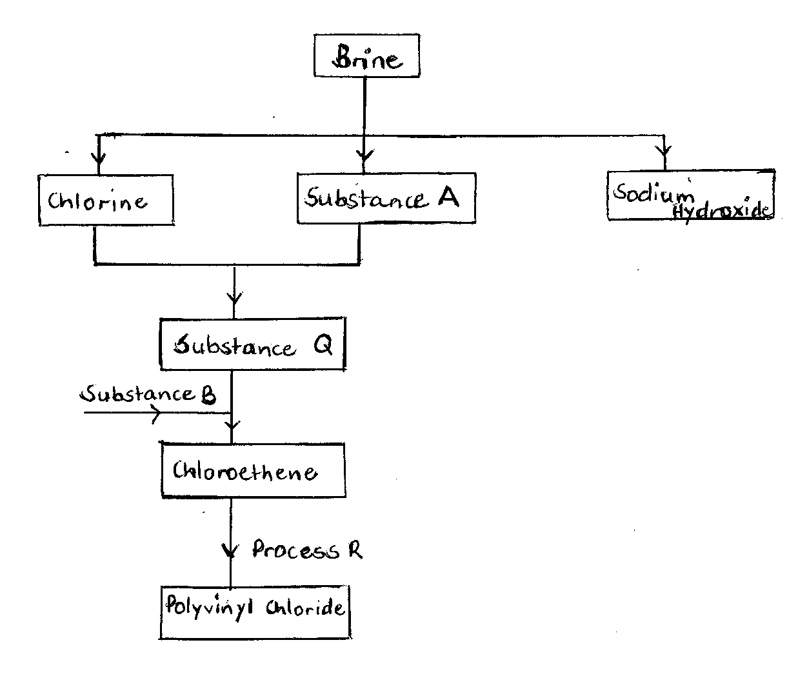
a) Identify the substances {3 marks}
A …………………………………………..
B …………………………………………..
Q …………………………………………..

b) Write the equation for the reaction that produces substance A. {1 mark}

c) i) Name two substances which are used in the laboratory preparation of substance B.
{1 mark}

ii) Write the equation for the reaction that takes place in (i) above. {1 mark}

d) i) Name the process R. {1 mark}

ii) State one property that compounds undergoing process R must possess. {1 mark}

3(a) The first, second and third ionization energies for the elements B and C are given below.

Element | Ionization energies kJ mol⁻¹
 | 1st | 2nd | 3rd
B | 520 | 7,300 | 9,500
C | 420 | 3,100 | 4,800

i) What is first ionization energy? {1 mark}

ii) Apart from decrease in energy levels, explain the difference between the first and second
ionization energies. {1 mark}

iii) Calculate the energy for the process
C_{(g)} C²⁺_{(g)} + 2 {1 mark}

b) Complete the table below to show the number of sub-atomic particles in the given nuclides. A and B are not the actual symbols of the elements.

Particle | Number of protons | Number of neutrons | Number of electrons
{3 marks}

4. In an experiment, a student measured the amount of gas produced with time when excess 1.0 M hydrochloric acid was reacted with 0.42 g of a carbonate, XCO₃ and obtained the following results.
(Note: The reaction was carried out at room temperature)

Time (minutes) | Volume of carbon (IV) oxide, cm³
0.0 | 0
0.5 | 20
1.0 | 32
2.0 | 52
5.0 | 86
7.5 | 103
10.0 | 112
12.0 | 118
14.0 | 120
16.0 | 120
18.0 | 120

a) On the graph paper provided, draw a graph of volume of carbon (IV) oxide against time. {3 marks}
b) From the graph,
i) determine the time at which half the original mass of marble chips will have reacted.
{1 mark}

ii) determine the reaction rate between the 5th and 6th minutes. {2 marks}

c) i) Write the equation for the reaction that takes place. {1 mark}

ii) Calculate the total number of moles of carbon (IV) oxide produced in this reaction.
(Molar gas volume at r.t.p = 24 dm³) {2 marks}

iii) Determine the relative molecular mass of XCO₃. {2 marks}

iv) Determine the relative atomic mass of X. {1 mark}

d) On the same graph paper, draw a sketch of the curve that would be obtained if 0.5 M hydrochloric acid was used. Label the curve A. {1 mark}

5. The flow chart below shows some reactions starting with copper (II) carbonate. Study it and answer the questions that follow.
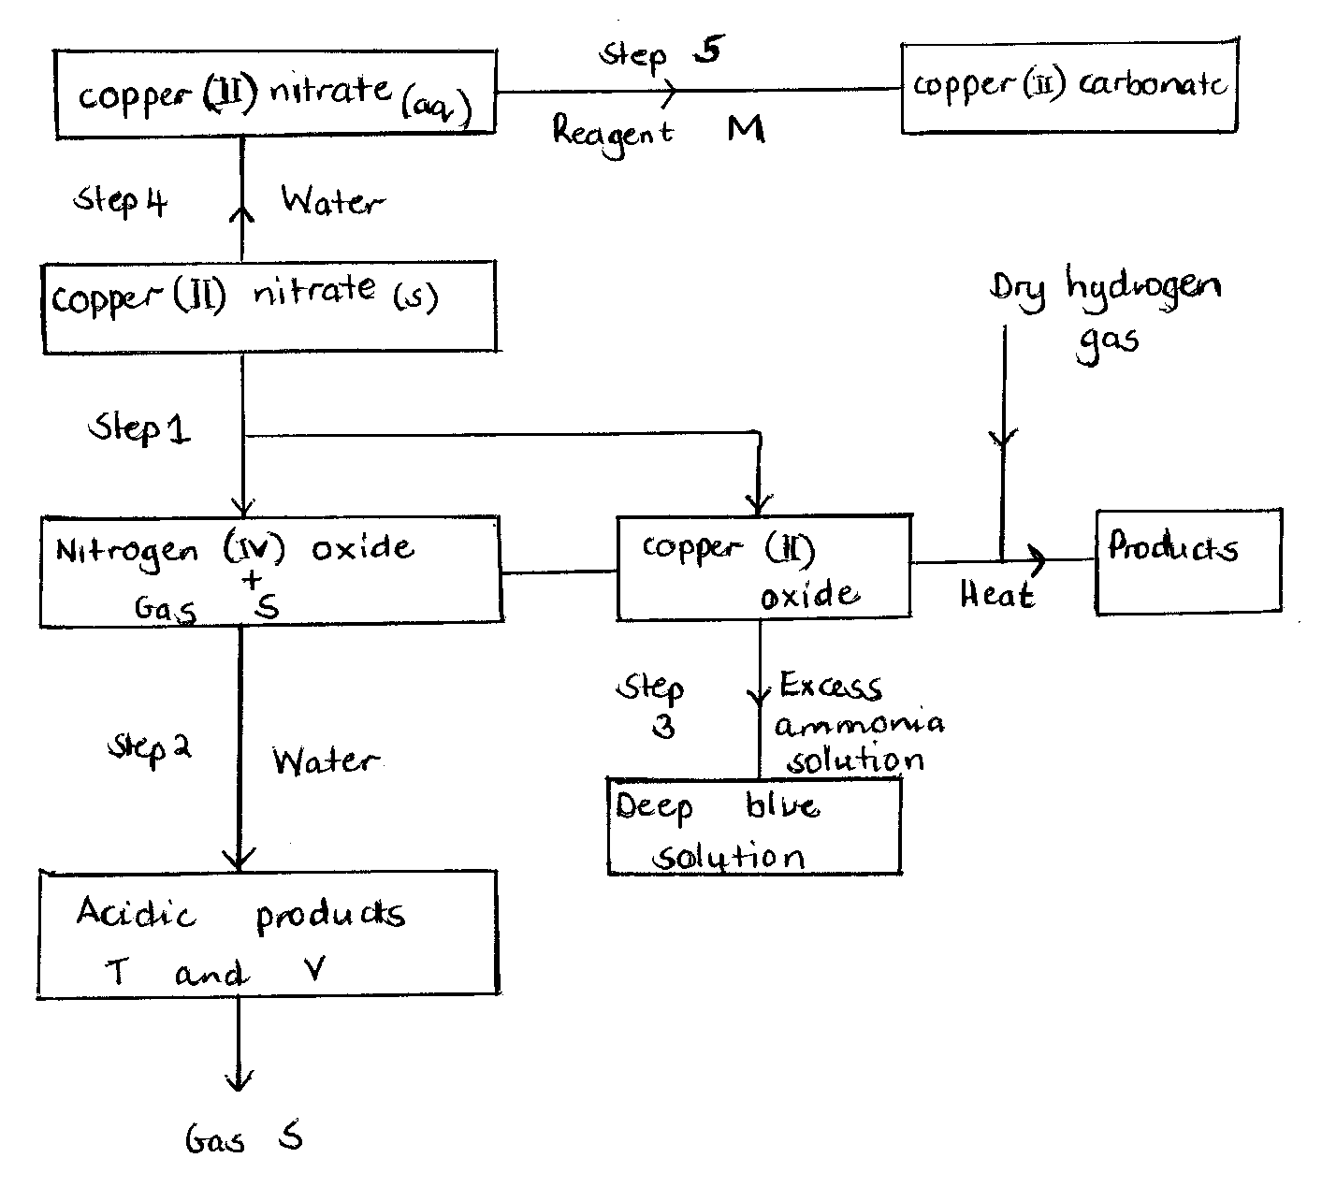

a) i) State the condition necessary in step 1. {1 mark}
ii) Identify {4 marks}
Reagent M ………………………………………….
Gas S ………………………………………….
Acidic products T ……………………………………
V ……………………………………
iii) Write the formula of the complex ion formed in step 3. {3 marks}

iv) Write the equations for the reaction in {2 marks}
Step 1

Step 2

b) The diagram below is a flow chart for the extraction of copper. Study it and answer the questions that follow.
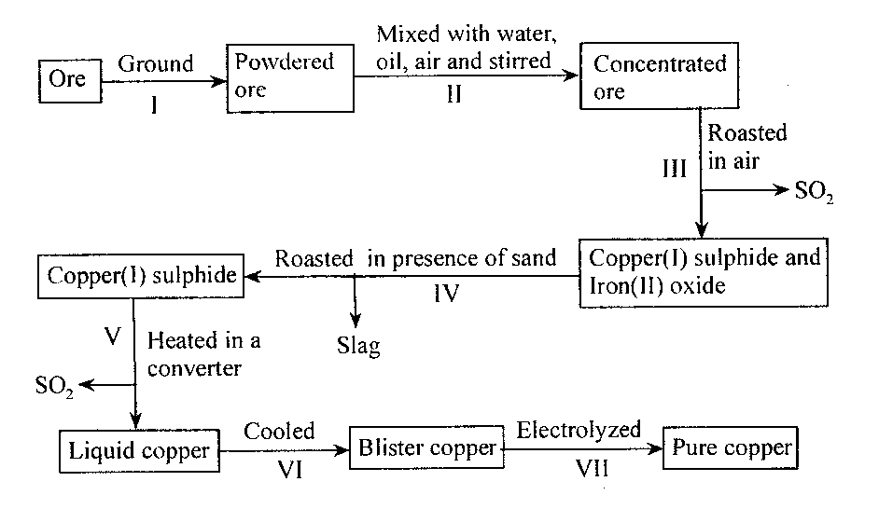
i) State the name of the process carried out in step II. {1 mark}

ii) Write the formula of the cation present in the slag. {1 mark}

iii) Write the equation for the reaction that takes place in step III. {1 mark}

iv) Blister copper is not pure and is refined by electrolysis. Draw a well labeled diagram to show
how it is refined. {3 marks}

v) During electrolysis of blister copper, contaminating metals such as zinc and ion also go into
solution as ions. Give one reason why these ions are not discharged at the cathode.
{1 mark}

6. Use the standard electrode potentials given below to answer the questions that follow.
E^{θ} (v)
Ag⁺_{(aq)} + e Ag_{(s)} +0.80
Cu²⁺_{(aq)} + 2e Cu_{(s)} +0.34
Pb²⁺_{(aq)} + 2e Pb_{(s)} -0.13
Zn²⁺_{(aq)} + 2e Zn_{(s)} -0.76

a) i) Select two half cells which when combined give the lowest electromotive force. {1 mark}

ii) Write the cell representation for the cell in (i) above. {1 mark}

iii) Calculate the e.m.f of the cell obtained by combining the two half cells. {1 mark}
b) Identify the strongest oxidizing agent. {1 mark}

c) A cell was set up using zinc and lead electrodes as shown in the diagram below.
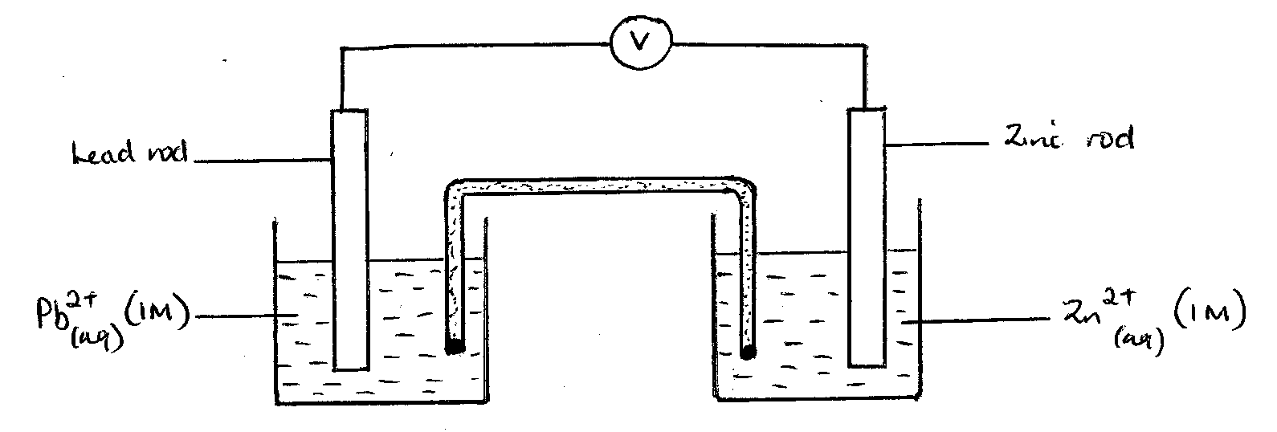

i) Write the equations for the reactions that occur at the half cells. {2 marks}
Zinc half cell

Lead half cell

ii) On the diagram, show the flow of electrons. {1 mark}
iii) Write the overall cell equation. {1 mark}

iv) The salt bridge is made of potassium nitrate or sodium nitrate solution. Give a reason for
this. {1 mark}

d) An iron cup was electroplated using chromium. The iron cup was thoroughly cleaned and weighed before dipping it into the electrolyte.
i) Why was the cup cleaned before electroplating? {1 mark}

ii) A current of 0.75 A was passed through the electrolyte for 1 hour 4 minutes. The mass of the
chromium deposited on the cup was 0.52 g.
(1 Faraday = 96,500 C, Cr = 52)

I) Calculate the quantity of electricity used. {1 mark}

II) Calculate the charge on the chromium ion. {3 marks}

7. Dry hydrogen chloride gas was passed over heated magnesium ribbon as shown below. The gas produced was then passed through heated copper (II) oxide.
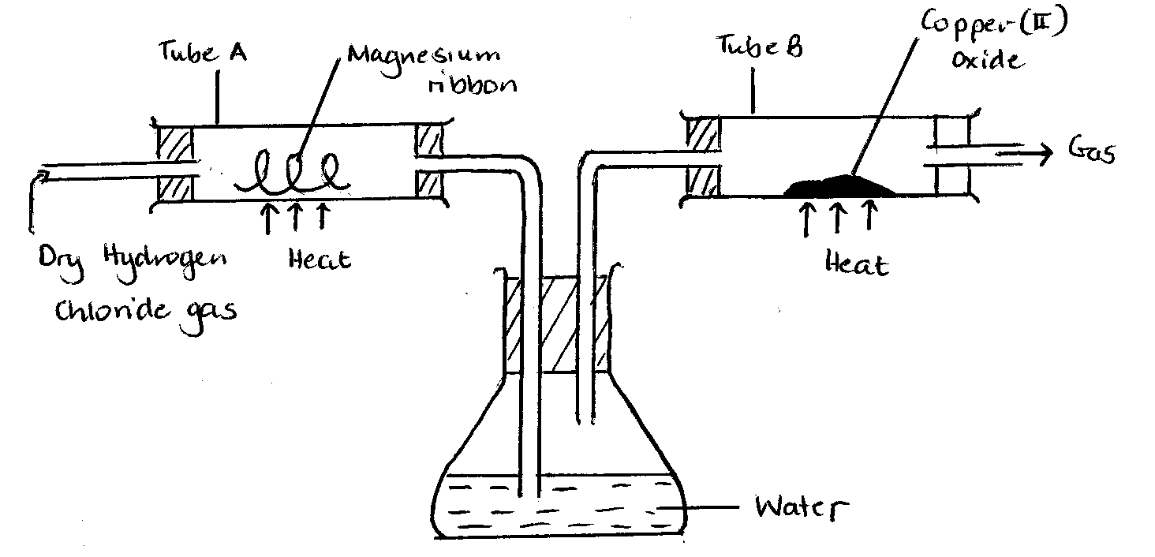

a) What is the function of the water in the flask? {1 mark}

b) Write chemical equations for the reactions that took place in the tubes A and B. {2 marks}
Tube A

Tube B
c) How would the total mass of tube B and its contents compare before and after the experiment?
Explain. {2 marks}

d) When hydrogen chloride gas is dissolved in methylbenzene the solution does not react with magnesium. When hydrogen chloride gas is dissolved in water the solution reacts with magnesium. Explain. {2 marks}

8. A student set up the apparatus shown below to investigate the effect of heat on a sample of zinc carbonate.
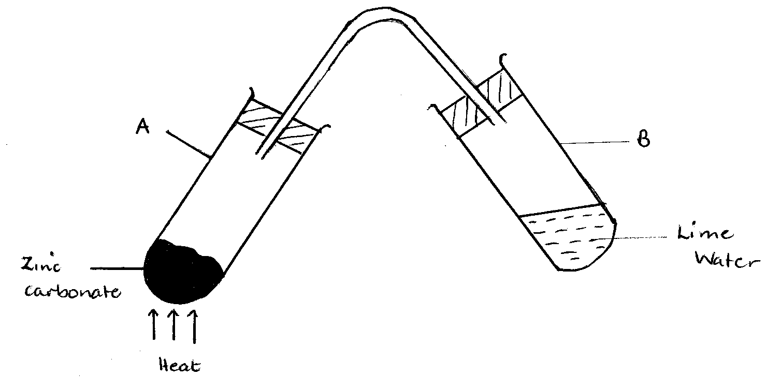
I) State the observations made in the test tubes when test tube A and B is heated strongly.
{2 marks}
A

B
ii) Write an equation for the reactions that occur in {2 marks}
A

B

iii) Name one alloy of zinc. {1 mark}

