NAME…………………………………………………INDEX NO:………
SIGN………………
DATE……………..
233/2
CHEMISTRY
PAPER 2
THEORY
2 HOURS
JULY - 2015

STAREHE GIRLS SCHOOL AND CENTRE
MOCK EXAMINATION
Kenya Certificate of Secondary Education

INSTRUCTIONS TO CANDIDATES
- Write your name and index on the space provided above.
- Answer ALL questions in the spaces provided.
- Mathematical tables and electronic calculators may be used.
- All workings must be clearly shown where necessary.

For Examiners Use Only

Questions |  | Maximum Score | Candidates Score
1-15
 | Total score | 80

This paper consists of 13 printed pages. Candidates should check the question paper to ensure that all pages are printed as indicated

- The grid below represents part of the periodic table. Study the information in it and answer the questions that follow. The letters do not represent the actual symbols of the elements.

J |  |  |  |  |  | N |  |  | Q | S | V
K | M |  |  |  |  |  |  | P |  | T
L |  |  |  |  |  |  |  |  | R

- (i) What name is given to the group of elements to which M belongs. (1 mk)
………………………………………………………………………………………………………………………………………………………………………………………
(ii) Which element forms a stable ion of -3?Explain (1mk)
………………………………………………………………………………………………………………………………………………………………………………………………(iii) Identify an element with an oxide which is soluble both in dilute hydrochloric acid and in sodium hydroxide solution. (1mk)
…………………………………………………………………………………………………………………………………………………………………………………………….
(iv) Both S and T react with heated sodium metal to form salts. Compare the melting points of salt S of sodium and salt T of sodium. (2 mks)
…………………………………………………………………………………………………………………………………………………………………………………………….
b) Comment on the stability of the compound formed between J and S. (1 mk)

………………………………………………………………………………………………………………………………………………………………………………………
c) Element W is in the group of Q and R and lies between Q and R. Compare the meeting point of Q and W. (1 mk)
………………………………………………………………………………………………………………………………………………………………………………………
d) (i) Write the formula of the compound formed between K and P. (1 mk)
………………………………………………………………..........................................……

(ii) Give the possible structure of the compound formed in d) (i) above. Give a reason.(1 mk)

………………………………………………………………………………………………
2 (a) Study the scheme below and use it to answer the questions that follow.
T
H H H
| |
⎯ C ⎯ C ⎯C
| |

H H H

| |
CH₃ H _{n}

Br_{2(g)} J
R
Y
V
CH₃CH = CH₂
CH₃CH₂CH₃

E
Gas Q
Na_{(S)}
CH₃CH₂CH₂OH

KMnO₄/H
NaOH
Na₂CO₃
GAS P
CH₃CH₂COONa
CH₃CH₂COOH
K
NaOH / HEAT
U
W
CH₃CH₃
CH₃CH₂COOCH₂CH₃
N
L
NaOH
Z
CH₃CH₂Cl
CH₃CH₂COONa
CH₃CH₂OH

Name i) Gas P……………………………………………………..

ii) Gas Q……………………………………………………...

iii) Substance J……………………………………………

iv) Substance N…………………………………………………..

v) Substance K……………………………………………………….

vi) Process U………………………………………………………(3mks)
(b) Give the structural formula of T …………………………………… (½ mk)
(c) Write down the equation for the reaction represented by step U. (½ mk)
………………………………………………………………………………………………………………………………………………………………………………………
(vii) Complete the table below (3 mks)

Reaction | Reagent | Condition
V
W
E
Z

3. (a) Study the potential differences below and use it to answer the questions that follow.
Metal under test | Voltage obtained
A  B  C  D  E  F | - 2.70  - 1.10  - 0.40  - 0.28  0.00  + 0.80
(i) Name metal E. Give a reason for your answer. (1 mk)
…………………………………………………………………………………………………..
(ii) Identify two half cells that when combined would have the highest voltage.(1 mk)
……………………………………………………………………………………………………..
…………………………………………………………………………………………………….
(iii) Work out the E.M.F. of the cell formed in (ii) above. (1 mk)
……………………………………………………………………………………………………..
…………………………………………………………………………………………………….
(b) An aqueous solution of sodium sulphate is electrolysed using platinum electrodes. When the current is passed, a gas that relights a glowing splint is produced at electrode X.
(i) Name the electrode which acts as cathode. Give a reason. (1 mk)
………………………………………………………………………………………………………………………………………………………………………………………………………………
(ii) Write an equation for the reaction at the anode. (1 mk)
(iii) 0.52g of metal R is deposited by electrolysis when a current of 0.75 amperes flows for 64 minutes. (R = 52.0, F = 96,500 coloumbs)
I. Find the number of moles of metal deposited. (½ mk)
………………………………………………………………………………………………………………………………………………………………………………………………………………
II. Find the quantity of electricity passed. (1 mk)
………………………………………………………………………………………………………………………………………………………………………………………………………………
………………………………………………………………………………………………………
III. Determine the value of n in the metallic ion R^{n+} (1¹/₂ mk)
………………………………………………………………………………………………………
………………………………………………………………………………………………………………………………………………………………………………………………………………………………………………………………………………………………………………………
4. A sample of hydrocarbon was completely burnt in oxygen to give 6.16g of carbon iv oxide and 2.52g of water.
(i) determine the empirical formula of the hydrocarbon.(H=1, C=12, O=16) (2mks)
………………………………………………………………………………………………………
……………………………………………………………………………………………....……
……………………………………………………………………………………………………
……………………………………………………………………………………………………
(ii) When the sample was in vapour form,it occupied 480cm³ at room temperature and pressure.Work out its molecular formula(Molar gas volume=24000cm³) (2mks)

5.Study the scheme below and answer the questions that follow
(i) Write the formula of the cation present in solution F. (1mk)
(ii) What property of Chlorine is shown in step I (¹/₂mk)
………………………………………………………………………………………………
(iii) Write an equation for the reactions taking place in Steps II and III. (2mks)
Step II:…………………………………………………………………………………
StepIII…………………………………………………………………………………
- Explain why Fe²⁺ solution slowly changes colour to brown when exposed to air for sometime. (1mk)
………………………………………………………………………………………………
6. Study the flow chart below and answer the questions that follow.
Clean
SO_{2 (g)}
AIR
Water
SO_{2 (g)}
Air
Purifier
SOLID A

Solution L
Air
Excess NaOH

Solution
M

White precipitate

Barium nitrate

(i) Other than sulphur, name two possible identities of solid A. (1 mk)
………………………………………………………………………………………………………
……………………………………………………………………………………………………...
(ii) Write an ionic equation for the formation of the white precipitate (1 mk)
………………………………………………………………………………………………………
……………………………………………………………………………………………………...
(iii) State and explain the observations made when red and blue litmus papers were dipped into solution L. (1mk)
………………………………………………………………………………………………………
……………………………………………………………………………………………………...
(iv) State and explain the observations made when dilute hydrochloric acid is mixed with the white precipitate. (1mk)
………………………………………………………………………………………………………

7 (a) State Hess’s law. (1 mk)
………………………………………………………………………………………………………
……………………………………………………………………………………………………...
(b) Use the following equations to determine the heat of formation of butane.
C_{(s)} + O_{2 (g)} CO_{2 (g)} ΔH = -393 kJmol⁻¹
H_{2 (g)} + ½O_{2 (g)} H₂O _{(g)} ΔH = -286 kJmol⁻¹
C₄H_{10 (g)} + ¹³/₂O_{2 (g)} 4CO_{2 (g)} + 5H₂O _{(g)} ΔH = -2877 kJmol⁻¹

(i) Draw an energy cycle diagram for the formation of butane. (2 mks)
………………………………………………………………………………………………………
……………………………………………………………………………………………………...
………………………………………………………………………………………………………
……………………………………………………………………………………………………...
………………………………………………………………………………………………………
……………………………………………………………………………………………………...
………………………………………………………………………………………………………
(ii) Calculate the heat of formation of butane. (2 mk)
………………………………………………………………………………………………………
……………………………………………………………………………………………………...
………………………………………………………………………………………………………
……………………………………………………………………………………………………...
………………………………………………………………………………………………………
……………………………………………………………………………………………………...
(c)The molar heat of vaporization is higher than molar haet of fusion.Explain. (1mk)
………………………………………………………………………………………………………
……………………………………………………………………………………………………...
………………………………………………………………………………………………………

8. The diagram below illustrates the Hall’s cell for the extraction of Aluminium. Study it and answer the questions that follow.
Molten Aluminium
Electrolyte
G
- (i) Name the electrode labeled G…………………..................................(½ mk)

(b) Electrolysis is carried at 800 – 900⁰C and newly formed Aluminium is tapped off as a liquid. What does this indicate about the melting point of Aluminium? (1 mk)
………………………………………………………………………………………………………
……………………………………………………………………………………………………...
(c) (i) Give the ionic equations for the reaction that takes place at the cathode. (1 mk)
………………………………………………………………………………………………………
……………………………………………………………………………………………………...
(ii) The anode has to be replaced frequently. Explain. (1mk)
………………………………………………………………………………………………………
……………………………………………………………………………………………………...
d) Cryolite is used in the extraction of aluminium from bauxite.State its function.(1mk)
………………………………………………………………………………………………………
……………………………………………………………………………………………………...
d) A piece of unpolished aluminium foil is not attacked by water steam and dilute hydrochloric acid. Explain. (1mk)
………………………………………………………………………………………………………
……………………………………………………………………………………………………...
e) (i) The basic raw material for extraction of aluminium is bauxite. Name two major impurities in bauxite. (1 mk)
………………………………………………………………………………………………………
……………………………………………………………………………………………………...
(ii) State one property of duralium that make it more suitable than pure aluminium in aeroplane construction. (½ mk)
………………………………………………………………………………………………………
……………………………………………………………………………………………………...
9.Study the flow chart below that represents the manufacture of sodium carbonate.
Solid Y
Ammonia
CO₂
Water
II
Kiln
I
V
III
T
Filter
Sodium carbonate
Calcium oxide
Limestone
Baffles in solvay tower
(i) Identify substances:K………………………………………………………….
T……………………………………………….. Y………………………………
V……………………………………………………………… (2mks)
(ii) Write an equation for the reaction that takes place in the:
I) Solvay tower. (1mk)
………………………………………………………………………………………………………………………………………………………………………………………………
II) Chamber labelled II (1mk)
………………………………………………………………………………………………………………………………………………………………………………………………
(iii) What is the role of the baffles in the solvay tower? (1mk)
………………………………………………………………………………………………………………………………………………………………………………………………
(iv) Name two substances that are recycled in this process (1mk) ………………………………………………………………………………………………………………………………………………………………………………………………
10. (a) Below is a diagram of a deflection and penetrating powers of three radiations from a radioactive source
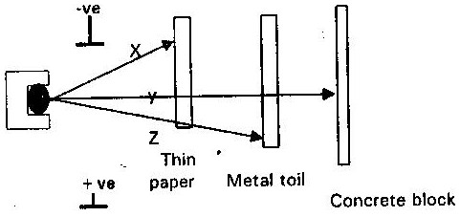

(i) Name the radiations labeled X, Y and Z and their property (3mks)
X……………………………………Property…………………………………………
Y……………………………………Property…………………………………………
Z……………………………………Property………………………………………
(ii) Why are radiation X stopped by a thin piece of paper (1mk)

………………………………………………………………………………………………
11. (a) Explain why potassium is kept under paraffin while phosphorous under water(1mk) ………………………………………………………………………………………………

(b) Study the diagram below and answer the questions that follows:
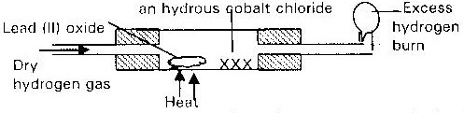

- State two observations that may be made in the combustion tube. (1mk)
………………………………………………………………………………………………
ii) Write an equation for the reaction of hydrogen with Lead (II) Oxide. (1mk)
……………………………………………………………………………………………………
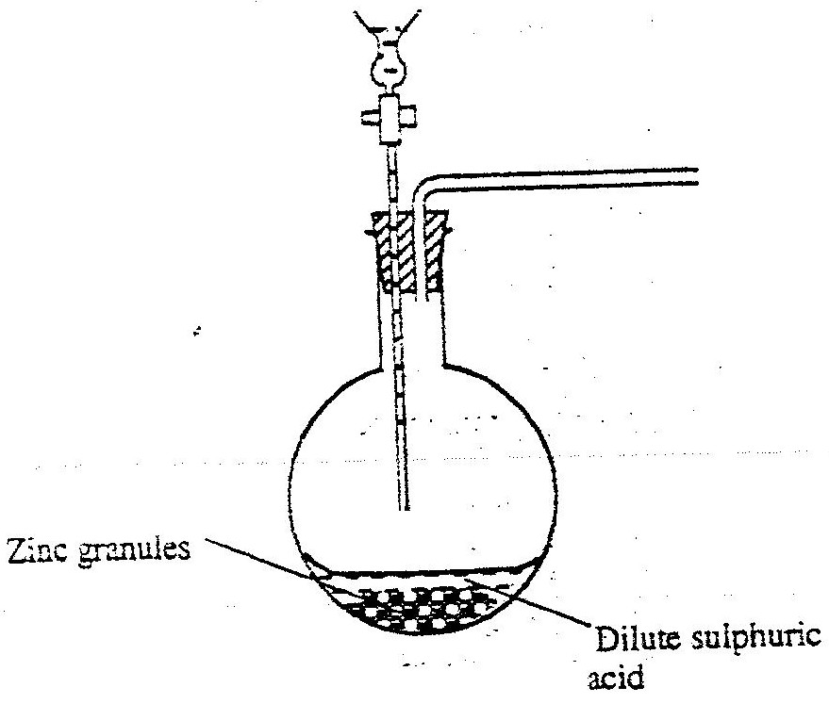
12. The set up below was used to prepare hydrogen gas.

a) Complete the diagram to show how a dry sample of hydrogen gas can be collected.(3mk)
b) Hydogen gas is one of the lightest gas known but has not lived to its expection to be used in observation balloons.Explain. (1mk)
……………………………………………………………………………………………………………………………………………………………………………………………………
c) Write an equation which takes place when hydrogen gas burns in air. (1mks)
………………………………………………………………………………………………
e) 1.2 litres of hydrogen gas was produced at room temperature and pressure when 3.27g of zinc were used.Determine the relative atomic mass of zinc (molar gas volume is 24 litres). (2mks)
……………………………………………………………………………………………………………………………………………………………………………………………………………………………………………………………………………………………………………………………………………………………………………………………
f)State two industrial used of hydrogen gas. (1mks)
………………………………………………………………………………………………………………………………………………………………………………………
13.(a) State the Graham’s law of diffusion (1mk)
………………………………………………………………………………………………………

…………………………………………………………………………………………………….

(b) The molar masses of gases Wand X are 16.0 and 44.0 respectively. If the rate of diffusion of W through a porous material is 12cm³S⁻¹, calculate the rate of diffusion of X through the same material. (2mks)
………………………………………………………………………………………………………………………………………………………………………………………
(c) Calculate the R.F.M of gas “A” given that the time taken for equal volumes of oxygen and gas “A” to diffuse through a hole is 20 seconds and 24 seconds respectively (O=16.0) (2mks)
……………………………………………………………………………………………………………………………………………………………………………………………
……………………………………………………………………………………………

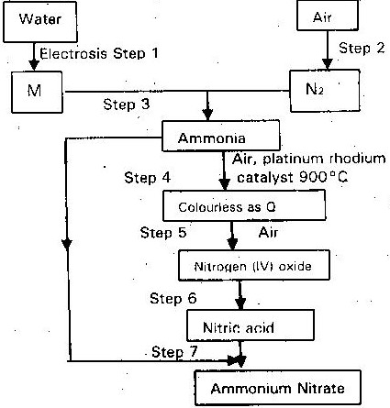
14. Study the flow chart below and answer the questions that follows

i)Name element M. (¹/₂mk)

………………………………………………………………………………………………
ii)Write an equation for the reaction in step 7. (1mk)

iii)Give one use of Ammonium –Nitrate. (¹/₂mk)

………………………………………………………………………………………………
iv)State and explain the observations that would be made if a sample of sulphur is heated with concentrated Nitric acid. (Nitric (V) acid. (1mks)
…………………………………………………………………………………………………………………………………………………………………………………………….

15.(a) The following diagrams show the structures of two allotropes of carbon. Study them and answer the questions that follow:-
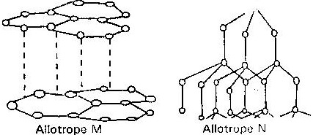

i) Name the allotrope
M………………………………………………………………….(1mk)
N………………………………………………………………….(1mk)
ii) Give one use of N (1mk)
……………………………………………………………………………………….
- Which allotrope conducts electricity? Explain (1mk)
……………………………………………………………………………………….

(b) Explain what is meant by the term cloud seeding (1mk)

THIS IS THE LAST PRINTED PAGE

