312/2
GEOGRAPHY
Paper 2
JUNE 2015
Time: 2¾ hours

KASSU-JET JOINT EXAMINATION
Kenya Certificate of Secondary Education
312/2
Paper 2
GEOGRAPHY

INSTRUCTIONS TO STUDENTS

- This paper has two sections A and B
- Answer ALL the questions in section A. In section B answer questions 6 and any other TWO questions.

SECTION A
QUESTION 6
QUESTION 7
QUESTION 8
TOTAL

SECTION A
Answer ALL the questions in this section.

1. (a) Name two indigenous softwood tree species found in Kenya. (2 marks)

(b) State three factors that favour the development of softwood forests in Canada. (3 marks)

2. Use the map of Kenya below to answer question (a).

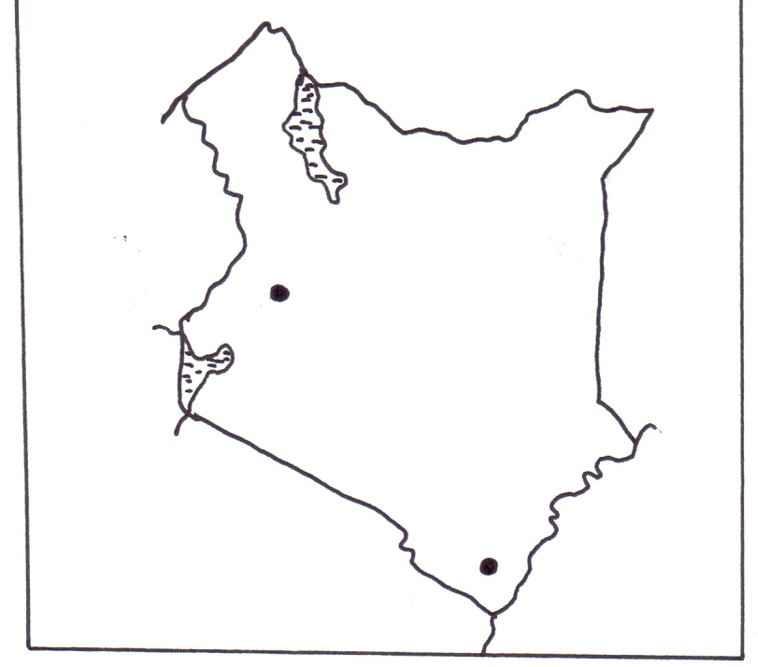
P
R
(a) Name the minerals mined in the areas marked P and R. (2 marks)

(b) State three benefits of Gold mining to the economy of South Africa. (3 marks)

3. (a) State three factors which led to the growth of Eldoret town. (3 marks)

(b) State three functions of Central Business District in a town. (3 marks)

4. (a) State two negative effects of tourism in Kenya. (2 marks)

(b) Sate three social-economic factors that attract tourists in Switzerland. (3 marks)

5. Describe long lining as a method of fishing. (4 marks)

SECTION B

Answer question 6 and any other TWO questions from this section.
6. The table below shows the prices of sugar in Kenya shillings per ton in some countries in Africa. Use it to answer question (a).
Year | Kenya | South Africa | Tanzania | Zambia
2010 | 95,400 | 61,927 | 68,702 | 84,447
2011 | 111,713 | 67,462 | 66,985 | 93,798
2012 | 110,878 | 65,173 | 90,649 | 86,832

(a) (i) Draw a divided rectangle 16cm long to represent the prices of sugar in the year 2012. (7 marks)
(ii) State two advantages of using divided rectangles to represent data. (2 marks)
(b) State three physical conditions that favour large scale sugarcane farming in Western Kenya. (3 marks)
(c) Describe the stages involved in sugar production from harvesting to marketing. (7 marks)
(d) Explain three problems facing sugarcane farming in Kenya. (6 marks)

7. (a) State two advantages of written communication. (2 marks)
(b) Use the outline map of East Africa provided to answer questions (i) and (ii).
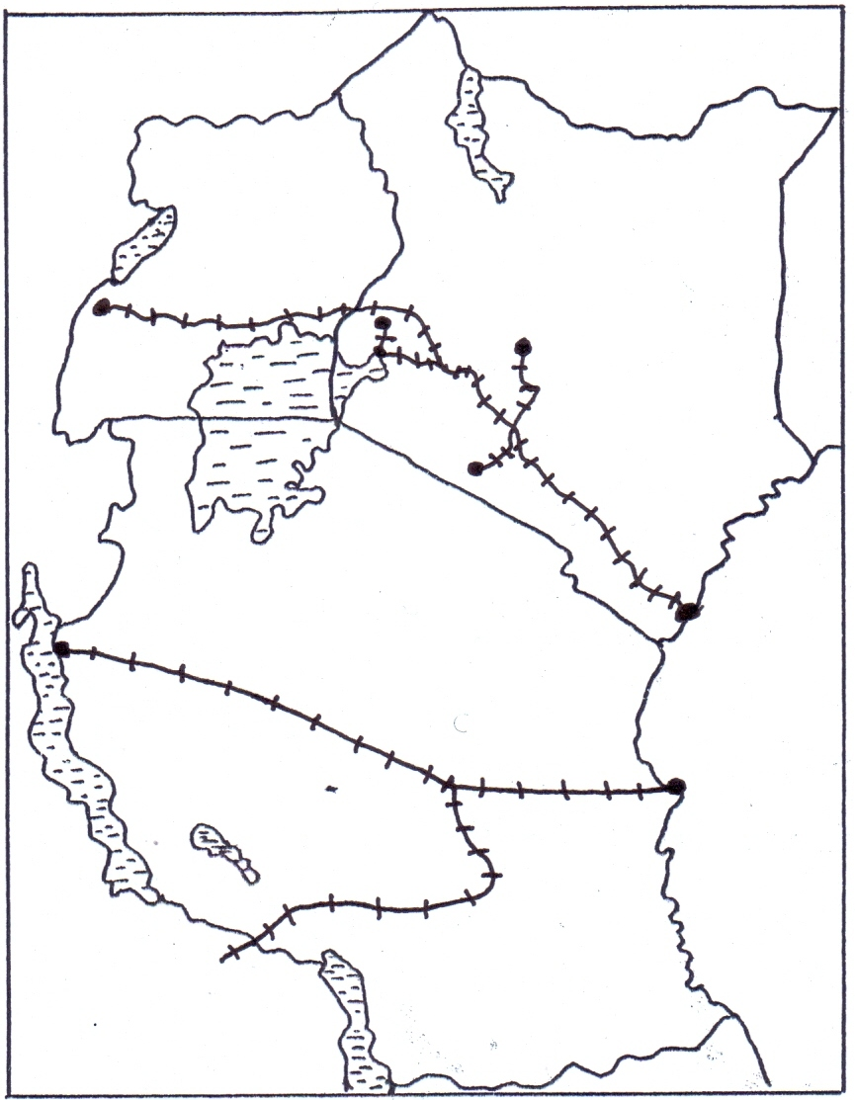
W
Mombasa
Dar es Salaam
Y
X
Z
(i) Name the towns marked W and X. (2 marks)
(ii) Name the railway lines marked Y and Z. (2 marks)
(c) (i) State two ways in which Kenya would benefit from the construction of the Standard gauge railway. (2 marks)
(ii) Explain three factors that hinder development of River transport in Africa. (6 marks)

(d) The map below shows the Great Lakes and St. Lawrence Seaway. Use it to answer question (i) and (ii).
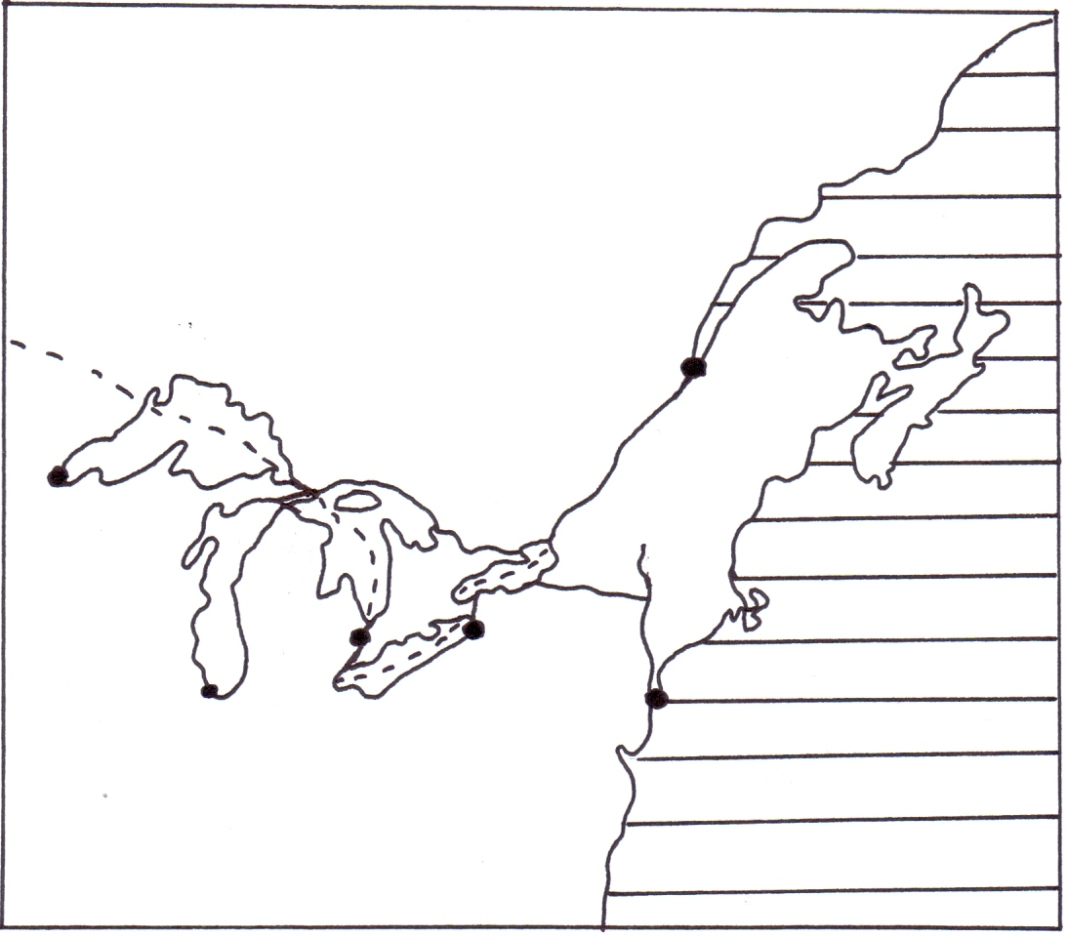
M
N
P
J
K
Chicago
Quebec
New York
Atlantic Ocean
River Hudson
River St. Lawrence
Lake Huron
CANADA
U.S.A
(i) Name the canals marked J and K. (2 marks)
(ii) Name the towns marked M, N and P. (3 marks)
(iii) Explain three measures that were taken to solve the challenges that faced navigation along the Great Lakes and St. Lawrence Seaway. (6 marks)
8. (a) Differentiate between manufacturing industries from tertiary industries. (2 marks)
(b) (i) Name two non-food agricultural industries in Kenya. (2 marks)
(ii) State three measures that are being taken by the government of Kenya to promote Jua-Kali industries. (3 marks)
(iii) Describe the characteristics of the cottage industries in India. (5 marks)
(c) (i) State three benefits of decentralizing industries in Kenya. (3 marks)
(ii) Other than iron and steel, name two other industries located in Ruhr region of Germany. (2 marks)
(iii) Explain four factors which influenced the location of iron and steel industry in the Ruhr region of Germany. (8 marks)

9. (a) (i) What is sex ratio? (1 mark)
(ii) Apart from population census, give two other primary sources of population data. (2 marks)
(iii) State three significance of population census to a country. (3 marks)
(b) Explain four factors that have led to a high population density in the Kenya Highlands. (8 marks)
(c) The pyramid below represents the population structure of Sweden.
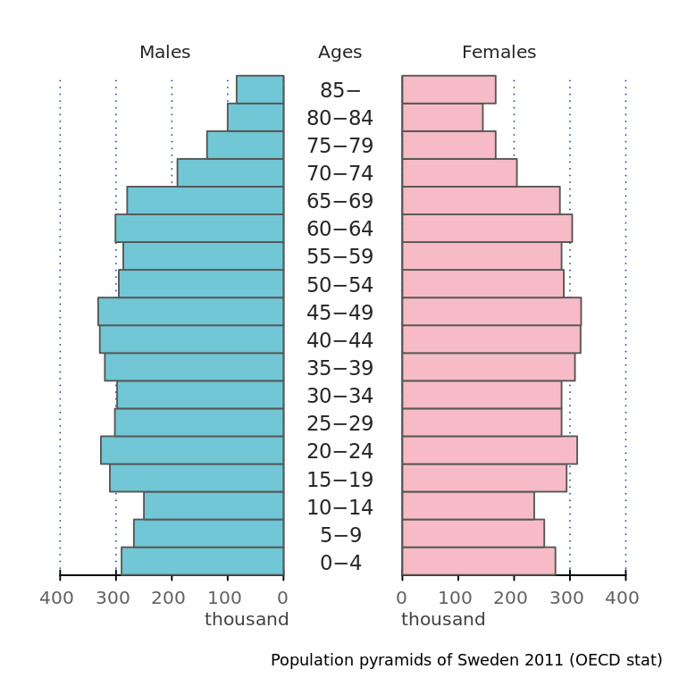
Describe the characteristics of population represented by the pyramid. (5 marks)
(d) Explain three cause of urban-rural migration. (6 marks)
10. (a) (i) Distinguish between visible and invisible exports. (2 marks)
(ii) Name two seaports that handle exports in East Africa. (2 marks)
(b) Explain three measures Kenya can take to reduce her unfavourable balance of trade. (6 marks)
(c) Explain three reasons for low volume of trade between the countries in Africa. (6 marks)
(d) (i) State three benefits of ECOWAS to the member states. (3 marks)
(ii) Explain three ways in which the future of international trade in Kenya can be improved. (6 marks)

