312/2
GEOGRAPHY
Paper 2
June 2015
Time: 2¾ Hours

STAREHE BOYS’ CENTRE & SCHOOL
Form 4 Mock Examination 2015
GEOGRAPHY PAPER 2
2¾ Hours

INSTRUCTIONS

- Answer all the questions in section A.
- In section B, answer question 6 and any other two questions.
- Answer section A and each question attempted in section B on a separate answer sheet.
- Failure to follow instructions will be penalized.

SECTION A
Answer all questions in this section

1(a) Give three physical factors that favour coffee growing in Kenya highlands. (3 marks)
b) State two problems facing coffee farming in Kenya. (2 marks)

2(a) Give two primary sources of population data. (2 marks)
b) What information can be derived from a population pyramid? (3 marks)

3(a) State three measures that have been taken to conserve fisheries in Kenya. (3 marks)
b) Give four reasons why Norway is a great fishing nation. (4 marks)

4. Give four reasons why it is necessary to conserve wildlife in Kenya. (4 marks)

5(a) State two economic benefits of the common market for Eastern and Southern Africa (COMESA) to the member countries. (2 marks)
b) Give two factors that limit trade among countries of Eastern Africa. (2 marks)

SECTION B

6(a) i) Name two types of dairy farming practiced in Kenya. (2 marks)
ii) Give two areas where commercial dairy farming is done along the Kenyan Coast.
(2 marks)
b) i) State five characteristics of Nomadic herding. (5 marks)
ii) Outline five steps the Kenyan Government is taking to improve livestock farming in
semi-arid areas. (5 marks)

c) Use the photograph to answer the questions below:

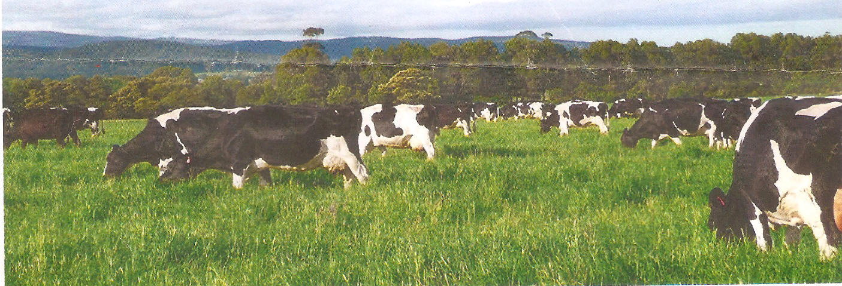

i) State the type of photograph represented (1 mark)
ii) Identify the type of commercial farming represented by the photograph. (1 mark)
iii) State four factors that may have favoured the type of farming shown above in this area. (4 marks)
d) i) Name two types of dairy animals kept in Denmark.
ii) State three differences between dairy farming in Kenya and Denmark. (3 marks)

7. Use the map of East Africa below to answer question (a) (i)
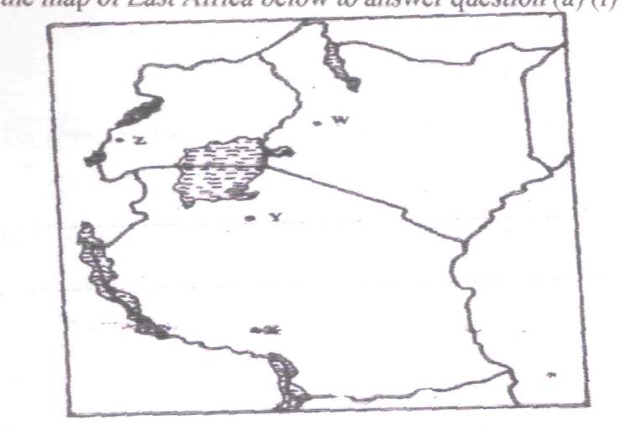

a) Identify the mineral mined in the areas marked W,X,Y, and Z. (4 marks)
b) Name:
i) Three methods of mining (3 marks)
ii) Two sea ports through which some of the minerals mined in East Africa are exported. (2 marks)
c) State five factors that influence the exploitation of minerals. (5 marks)
d) i) Explain four ways in which soda ash contributes to the economy of Kenya. (8 marks)
ii) State three ways in which derelict land can be reclaimed. (3 marks)

8(a) Differentiate between transport and communication. (2 marks)
b) i) State two main transcontinental highways in Africa. (2 marks)
ii) Give three reasons why the inland water transport is not well developed in Africa. (3 marks)

c) Study the map of the St. Lawrence Seaway and the Great Lakes of North America and use it to answer the questions below.
i) Identify the towns marked K,L,M and N. (4 marks)
ii) Explain four benefits achieved from the construction of the St. Lawrence Seaway to the economies of Canada and United States of America. (8 marks)
d) i) What is regional trade?
ii) State five ways through which the government of Kenya is promoting expert trade. (5 marks)
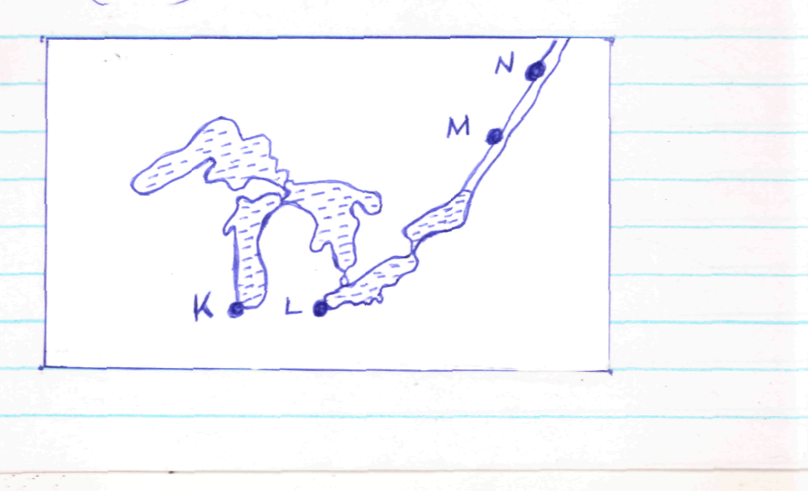

9(a) i) Define the term energy. (2 marks)
ii) List three renewable sources of energy. (2 marks)
b) i) State two advantages of solar energy. (2 marks)
ii) Give two disadvantages of coal as a source of energy. (2 marks)
c) i) State three factors hindering the development of geothermal power projects in
Kenya. (3 marks)
ii) Apart from generation H.E.P state any other five benefits of The Seven Folks Dam
Project. (5 marks)
d) Explain four measures taken by the Kenyan government to conserve energy resources. (8 marks)
10(a) i) Apart from nucleated pattern, name two other types of settlement patterns. (2 marks)
ii) Give three factors that influence the development of nucleated settlement.
(3 marks)
b) Explain four factors influencing the growth of urban centres in East Africa. (8 marks)
c) i) Define the term hinterland (1 mark)
ii) Outline four ways in which the ports of Mombasa and Rotterdam differ. (8 marks)
iii) State three benefits of urbanization. (3 marks)

