NAME ____________________________________ INDEX NO. _______________
SCHOOL ____________________________________ SIGNATURE _______________
DATE _______________

441/2
HOME SCIENCE
(CLOTHING CONSTRUCTION)
PAPER 2
PRACTICAL
JULY/AUGUST, 2015
TIME: 2½ HOURS

441/2
HOME SCIENCE
(CLOTHING CONSTRUCTION)
PAPER 2
PRACTICAL
TIME: 2½ HOURS

INSTRUCTIONS TO CANDIDATES
- This paper consists of three printed pages.
- Candidates should check the question paper to ascertain that all the pages are printed as indicated and that no questions are missing.
- Candidates are advised to ensure that the pattern pieces match with sketches shown on question paper.

A pattern of a bodice of a girl’s dress is provided. You are advised to study the sketches, the question paper and a layout before you begin the test.

MATERIALS PROVIDED
- Six pattern pieces for making the bodice of the dress as follows:
- Bodice Front
- Bodice Back
- Sleeve
- Collar
- Opening facing
- Neckband
- Plain cotton poplin material
- Mercerized sewing cotton thread to match the fabric
- Interfacing material 30cm by 21cm.

THE TEST
Making use of the materials provided and the layout shown, cut out and make up the right half of girls’ dress bodice to show the following.
  - Working of the faced opening at centre back
  - Working of burst dart
  - Making French seam at the shoulder
  - The preparation of the collar and its attachment using the neckband. The collar should be interfaced
  - Hemming down the neckband.
  - Joining the side with an open seam.
  - Preparation and setting in of the bell sleeve. Omit the neatening of the armhole seam.
  - Turning a narrow hem to neaten the lower edge of the sleeve.

At the end of the examination, firmly sew onto your work, on single fabric, a label bearing your name and Index Number. Remove the needle, pins and unnecessary threads from your work. Then fold your work carefully and place it in the envelope provided.
Do not put scraps of material in the envelope.

THE LAYOUT (NOT DRAWN TO SCALE)
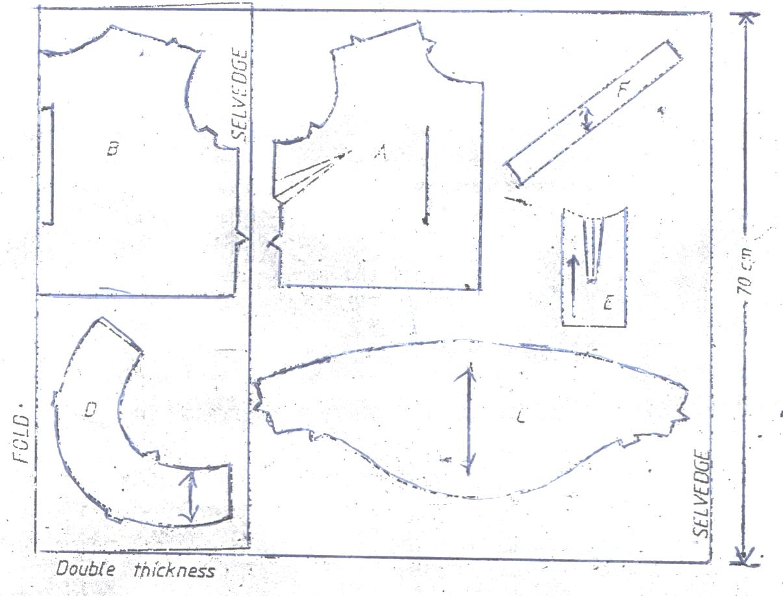
F

SELVEDGE
SELVEDGE

E

70 cm
Fold
Double thickness
D
L
A
B

BACK VIEW
FRONT VIEW

