Name…………………………………………………………..… Adm No………Class………

121/1
Mathematics
Paper 1
2 ½ Hours
June 2015

KASSU JOINT EVALUATION TEST (J.E.T)
Kenya Certificate of Secondary Education (K.C.S.E)

INSTRUCTIONS TO CANDIDATES

- Write your name and Admission number in the spaces provided at the top of this page.
- This paper consists of two sections: Section I and Section II.
- Answer ALL questions in section 1 and ONLY FIVE questions from section II
- All answers and workings must be written on the question paper in the spaces provided below each question.
- Show all the steps in your calculation, giving your answer at each stage in the spaces below each question.
- Non – Programmable silent electronic calculators and KNEC mathematical tables may be used, except where stated otherwise.

FOR EXAMINERS USE ONLY
SECTION I
1 | 2 | 3 | 4 | 5 | 6 | 7 | 8 | 9 | 10 | 11 | 12 | 13 | 14 | 15 | 16 | TOTAL

SECTION II GRAND TOTAL

17 | 18 | 19 | 20 | 21 | 22 | 23 | 24 | TOTAL

SECTION I

1. Evaluate without using tables or calculator. (3 marks)

$$\frac{¼ of 2 + 3 ¾ ÷ 3/8 - 4 ½ x 3 1/3}{ 2 4/5 x 13/7 - 4 ÷ 2/3 + 3/5 of 15}$$

2. Using tables evaluate. (3marks)
$\frac{1}{34.52}+ \sqrt[3]{0.787}+ {\left(0.934\right)}^{3}$

3. A tourist arrived in Kenya with US Dollars 3000 which he exchanged into Kenya shillings. He spent Ksh. 75000 on hotel accommodation and Ksh.42500 on travel and other expenses. He changed the remaining money into sterling pounds. Calculate how much money in sterling pounds that he remained with using the following rates. (Leave your answer to the nearest 1£)

 | Buying(Kshs) | Selling(Kshs)
1 US dollar($) | 78.45 | 78.95
1 Sterling pound(£) | 120.27 | 121.04
(3marks)

4. Solve for y in the equation 8 ^{(2y – 1)} x 32^{y} = 16 ^{(y + 1)}. (3marks)

5. Solve the equation: (3marks)

$\frac{1 \left(x+3\right)+ x}{x (x+3)}=\frac{11}{28x}$

6. Determine the equation of the normal to the curve y = 3x² – 4x + 1 at the point (2, 5).
(3marks)

7. given that AB = $\begin{matrix}3 \\ 5\end{matrix}$ and CD = $\begin{matrix}K-1 \\ 15\end{matrix}$ are parallel, find the value of K and hence evaluate |CD| (3marks)

8. Make a the subject of the formula:
x = y $+\sqrt{x^{2}+ a^{2}}$ (3marks)

9. Find the equation of a straight line which is equidistant from the points A(2, 3) and B(6, 1). Express your answer in the form $\frac{x}{a}$+ $\frac{y}{b}$ = 1 where a and b are constant. (3marks)

10. The GCD and LCM of three numbers are 3 and 1008 respectively. If two of the numbers are 48 and 72 respectively, find the least possible value of the third number. (3 marks)

11. Kamau salary increased from Ksh 16,800 to 18,00 in the month of April. State the ratio in which it changed. What was the percentage change in his salary? Leave you percentage answer to 4. s. figures. (3marks)

12. If tan X = ⁴/₃ , find the value of sin²X + cos X without using tables or calculator. (3marks)

13. The area of a rhombus is 60cm². Given that one of its diagonal is 15cm long. Calculate the perimeter of the rhombus. (3 marks)

14. If x is a positive integer find all the integral values of x given that: (3marks)

-3 < 2x + 4 < -3x + 9

15. Solve for x in log₃ (4 + 3x) + 3log₃3 – 2 = log₃(x + 6) (3marks)

16. The figure below shows triangle ABC and its image A¹B¹C¹ after the transformation. Describe the transformation fully. (3 marks)
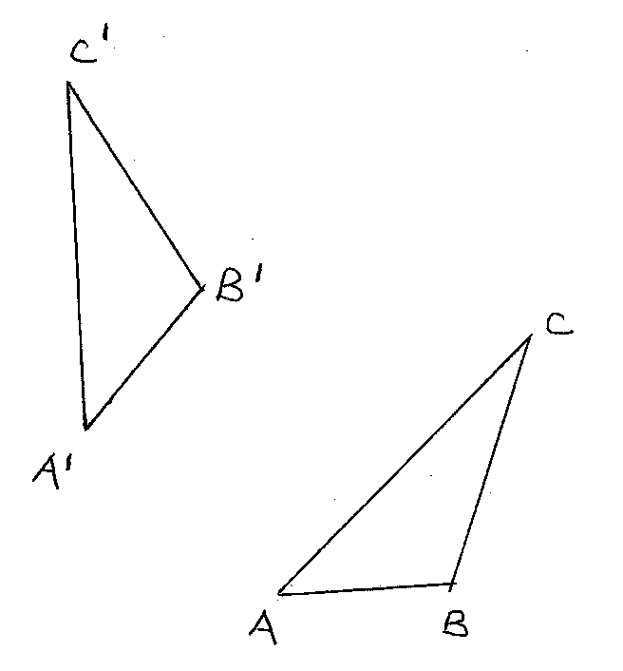

SECTION II

17. Consider points A (50⁰N, 30⁰E) and B (50⁰N, 150⁰W) (Take $π= {22}/7)$ and radius of the earth R = 6370 km. Find:
(a) The distance between A and B along a parallel of latitude in:
(i) Kilometres (km) (3 marks)

(ii) Nautical miles (nm) (2 marks)

(b) The shortest distance from A to B in nautical miles. (3 marks)

(c) An aircraft takes 54 hours to fly between the two towns A and B along the great circle. Calculate its speed in knots correct to 2 significant figures. (2 marks)

18. A curve whose equation is 2y = 6-12x+9x²- 2x³ turns at points A and B.
a) Find the coordinates of a and b (5marks)
b) Determine the nature of points A and B (3marks)
c) Sketch the curve (2marks)

19. Income tax is charged on annual income at the rate shown below.
Taxable income K£p.a | Rate Ksh/£.
1-2300 | 2
2301- 4600 | 3
4601- 6900 | 5
6901- 9200 | 7
9201- 11500 | 9
11501 and over | 10

Mr. Kipsoroi earn a basic salary of Ksh.15,000 per month and lives in a company house for which he pays nominal rent of Ksh.1250 per month. He enjoys personal relief of Ksh.1056 per month and insurance relief of Ksh.270 per month.
Calculate;
- His taxable income in K£.p.a. (3 marks)

- The amount of tax he pays per month in Kenya shillings. (5 marks)

- His net monthly salary in shillings. (2 marks)

20. The frequency distribution table below shows the marks scored by 117 form four candidates of Sanga High School.

Marks | 10 – 19 | 20 – 29 | 30 – 39 | 40 – 49 | 50 – 59 | 60 – 69 | 70 – 79
No. of students | 13 | 14 | 18 | 20 | 23 | 17 | 12

- Draw a cumulative frequency curve of the distribution. (5marks)

- Use you graph to determine:
(i) The median (2 marks)

(ii) Quartile deviation (3 marks)

21. In the figure below OF is the radius of the circle centre O chords EDC and CB are extend to meet at A and OE is perpendicular to DF at E. OF = 61cm, AB= 30cm, BC = 50cm, AD= 40cm.
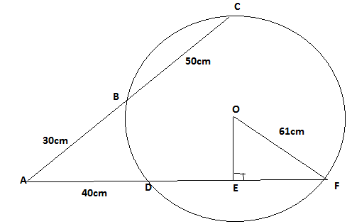
- Calculate the length of
- DF ( 2marks)
- OE (2marks)

- Calculate correct to 1dp
- Size of angle EOF ( 2marks)
- The length of the minor arc DF ( 3marks)

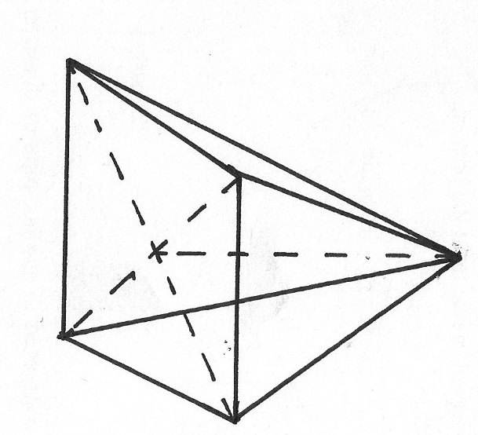
22. ABCDE is a right pyramid on a horizontal square base of side 10 cm. The slant edges are all 8 cm long. Calculate;

(a) The height of the pyramid (3 marks)

(b) The angle between;
(i) A slant face and the base (2 marks)

(ii) A slant edge and the base (2 marks)

(c) The angle between the planes ABE and DCE (3 marks)

23. In the figure below OE = a , OB = b, OA : AE = 2 : 3

- Express AC and BE in terms of a and b. (2 marks)

- DC and kAC and BD = mBE. Determine the values of k and m by expressing DC in two ways. (6 marks)

- Find the ratio of AD: DC. (2 marks)
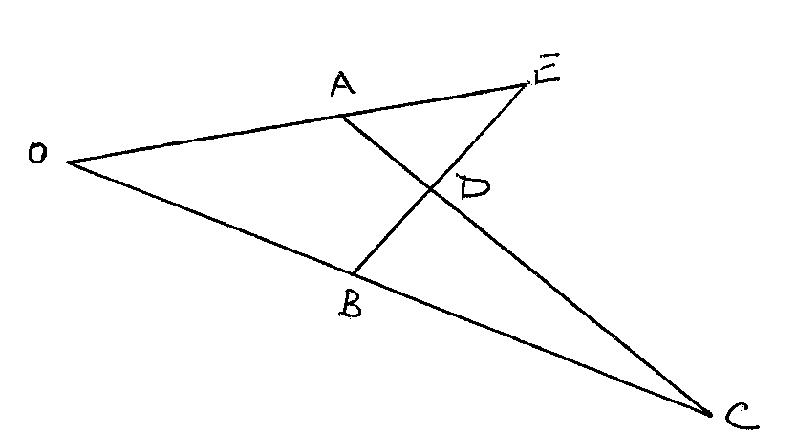

24. A theatre has seating capacity of 250 people. The charges are shs. 100 for ordinary seat and shs 160 for special seat. It cost shs 16000 to stage a show and the theatre must make a profit. There are never more than 200 ordinary seats and for a show to take place, at least 50 ordinary seats must be occupied; the number of special seats is always less than twice the number of ordinary seats.

- Taking X to be number of ordinary seats and y to be the number of special seats, write down all the inequalities representing the above information (2 marks)

- On the grid provided, draw a graph to show the inequalities in (a) above (4marks)

- Determine the number of seats of each type that should be booked in order to maximize the profit ( 2 marks)
- Calculate this maximum profit ( 2marks)

