NAME:………………………………………………………………………………………..
INDEX NO:……………………………..

121/2
MATHEMATICS
PAPER 2
JULY
2 ½ HOURS

STAREHE GIRLS’ CENTRE MOCK EXAMINATION-2015
Kenya Certificate of Secondary Education (K.C.S.E)

121/2
MATHEMATICS
PAPER 2
JULY
2 ½ HOURS

INSTRUCTIONS TO CANDIDATES
- Write your NAME and INDEX NUMBER in the spaces provided at the top of this page
- Answer all questions in section I and any five questions in section II.
- Show all the steps in your calculations giving your answer at each stage in the spaces below each question
- Marks may be given for correct working even if the answer is wrong.
- Non-programmable silent electronic calculators and KNEC Mathematical tables may be used.

Section I FOR EXAMINER’S USE ONLY
Question | 1 | 2 | 3 | 4 | 5 | 6 | 7 | 8 | 9 | 10 | 11 | 12 | 13 | 14 | 15 | 16 | TOTAL
Marks

Section II
Question | 17 | 18 | 19 | 20 | 21 | 22 | 23 | 24 | 25 | TOTAL
Marks

Grand Total

This paper consists of 18 printed pages.

Candidates should check the question paper to ensure that all pages are printed as indicated
and no questions are missing

SECTION 1 ( 50 MARKS)
Answer all the questions in the spaces provided after each.

- Solve the following equations for values of θ from O⁰ to 360⁰
3 cos²θ - 7 cos θ = 6. 3mks

- The figure below shows a circle center O of radius 14cm. TP and TQ are tangents to the
circle at points P and Q respectively OT = 50cm.
Calculate the length of the chord PQ to 4s.f. 2mks

- Two variables P and Q are such that P varies partly as Q and partly as the square root of Q. Given that P=30 when Q=9 and P=16 when Q=14 find P when Q=36. 3mks

4. A shopkeeper mixes coffee costing sh. 160 per kg with another type which costs sh. 240 per kg. Find the ratio in which the two types should be mixed so that if one of the mixtures is sold at Sh. 220, a profit of 10% is realized. (3mks)

5. Ogwan’g was employed with a staritng salary of Ksh. 12,560 p.m followed by increament of Ksh. 3756 p.a. Determine
- His monthly salary in the 5th year (2marks)

- The total amount Ogwang had earned by the end of his 10th year in employment. (2mks)

6. The first, the fifth and eleventh terms of an increasing arithmetic progression are three consecutive terms of a geometrical progression. If the first term of the arithmetic progression is 6. Find
  - The common difference of the arithmetic progression. (2 marks)

  - The common ratio of the geometric progression. (1 marks)

7. A particle moves such that its distance S obeys the law S=2t² + 5 where t is time in seconds. Calculate the distance between t=1 and t=5 by mid-ordinate rule. (4mks)

8. Determine the cordinate of the turning point and state its nature from the curve y=9+3x – 2x². (3mks)

9. A machine has an inverse drive systems which has a crossover belt connecting the two pulleys center A and B of radii 7 cm and 3.5 cm respectively. They distance between the centers is 20cm.
Given that reflex angle DAE=240⁰. Find the total length of the belt DGEFHC. (4mks)

10. (2x + 5y), (x + y), (x –y) are the first three terms of a Geometric Progression. Express x in terms of y. (2mks)

11. (a) Expand [1 + ½ x ]⁷ up to the term in x³. (1mks)

(b) Hence find the value of (0.96)⁷ correct to 3 decimal places. (1mks)

12. The diagram below shows a straight line y=x+7 intersecting the curve y=(x –1)²+ 4 at the point A and B.
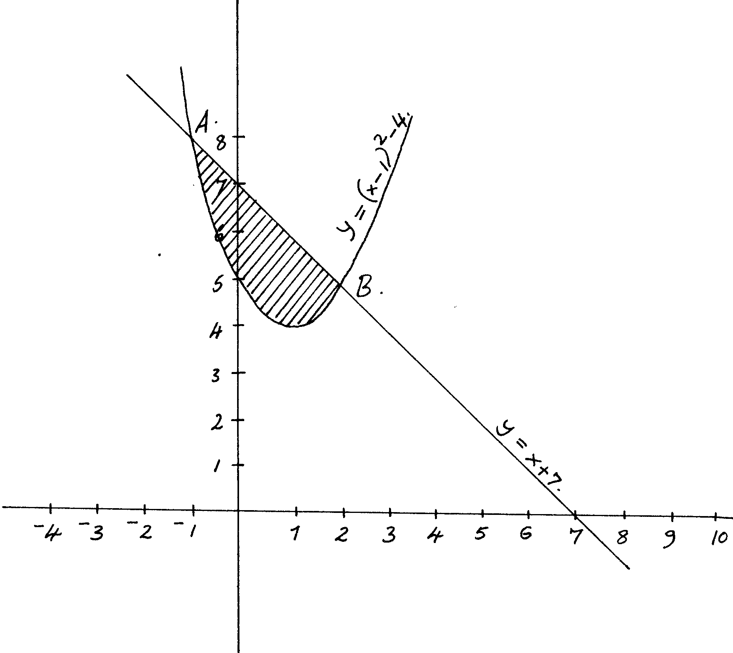
a) Find the coordinates of A and B. 2mks

b) Calculate the area of the shaded region. 2mks

13. A colony of Bees was found to have 250 Bees at the beginning. Thereafter the number of bees doubled every two days. Find how many bees there were after 16 days. 3mks

14. The table below shows the weight in kg of 40 students in a class
Weight in kg | 50 – 59 | 60 – 69 | 70 – 79 | 80 – 89 | 90 - 99
Number of students | 6 | 8 | 16 | 9 | 3
Calculate the percentage of the students in the class whose ages were 74.5kg and below 3mks

15. A right circular cylinder is to be made so that the sum of its radius and its height is 6cm. Find the maximum possible volume of the cylinder. (3marks)

16. Using a ruler and pair of compasses only. Construct an equilateral triangle ABC of sides 4cm construct the locus of a point P such that P is always on the same side of BC as A and BPC=30⁰. Shade the region where Q can be found if Q is outside the triangle and
angle BQC > 30⁰. (4marks)

SECTION II ( 50 MARKS)
Answer all the questions in the spaces provided after each.

17. The probabilities that Martha , Peter and James will be late for breakfast are ¼ , ¹/₃ and ¹/₅ respectively. On any one morning what is the probability that
a) None of them will be late? 2mks

b) Only one of them will be late? 2mks

c) At least one of them will be late? 2mks

d) At most one of them will be late? 2mks

e) All of them will be late 2mks

18. (a) Complete the table below. 2mks
X | 0⁰ | 30⁰ | 60⁰ | 90⁰ | 120⁰ | 150⁰ | 180⁰ | 210⁰ | 240⁰ | 270⁰ | 300⁰ | 330⁰ | 360⁰
– Cos x | – 1 |  | – 0.5 |  | 0.5 | 0.87 |  | 0.87 |  |  | 0.5 | 0.87
Sin ( x – 30⁰) |  | 0.0 | 0.5 |  |  | 0.87 | 0.5 |  | – 0.5 |  |  | – 0.87 | – 0.5
(b) Draw the graphs of y=sin ( x – 30⁰) and y= – Cos x on the same axes, for 0⁰ < x < 360⁰.
5mks
(c ) Use your graph to solve the equation sin (x-30⁰) + Cos x = 0. 3mks

19. In the figure below M and N are points on OB and BA respectively such that OM:MB=2:3 and BN:NA=2:1. ON and AM intersect at x.
a) Given that OA = a and OB = b express ON, AM and AB in terms of a and b. (4mks)

b) By taking OX=h ON and AX = kAM, where h and k are scalars. Find two expressions for OX in terms of a and b. Hence determine the constants h and k and ratio in which x divides AM. (6mks)

20. Two towns P and Q, lie on the same parallel of latitude, 61.5⁰N. (Take radius of the earth,
R = 6370km and π= ²²/₇)
a) Find the shorter distance between the towns and the north pole in kilometers. 2mks

b) If the longitudes of P and Q are 42⁰W and 29⁰E respectively, find the shortest distance between them in km. 3mks

c) If R is another town due south of P and 960 km away from P, find the coordinates of R. 5mks

- The table below shows the distribution of marks scored by Form 4 students in one of the national school in mathematics examination.
Marks | 30-34 | 35-39 | 40-44 | 45-49 | 50-54 | 55-59 | 60-64 | 65-69 | 70-74 | 75-79 | 80-84
No. of students | 1 | 5 | 12 | 14 | 21 | 24 | 25 | 8 | 5 | 3 | 2

- Calculate the median mark (3mks)

- Using 57 as the assumed mean mark, calculate
  - The actual mean for the grouped mark. (3mks)

  - The standard deviation (3mks)

- State the modal class (1mk)

22. A triangle has vertices A( 1,2), B ( 4,4) and C (6,2)
a) Draw triangle ABC on the Cartesian plane. 1mk
b) Construct the image angle A’B’C’ the image of triangle ABC under a rotation of 90⁰ clockwise about the origin. 2mks
c) Draw triangle A’’B’’C’’, the image of triangle A’B’C’ under reflection in line y=x, state the coordinates of A’’B’’C’’ 3mks
d) Draw triangle A’’’B’’’C’’’ the image of triangle A’’B’’C’’ under a reflection in the line y=0 and state the coordinates of its vertices
e) Describe a single transformation that maps angle A’’’B’’’C’’’ onto angle ABC.2mks

23. Figure below is a pyramid on a rectangular base. PQ=16cm, QR = 12cm and VP = 13cm.
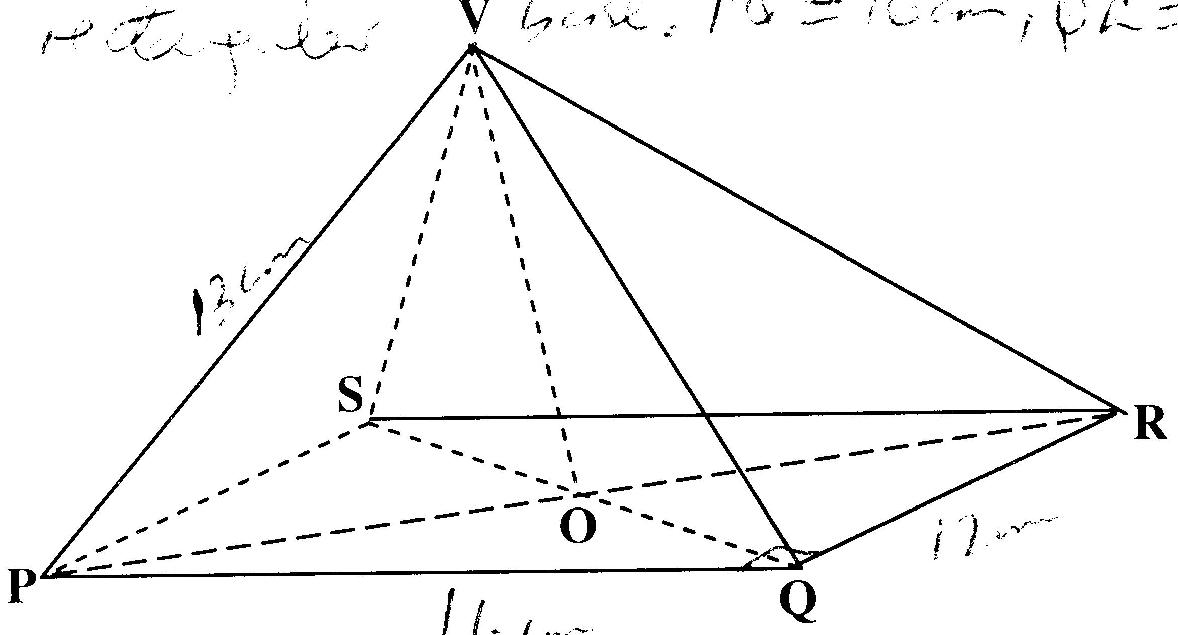
13cm
12cm
16cm

Find
(a) The length of the QS. 2mks

(b) The height of the pyramid. 2mks

(c ) The angle between VQ and the base. 2mks

(d) The angle between plane VQR and the base. 4mks

24. A farmer has 50 acres of land. He has a capital Shs. 2,400 to grow carrots and potatoes as cash crops. The cost of growing carrots is Shs.40 per acre and that of growing potatoes is Shs.60 per acre. He estimates that the respective profits per acre are Shs.30 (on carrots) and Shs. 40 (on potatoes).
By letting X and Y to represent carrots and potatoes respectively:-
a) Form suitable inequalities to represent this information. 4mks

b) By representing this information on a graph, determine on how many acres he should grow each crop for maximum profit. 4mks

c) Find the maximum profit. 2mks

25. The acceleration of a moving particle is given as. The velocity at the starting point is 8m/s. Determine
  - Its velocity in terms of t. (2marks)

  - The distance covered after 3 seconds (2marks)

  - The distance covered during the 3rd second. (4marks)

  - Maximum velocity of the particle (3marks)

