NAME ......................................................................INDEX NUMBER..................................
511/3 CANDIDATE’S SIGNATURE...................
MUSIC DATE ...................................................
PAPER 3
JUNE/ JULY 2015
2 ½ HOURS

STAREHE GIRLS’/ BOYS CENTRE AND SCHOOLS
Kenya certificate of secondary education
MOCK EXAMINATION
MUSIC
Paper 3
2 ½ hours

Instructions to candidates

- Write your name, index number, sign and date of the examinations in the spaces provided above.
- Answer all the questions in this paper
- In question 1 choose either (a) or (b).
- In question 4 choose any two of the questions numbered (a), (b), (c) and (d).
- All answers must be written in the spaces provided
- This paper consists of 8 printed pages
- Candidates should answer the questions in English.

SECTION A: BASIC MUSIC SKILLS (32 MARKS)
- Either
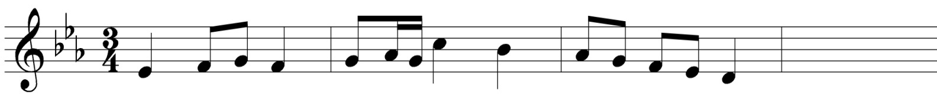
  - Continue the following opening to make a melody of 16 bars for voice, incorporating a triplet, articulation marks and dynamic changes. Modulate to the sub- dominant before returning to the tonic. (12 marks)
Or
  - Using the text below, compose a melody in staff notation. Add phrase marks to indicate cadencial points. (12 marks)
I have been looking for a treasure,
Hidden down beyond measure,
But due to my academic pressure,
I found it in you.

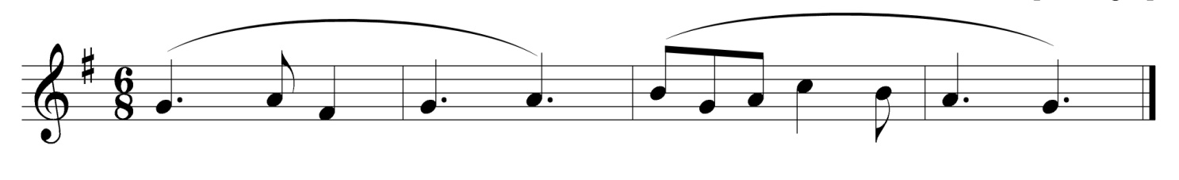
- Harmonize the following melody for soprano, alto, tenor and bass (satb). Choose appropriate chords from the following: i, ii,iv, v and vi. Incorporating a dominant seven (V7) at the final cadence. (20 marks)

SECTION B: HISTORY AND ANALYSIS (48 MARKS)
- AFRICAN MUSIC
  - Nyatiti is a traditional instrument from the luo community
    - Outline its solfa tuning (2 marks)

    - Name the two instruments the player plays to accompany himself (2 marks)

    - The instrument is said to play the ostinato, define ostinato. (2 marks)

  - Identify the community that perfomes the following dances (4 marks)
    - Hinesse .........................................................................
    - Risiga .........................................................................
    - Epunyas ..........................................................................
    - Gonda ..........................................................................

  - Describe the Isukuti ensemble (4 marks)

- WESTERN MUSIC
- ELGAR
- State Elgar’s nationality. (1 mark)

- State any two styles that Elgar uses in writing melodies of his orchestral music.(2 marks)

- What types of works are the following: (4 marks)
    - The apostles ..............................................................................
    - The kingdom ..............................................................................
    - Falstaff ..............................................................................

- PROKOFIEV
  - What type of music composition by Prokofiev is Romeo and Juliet? (1mark)

  - List the three career periods of music by Prokofiev. (3marks)

  - Outline any two styles of composition by Prokofiev. (1mark)

  - Identify the following works by Prokofiev. (2marks)

    - Lieutenant Kije ..........................................................................................
    - The Gambler ..........................................................................................
    - The Prodigal Son ..........................................................................................
    - Ivan the terrible ..........................................................................................

- MONTERVERDI
- How many instruments did Monterverdi used in the opera ‘orpheus’? (1 mark)

- Explain any four styles of composition Monterverdi used in his opera. (2 marks)

- Name any two operas composed by Monterverdi. (1 mark)

- Explain each of the following: (3 marks)

    - Antiphony .....................................................................................................
    - String tremolando ........................................................................................
    - Pizzicato. ........................................................................................................

- HANDEL
- What type of music composition is ‘The water music’? (1mark)

- List two operas by Handel. (1marks)

- What sections of performance are found in Handel’s oratorios? (2marks)

- Give the title of the two secular oratorios by Handel. (2 marks)

- What type of work is the Harmonious Blacksmith? (1 mark)

- PRESCRIBED TRADITIONAL AFRICAN MUSIC
Mijikenda ensemble, a recording from folk music of east Africa
  - Describe the sequence of activities in the main section. (3 marks)

  - What is the role of the upatsu in the performance (2 marks)

  - Name the tuned membranophone in the recording (2 marks)

  - Outline three features of African music evident in the recording. (3 marks)

- PRESCRIBED WESTERN MUSIC
Recitative ‘behold I tell you a mystery’ and aria ‘the trumpet shall sound’ by G.F Handel

  - With reference to bar numbers, give examples of: (4 marks)
    - Dominant pedal

    - Scalic movement

    - Arpeggio

    - Melisma

  - Describe the cadence at bar 7-8 of the aria (2 marks)

  - Define the following terms. ( 4 marks)
    - Funfare

    - Retornello

    - Tutti

    - Pomposo, ma non allegro

SECTION C: GENERAL MUSIC KNOWLEDGE (20 MARKS)

  - Define the following (5 marks)
    - Dolce

    - Giusto

    - Baton

    - Drum major

    - Idiophone

  - Name the commissioners tasked with the writing of the national anthem. (5 marks)

  - Name two songs composed by fadhili Williams (2 marks)

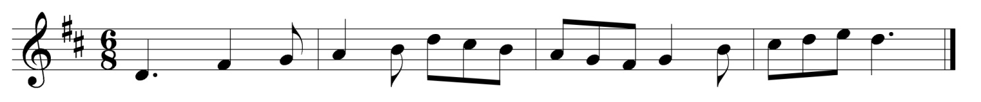
  - The melody below has been written for horn in F. Transpose it for:

    - Baritone saxophone in E flat (4 marks)
    - Trumpet in D. (4 marks)

