Name: ................................................................................... Index No. ............................... Class: ..........

STAREHE BOYS’ CENTRE & SCHOOL
232/1
Physics Paper 1 (Theory)
June/July 2015
2 Hours

Kenya Certificate of Secondary Education
Physics Mock Examination 2015

Instructions to candidates

- Write your name and class in the spaces provided above.
- This paper consists of TWO sections; A and B.
- Answer ALL the questions in section A and B in the spaces provided after each question.
- ALL working MUST be clearly shown.
- Non-programmable silent electronic calculators and KNEC mathematical tables may be used.

Take: Acceleration due to gravity g = 10 ms⁻² Density of water = 1000 Kg/m³

FOR EXAMINERS USE ONLY

Section | Questions | Maximum score | Candidates score
A | 1 – 12 | 25
B | 13 | 10
 | 14 | 9
 | 15 | 10
 | 16 | 12
 | 17 | 14
 | TOTAL | 80

This paper consists of 12 printed.
Candidates should check the question paper to ascertain that all the pages are printed as indicated and that no questions are missing.
SECTION A: (25 MARKS)
ANSWER ALL THE QUESTIONS IN THE SPACES PROVIDED

1. The figure below shows the level of water in a measuring cylinder. 20 lead shots each of volume 0.5cm³ are dropped into the water. Indicate on the diagram the level water. (2 marks)
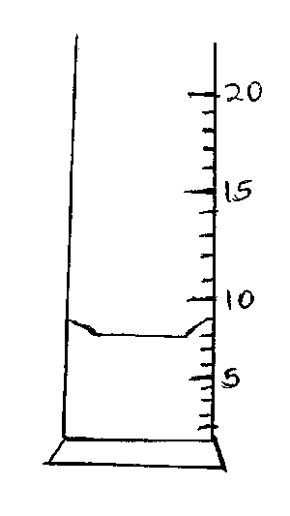
2. A ball bearing of mass 0.0015 Kg is held between the anvil and spindle of a micrometer screw gauge. The reading on the gauge when jaws are closed without anything in between is 0.11 cm. Use this information and the portion of the scale in the figure below to answer questions (i)and (ii).
i) What is the diameter of the ball bearing? (2 marks)

ii) Find the density of the ball bearing giving your answer correct to three significant figures.
(2 marks)

3. The diagram below shows a coin resting on the surface of a paper.
Coin
Force
Paper
State, with reason, what happens to the coin when the paper is pulled sharply in the direction shown by the arrow. (2 marks)

4. A bullet is fired horizontally at a target, neglecting air resistance, give a reason why the horizontal acceleration of the bullet is zero. (1 mark)

5. The Figure below shows a velocity time graph for a car in motion. If the mass of the car is 920kg, determine the maximum kinetic energy acquired for part of the journey shown. (2 marks)
time (s)
Velocity (m/s)

6. The diagram below shows a funnel inverted over a light pith ball on a table. Air is blown into the funnel as indicated on the diagram.
Air
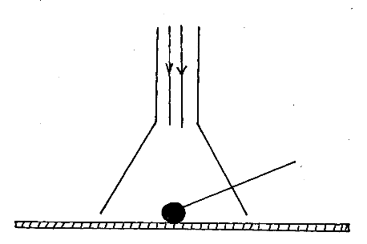

Pith ball

State and explain what is likely to be observed. (2 marks)

7. The figure below shows a bar made of iron and wood, and a flame is passed the joint with a piece of paper. State what was observed at the junction between the two bars after sometimes. (1 mark)

Wooden iron
X X

paper

8. The figure below is a gas jar completely filled with water and covered with a wire gauze.
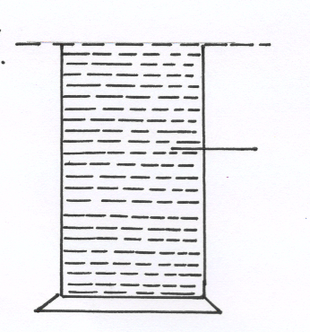

Water

(a) State the observation when the set-up is suddenly inverted. (1 mark)

(b) Explain the observation made in (a) above. (1 mark)

9. The diagram below shows a mass of 10kg hanged on a set of 6 identical springs.
When a mass of 10g was hanged on spring A, its extension was 5cm. Find the extension of the combination shown if each spring has mass of 50g. (3 marks)

10. The mass M was suspended from a tight copper wire using a rider as shown .The copper wire was then heated.
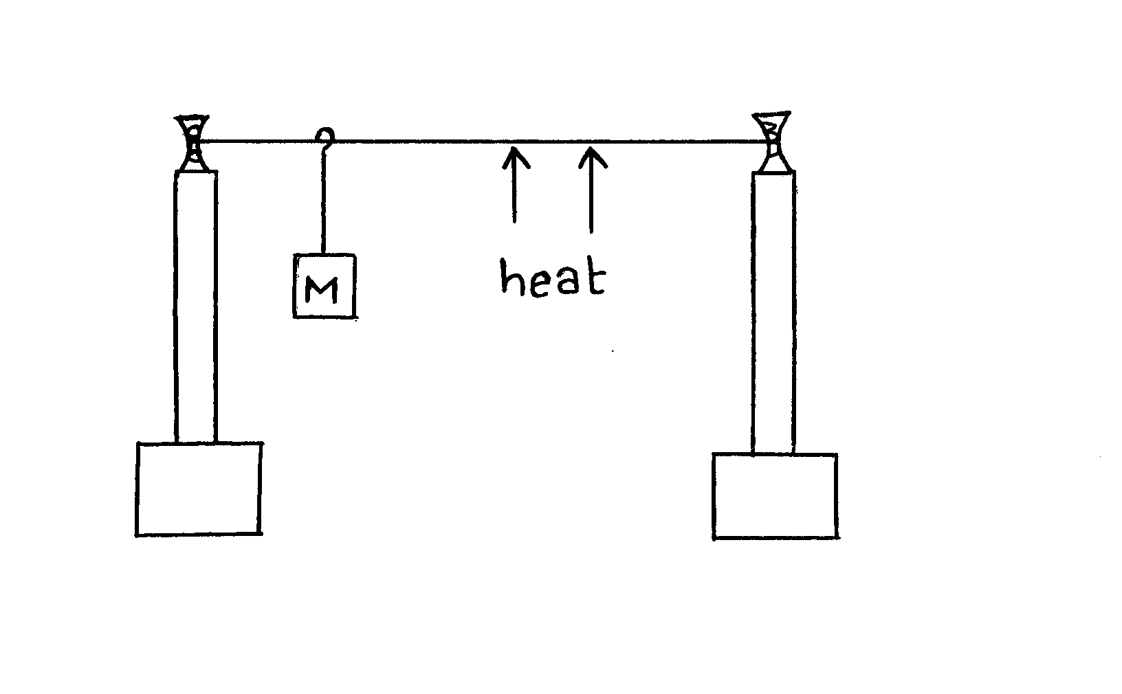
State what was observed on the position of M as the wire was heated for sometime. (1 mark)

11. The system in the figure below is at equilibrium.
State and explain what may be observed as temperature of surrounding is increased. (2 marks)

12. A hole of diameter 1.0mm is made in the side of a water pipe. If the Pressure of the flow is maintained at 3.0 X 10⁶Nm⁻², calculate the force with which the water jets out of the hole.(3 marks)

SECTION B: (55 MARKS)
13. Figure below shows the apparatus that a student used to investigate the relationship between
temperature and pressure of a fixed mass of a gas at constant volume.
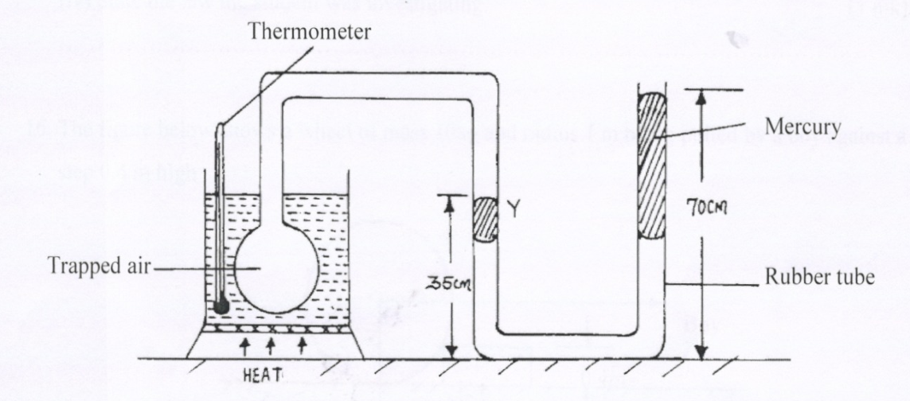

a) i) Describe how the student should ensure that all air trapped has the same temperature as
indicated by the thermometer. (2 marks)

ii) Give a reason why it is necessary to ensure that before taking any reading on pressure, the
liquid level should reach the level marked Y. (1 mark)

iii) Using the measurements given in the diagram, determine the total pressure of the trapped air.(Given your answer in cmHg, atmospheric pressure = 76cmHg) (3 marks)

iv) State the law the student was investigating. (1 mark)

b) Before starting a long journey a motorist checked her tyre pressures and found them to be
3x 10⁵ Pa. At the end of the journey, the pressures were found to be 3.3x10⁵pa.The temperature of the tyres and contained air at the start of the journey was 17ºc. Assuming the volume of the tyres remains constant, determine the temperature of the air in the tyres at the end of the journey.
(3 marks)

14(a) i) State the law of floatation (1 mark)

ii) A glass block is suspended from a spring balance and held inside a beaker without touching the beaker. Water is added gradually into the beaker. The figure below shows the variation of the upthrust on the block with depth of water in the beaker.
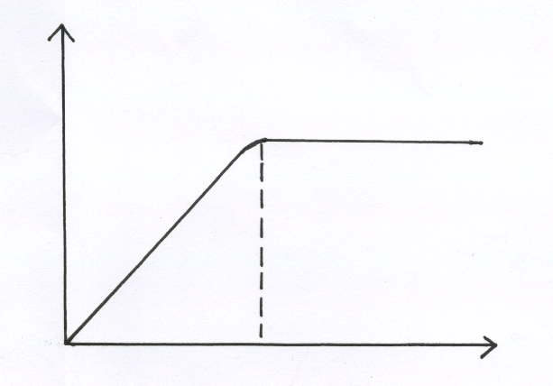
Upthrust

Y
Depth (cm)

State the reasons for the observation at Y (2 marks)

b) An ice cube of mass 50g floats on the surface of strong brine solution of volume 200 cm³ inside a measuring cylinder. Calculate the level of the liquid in the measuring cylinder
i) before (2 marks)

ii) after all the ice melted (2 marks)

iii) What happens to the level if the brine is replaced by 200 cm³of water and 50g of ice is again added( take density of ice and brine to be 900 kg/m³, 1100kg/m³respectively) (2marks)

15. i) The figure below shows a centrifuge and two tubes containing muddy water being whirled at
high speed
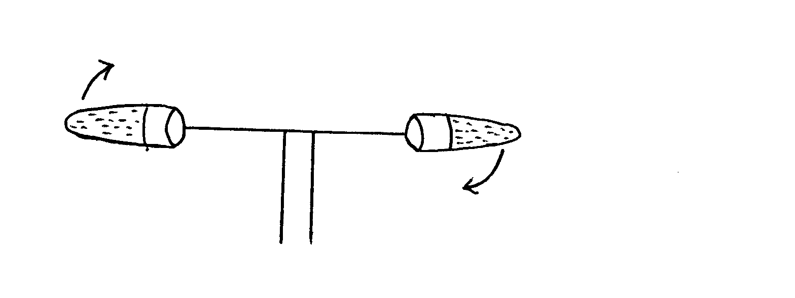
Explain how the high speed rotation causes the separation of mud from water. (2 marks)

(ii) A perforated drum in a spin –dryer is used to dry wet clothes by rotating it at very
high speed. Explain. (2 marks)

(b) Below is a diagram of an aircraft of mass 2000 kg together with the pilot performing some air maneuvers in a vertical plane.
C
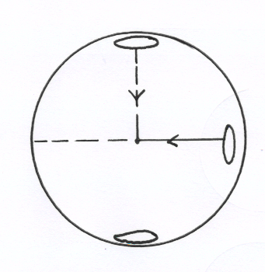

B
D
F ₁
r=40m
F ₂
A

If the radius of the circular path is 40 m and the aircraft is moving at a velocity of 200 ms⁻¹. Calculate
i) The external force F₁ provided by the air at point C. (3 marks)

ii) The external force F₂ provided by the air at point B. (3 marks)

16(a) Why is a burn from steam of boiling water more severe than that of boiling water itself? (1 mark)

(b) An energy saving stove when burning steadily has an efficiency of 60%. The stove melts 0.03 kg of ice at 0⁰C in 180 seconds. Calculate: (take the specific latent heat of formation of ice = 340000 Jkg⁻¹)
i) The power of the stove (3 marks)

ii) The heat energy wasted by the machine (2 marks)

(c) i) State two differences between boiling and evaporation. (2 marks)

ii) In a coffee making machine steam at 100 ºc was passed into cold milk and coffee of mass 3kg
at 12 ºc until its temperature rose to 80 ºc. Given that the specific heat capacity of the coffee and milk mixture is 4000J/kgK and the specific latent heat of vapourization of water is 2.3x10 ⁶J/kg. calculate
I) the energy gained by the coffee and milk mixture assuming heat taken up by coffee
pot is negligible and no heat lost. (2 marks)

II) the mass of steam condensed to warm the mixture (2 marks)

17(a) The figure below shows an effort of 100N being applied on a single moving pulley to exert pressure on a gas in a cylinder.
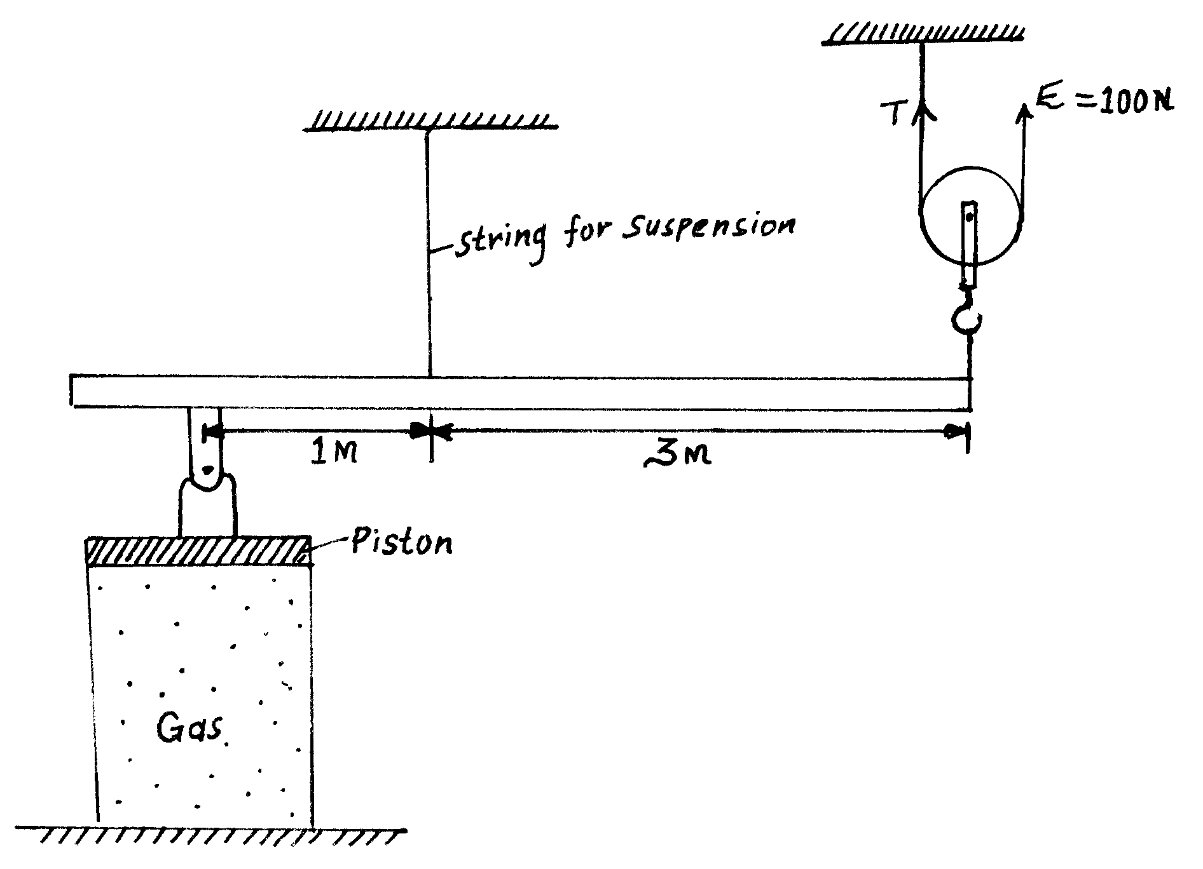
Piston
String for suspension

The area of the piston is 10cm² and the volume of the gas is 20cm³. The weight of the pulley, the beam and the frictional forces at the movable parts are taken to be zero. If the beam is in equilibrium,
i) Calculate the force acting on the piston. (2 marks)

ii) Calculate the pressure exerted on the gas by the piston. (2 marks)

b) A boy used a wooden plank 4 meters long to push a log of wood out of a ditch 1.6 meters deep as shown in the diagram below
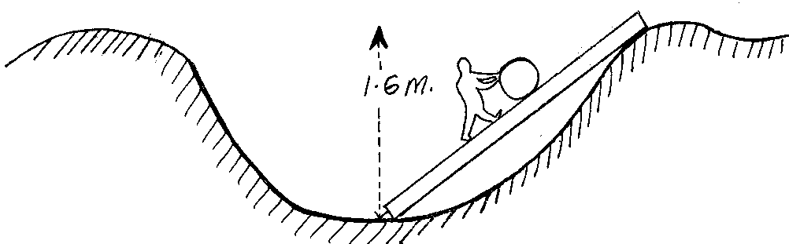
i) Determine the velocity ratio of the arrangement (2 marks)

ii) Determine the mechanical advantage of the arrangement if its efficiency is 60%. (3 marks)

iii) Give one reason why the efficiency is less than 100% (1 mark)

(c) In areas of the world where a plane is unable to land, free fall air drops can be used to deliver supplies. A plane travelling at a speed of 80m/s and at a height of 70 m releases a package of supplies.
i) Sketch the path of the falling package (1 mark)

ii) Calculate how far the package will land from the drop zone (3 marks)

