NAME ____________________________________ INDEX NO. _______________
SCHOOL ____________________________________ SIGNATURE _______________ DATE _______________

232/2
PHYSICS
PAPER 2
(THEORY)
JULY / AUGUST, 2015
TIME: 2 HOURS

232/2
PHYSICS
PAPER 2
(THEORY)
TIME: 2 HOURS

INSTRUCTIONS TO CANDIDATES
- Write your name, school and index number in the spaces provided above.
- Sign and write the date of the examination in the spaces provided above.
- The paper consists of two sections, Section A and B.
- Answer ALL the questions in section A and B in the spaces provided.
- ALL answers and working MUST be clearly shown.
- Mathematical tables and electronic calculators may be used.

FOR EXAMINER’S USE:
SECTION | question | maximum score | Candidate’s score
A | 1−11 | 25
B | 12 | 12
 | 13 | 12
 | 14 | 12
 | 15 | 09
 | 16 | 10
Total score |  | 80

This paper consists of 12 printed pages.
Candidates should check to ensure that all pages are printed as indicated and no questions are missing.
SECTION A (25 MARKS)
Answer ALL the questions in this section in the spaces provided.
- The figure below shows a metallic sphere (A) suspended by a cotton thread. A negatively charged rod (B) is brought near the sphere. Explain other three steps for charging sphere A positive. (3 marks)
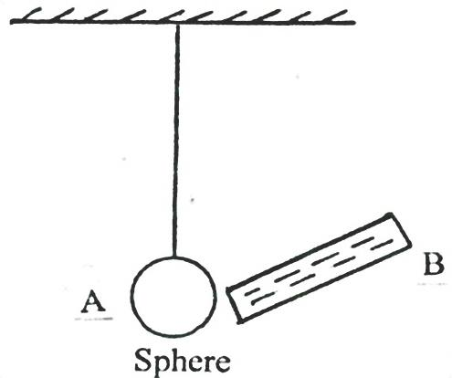
B
A
Sphere
____________________________________________________________________________________________________________________________________________________________________________________________________________________________________________________________________________________________________________________________________________
- State two quantities that are used to determine whether accumulators require charging or not.(2 marks)
______________________________________________________________________________________________________________________________________________________________________
- In an attempt to make a magnet, a student used the double stroke method as shown below.
State the polarities at the ends A and B (2 marks)
______________________________________________________________________________________________________________________________________________________________________
- The figure below shows a conductor carrying current placed within the magnetic field of two magnets. Complete the diagram by showing the field pattern and the direction of force F that acts on the conductor. (2 marks)

- An object 10cm high is placed 30cm in front of a concave mirror. The image is 45cm in front of the mirror. Find its magnification and size of the image. (3 marks)

- The figure below shows the path of a ray of light after striking two mirrors XY and YZ at an angle.
Z
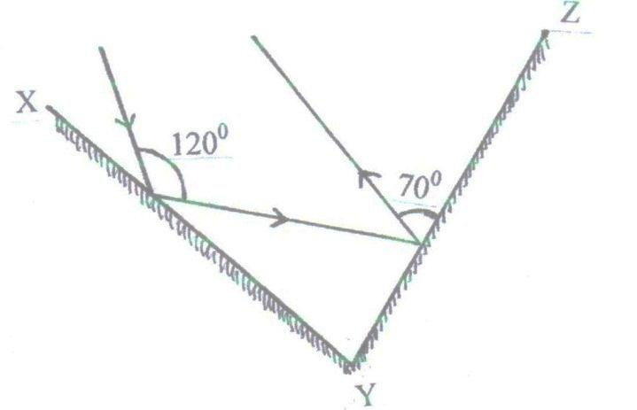
Y
X
Determine the angle between the two mirrors (2 marks)

- The graphs in the figure 4 below represent the same wave. 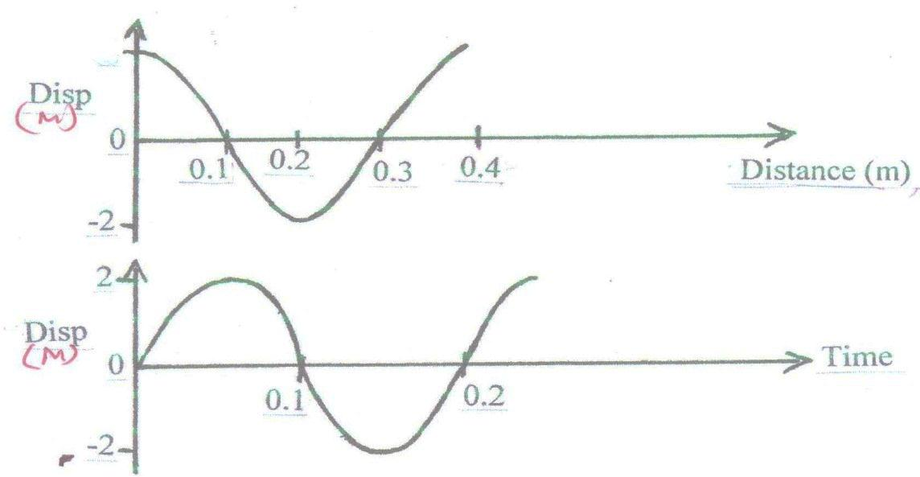

Disp (m)
Disp (m)
Time
Distance (m)
Determine the velocity of the wave. (3 marks)

- The figure below shows a ray of light travelling through water, whose refractive index is 1.33.
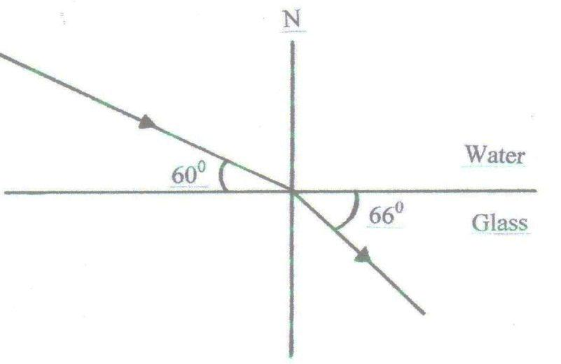
Determine the refractive index of glass. (3 marks)

- State the type of electromagnetic spectrum emitted by warm objects. (1 mark)
______________________________________________________________________________________________________________________________________________________________________
- A candle flame is brought near the cap of a charged electroscope. State and explain the observation made on the leaf. (3 marks)
__________________________________________________________________________________________________________________________________________________________________________________________________________________________________________________________________________________________________________________________________________________________________________________________________________________________________________________________________________________________________________________
- Name one factor that determines the velocity of photoelectrons produced on a metal surface when light shines on it. (1 mark)
______________________________________________________________________________________________________________________________________________________________________

SECTION B (55 MARKS)
Answer all the questions in this section in the spaces provided.
- a) A student set up a circuit using three identical bulbs A,B and C each rated at 6V, 1.0A as shown below
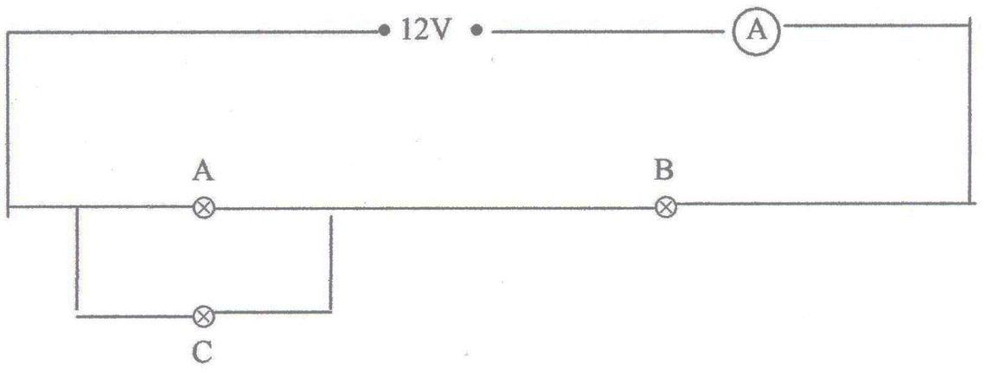
- Determine the resistance of one of the bulbs when operating normally. (1 mark)

- Calculate the effective resistance of the three bulbs. (2 marks)

- Draw a circuit diagram showing the three bulbs A, B and C connected in such a way that they would all light at normal brightness. (1 mark)

b) The circuit below shows a 0.47$μ$F capacitor which can be charged through a 3000Ω resistor when the switch is closed.
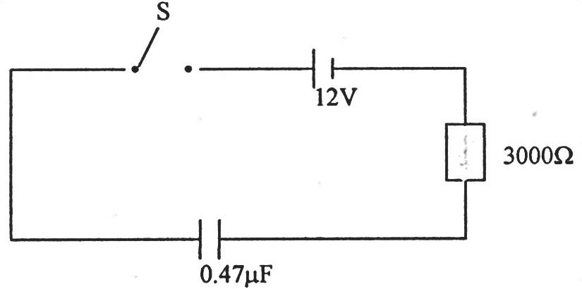
The capacitor is initially uncharged. Find:
- The initial charging current. (2 marks)

- The charging current after a long time. (1 mark)

- The maximum stored charge on the capacitor. (2 marks)

- The maximum energy stored on the capacitor. (3 marks)

- The figure below shows plane waves in a ripple tank. The water is deeper in section A and C then in section B.
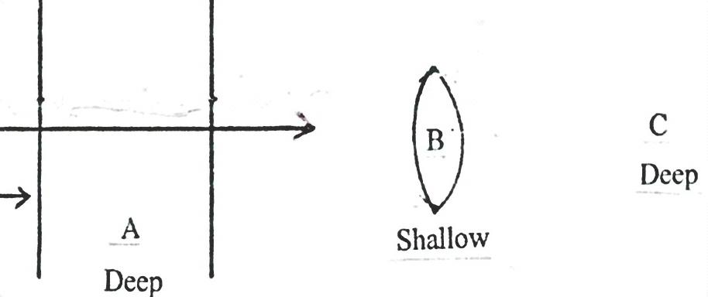
- Draw the waves after passing section B. (2 marks)

- State two conditions necessary for production of constructive interference. (2 marks)
____________________________________________________________________________________________________________________________________________________________________________________________________________________________________________________________________________________________________________________________________________
- A tube of length 36cm is closed at one end. It is at resonance with a turning fork of frequency 256Hz sounded above the open end. Given that the velocity of sound in air is 334m/s.
Determine:
- The wavelength of the wave generated by the turning fork. (2 marks)

- The end correction of the tube. (2 marks)

- i) Explain how the resistance of semi-conductors and metal conductors are affected by temperature rise. (2 marks)
____________________________________________________________________________________________________________________________________________________________________________________________________________________________________________________________________________________________________________________________________________
ii) The diagram below is a circuit with 2 bulbs and components D.
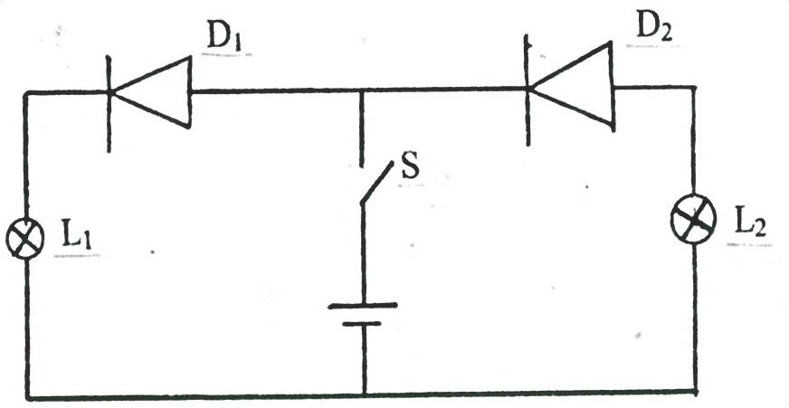
State and explain which of the lamps L₁ and L₂ would light when the switch is closed. (2 marks)
_________________________________________________________________________________________________________________________________________________________________________________________________________________________________________________________

- a) i) Define flux leakage as used in transformers. (1 mark)
______________________________________________________________________________________________________________________________________________________________________
ii) How is it minimized? (1 mark)
______________________________________________________________________________________________________________________________________________________________________
b) i) In the design of a transformer in a (i) above which coil would be made with thick conductors if the transformer is a step-up. (1 mark)
___________________________________________________________________________________
ii) Explain your answer in b(i). (1 mark)
_________________________________________________________________________________________________________________________________________________________________________________________________________________________________________________________

c) The diagram below shows a simple d.c generator.
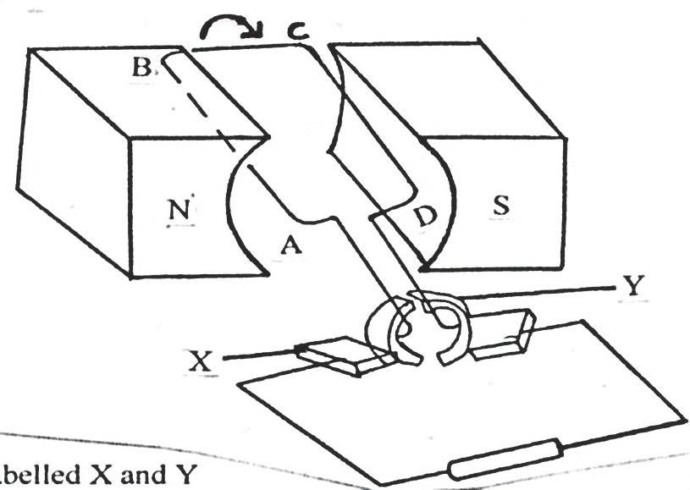

- Name the parts labelled X and Y (2 marks)
______________________________________________________________________________________________________________________________________________________________________
- The coil is rotated in a clockwise direction, indicate using an arrow on the figure the direction of the
induced current as the coil passes the position shown. (1 mark)
- Sketch on the axis below a graph of the e.m.f generated against the angle as the coil rotates from 0⁰
to 90⁰ and from 90⁰ to 180⁰. (2 marks)

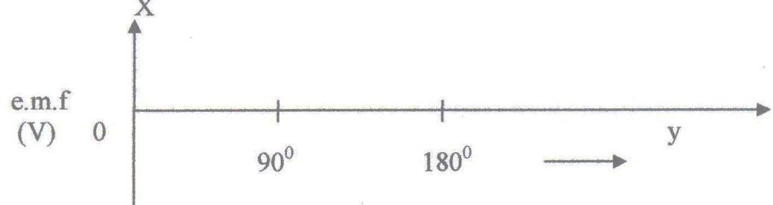

- Give reasons for the changes in the e.m.f as the coil rotates from 0⁰ to 180⁰. (3 marks)
_______________________________________________________________________________________________________________________________________________________________________________________________________________________________________________________________________________________________________________________________________________________________________________________________________________________________

- In an experiment to find the relationship between frequency of radiation and kinetic energy of photoelectric device, the following graph was obtained.
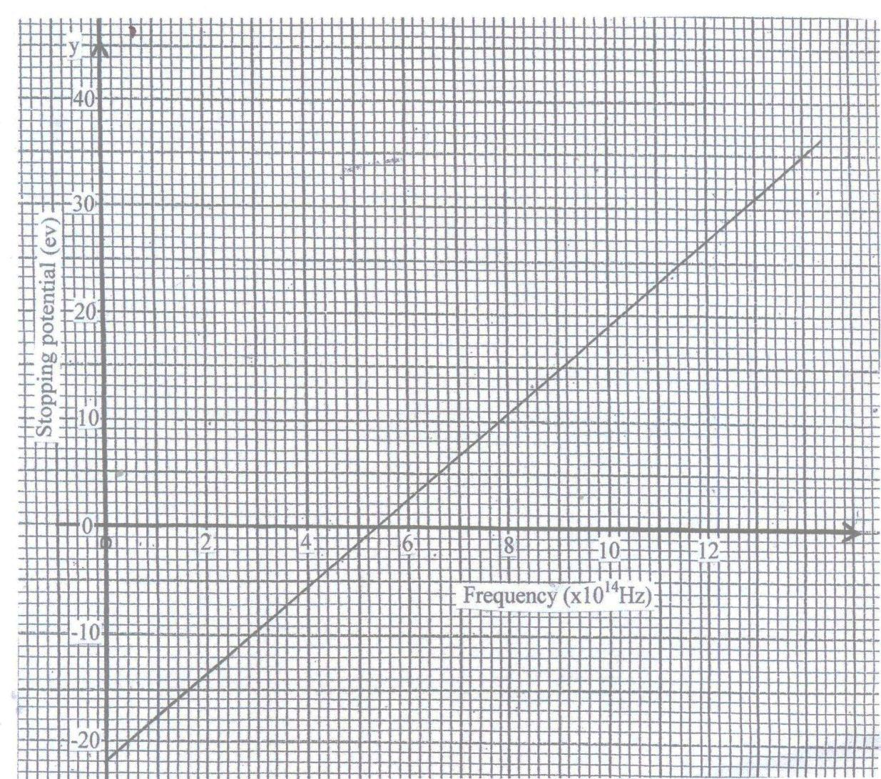
Use the graph to answer the following questions.
- i) Determine the threshold frequency. (1 mark)

ii) Find the plank’s constant (Take the charge of an electron to be 1.6 x 10⁻¹⁹ C) (3 marks)

- Calculate the work function of the metal in joules. (2 marks)

- Sodium has work function of 2.42eV. Calculate its threshold frequency. (3 marks)
(Take the plank’s constant to be 6.6 x 10⁻³⁴ J)

- a) The figure below shows the diagram of Geiger–Muller tube connected to a power supply and a pulse counter.
Gas at low pressure (argon gas with little bromine)
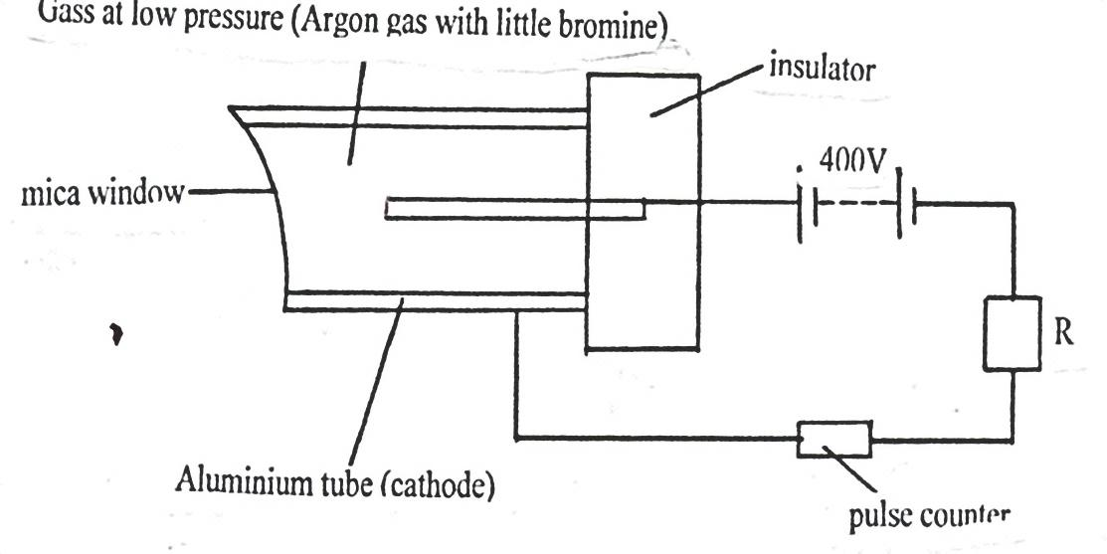
R
Aluminium tube (cathode)
Insulator

Mica window
400V

Pulse counter
i) Why should the argon gas be at low pressure? (1 mark)
______________________________________________________________________________________________________________________________________________________________________
ii) Briefly explain how Geiger – muller tube detects the radiation emitted by a radioactive. (4 marks)
_____________________________________________________________________________________________________________________________________________________________________________________________________________________________________________________________________________________________________________________________________________________________________________________________________________________________________________________________________________________________________________________________________________________________________________________________________
iii) State the purpose of the bromine gas in the tube. (1 mark)
___________________________________________________________________________________
______________________________________________________________________________________________________________________________________________________________________
iv) Suggest one way of increasing the sensitivity of the tube. (1 mark)
______________________________________________________________________________________________________________________________________________________________________
b) The expression below is an equation for a radioactive element A. Elements B and C are the daughter nuclides. A, B and C are not the actual symbols of any of the elements.
${}_{92}^{238}A$ → ${}_{90}^{234}B$ + ${}_{y}^{x}C$
Identify the element C and state two of its characteristics.
Identity of C. (1 mark)
__________________________________________________________________________________
Characteristics . (2 marks)
____________________________________________________________________________________________________________________________________________________________________________________________________________________________________________________________________________________________________________________________________________

