**Name: …………………………………………………………… Index No. …………………………**

**Candidate’s Sign. …………............**

**Date:………………………………..............................**

**232/1**

**PHYSICS**

**PAPER 1**

**JULY 2015**

**TIME: 2 HOURS**

**STAREHE GIRL’S CENTRE MOCK EXAMINATION**

***Kenya Certificate of Secondary Education (K.C.S.E.)***

**Physics**

**Paper 1**

**INSTRUCTIONS TO THE CANDIDATES:**

* Write your **name** **and index number** in the spaces provided above.
* Answer ***all*** the questions both in section **A** and **B** in the spaces provided below each question
* All workings ***must*** be clearly shown; marks may be awarded for correct steps even if the answers are wrong.
* Mathematical tables and silent electronic calculators may be used.
* Take g= 10m/s2

**For Examiners’ Use Only**

|  |  |  |  |
| --- | --- | --- | --- |
| **SECTION** | **QUESTION** | **MAXIMUM SCORE** | **CANDIDATE’S SCORE** |
| Section A | 1-13 | 25 |  |
| Section B | 14 | 11 |  |
| 15 | 10 |  |
| 16 | 10 |  |
| 17 | 09 |  |
| 18 | 15 |  |
| **TOTAL** | **80** |  |

*This paper consists of 10 printed pages. Candidates should check to ascertain that all pages are*

*printed as indicated and that no questions are missing.*

**SECTION A**: (25 MARKS)

*Answer* ***all*** *the questions in this section in the spaces provided.*

1. **Figure 1** below shows the change in volume of a liquid in a measuring cylinder when an irregular solid is immersed in it.



**Fig.1**

Given that the mass of the solid is 540g, determine the density of the solid in S. I unit. (2mks)

2. Explain why a glass with a thick wall is more likely to crack than one with a thin wall when a very hot liquid is poured into them (2mks)

3. A steel ball is dropped into a cylinder containing oil. Sketch on the axis given **below** a graph showing the variation of acceleration with time. (1mk)

Time (s)

Acceleration (m/s²)

4. A uniform metre rule of mass 100g is balanced by suspending a 10g mass and a 20g mass on its ends as shown in **figure 2** below.

20g

10g

**Fig.2**

Determine the position of the pivot. (3 marks)

5. A student obtained ice at 0oCfrom a refrigerator and placed it in a beaker on a bench. After 4 minutes, the temperature rose to 4oC. State the changes that would be observed in the water in terms of;

(i) density (1 mark)

(ii) mass (1 mark)

(ii) volume (1 mark)

6. In the Brownian motion experiment, smoke particles are observed to move randomly. Explain how this motion is caused (1mk)

7. Explain why ice skaters use sharp-edged shoes to slide on ice (2mks)

8. Boiling water is poured into two identical vacuum flasks **A** and **B** flask **A** is partially filled while flask **B** is completely filled. Both are closed tightly. State with reasons the flask in which the water is likely to have a higher temperature eight hours later. (2mks)

9. A footballer kicks a ball of mass 0.6 kg initially at rest using a force of 720N. If the foot was in contact with the ball for 0.1 seconds, what was the take of speed of the ball? (3mks)

10. Three identical springs each of spring constant 4.5N/m and weight 0.5 N are used to support a load as shown in **figure 3** below. Determine the total extension of the system (2mks)

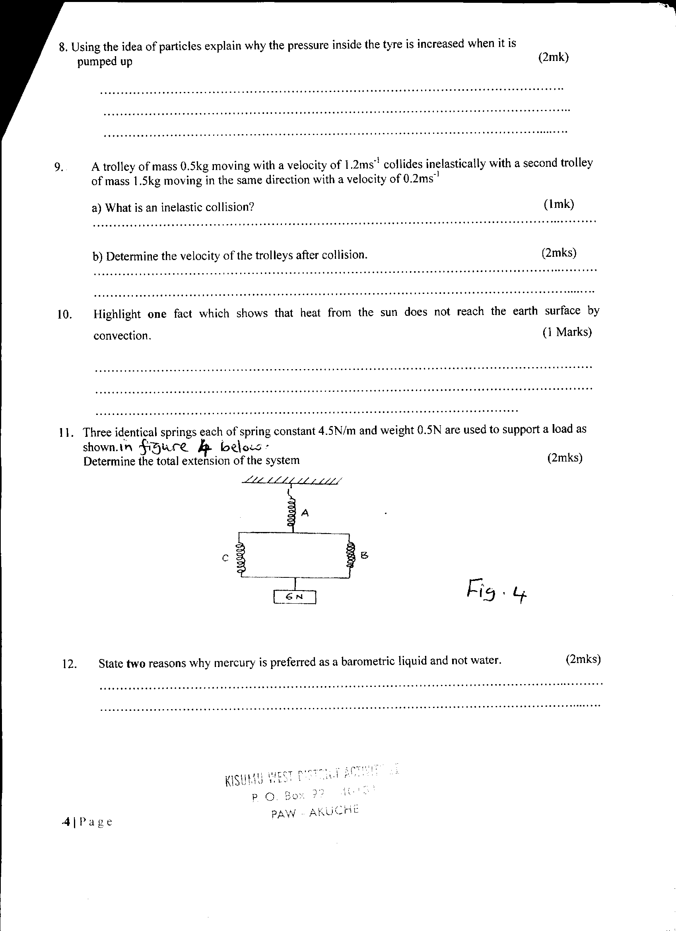

**Figure 3**

11. **Figure 4** **below** shows a section of a pipe XY. A constant pressure difference maintains a streamline flow of a liquid in the pipe.

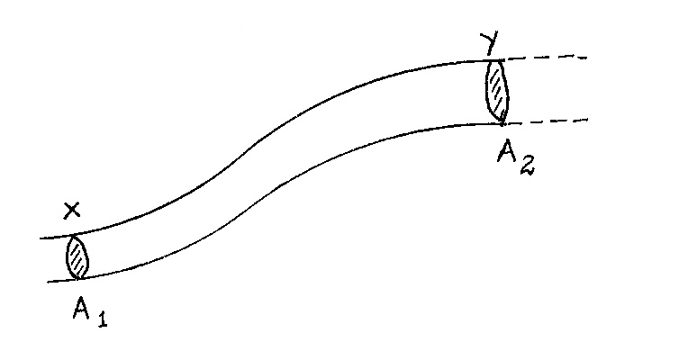

**Figure 4**

If the cross-sectional area A1 at X is less than A2 ay Y, state how the liquid velocity V2 at Y compares with V1 at X. (1mk)

12. The **figure 5** below shows a circuit diagram for a device for controlling the temperature in a room.

S

Brass

Iron

Contact

Copper strip

Heater element

**Figure 5**

Describe how the circuit controls the temperature when the switch S is closed. (3mks)

13. A gas occupies a volume of 4000 litres temperature of 370C and normal atmosphere pressure. Determine the new volume of the gas if it is heated at constant pressure to a temperature of 670C (normal atmosphere pressure P = 1.01 x 105pa) (3mks)

**SECTION B** (55marks)

14. (a) 200g of a solid was uniformly heated by a 0.2kw heater for sometime. The graph in the **figure 6** below shows how the temperature of the solid changed with time.

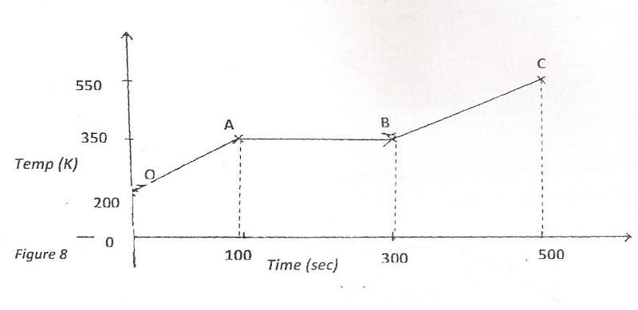

**Figure 4**

i) Explain what is happening between OA and AB. (2 marks)

ii) Calculate the specific heat capacity of the solid. (3 marks)

iii) Calculate the specific latent heat of fusion **k** of the solid. (3 marks)

(b)An electric heater 1KW 240V is used to raise the temperature of a 5kg copper block from 15oC to 33oC. If the specific heat capacity of copper is **400JKg-1K-1** and assuming no heat is lost to the surrounding. Calculate the time taken (3mks)

15. (a) State **Newton’s second law** of motion (1mk)

(b) **Figure 7** below shows two mini buses **A** and **B** at a speed of 40m/s and 20m/s respectively moving in opposite directions. They collided head on

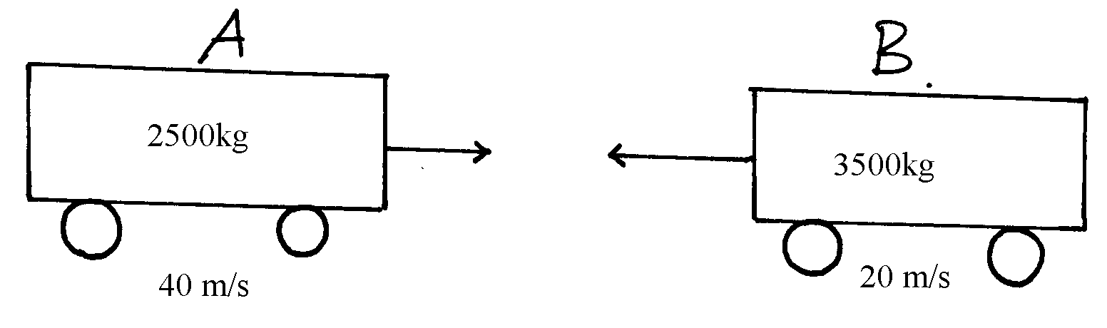

**Figure 7**

Determine the common speed of the vehicles if they stuck to each other (4mks)

(c) A ball of mass 100g is dropped from a height of 1.25m above the ground surface. It rebounds to a height of 1.1m. Calculate

(i) Velocity of ball before impact (2mks)

(ii) Force of impact (Take g = 10N/kg) (3mks)

16. a) Find the velocity ratio of the following gear wheels shown in **figure 8** below. (2mks)

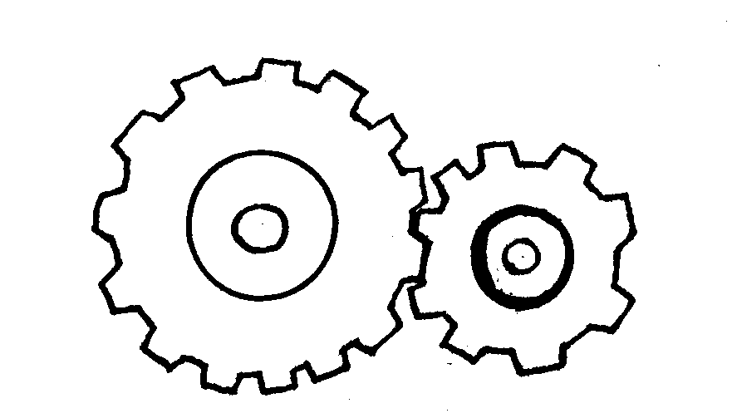

**Load gear**

**Effort gear**

***Fig8***

b). A hydraulic machine is used to raise a load of 100kg at a constant velocity through a light of 2.5m. The radius of the effort piston is 1.4cm while that of the load piston is 7.0cm. given that the machine is 80% efficient, calculate: -

1. The effort needed (3 marks)
2. The energy wasted in using the machine (3 marks)

c) State two factors that determine the efficiency of a machine (2mks)

17. a) A particle moving along a circular path of radius 5cm describes an arc of length 2cm every second. Determine:

I}Its angular velocity (2mks)

II}Its periodic time. (2mks)

b) (i) Define a radian (1mk)

(ii) Three masses are placed in a rotating table at distances 6cm, 9cm and 12cm respectively from the centre of rotation. When the frequency of rotation is varied it is noted that each mass slides off at a different frequency of rotation of the table. Table 1 shows the frequency at which each mass slides off.

|  |  |  |  |
| --- | --- | --- | --- |
| Radius, r (cm) | 12 | 9 | 6 |
| Sliding off frequency rev/s | 0.68 | 0.78 | 1.0 |

I. State two factors that determine the frequency at which each mass slides off. (2mks)

II. Oil is now poured on the table before placing the masses. Explain the effect of this on the frequency at which the mass slides off. (2mks)

18.a) State Archimede’s principle. (2 marks)

b) **Figure 9** below shows a block of mass 25g and density 2000kg/m3 submerged in a certain liquid and suspended from a uniform horizontal beam by means of a thread. A mass of 2g is suspended from the beam as shown.

**Figure 9**



i)Indicate on the same diagram all the forces acting on the block (3mks)

ii) Determine the thrust force acting on the liquid. (3mks)

iii) Calculate the density of the liquid. (3mks)

c) The rubber used to make a balloon weighs 0.1kg.The balloon is inflated to a volume of 0.5m3with hydrogen whose density is 9.0 x10-2Kg/m3.What is the maximum load the balloon can lift. (Density of air=1.3Kg/m3) (4mks)