232/3
PHYSICS
PAPER 3
JULY /AUGUST 2015

GATUNDU JOINT EXAMINATION - 2015
Kenya Certificate of Education
Physics Paper 3

Instructions to candidates

- This paper consists of two Questions 1 and 2.
- Answer all the questions in the spaces provided.
- Electronic calculators, mathematical tables may be used.
- All numerical answers should be expressed in the decimal notations.

QUESTION | MAX MARKS | CANDIDATE’S SCORE
1 | 20
2 | 20
TOTAL | 40

QUESTION 1
You are provided with the following:
- Wooden plank 100cm long or a metre rule
- two knife edges
- Retort stand, boss and clamp
- Half metre rule
- An optical pin and a piece of cello tape
- Five 100g masses or (two 200g masses and one 100g mass)

Proceed as follows
- Balance the wooden plank (metre rule) on a knife edge and record the point of balance.

--------------------------------------------------------cm (2marks)
Fix a pointer on the plank at this point

- Put the wooden plank so that it lies horizontally on the two knife edges provided.

- Clamp the half metre rule vertically and place it near the pointer on the wooden plank as shown in the figure

Half meter rule

Pointer

400g

100g

d

- Adjust the knife edges such that the distance d, between them is equal to 90cm and they are equidistant from the position of the pointer.
- Read and record the position of the pointer on the vertical scale

X0 ………………………………………………………………………………………………cm (1mark)

- Suspend a mass of 500g at the center of the wooden plank (where the optical pin is fixed as a pointer). Read and record the position of the pointer on the scale.

X₁ =………………………………………………………………………………………………cm (1mark)

- Hence find the depression, X of the metre rule at its mid-point and fill the table

- Remove the mass from the metre rule.

h) Repeat procedures ( c ) to (g) for values of d equal to 80 70 60 50 and 40cm (8 marks)

d(cm) | 90 | 80 | 70 | 60 | 50 | 40
X₀(cm)
X₁cm)
X (cm)
Log₁₀ d
Log ₁₀X

Question 2
You are provided with the following
-A stop watch
A milliameter
-A capacitor
-Two switches S₁and S₂
-Six 1000 Ohms Resistors
-a dry cell and a cell holder
Seven pieces connecting.
At least six crocodiles clips.

Proceed as follows
- Connect the circuit as shown in figure 1.0 bellow

E

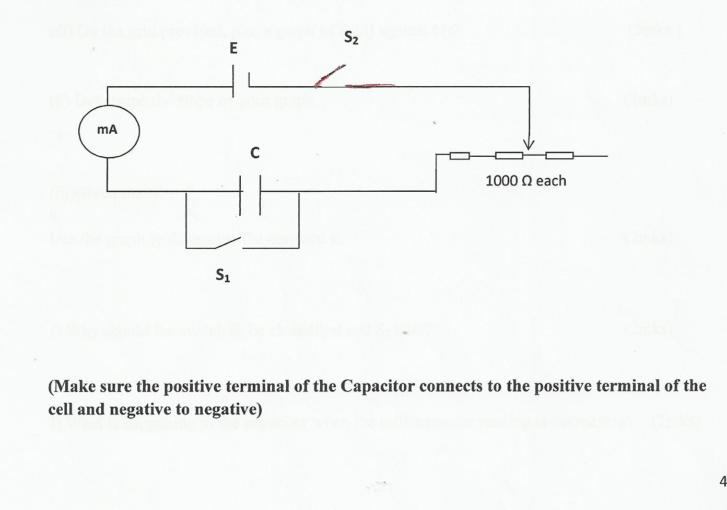

- Close switch S₁first and then switch S₂and record the maximum reading of the milliameter in the Table 1.0 below.
- Open switch S₁ and at the same instant, start the stop clock.Record the time taken for the value of current to fall to a half of its original value.

- Repeat step (b) and (c) with other values of R(Ω).

Table 1.0 (6 mks)
Resistance,R (Ω) | 2000 | 3000 | 4000 | 5000 | 6000 | 7000
Maximum Current I(mA)
Time t(s)

e(i) On the grid provided, plot a graph of R(Ω) against t (s) (5mks )

(ii) Determine the slope of your graph. (3mks)

(iii)Given that R = t
k
Use the graph to determine the constant k. (2mks)

f) Why should the switch S₁ be closedfirst and S₂ later?. (2mks)

f) What is happening to the capacitor when the milliammeter reading is decreasing? (2mks)

