NAME ____________________________________ INDEX NO. _______________
SCHOOL ____________________________________ SIGNATURE _______________ DATE _______________

443/1
AGRICULTURE
PAPER 1
JULY/AUGUST, 2015
TIME: 2 HOURS

443/1
AGRICULTURE
PAPER 1
TIME: 2 HOURS

INSTRUCTIONS TO CANDIDATES
- Write your name, school and index number in the spaces provided above.
- Sign and write the date of the examination in the spaces provided above.
- This paper consists of three sections: A, B and C.
- Answer all the questions in section A and B and any two questions from section C.
- All answers must be written in the spaces provided in this booklet.
- This paper consists of 12 printed pages.
- Candidates should check the question paper to ascertain that all pages are printed as indicated and that no questions are missing

For OFFICIAL use only
SECTION | QUESTIONS | MAXIMUM SCORE | CANDIDATE’S SCORE
A | 1 − 18 | 30
B | 19 − 24 | 20
C |  | 20
 |  | 20
 | TOTAL SCORE | 90

SECTION A (30 MARKS)
Answer ALL the questions in the spaces provided.
- Give two areas of study that make agriculture to be regarded as a science. (1 mark)
______________________________________________________________________________________________________________________________________________________________________
- State four reasons for ridging in crop production. (2 marks)
____________________________________________________________________________________________________________________________________________________________________________________________________________________________________________________________________________________________________________________________________________
- a) A farmer has the option of growing either wheat or maize in his one hectare land. Wheat gives a return of Kshs. 20, 000 while maize gives a return of Kshs. 35, 000. What will be the opportunity cost. (1 mark)

b) State two conditions under which opportunity cost is zero. (1 mark)
______________________________________________________________________________________________________________________________________________________________________
- List four benefits of practicing organic farming. (2 marks)
____________________________________________________________________________________________________________________________________________________________________________________________________________________________________________________________________________________________________________________________________________
- State four factors that influence the stage at which a crop is harvested. (2 marks)
____________________________________________________________________________________________________________________________________________________________________________________________________________________________________________________________________________________________________________________________________________
- Give two ways in which pruning helps to control diseases in tomatoes. (1 mark)
____________________________________________________________________________________________________________________________________________________________________________________________________________________________________________________________________________________________________________________________________________

- State any four ways of increasing labour efficiency in agricultural production. (2 marks)
____________________________________________________________________________________________________________________________________________________________________________________________________________________________________________________________________________________________________________________________________________
- State four effects of mass wasting / solifluction erosion. (2 marks)
____________________________________________________________________________________________________________________________________________________________________________________________________________________________________________________________________________________________________________________________________________
- State four factors that should be considered when classifying crop pests. (2 marks)
____________________________________________________________________________________________________________________________________________________________________________________________________________________________________________________________________________________________________________________________________________
- Give one reason why per capita income is not a good measure of the economic development
of a nation. (1 mark)
______________________________________________________________________________________________________________________________________________________________________
- Outline any two observable indicators of economic development of a nation. (1 mark)
______________________________________________________________________________________________________________________________________________________________________
- Give two practices that are commonly used in hardening seedlings in a kales nursery. (1 mark)
______________________________________________________________________________________________________________________________________________________________________
- Give four financial books which may be prepared on a farm (2 marks)
____________________________________________________________________________________________________________________________________________________________________________________________________________________________________________________________________________________________________________________________________________
- Outline four advantages of tissue culture (2 marks)
____________________________________________________________________________________________________________________________________________________________________________________________________________________________________________________________________________________________________________________________________________

- Name any four farming practices used to achieve minimum tillage. (2 marks)
____________________________________________________________________________________________________________________________________________________________________________________________________________________________________________________________________________________________________________________________________________
- State four factors that determine the choice of irrigation method to be used in the farm. (2 marks)
____________________________________________________________________________________________________________________________________________________________________________________________________________________________________________________________________________________________________________________________________________
- Name two liming elements in crop production. (1 mark)
______________________________________________________________________________________________________________________________________________________________________
- Outline four factors that determine the depth at which seeds are planted. (2 marks)
____________________________________________________________________________________________________________________________________________________________________________________________________________________________________________________________________________________________________________________________________________

SECTION B (20 MARKS)
Answer ALL questions from this section in the spaces provided.
- The diagram below shows a method of layering. Study it and answer the questions that follow.
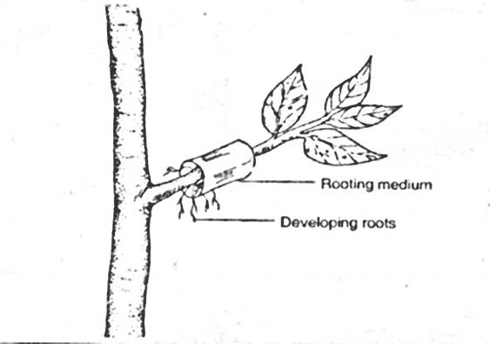
Developing roots

Rooting medium

- Identify the method of layering illustrated above. (1 mark)
___________________________________________________________________________________
- State one circumstance in which the method of layering indicated above is recommended. (1 mark)
______________________________________________________________________________________________________________________________________________________________________
- a) Maize requires 120kg/ha of phosphorus pentoxide (P₂O₅). How much of the compound
fertilizer 20:20:10 would be applied to 0.4 hectare of land to achieve this rate.
(show your working). (2 marks)

b) Distinguish between straight fertilizers and compound fertilizers. (2 marks)
____________________________________________________________________________________________________________________________________________________________________________________________________________________________________________________________________________________________________________________________________________

- The diagram below shows a graphical representation of an economic law.
- Name the economic law depicted in the curve above (1 mark)
___________________________________________________________________________________
- Explain what is happening in each of the zones marked A, B and C in relation to utilization
of scarce resources. (3 marks)
___________________________________________________________________________________________________________________________________________________________________________________________________________________________________________________________________________________________________________________________________________________________________________________________________________________________________________________________________________________________________________________________________________________________________________________________________________________________________________________________________________________________________________________________________________________________________________
- The diagram below shows a cabbage seedling which has been attacked by a certain pest.
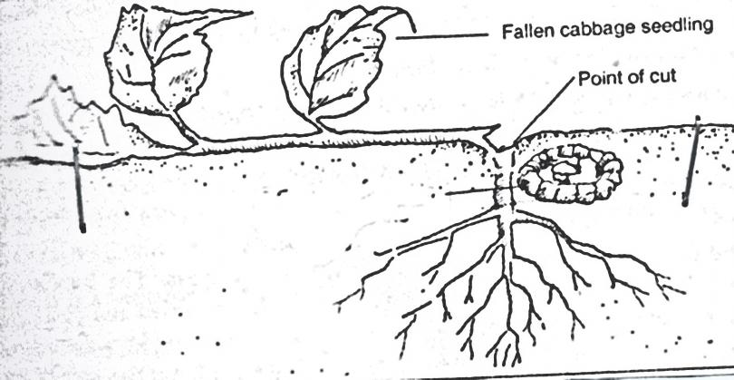
Point of cut
Fallen cabbage seedling
- Identify the pest (1 mark)
___________________________________________________________________________________
- State two methods of controlling the above pest (2 marks)
________________________________________________________________________________________________________________________________________________________________________

- State four methods of harvesting water on the farm. (2 marks)
____________________________________________________________________________________________________________________________________________________________________________________________________________________________________________________________________________________________________________________________________________

- a) Outline the procedure of constructing a cut off drain. (4 marks)
_______________________________________________________________________________________________________________________________________________________________________________________________________________________________________________________________________________________________________________________________________________________________________________________________________________________________
b) State two factors which may determine the size of a cut off drain. (1 mark)
______________________________________________________________________________________________________________________________________________________________________

SECTION C (40 MARKS)
Answer any TWO questions from this section in the spaces provided after question 27.
- a) Outline five factors that determine the quality of hay. (5 marks)
b) Explain five objectives of land tenure reform in Kenya. (5 marks)
c) Explain ten factors that can influence soil erosion. (10 marks)

- a) Outline the process of chemical water treatment for use in the farm. (12 marks)
b) Describe eight safety precautions that should be taken when using herbicides to control
weeds. (8 marks)

- The following information was extracted from the farm records of Mukulu farm, as at 31/12/2014.
Sale of poultry  Sale of milk  Telephone bill  Purchase of feeds  Purchase of calves  Purchase of lambs  Sale of goats  Closing valuation  Rent  Casual labour  Sale of cereals  Opening valuation  Depreciation of machinery  Interest on loan  Sale of sukuma wiki  Purchase of chicks | 5000  6000  1000  2500  3000  2800  5000  150,000  2000  2500  12,000  140,000  500  400  500  800

- Prepare profit and loss account for Mukulu farm using the above information. (11 marks)
- Distinguish between opening and closing valuation. (2 marks)
- State five functions of a farm manager. (5 marks)
- State four guiding questions that a farm manager may ask while preparing a partial budget. (2 marks)

_____________________________________________________________________________________________________________________________________________________________________________________________________________________________________________________________________________________________________________________________________________________________________________________________________________________________________________________________________________________________________________________________________________________________________________________________________________________________________________________________________________________________________________________________________________________________________________________________________________________________________________________________________________________________________________________________________________________________________________________________________________________________________________________________________________________________________________________________________________________________________________________________________________________________________________________________________________________________________________________________________________________________________________________________________________________________________________________________________________________________________________________________________________________________________________________________________________________________________________________________________________________________________________________________________________________________________________________________________________________________________________________________________________________________________________________________________________________________________________________________________________________________________________________________________________________________________________________________________________________________________________________________________________________________________________________________________________________________________________________________________________________________________________________________________________________________________________________________________________________________________________________________________________________________________________________________________________________________________________________________________________________________________________________________________________________________________________________________________________________________________________________________________________________________________________________________________________________________________________________________________________________________________________________________________________________________________________________________________________________________________________________________________________________________________________________________________________________________________________________________________________________________________________________________________________________________________________________________________________________________________________________________________________________________________________________________________________________________________________________________________________________________________________________________________________________________________________________________________________________________________________________________________________________________________________________________________________________________________________________________________________________________________________________________________________________________________________________________________________________________________________________________________________________________________________________________________________________________________________________________________________________________________________________________________________________________________________________________________________________________________________________________________________________________________________________________________________________________________________________________________________________________________________________________________________________________________________________________________________________________________________________________________________________________________________________________________________________________________________________________________________________________________________________________________________________________________________________________________________________________________________________________________________________________________________________________________________________________________________________________________________________________________________________________________________________________________________________________________________________________________________________________________________________________________________________________________________________________________________________________________________________________________________________________________________________________________________________________________________________________________________________________________________________________________________________________________________________________________________________________________________________________________________________________________________________________________________________________________________________________________________________________________________________________________________________________________________________________________________________________________________________________________________________________________________________________________________________________________________________________________________________________________________________________________________________________________________________________________________________________________________________________________________________________________________________________________________________________________________________________________________________________________________________________________________________________________________________________________________________________________________________________________________________________________________________________________________________________________________________________________________________________________________________________________________________________________________________________________________________________________________________________________________________________________________________________________________________________________________________________________________________________________________________________________________________________________________________________________________________________________________________________________________________________________________________________________________________________________________________________________________________________________________________________________________________________________________________________________________________________________________________________________________________________________________________________________________________________________________________________________________________________________________________________________________________________________________________________________________________________________________________________________________________________________________________________________________________________________________________________________________________________________________________________________________________________________________________________________________________________________________________________________________________________________________________________________________________________________________________________________________________________________________________________________________________________________________________________________________________________________________________________________________________________________________________________________________________________________________________________________________________________________________________________________________________________________________________________________________________________________________________________________________________________________________________________________________________________________________________________________________________________________________________________________________________________________________________________________________________________________________________________________________________________________________________________________________________________________________________________________________________________________________________________________________________________________________________________________________________________________________________________________________________________________________________________________________________________________________________________________________________________________________________________________________________________________________________________________________________________________________________________________________________________________________________________________________________________________________________________________________________________________________________________________________________________________________________________________________________________________________________________________________________________________________________________________________________________________________________________________________________________________________________________________________________________________________________________________________________________________________________________________________________________________________________________________________________________________________________________________________________________________________________________________________________________________________________________________________________________________________________________________________________________________________________________________________________________________________________________________________________________________________________________________________________________________________________________________________________________________________________________________________________________________________________________________________________________________________________________________________________________________________________________________________________________________________________________________________________________________________________________________________________________________________________________________________________________________________________________________________________________________________________________________________________________________________________________________________________________________________________________________________________________________________________________________________________________________________________________________________________________________________________________________________________________________________________________________________________________________________________________________________________________________________________________________________________________________________________________________________________________________________________________________________________________________________________________________________________________________________________________________________________________________________________________________________________________________________________________________________________________________________________________________________________________________________________________________________________________________________________________________________________________________________________________________________________________________________________________________________________________________________________________________________________________________________________________________________________________________________________________________________________________________________________________________________________________________________________________________________________________________________________________________________________________________________________________________________________________________________________________________________________________________________________________________________________________________________________________________________________________________________________________________________________________________________________________________________________________________________________________________________________________________________________________________________________________________________________________________________________________________________________________________________________________________________________________________________________________________________________________________________________________________________________________________________________________________________________________________________________________________________________________________________________________________________________________________________________________________________________________________________________________________________________________________________________________________________________________________________________________________________________________________________________________________________________________________________________________________________________________________________________________________________________________________________________________________________________________________________________________________________________________________________________________________________________________________________________________________________________________________________________________________________________________________________________________________________________________________________________________________________________________________________________________________________________________________________________________________________________________________________________________________________________________________________________________________________________________________________________________________________________
_______________________________________________________________________________________
_______________________________________________________________________________________
_______________________________________________________________________________________
_______________________________________________________________________________________
_______________________________________________________________________________________
_______________________________________________________________________________________

