Name……………………………………………………….......index no:………………………………………
School ……………………………………………………Candidate’s Signature …………..…..…………….
Date: ……………………………………………
231/1
BIOLOGY
PAPER 1
(THEORY)

TIME: 2 HOURS

Kenya Certificate of Secondary Education (K.C.S.E.)
(FORM FOUR)
231/1
Biology
Paper 1
Time: 2 hours
INSTRUCTIONS TO CANDIDATES
- Write your name, Admission number and name of your school in the spaces provided above
- Sign and write the date of examination in the spaces provided.
- Answer all the questions in the spaces provided.
- This paper consists of 8printed pages.
- Candidates should check to ascertain that all pages are printed as indicated and that no questions are missing

For Examiners Use Only
Question | Maximum score | Candidate’s score
1- 29 | 80

1 . a) What is metamorphosis? (1mark)
............................................................................................................................................................................................................................................................................................................................................................ b) What is the biological significance of metamorphosis to an insect? (2marks)
............................................................................................................................................................................ ............................................................................................................................................................................................................................................................................................................................................................
2. a)The diagram below shows a certain plant.
- Name the division in the kingdom Plantae to which the plant belongs. (1mark)
....................................................................................................................................................................................................................................................................................................................................
- State the functions of structure labelled K and L. (2marks)
K .............................................................................................................................................................

L...............................................................................................................................................................
3. State three functions of an exoskeleton in members of the phylum Arthropoda. (3marks)
...................................................................................................................................................................................................................................................................................................................................................................................... ...................................................................................................................................................
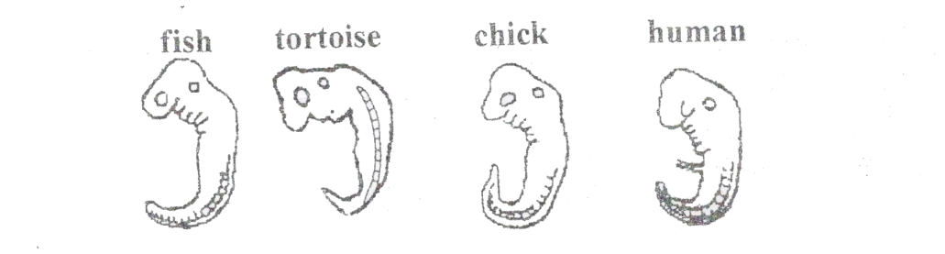
4. The diagrams below show embryos of certain vertebrates animals. Study them and answer the question that follows.

- Mention two observable structural features in these embryos that suggest that they have a common ancestral origin. (2marks)
………................................................................................................................................................................................................................................................................................................................................................

- What phenomenon in organic evolution is exhibited by these diagrams of embryos? (1mark)
..........................................................................................................................................................................................
..........................................................................................................................................................................................
5. What is meant by the terms? (3marks)
a) Hypogenous flower
……..……………………………………………………………………………………………………..
b) Gamesepalous ………………………………………………………………………………………………………………………………………………………………………………………………………………………………………………
c) Dichagamy …………………………………………………………………………………………………………………………………….………………………………….………………………………………………………………..
6. a) Name two salts in bile that aid in emulsification of fats. (2marks)
...............................................................................................................................................................................
...............................................................................................................................................................................
b) In what ways does sex of an individual determine their energy requirements? (1mark)
…….................................................................................................................................................................................
7. What is the main difference between the phloem tissues of subdivisions Gymnospermaphyta and
Angiospermaphyta. (1mark)
................................................................................................................................................................................................
.................................................................................................................................................................................................
8. a) State two ways in which the protection of the heart against mechanical injury is achieved during heartbeat. (2marks)
.................................................................................................................................................................................................
.................................................................................................................................................................................................. b) State the cause of arteriosclerosis (2marks)
..................................................................................................................................................................................................
..................................................................................................................................................................................................
9. a) State two functions of aerenchyma tissue in hydrophytes. (2marks)
..................................................................................................................................................................................................
..................................................................................................................................................................................................
b) State the difference between habitat and ecological niche. (2marks)
..................................................................................................................................................................................................
..................................................................................................................................................................................................
..................................................................................................................................................................................................
..................................................................................................................................................................................................
10.Name two type of mutation represented below. (2mks)
(i) Original strand (ii) Mutated strand

A B C D E F P B C D E F
..................................................................................................................................................................................................
..................................................................................................................................................................................................
11. Name the enzyme in the red blood cell that speeds up the conversion of carbonic acid to carbon (IV) oxide. (1mark)
.............................................................................................................................................................................................
12. State three ways in which the skin of a frog is adapted for gaseous exchange. (3marks)
...........................................................................................................................................................................................
13. What would be the effect of the following treatments on the nerve transmission?
(i) Inducing the axon with metabolic inhibitors. (1mark)
…………................................................................................................................................................................................
(ii) Removing myelin sheath from a nerve fibre. (1marks)
…............................................................................................................................................................................................
14. a) Under which of the following light microscope magnification would one see a larger part of the
specimen. $×40 or ×400$ (1mark)
.........................................................................................................................................................................
b) Give your reason (1mark)
..…………..................................................................................................................................................................
15. Give two reasons why blood leaving the lungs may not be fully oxygenated (2marks)
..........................................................................................................................................................................
.........................................................................................................................................................................
16. The diagram below represents a simple endocrine feedback mechanism in human male.

PITUITARY
GLAND

HORMONE HORMONE
X Y

TESTES
- Name the hormone labelled X ………………………………………………………………..(1marks)
- State two differences that may be observed between a normal male and one who is incapable of producing hormone labelled Y. (2marks)
...........................................................................................................................................................................
...........................................................................................................................................................................
17. What is the importance of Retina in vision? (2marks)
……. ...........................................................................................................................................................................
……. ...........................................................................................................................................................................
18. State four differences between wind pollinated flower and insect pollinated flower. (4marks)
......................................................................................................................................................................................
…………………………….........................................................................................................................................
..…………....................................................................................................................................................................
………............................................................................................................................................................................
19. a) Name the cartilage found between the bones of the vertebral column. (1mark)
..…………...............................................................................................................................................................
.............…………...........................................................................................................................................................
b) State the function of the cartilage named in (a) above. (1mark)
………...............................................................................................................................................................................
.........…............................................................................................................................................................................
20. State the functions of the following organelles
a) Lysosomes (1mark)
..…………..................................................................................................................................................................
b)Golgi apparatus (2marks)
............…………........................................................................................................................................................
21. The cells shown below were obtained from two different plant cells which were immersed in 2% and 25% salt solutions.
A B

- Which of the two cells A and B was immersed in 2% salt solution? (1mark)
............…………........................................................................................................................................................
- Name the substance present in part marked X. (1mark)
............…………........................................................................................................................................................
- Comment on the nature of 25% salt solution in relation to the cell sap. (1mark)
............…………........................................................................................................................................................
- What biological phenomenon leads to the observation made in A. (1mark)
............…………........................................................................................................................................................
22. Name two structures found in the cortex of the kidney (2marks)
............…………........................................................................................................................................................
............…………........................................................................................................................................................
23. State the importance of osmoregulation in organisms (2marks)
.…………............................................................................................................................................................................
.…………............................................................................................................................................................................
24. State the role of the following hormones in human body. (2marks)
(i) Insulin……………………………………………………………………………………………………
(ii) Anti diuretic hormone……………………..……………………………………………………………
25. Explain how high humidity lowers the rate of transpiration. (2marks)
............…………........................................................................................................................................................
............…………........................................................................................................................................................
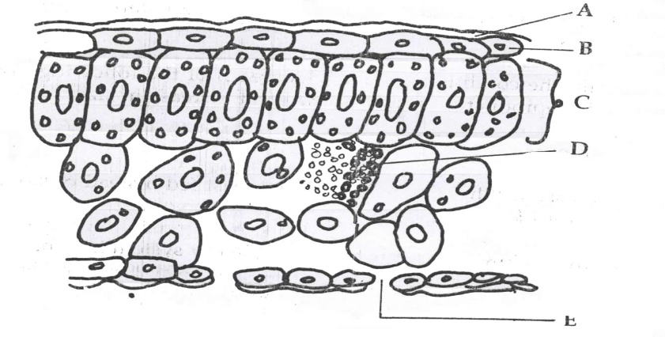
26. The diagram below shows the internal structure of a leaf

E
- Name the part labelled B. ……………………………………………………………………………………………….. (1mark)

- State the function of the part labelled C. ……………………………………………………………………………………………… (1mark)
- State the difference between xerophytes and hydrophytic leaves. (2marks)
.………….......................................................................................................................................................................…………...............................................................................................................................................................
27. a) Distinguish between breathing and respiration. (2marks)
............………….............................................................................................................................................................
............…………...............................................................................................................................................................
b) Explain the disadvantages of anaerobic respiration in plant rots. (2marks)
............…………........................................................................................................................................................
............…………........................................................................................................................................................
28. a) Suggest the significance of the following adaptations in bony fish.
(i) Flexible vertebral column (1mark)
............…………........................................................................................................................................................
(ii) Presence of swim bladder (1mark)
............…………........................................................................................................................................................
b) State two features which reduce resistance in fish during swimming. (2marks)
............…………........................................................................................................................................................
............…………........................................................................................................................................................
29. State three protective functions of human eye. (3marks)
.…………............................................................................................................................................................................
.…………............................................................................................................................................................................
.…………............................................................................................................................................................................

