**Name:…………………………………………………..……………Index no ……..…......................................**

**School…………………………………………………………….…. Candidate’s sign ….……………………..**

**Date: ……………………………………**

**233/1**

**CHEMISTRY**

**PAPER 1**

**TIME: 2 HOURS**

***Kenya Certificate of Secondary Education (K.C.S.E.)***

233/1

**Chemistry**

Paper 1

**Time: 2 Hours**

**INSTRUCTIONS TO CANDIDATES:**

* *Write your* ***name*** *and* ***index number*** *in the spaces provided above.*
* *Answer* ***All*** *the questions in the spaces provided below each question.*
* *All working* ***MUST*** *be clearly shown where necessary.*
* *Sign and write the date of examination in the spaces provided above.*
* *Electronic calculators may be used*
* ***This paper consists of 11 printed pages.***
* ***Candidates should check to ascertain that all pages are printed as indicated and that no questions are missing***

**For Examiner’s Use Only**

|  |  |  |
| --- | --- | --- |
| **Question** | **Maximum score** | **Candidate’s score** |
| **1- 30** | **80** |  |

1. Give two reasons why non-luminous flame is used in school laboratories. (2marks)

.…………………………………………………………………………………………………………

………………………………………………………………………………………………………….

1. Using kinetic theory explain the difference between solid and liquid (2marks)

.…………………………………………………………………………………………………………

………………………………………………………………………………………………………….………………………………………………………………………………………………………….

1. Name the most suitable method of separation that can be used to separate:

(a) Oil from cashew nut (1mark)

………………………………………………………………………………………………………….

b) Sodium chloride from a solution of potassium chloride and sodium chloride mixture

…………………………………………………………………………………………………….. (1mark)

1. The diagram below shows oxygen can be prepared in a laboratory. Study it and answer the questions that follow.

**Water**

**Oxygen**

**Liquid X**

**MnO2**

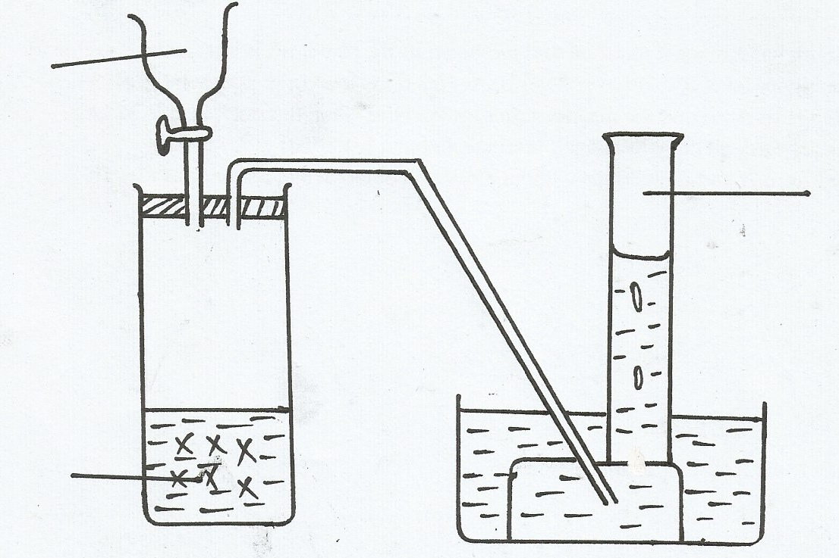

a) Name the liquid **X** (1mark)

…………………………………………………………………………………………………….

b) Write a balance chemical equation to shows how oxygen is produced in the boiling tube. (1mark)

c) Give one industrial use of oxygen (1mark)

.…………………………………………………………………………………………………………

1. Metal **X** reacts with cold water slowly while Y does react with neither cold water nor hot water. Metal **Z** react with both cold water and hot water vigorously and explosively respectively.
2. Arrange these metals in order of increasing reactivity (1mark)

.…………………………………………………………………………………………………………

………………………………………………………………………………………………………….

b) Chlorine was passed through solution of iodide of **X** .Give one observation. That can be made. (1mark)

.…………………………………………………………………………………………………………

………………………………………………………………………………………………………….

c) Explain the observation made in (b) above (1mark)

.…………………………………………………………………………………………………………

………………………………………………………………………………………………………….

1. Give two environmental effect of burning sulphur based compounds in the environment. (2marks)

.…………………………………………………………………………………………………………

………………………………………………………………………………………………………….

1. The grid below shows part of the periodic table. The letters do not represent the actual symbols of elements.

|  |  |  |  |  |  |  |  |  |
| --- | --- | --- | --- | --- | --- | --- | --- | --- |
|  |  | | | | | | |  |
| **P** | **Q** |  |  |  |  |  | **X** |  |
|  |  |  |  | **Z** |  |  | **Y** |  |

(a) Compare

(i) Atomic radii of **P** and **Q** (1mark)

.…………………………………………………………………………………………………………

………………………………………………………………………………………………………….

(ii) Reactivity of **X** and **Y**  (1mark)

.…………………………………………………………………………………………………………

………………………………………………………………………………………………………….

(b) Write the chemical formula of a compound formed by **Q** after reacting with **X**. (1mark)

1. (a) Element A has atomic number 11. Compare its atomic radius and ionic radius (1mark)

.…………………………………………………………………………………………………………

………………………………………………………………………………………………………….

(b) Explain why metals conduct electricity (1mark)

.…………………………………………………………………………………………………………

………………………………………………………………………………………………………….

1. Using dots**(.)** and crosses **(x)** show the bonding
2. NH4+  (1mark)
3. H2O (1mark)
4. The table below gives information on four elements S, T, Q and R. Study it and answer the question that follows. The letters do not represent the actual symbols of the elements

|  |  |  |  |
| --- | --- | --- | --- |
| Elements | Electronic configuration | Atomic radius (nm) | Ionic radius (nm) |
| **S**  **Q**  **R**  **T** | 2.8.2  2.8.7  2.8.8.1  2.8.8.2 | 0.136  0.099  0.203  0.174 | 0.065  0.181  0.133  0.099 |

1. Select two element with similar physical and chemical properties (2marks)

.…………………………………………………………………………………………………………

………………………………………………………………………………………………………….

1. Which one is likely to be a gas at room temperature and pressure? (1mark)

………………………………………………………………………………………………………….

1. Describe how you can prepare crystals of copper (II) sulphate starting with copper metal, without using concentrated sulphuric acid (3marks)

.…………………………………………………………………………………………………………

………………………………………………………………………………………………………….

.…………………………………………………………………………………………………………

…………………………………………………………………………………………………………..…………………………………………………………………………………………………………

………………………………………………………………………………………………………….

1. (a)Why is it not advisable to use sulphuric acid and CaCO3 when preparing calcium sulphate? (2marks)

.…………………………………………………………………………………………………………

………………………………………………………………………………………………………….

.…………………………………………………………………………………………………………

(b)Give reason as to why it is not advisable to heat strongly ammonium nitrate. (1mark)

.…………………………………………………………………………………………………………

………………………………………………………………………………………………………….

1. The diagram below shows electrolysis of dilute hydrochloric acid using carbon electrodes.

**X**

**Y**

HCl(aq)

**A**

**B**

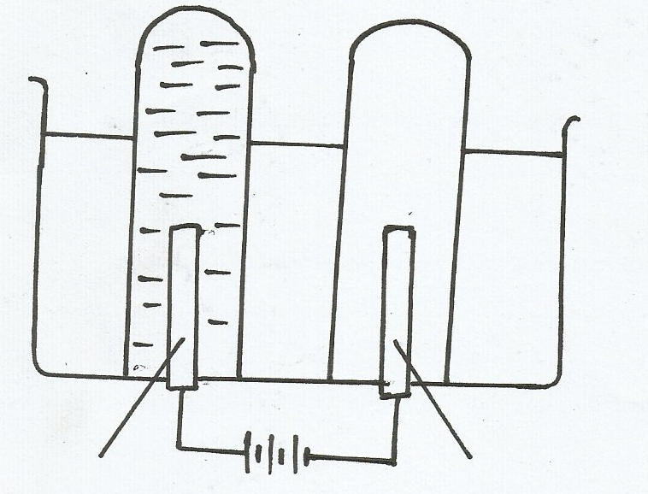

(a) Show the level of water in the tubes A and B after some time. (1mark)

(b) Write ionic equation of the reaction that takes place in (2marks)

**X**

**Y**

1. Complete the diagram below to show how you can electroplate a spoon using copper sulphate solution

(2marks)

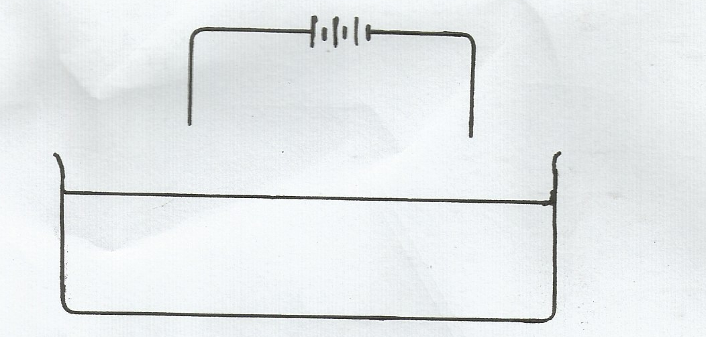

**Copper (II) Sulphate.**

1. (a)Name two allotropes of carbon. (1mark)

.…………………………………………………………………………………………………………

………………………………………………………………………………………………………….

1. Explain why diamond is very hard. While graphite is very soft. (2marks)

.…………………………………………………………………………………………………………

………………………………………………………………………………………………………….

.…………………………………………………………………………………………………………

.…………………………………………………………………………………………………………

1. Carbon (II) oxide is a ‘silent killer’. Explain. (2marks)

.…………………………………………………………………………………………………………

………………………………………………………………………………………………………….

1. (a)Give two uses of chlorine (1mark)

.…………………………………………………………………………………………………………

………………………………………………………………………………………………………….

(b) Chlorine gas was passed through water and two acids were formed. Identify the acids. (2marks)

.…………………………………………………………………………………………………………

………………………………………………………………………………………………………….

1. Nitric acid reacts with copper metal though it is below hydrogen in the reactivity series. Name the chemical property of nitric acid which is exhibited in these case. (1mark)

.…………………………………………………………………………………………………………

………………………………………………………………………………………………………….

1. (a) A mixture of 100cm3 of methane (CH4 ) and 100cm3of oxygen was ignited. Write a chemical equation of reaction. (1mark)

(b)Calculate the volume of methane (CH4) which remained unreacted (2marks)

1. Study the flow chart below and answer the question that follows.

**-[CH2- CH2- CH2-CH2]-**

**CH2= CH2**

**CH2ClCH2Cl**

**Step II**

**Step I**

**Step III**

**CH3 CH3**

1. Name the chemical process in step

**I** ……………………………………………………………………………………………… (1mark)

**II** ……………………………………………………………………………………………… (1mark)

(b)Give one use of the chemical obtained in step **III**. (1mark)

.…………………………………………………………………………………………………………

1. Calculate the volume of 2M HCl which is required to completly react with 1g of CaCO3 (Ca=40, C= 12, O=16) (3marks)

22. The diagram below shows concentric pipes used in extraction of sulphur

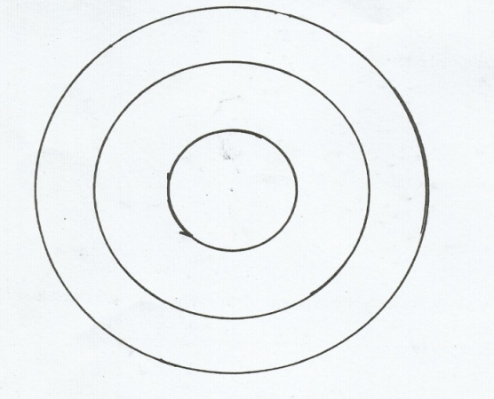

**A B C**

1. Name the substance carried by the pipe. (2marks)

**A**……………………………………………………..………………………………………………

**C**………………………………………………………………………………………………………

1. Using a diagram, show how sulphur atoms are bonded in sulphur molecule. (1mark)

23. a) Define the term solubility. (1mark)

………………………………………………………………………………………………………………………………………………………………………………………………………………………………

b) The table below shows the solubility of a salt various temperatures.

|  |  |
| --- | --- |
| Temperature (0C) | Solubility (g100g water) |
| 0  40  80  110 | 36  30  25  24 |

What would happen if a sample of a saturated solution of salt at 400C is heated to 800c. Explain (2marks)

.…………………………………………………………………………………………………………

………………………………………………………………………………………………………….

24. Study the energy cycle diagram below and then answer the question that follow.

**CO2(g)**







C(graphite) CO(g)

(a)Name heat changes labeled H1 and H2 (1mark) ...…………………………………………………………………………………………………………

………………………………………………………………………………………………………….

1. Given that the heat changes occurring are: H2=110Kj/mol, H3=-283Kj/mol. Calculate the value of H1 for one mole of graphite. (C=12, O=16) (2marks)

25. **Xg** of potassium hydroxide were dissolved in water to make 100cm3 of solution. 50cm3 of the solution required 50cm3 of 2**M** nitric acid for complete neutralization. Calculate the mass **X**(g) of potassium hydroxide. ( K=39, O=16, H=1) (3marks)

26. (a) State Charles Law. (1 mark)

.…………………………………………………………………………………………………………

………………………………………………………………………………………………………….

(b) A gas A was found to occupy 300cm3. When the temperature is 470c. Calculate the volume which can be occupied by the gas if the temperature is increased by 200C. (2marks)

27. The apparatus below was set up to show the catalytic oxidation of ammonia

**NH3**

**Oxygen Gas**

**Hot nichrome wire.**

**Gas jar**

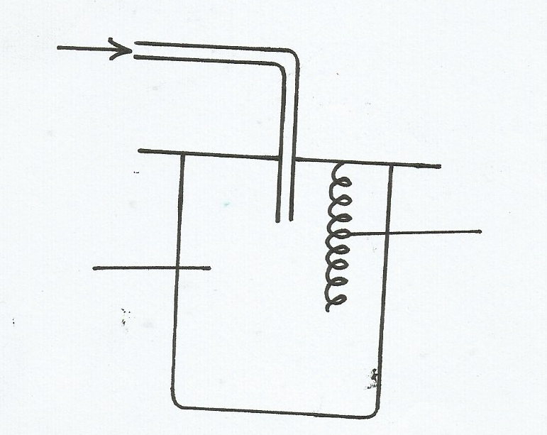

1. Write an equation for the reaction that takes place in the gas jar. (1mark)
2. Why is it necessary to have hot nichrome wire in the gas jar. (1mark)

.…………………………………………………………………………………………………………

………………………………………………………………………………………………………….

1. State **one** use of ammonia. (1mark)

.…………………………………………………………………………………………………………

28. The following equation shows a reversible reaction

H2(g)+ Br2(g) 2HBr(g) H= -74.4Kj

(Reddish brown) (Colourless)

State and explain the observations made when:

1. Temperature is increased. (1 ½ marks)

.…………………………………………………………………………………………………………

………………………………………………………………………………………………………….

1. Pressure is reduced (1 ½ marks)

…………..………………………………………………………………………………………………

…………….…………………………………………………………………………………………….

29. The structures shown below represent two cleansing agent A and B.

**R OSO3-Na+**

**A B**

R-

1. Name the type of cleansing agent **A** (1mark)

.…………………………………………………………………………………………………………

1. Which of the **two** cleansing agents is more suitable for washing in water containing calcium chloride? Give a reason. (2marks)

.…………………………………………………………………………………………………………

………………………………………………………………………………………………………….

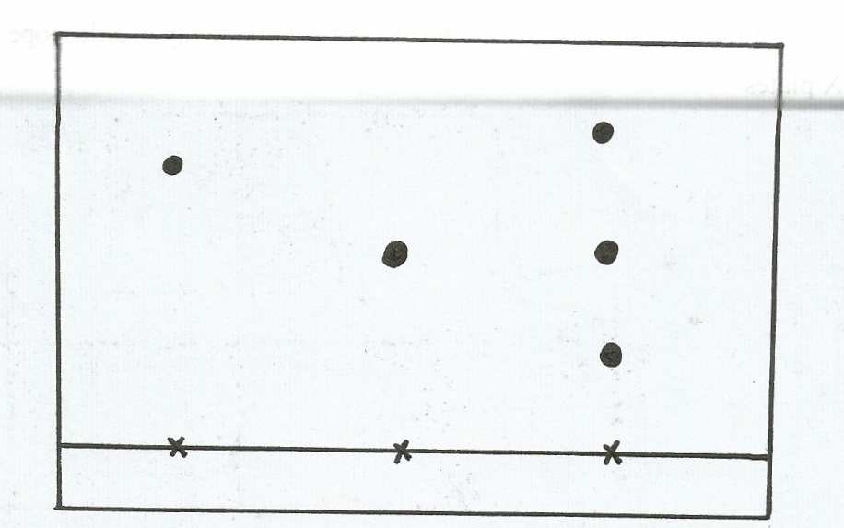 30. The diagram below represents a paper chromatogram for three brands of juices suspected to contain banned food colourings

**K L M**

The results showed the presence of banned food colourings in L and M only. On the same diagram

1. Circle the spots which show banned food colouring (1mark)
2. Indicate the solvent front (1mark)
3. Give one application of chromatography. (1mark)

.…………………………………………………………………………………………………………