NAME ____________________________________ INDEX NO. _______________
SCHOOL ____________________________________ SIGNATURE _______________ DATE _______________

233/1
CHEMISTRY
PAPER 1
(THEORY)
JULY/AUGUST, 2015
TIME: 2 HOURS

233/1
CHEMISTRY
PAPER 1
(THEORY)
TIME: 2 HOURS

INSTRUCTIONS
- Write your name and index no. in the spaces provided above.
- Sign and write the date of examination in the space provided above.
- Answer all the questions in the spaces provided.
- Mathematical tables and silent electronic calculators may be used.
- All working MUST be clearly shown where necessary.

FOR EXAMINER’S USE ONLY
QUESTIONS | MAXIMUM SCORE | CANDIDATE’S SCORE
1 − 28 | 80 marks

This paper consists of 12 printed pages.
Candidates should check to ensure that all pages are printed as indicated and no questions are missing.

- The diagram below shows a set-up of apparatus used to separate immiscible liquids.
B
A
Mixture
Heat
- Name the parts labelled A and B. (1 mark)
A _________________________________________________________________________________
B _________________________________________________________________________________
- State the function of the part labelled A . (1 mark)
______________________________________________________________________________________________________________________________________________________________________
- State the property of the mixture that makes it suitable to be separated by the method above. (1 mark)
______________________________________________________________________________________________________________________________________________________________________
- Study the information in the table below and answer the questions that follow. The letters do not represent the actual symbols of the elements
Element | Atomic number | Melting point ($℃$)
L | 11 | 97.8
M | 13 | 660
R | 19 | 63.7

- Write the formula of carbonate of R and M (1 mark)
______________________________________________________________________________________________________________________________________________________________________
- Describe how the carbonate of M can be obtained from a mixture of carbonate R and M. (2 marks)
__________________________________________________________________________________________________________________________________________________________________________________________________________________________________________________________________________________________________________________________________________________________________________________________________________________________________________________________________________________________________________________
- R is more reactive than L. Explain. (1 mark)
_________________________________________________________________________________________________________________________________________________________________________________________________________________________________________________________
- In an experiment, concentrated sulphuric acid was put in a beaker and exposed to air for one week as shown below.
- What observation was made after one week? Explain. (2 marks)
_________________________________________________________________________________________________________________________________________________________________________________________________________________________________________________________
- What property of sulphuric acid was being investigated in the experiment? (1 mark)
_________________________________________________________________________________________________________________________________________________________________________________________________________________________________________________________
- a) Define the term solubility. (1 mark)
______________________________________________________________________________________________________________________________________________________________________
b) A form four student wanted to determine the solubility of potassium nitrate. He obtained the following results.
Mass of evaporating dish =15.13g
Mass of evaporating dish and solution =36.51g
Mass of evaporating dish and salt =19.41g
Use the information above to calculate the solubility of potassium nitrate. (3 marks)
_____________________________________________________________________________________________________________________________________________________________________________________________________________________________________________________________________________________________________________________________________________________________________________________________________________________________________________________________________________________________________________________________________________________________________________________________________
- The table below shows the standard electrode potentials of two elements P and Q.
Half reactions | E^{θ} (v)
P²⁺_{(aq)}+ 2e⁻ $→$ P_{(s)} | - 2.37
Q²⁺_{(aq)}+ 2e⁻ $→$ Q_{(s)} | - 0.402

- Draw a well labelled diagram of a cell that could be constructed from the pair of elements. (2 marks)

- Calculate the e.m.f. of the cell above. (1 mark)
_________________________________________________________________________________________________________________________________________________________________________________________________________________________________________________________
- Predict whether displacement reaction between metal Q and solution of P from e.m.f in 5 (ii) above will occur. (1 mark)
_________________________________________________________________________________________________________________________________________________________________________________________________________________________________________________________
- The diagram below shows an incomplete set – up for the laboratory preparation and collection of chlorine gas. Study it and answer the questions that follow.
Conc. HCl
Black solid Q

Heat
Water

a) Complete the set up to show how dry chlorine gas is collected. (2 marks)
b) Name substance Q. (1 mark)
___________________________________________________________________________________
- If aqueous lead (II) nitrate is added to aqueous solution potassium iodide, a bright yellow precipitate is formed.
i) Write down the formula of the precipitate formed. (1 mark)
___________________________________________________________________________________
ii) Write the ionic equation for the reaction above. (1 mark)
______________________________________________________________________________________________________________________________________________________________________
- Zinc carbonate decomposes on heating producing a gaseous product and a residue. What volume of the gaseous product at s.t.p. is produced from 2.5g of the carbonate?
(Zn = 65, C = 12, O = 16, MGV at s.t.p =22400cm³) (3 marks)
__________________________________________________________________________________________________________________________________________________________________________________________________________________________________________________________________________________________________________________________________________________________________________________________________________________________________________________________________________________________________________________
- Identify the type of bond formed in (i) and (ii) (2 marks)
- ii)
- _________________________________________________________________________________
- _________________________________________________________________________________
- Give the systematic names of the following compounds. (3 marks)
a) CH₃ – C – CH₂ – CH₃
||
CH₂
___________________________________________________________________________________
b) CH₃ CH CH₂ CH₂ OH
|
C₂H₅
___________________________________________________________________________________
c) O
||
CH₃ CH₂ CH₂ COH
___________________________________________________________________________________

- The set up below was used to investigate a chemical property of carbon. Study it and answer the questions that follow
Mixture of charcoal & Copper (II) oxide

Heat
Boiling tube
Lime water
Test tube
i) What observations were made on heating the mixture? (2 marks)
_________________________________________________________________________________________________________________________________________________________________________________________________________________________________________________________
ii) What is the industrial application of carbon in terms of property investigated above? (1 mark)
______________________________________________________________________________________________________________________________________________________________________
- In an experiment, a few drops of concentrated nitric (V) acid were added to aqueous iron (II) sulphate in a test tube. Excess sodium hydroxide solution was then added to the mixture.
a) State the observations that were made when;
i) Concentrated nitric (V) acid was added to aqueous iron (II) sulphate. (1mark)
______________________________________________________________________________________________________________________________________________________________________
ii) Excess sodium hydroxide was added to the mixture. (1mark)
______________________________________________________________________________________________________________________________________________________________________
b) Write an ionic equation for the reaction that occurred in a) ii) above (1 mark)
______________________________________________________________________________________________________________________________________________________________________
- Consider the reaction represented by the equation:
N_{2 (g)} + O_{2 (g)} ⇌ 2NO _{(g)} $∆$H = + 1259kJ
Explain the effects of the following on the reaction;
a) An increase in pressure (1 mark)
______________________________________________________________________________________________________________________________________________________________________

b) Increase in temperature (2 marks)
_________________________________________________________________________________________________________________________________________________________________________________________________________________________________________________________
- Study the energy level diagram below and answer the questions that follow.
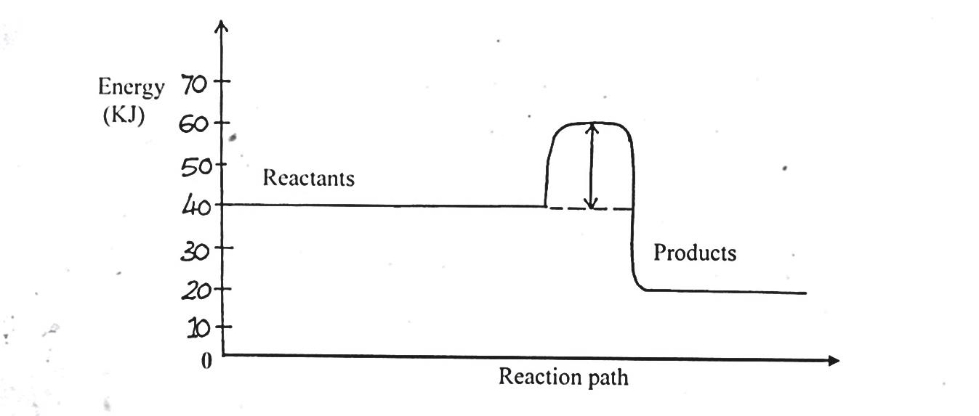
Reactants
Energy (KJ)
Reaction path
Products
i) State and explain whether the reaction represented is endothermic or exothermic. (1 mark)
_________________________________________________________________________________________________________________________________________________________________________________________________________________________________________________________
ii) From the diagram, determine;
I. The activation energy (1 mark)
____________________________________________________________________________________________________________________________________________________________________________________________________________________________________________________________________________________________________________________________________________
II. Enthalpy of reaction (1mark)
____________________________________________________________________________________________________________________________________________________________________________________________________________________________________________________________________________________________________________________________________________
- Explain why when heating substances with non – luminous flame, tubes should not be placed very close to the top of the chimney. (2marks)
_________________________________________________________________________________________________________________________________________________________________________________________________________________________________________________________
- a) State graham’s law of diffusion. (1mark)
______________________________________________________________________________________________________________________________________________________________________
b) Two gases A and B diffuse from two opposite ends of the glass tube as shown. After 12 seconds gas B was detected at point P and A was detected 4 seconds later.
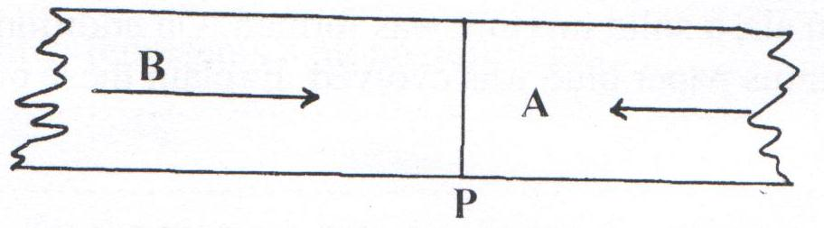
P
A

Calculate the relative molecular mass of A given the relative molecular mass of B is 2. (3 marks)
_______________________________________________________________________________________________________________________________________________________________________________________________________________________________________________________________________________________________________________________________________________________________________________________________________________________________
- Starting with copper metal, describe how a sample of crystals of copper (II) chloride may be prepared in the laboratory. (3 marks)
_______________________________________________________________________________________________________________________________________________________________________________________________________________________________________________________________________________________________________________________________________________________________________________________________________________________________
- Thorium ${}_{90}^{232}{ Th}$ undergoes two consecutive alpha decays followed by two consecutive beta decays to form the nuclide ${}_{y}^{x}{ Ra}$. Identify the values of x and y. (3 marks)
_______________________________________________________________________________________________________________________________________________________________________________________________________________________________________________________________________________________________________________________________________________________________________________________________________________________________
- Explain why the reaction between 1g of calcium carbonate and 1M hydrochloric acid is faster than the reaction between 1g of calcium carbonate and 1M butanoic acid. (2 marks)
_________________________________________________________________________________________________________________________________________________________________________________________________________________________________________________________

- A hydrocarbon gas Y in which the percentage of hydrogen by mass is 14.3% occupies a volume of 2.24dm³ at s.t.p. and weighs 7g.
i) Determine the empirical formula of Y. (C = 12, H = 1.0) (2 marks)
_______________________________________________________________________________________________________________________________________________________________________________________________________________________________________________________________________________________________________________________________________________________________________________________________________________________________
ii) Give the structural molecular formula of Y. (2 marks)
____________________________________________________________________________________________________________________________________________________________________________________________________________________________________________________________________________________________________________________________________________
- When magnesium was burnt in air, a solid mixture was formed. On addition of water to the mixture a gas which turned moist red litmus paper blue was evolved. Explain these observations. (2 marks)
____________________________________________________________________________________________________________________________________________________________________________________________________________________________________________________________________________________________________________________________________________
- In an experiment to prepare nitrogen (I) oxide, ammonium nitrate was gently heated in a flask.
a) State and explain how the gas was collected. (1 mark)
_________________________________________________________________________________________________________________________________________________________________________________________________________________________________________________________
b) A sample of the gas was tested with damp blue and red litmus papers. What observations were made? (1 mark)
_________________________________________________________________________________________________________________________________________________________________________________________________________________________________________________________
- The following are standard electrode potentials of some half-cell reactions. Use the data to answer the questions that follow.
Element | Electrode potentials
S | - 1.37
T | - 0.83
U | 0.00
V | + 0.58
W | + 1.46

i) Suggest the identity of element U. (1 mark)
___________________________________________________________________________________
ii) Which of the above elements is the most:
I) Reducing agent? Explain. (2 marks)
_________________________________________________________________________________________________________________________________________________________________________________________________________________________________________________________
II) Oxidizing agent? Explain. (2 marks)
_________________________________________________________________________________________________________________________________________________________________________________________________________________________________________________________
- The grid below is part of the periodic table. Use it to answer the questions that follow.
(The letters do not represent the actual symbols of the elements)
 |  |  |  |  |  | R | S
N | Q |  |  |  |  |  | T | U
P

- Indicate in the grid the position of an element represented by letter V, Whose atomic number is 14. (1 mark)
b) Select a letter which represents a mono atomic gas. (1 mark)
___________________________________________________________________________________
c) Write an equation for the reaction between Q and T. (1 mark)
______________________________________________________________________________________________________________________________________________________________________
- In an experiment, dilute hydrochloric acid was added to sodium hydroxide solution drop wise. The concentration of sodium hydroxide was noted at regular time intervals.
i) Sketch a graph of concentration (y-axis) against time interval to show the concentration of sodium hydroxide changes. (2 marks)

ii) Explain the shape of the curve sketched above. (1 mark)
_________________________________________________________________________________________________________________________________________________________________________________________________________________________________________________________
- Below is a set-up of apparatus used to prepare hydrogen gas in the laboratory. Study it and answer the questions that follow.
Dilute H₂SO₄
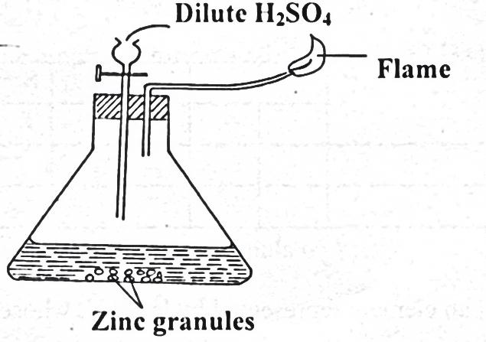
Zinc granules

Flame

a) Write the chemical equation for the two reactions taking place in the above set up. (1 mark)
______________________________________________________________________________________________________________________________________________________________________
b) State the chemical test for hydrogen gas. (1 mark)
______________________________________________________________________________________________________________________________________________________________________
- Below is a table of 1st ionization energies for elements A, B, C and D which are metals.
Elements | A | B | C | D
Ionization energies KJ/mol | 494 | 418 | 519 | 376

a) What is meant by 1st ionization energy? (1 mark)
______________________________________________________________________________________________________________________________________________________________________
b) With an explanation, arrange the elements in order of increasing reactivities. (1 mark)
____________________________________________________________________________________________________________________________________________________________________________________________________________________________________________________________________________________________________________________________________________
- a) What are alkali metals? (1 mark)
______________________________________________________________________________________________________________________________________________________________________

b) Explain why potassium atom is larger than sodium atom. (1 mark)
_________________________________________________________________________________________________________________________________________________________________________________________________________________________________________________________

