NAME ____________________________________ INDEX NO. _______________
SCHOOL ____________________________________ SIGNATURE _______________
DATE _______________

451/1
COMPUTER STUDIES
PAPER 1
THEORY
JULY/AUGUST, 2015
TIME: 2½ HOURS

451/1
COMPUTER STUDIES
PAPER 1
THEORY
TIME: 2½ HOURS

INSTRUCTIONS TO CANDIDATES:
- Write your name, index number and school in the spaces provided above.
- Write the date of examination and sign in the spaces provided.
- This paper consists of two sections.
- Answer all the questions in section A.
- Answer question 16 (compulsory) and any other three questions from section B.
- All answers must be written in the spaces provided in this question paper.

FOR EXAMINER’S USE ONLY
SECTION | QUESTION | MAXIMUM SCORE | ACTUAL SCORE
A | 1 – 15 | 40
B | 16 | 15
 | 17 | 15
 | 18 | 15
 | 19 | 15
 | 20 | 15
 |  | TOTAL SCORE

This paper consists of 12 printed pages
Candidates should check to ensure that all pages are printed as indicated and no questions are missing.

SECTION A (40MARKS)
Answer ALL questions in this section in the spaces provided
1. State two practices to be observed in a computer laboratory in order to ensure the safety of the computer user (2marks)
___________________________________________________________________________________ ___________________________________________________________________________________ ___________________________________________________________________________________
2. Define portability as used in software selection (1mark)
______________________________________________________________________________________________________________________________________________________________________
3. a) How does an operating system manage computer memory (2marks)
___________________________________________________________________________________ ___________________________________________________________________________________ ___________________________________________________________________________________
b) i) What is meant by disk partitioning? (1mark)
___________________________________________________________________________________ ___________________________________________________________________________________
ii) State the purpose of disk partitioning (1mark)
___________________________________________________________________________________ ___________________________________________________________________________________
4. a) List four stages in data processing cycle (2marks)
___________________________________________________________________________________ ___________________________________________________________________________________ ___________________________________________________________________________________ ___________________________________________________________________________________ ___________________________________________________________________________________
b) What is meant by the following (2marks)
i) Reference file
___________________________________________________________________________________ ___________________________________________________________________________________
ii) Master file
___________________________________________________________________________________ ___________________________________________________________________________________

5. a) Describe two situations in the bus transport industry where computerized systems could replace human employees. (2marks)
___________________________________________________________________________________ ___________________________________________________________________________________ ___________________________________________________________________________________
b) State one role of
i) Webmaster (1mark)
___________________________________________________________________________________ ___________________________________________________________________________________
ii) Network administrator (1mark)
___________________________________________________________________________________ ___________________________________________________________________________________
6. a) Give one reason why parallel cables are faster than serial cables in data transmission (1mark)
___________________________________________________________________________________ ___________________________________________________________________________________
b) State any two ways that may be used to represent a negative number in a computer. (2marks)
___________________________________________________________________________________ ___________________________________________________________________________________ ___________________________________________________________________________________
7. a) Distinguish between autocomplete and the autocorrect feature in word processing. (2marks)
___________________________________________________________________________________ ___________________________________________________________________________________ ___________________________________________________________________________________
b) What is thesaurus? (1mark)
___________________________________________________________________________________ ___________________________________________________________________________________
8. a) Define the following terms as used in internet (2marks)
i) Internet
___________________________________________________________________________________ ___________________________________________________________________________________
ii) Piconet
___________________________________________________________________________________ ___________________________________________________________________________________

9. Give two reasons why a DTP is preferred over Word Processors in creation and editing of magazines (2marks)
___________________________________________________________________________________ ___________________________________________________________________________________ ___________________________________________________________________________________
10. The following are symbols of some keys on the keyboard. Name the keys represented by the symbols (2marks)
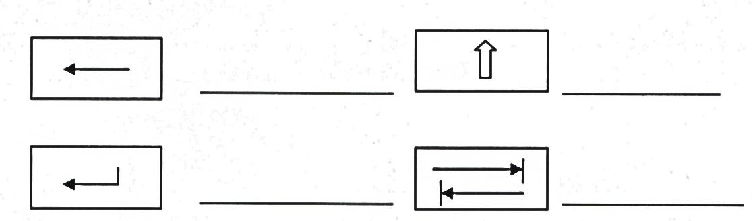
11. As a computer student you have been asked to assist in buying an input device. State any four factors to consider when buying input devices (4marks)
___________________________________________________________________________________ ___________________________________________________________________________________ ___________________________________________________________________________________ ___________________________________________________________________________________ ___________________________________________________________________________________
12. a) Distinguish between a workbook and a worksheet as used in spreadsheets (2marks)
___________________________________________________________________________________ ___________________________________________________________________________________ ___________________________________________________________________________________
b) What is the meaning of ‘what if analysis’ with respect to spreadsheet? (1mark)
___________________________________________________________________________________ ___________________________________________________________________________________
13. Give a reason why HTML is not considered as a true programming language. (1mark)
___________________________________________________________________________________ ___________________________________________________________________________________
14. Define the following computer crimes
i) Piracy (1mark)
___________________________________________________________________________________ ___________________________________________________________________________________
ii) Industrial espionage (1mark)
___________________________________________________________________________________ ___________________________________________________________________________________
15. State the following types of relationship as used in database design (3marks)
i)
Student
Books

___________________________________________________________________________________
Student
Registration number
ii)
___________________________________________________________________________________

Course Unit
Student
iii)
___________________________________________________________________________________

SECTION B (60MARKS)
Answer question 16 (compulsory) and any other THREE questions from this section
16. a) Study the Pseudo code below and answer the questions that follows.
BEGIN
Print “enter the value of A and B”;
Read A, B
Y = A+B
While Y<20 Do
BEGIN
PRINT Y
A = B
B = Y
Y = B+A
END WHILE
PRINT A, B, Y;
END

i) Assuming the user keys in 2 and 4 when prompted to enter the values for A and B respectively, determine the values of A, B and Y show your working (4marks)
____________________________________________________________________________________________________________________________________________________________________________________________________________________________________________________________________________________________________________________________________________________________________________________________________________________________________________________________________________________________________________________________________________________________________________________________________________________________________________________________________________________________________________________________________________________________________________________________________________________________________________________________________________________________________________________________________________________________________________________________________________________________________
ii) State the control structures used in the above pseudocode. (2marks)
____________________________________________________________________________________________________________________________________________________________________________________________________________________________________________________________________________________________________________________________________________
b) Draw a flowchart that would be used in place of the pseudocode (6marks)

c) Give three examples of Iteration construct (3marks)
____________________________________________________________________________________________________________________________________________________________________________________________________________________________________________________________________________________________________________________________________________
17. Study the diagram below and answer the questions that follow.
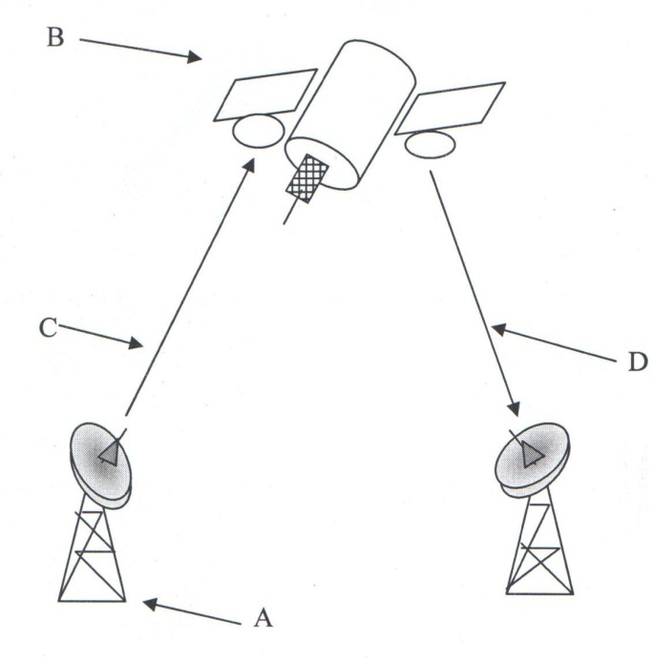
a) i) Name the communication media in the diagram (1mark)
___________________________________________________________________________________
ii) Name the parts labeled A, B, C and D (4marks)
A _______________________________________________
B _______________________________________________
C _______________________________________________
D _______________________________________________
iii) List three advantages of the above communication media (3marks)
____________________________________________________________________________________________________________________________________________________________________________________________________________________________________________________________________________________________________________________________________________
b) In relation to networking
i) Define the term network topology (1mark)
___________________________________________________________________________________ ___________________________________________________________________________________

ii) Distinguish between logical and physical network topologies (2marks)
___________________________________________________________________________________ ___________________________________________________________________________________ ___________________________________________________________________________________
c) Explain the functions of the following network device (4marks)
i) Network interface card (NIC)
___________________________________________________________________________________ ___________________________________________________________________________________
ii) Gateway
___________________________________________________________________________________ ___________________________________________________________________________________
iii) Bridge
___________________________________________________________________________________ ___________________________________________________________________________________
iv) Repeater
___________________________________________________________________________________ ___________________________________________________________________________________
18. a) Highlight three circumstances that necessitate the development of new information systems(3marks)
___________________________________________________________________________________ ___________________________________________________________________________________ ___________________________________________________________________________________ ___________________________________________________________________________________
b) Describe three factors that cause system entropy (3marks)
__________________________________________________________________________________________________________________________________________________________________________________________________________________________________________________________________________________________________________________________________________________________________________________________________________________________________________________________________________________________________________________
c) State two tools that a system analyst may use to design a system (1mark)
___________________________________________________________________________________ ___________________________________________________________________________________ ___________________________________________________________________________________

d) Outline three factors that should be considered when sourcing for hardware and software resources required for a new system (3marks)
___________________________________________________________________________________ ___________________________________________________________________________________ ___________________________________________________________________________________ ___________________________________________________________________________________
e) Name two circumstances in which it is better to use a questionnaire than a interview for gathering information (2marks)
___________________________________________________________________________________ ___________________________________________________________________________________ ___________________________________________________________________________________
f) State three reasons why users may resist the introduction of an information system in their place of work (3marks)
___________________________________________________________________________________ ___________________________________________________________________________________ ___________________________________________________________________________________ ___________________________________________________________________________________
19. a) Workout the equivalent of the following numbers
i) 113.25₁₀ = X₂ (3marks)

ii) 1001110.10011₂ = X₁₀ (3marks)

b) Workout using two’s complements
i) 57₁₀ – 29₁₀ (3marks)

ii) 11001₂ + (-111101₂) (3marks)

iii) Find the BCD equivalent of 37₁₀ (2marks)

20. a) What is Virtual reality? (2marks)
___________________________________________________________________________________ ___________________________________________________________________________________
b) Explain the following interactive sensory equipment used in virtual reality (2marks)
i) Head gear
___________________________________________________________________________________ ___________________________________________________________________________________
ii) Body suit
___________________________________________________________________________________ ___________________________________________________________________________________
c) i) What is Artificial Intelligence? (2marks)
___________________________________________________________________________________ ___________________________________________________________________________________

ii) State and explain three components of an experts system (6marks)
_____________________________________________________________________________________________________________________________________________________________________________________________________________________________________________________________________________________________________________________________________________________________________________________________________________________________________________________________________________________________________________________________________________________________________________________________________
d) Most computerized security systems make use of Biometric analysis, name three physical features of human beings that can be considered in this analysis (3marks)
___________________________________________________________________________________ ___________________________________________________________________________________ ___________________________________________________________________________________ ___________________________________________________________________________________

