Name……………………………………..………………….…Index No:……………………………………………..

School ………………………………………………………. Candidate’s Signature …………..…………………….
Date:……………………………………………………..

449/1
DRAWING AND DESIGN
PAPER 1

TIME: 2 ½ HOURS

Kenya Certificate of Secondary Education (K.C.S.E.)

449/1
Drawing and design
Paper 1
2 ½ Hours
Instructions to candidates.
- You should have the following for this examination.
Size A3 sheet of drawing papers
Drawing instruments, scale, ruler
- This paper contain three section A,B and C
- Answer all question in section A and B and any other two from section C
- Question in A must be answered in the spaces provided.
- Question in section B and C should be answered on the A3 sheets provided.
- All dimension are in mm unless otherwise started

  - (a) Distinguish between the role of an architect and a draughtsman (2marks)
.……………………………………………………………………………………………………...…………
…………………………………………………………………………………………………………………
(b) State two precautions to be observed when storing a T-square (2marks)
.……………………………………………………………………………………………………...…………
…………………………………………………………………………………………………………………
  - (a) State two uses of the line shown in figure 1. (2marks)

.……………………………………………………………………………………………………...…………
…………………………………………………………………………………………………………………
(b) Sketch the convectional drawing symbols for the following: (4marks)
(i) Machined surface

(ii) Hard core

(iii) Centre line

(iv) Two-way switch.

  - (a)With reference to engineering design ,define the following terms: (2marks)
(i) Restriction…………………………………………………………………………………………
(ii) Ergonomics………………………………………………………………………………………..
(b) Fig 2 shows a longitudinal section of an ISO metric thread. Show the following: (4marks)
(i)Pitch
(ii) Crest
(iii) Root
(iv) Major diameter
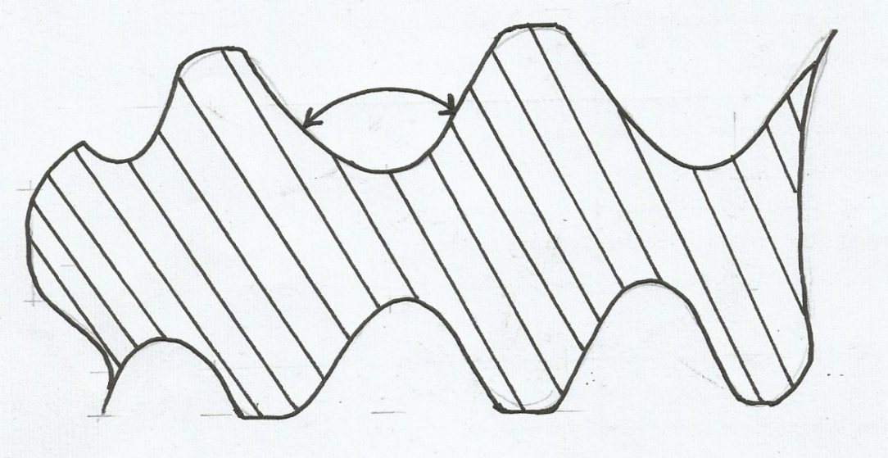
60⁰

Fig 2..

  - Fig 3 shows the elevation of a cam profile construct the profile (5mks)
R40
Ǿ20
R70
67

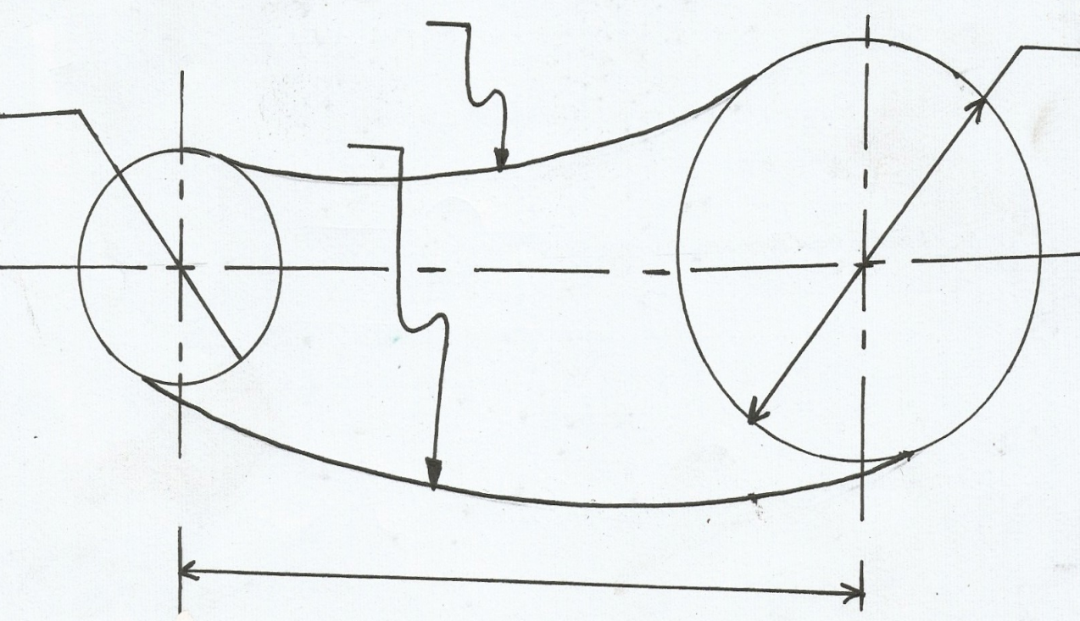

  - (a) give two major elements in each of the following materials: (3marks)
(i) Bronze……………………………………………………………………………..………………
(ii) Stainless steel………………………………………………………….…………………………
(iii) Brass…………………………………………………………..…………………………………
(b) Fig 4 shows two views of a block. Sketch the isometric views of the block with X being the lowest point. (5marks)
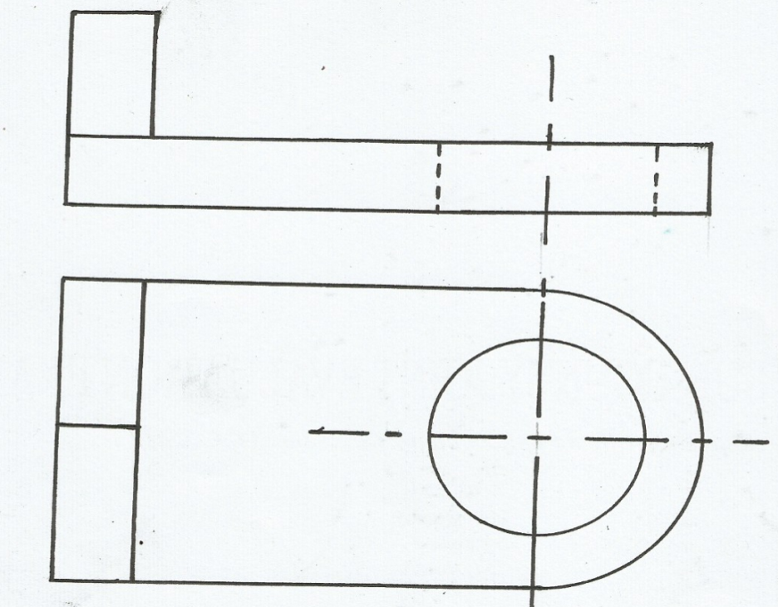

X
Fig 4

6. Sketch free hand exploded pictorial views, for each of the following wood joints: (4marks)
(a) Double mortise and Tenon joint

(b) Stopped housing joint

7. Construct a plain scale of 1:5 to measure to accuracy of 10mm and to maximum length of 600mm. Shows a reading of 380mm.

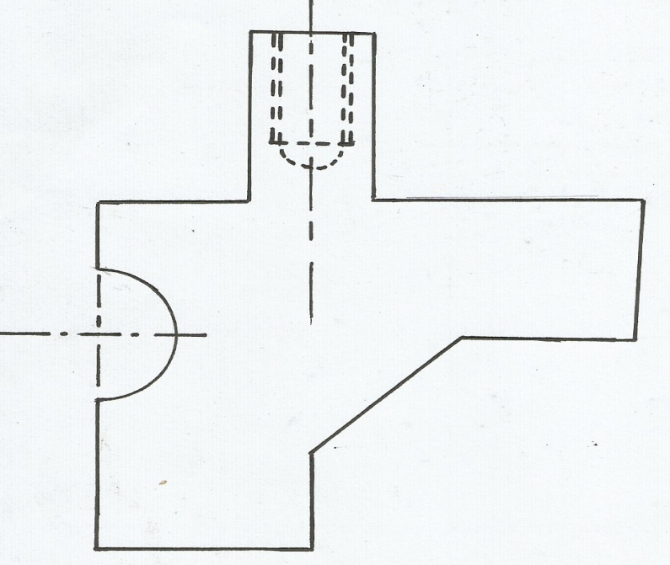
8. (a) Figure 5 shows a plan of a machine parts drawn to a scale twice full size. Measure and dimension correctly the arc, tapped hole and bevel. (5marks)
Fig 5.

(b) Draw an oblique square based pyramid whose vertical height is equal to the base length. Retain the construction lines (3marks)

- A right square pyramid is truncated along X-X and Y-Y as shown in figure 6.. complete the plan.(3marks)
X
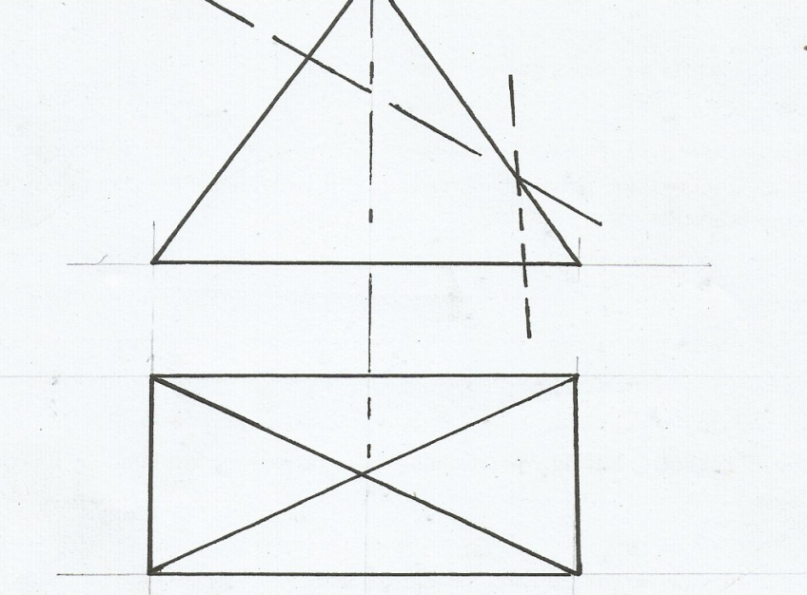
Fig 6
Y

X

Y

- Figure 7 shows two views of shaped block drawn in first angle projection. Sketch the third view by
projecting the given views. (3marks)
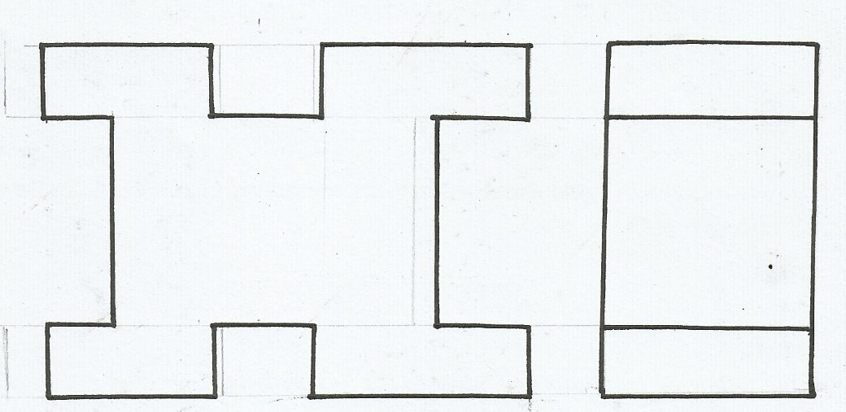
Fig7.

SECTION B (20MARKS)
Question 11 is compulsory. Candidates are advised to spend not more than one hour on this question.
- Figure 8 shows parts of a tool post drawn in the first angle projection. Assemble the parts and draw FULL
SIZE, the following views in third angle projection:
- A sectional front elevation along the cutting plain X-X
- The plan
Insert four leading dimensions and do not show hidden details
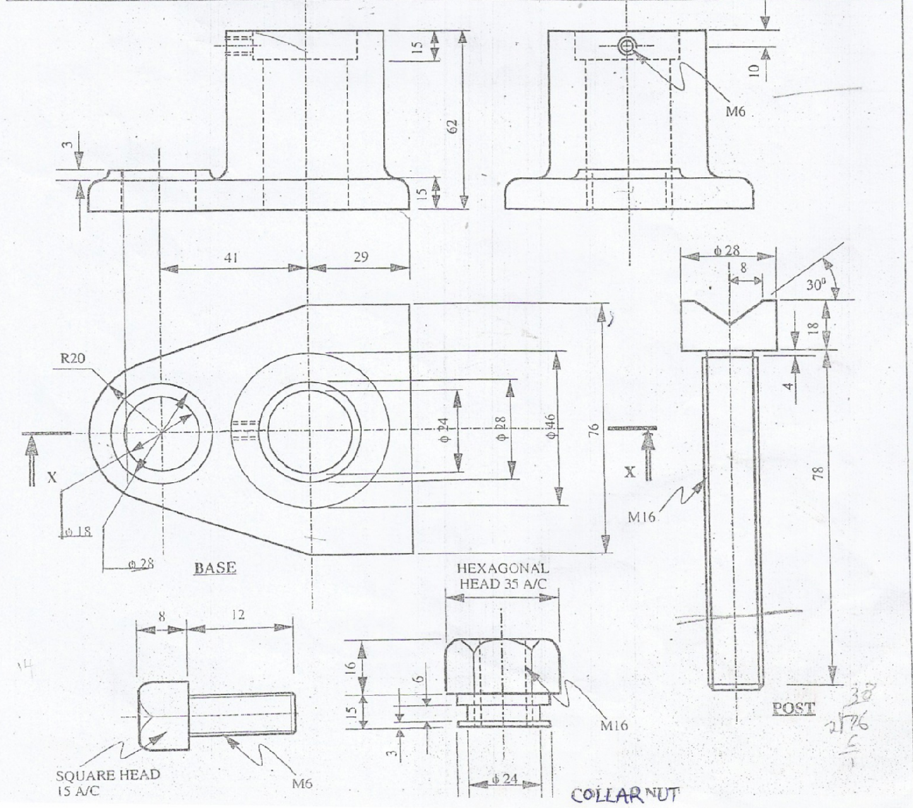

SECTION C (30MARKS)
Answer any two questions from this section.
- Figure 8 show the front elevation and an incomplete plan of a truncated hexagonal prism.
- Copy the views and complete the plan
- Draw the surface development of the prism (15marks)
(omits the flap)
Fig8

- A cylinder has 30mm diameter and a piece of string equal in length to circumference is attached to a point
on the cylinder.
- Draw the path of the free end of the string if it is wound round the cylinder keeping it tight
( take$π=\frac{22}{7}$) (11marks)
- Name the resulting curve (1mark)
- Construct the tangent to the curve

- Figure 9 shows an isomeric view of a block. Draw FULL SIZE in first angle projection.
(a)Front elevation in the direction of arrow E
(b) Sectional end elevation along plane X-X.
(c )Plan
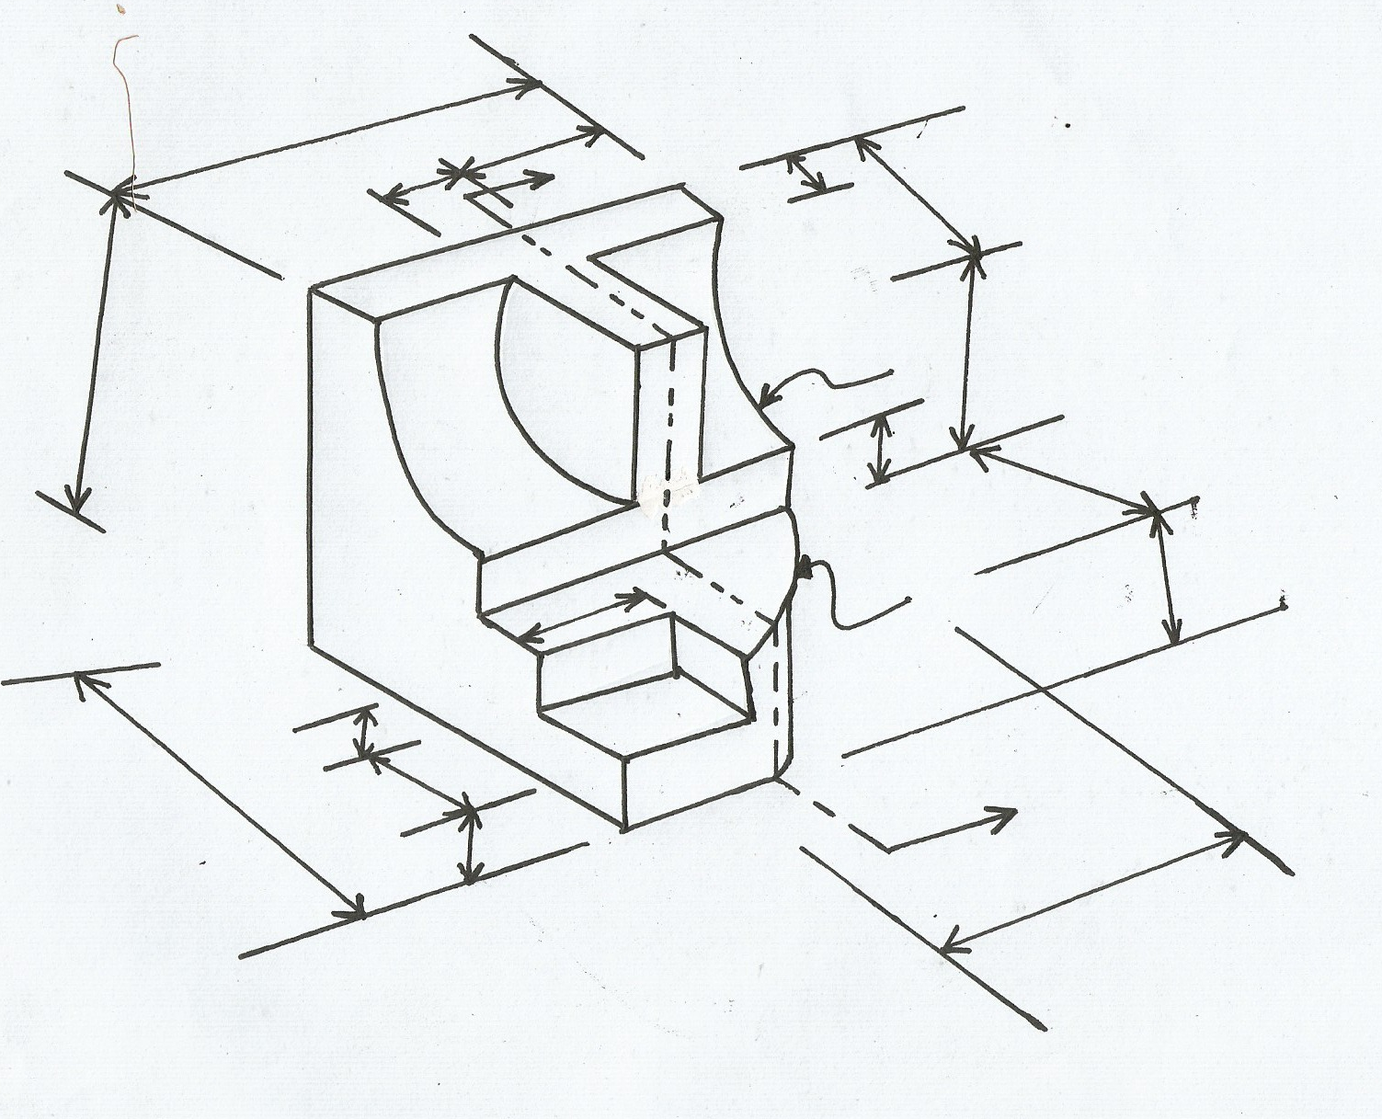
(15mark
X
15
10
34
20
22
40
6
11
6
6
15
12
20
40
40
8
X
R14
R20
34
22
R14
20
6
15
10
40

