Name……………………………………..………………….… Index No:…………………………………………….

School ………………………………………………………. Candidate’s Signature …………..……………………..
448/1 Date: ………………………………………………..
ELECTRICITY
PAPER 1
THEORY

TIME: 2 ½ HOURS

Kenya Certificate of Secondary Education (K.C.S.E.)

448/1
Electricity
Paper 1
2 ½ Hours

INSTRUCTIONS TO CANDIDATES.
- WRITE YOUR NAME AND INDEX No. in the spaces provided.
- Candidate should have the following materials for this examination
Drawing instruments
Mathematical table
- This paper has two section A and B
- Answer all question in section A in the spaces provided and fours question from section B in the spaces after question 15.
- All dimensions are in millimeters unless otherwise started. Candidates should check the question paper to ascertain that all pages are printed and no questions are missing.

Section | Question | Maximum scare | Candidates score
A | 1-10 | 52
B | 11  12  13  14  15 | 12  12  12  12  12
 |  | 100

SECTION A (52 MARKS)
Answer all question in this section

1. (a) List four documents that you would carry while attending an employment interview (2marks)
………………………………………………….……………………………………………………………
..…………………………………………………………..…………………………………………………
………………………………………………………………………………………………………………
..………………………………………………………….…………………………………………………
(b)State the danger posed by each of the following (2marks)
- Exposed electrical fittings…………………………………………………………………………
…………………………………………………………………………………………………….
- Plastic conduits stored under excessive sun heat…………………………………………………
…………………………………………………………………………………………………..
(c) An alternator has twelve poles and generates voltage at 60 Hz. Calculate the speed of the machine.
(2marks)

2. (a) List four factors that determine the inductance of a coil (2marks)
………………………………………………….……………………………………………………………
..…………………………………………………………..…………………………………………………
………………………………………………………………………………………………………………
..………………………………………………………….…………………………………………………
(b) A full scale voltage drops across a 5MA is 50MV. Determine the value of the shunt resistance to
increase the range to 2A ammeter (2marks)

(c) State any four characteristics of magnetic lines of force. (2marks)
………………………………………………….……………………………………………………………
..…………………………………………………………..…………………………………………………
………………………………………………………………………………………………………………
..………………………………………………………….…………………………………………………
3. (a) Explain the purpose of each of the following parts of a d.c generator; (4marks)
(i) Armature windings
………………………………………………………………………………………………………
..……………………………………………………………………………………………………
- Poles
………………………………………………………………………………………………………
..……………………………………………………………………………………………………
- Commutator
………………………………………………………………………………………………………
..……………………………………………………………………………………………………
(b) State four safety precautions to be taken when handling audio and visual music CD’s (2marks)
………………………………………………….……………………………………………………………
..…………………………………………………………..…………………………………………………
………………………………………………………………………………………………………………
..………………………………………………………….…………………………………………………
4. (a) Two capacitors C₁ and C₂ of values 0.02 μF and 0.06μF respectively are connected in series to a 400V source. Calculate the:-
(i) Total charge in the circuit (4mark)

(ii) Energy stored in the 0.06 μF capacitor

(b) Sketch the standard schematic symbol for each of the following: (4marks)
(i)PNP transistor

(ii)Dimmer switch

(iii) Telephone call point

(iv)Zener diode

5. (a) Sketch and labelled the schematic diagram of a d.c shunt motor connected to a supply. (3marks)

(b) A moving c oil galvanometer of resistance 10Ω requires a current of 100mA for full scale deflection. A
resistor is connected to convert the galvanometer to 2A ammeter. Sketch a diagram to show how the
resistor is connected and calculate the value of the resistor. (3marks)

6. (a) State recommended cable size for each of the follow final –sub –circuits in a domestic installation. (1 ½ marks)
(i) Lighting circuit…………………………………………………………………………………………
(ii) Water heater circuit……………………………………………………………………………………
(iii) 13A ring socket circuit…………………………………………………………………………………
(b) State the meaning of each of the following (1 ½ marks)
(i)P.V.C……………………………………………………………………………………………………
(ii)E.C.C……………………………………………………………………………………………………
(iii)C.C.U……………………………………………………………………………………………………
7. (a) Draw a circuit diagram to show the forward and reverse bias condition of a PN junction diode. (2marks)

(b) List three equipments which belong to each of the following at the consumer intake point (3marks)
(i)Power Company
………………………………………………………………………………………………………
..………………………………………………………………………………………………………
………………………………………………………………………………………………………
(ii) Consumer
………………………………………………………………………………………………………
..………………………………………………………………………………………………………
………………………………………………………………………………………………………
8. (a) A transformer delivers 5KW of power to load. If the copper losses are 120 watts and the iron losses are 70awatts, determine the transformer efficiency. (3marks)

(b) State one disadvantage of an auto transformer over a double wound transformer.
..…………………………………………………………..…………………………………………………
………………………………………………………………………………………………………………
..………………………………………………………….…………………………………………………
9. Table 1 shows electrical quantities; their units’ and instrument are used to measure each quantity. Copy and
complete the table.

 | Quantity | Units | Instrument
(a) | Voltage
(b) |  | Watts
(c ) |  |  | ammeter
(d) |  | Farad

SECTION B (48 MARKS)
Answer any four questions from this section

10. (a) State the minimum and maximum value of a resistor with the following colour codes: (3marks)
Orange, green, red, silver
………………………………………………….……………………………………………………………
..…………………………………………………………..…………………………………………………
………………………………………………………………………………………………………………
..………………………………………………………….…………………………………………………
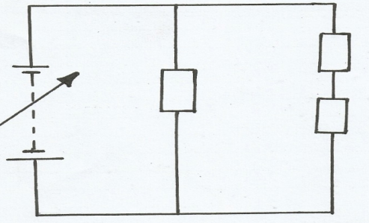
(b) Figure 1 show a series –parallel circuit. Determine the:- (6marks)
R1 12kΩ
R2=6kΩ

R3 = 4kΩ

90V

(i) Current thought R1

(ii) Voltage across R2

(iii) Total circuit resistance

(c) With aid of a diagram show how three 50Ὠ resistance and two 100Ω resistances are connected to give a
equivalent resistance of 200Ω

11.Figure 2 shows an isometric view of a wooden block sketch in first angle projection the front elevation in the direction of arrow F, front elevation in the direction of arrow E and plan P (4marks)
P
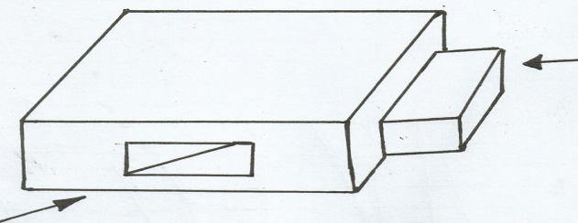
E
F

12. (a) Explain the meaning of each of the following transistors ratios. (2marks)
(i) D.C alpha……………………………………………………………………………………………
(ii) a.c beta………………………………………………………………………………………………
(b) State the difference in construction between power transistor and general purpose transistors (2marks)
………………………………………………….……………………………………………………………
..…………………………………………………………..…………………………………………………
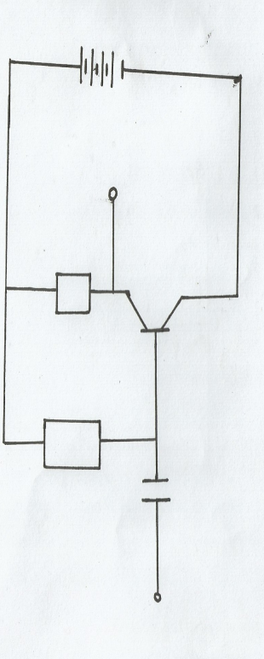
(c ) Explain the term “Zener Voltage” (2marks)
………………………………………………….……………………………………………………………
..…………………………………………………………..…………………………………………………
(d)The figure 3 shows an amplified circuit whose current gain is 200.
RB
RC VCC=20V
VCE

If VCE=10v, VBE= 0.7v and 1c=10mA, calculate the value of:-
- RB

- RC

(e) List four methods used in producing electricity (2marks)
………………………………………………….……………………………………………………………
..…………………………………………………………..…………………………………………………
………………………………………………………………………………………………………………
..………………………………………………………….…………………………………………………
(f ) Name one generating plant where each of the methods in (b) is used in Kenya. (2marks)
………………………………………………….……………………………………………………………
..…………………………………………………………..…………………………………………………
………………………………………………………………………………………………………………
..………………………………………………………….…………………………………………………
13. (a) An electric pressing iron gets very hot when the temperature control knobs is at any position:-
(i) State three possible causes of the problem. (3marks)
..………………………………………………………………………………………………………
………………………………………………………………………………………………………
..………………………………………………………………………………………………………
(ii) List four sequential steps that would be taken to identify the fault. (2marks)
..………………………………………………………………………………………………………
………………………………………………………………………………………………………
..………………………………………………………………………………………………………
………………………………………………………………………………………………………
(b) Give two reasons why aluminum is preferred to copper for overhead power line cable (2marks)
………………………………………………….……………………………………………………………
..…………………………………………………………..…………………………………………………
………………………………………………………………………………………………………………
(c ) Explain why electric power is transmitted at high voltage. (1mark)
………………………………………………….……………………………………………………………
..…………………………………………………………..…………………………………………………
(d) Calculate the number of poles in an alternator which generates 60Hz at a speed of 300rev/min (3marks)

(e) Name two types of rotors used in revolving field alternators (1mark)
………………………………………………….……………………………………………………………
..…………………………………………………………..…………………………………………………
14.(a) Explain the term ideal transformer (2marks)
………………………………………………….……………………………………………………………

..…………………………………………………………..…………………………………………………
………………………………………………………………………………………………………………
..………………………………………………………….…………………………………………………
(b)Draw a labelled line diagram showing all the parts of a consumer intake point. (3marks)

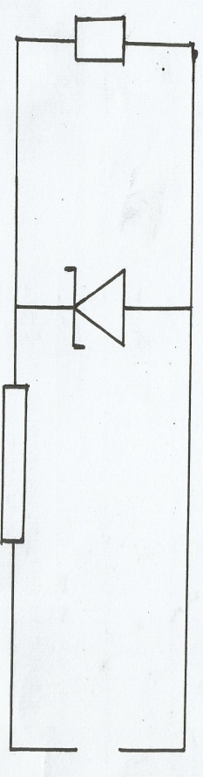
(c) Determine the value of resistance R_{s} in figure 4 when the Zener current is 20mA and the load current is 80mA (3marks)
Rs

V=20V VZ 10V RL

15. (a)State three characteristics of a RLC series resonance (3marks)
………………………………………………….……………………………………………………………
..…………………………………………………………..…………………………………………………
………………………………………………………………………………………………………………
..………………………………………………………….…………………………………………………
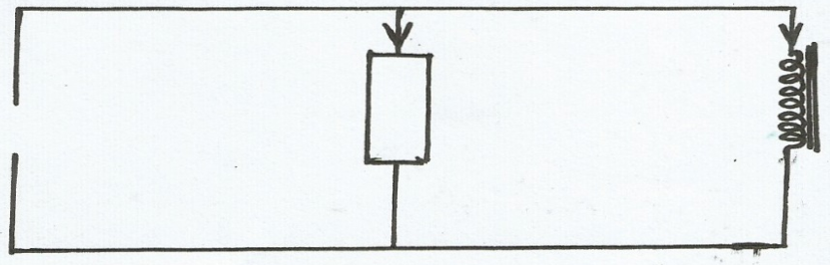
(b) Figure 5 shows p.a parallel circuit.

1R 1L

240V 25Ω 0.04H
50Hz

(i)Determine the value of IR and IL (3marks)

(ii) Determine the impendence of the circuit. (3marks)

(c) State the space factor for the following wiring systems. (1 ½ marks)
(i) Conduit……………………………………………………………………………………………….……
..………………………………………………………….…………………………………………………
(ii) Trunking……………………………………………………………………………………………………
..………………………………………………………….…………………………………………………
(iii)Ducting……………………………………………………………………………….…………………….
..………………………………………………………….…………………………………………………

(d) Define the following terms (1½ marks)
(i) Current rating………………………………………………………………………………………………
..………………………………………………………….…………………………………………………
(ii) Fusing current……………………………………………………………………………………………..
..………………………………………………………….…………………………………………………
(iii) Fusing factor……………………………………………..………………………………………………
..………………………………………………………….…………………………………………………

