Name……………………………………..………………….…Index No:…………………………………………….

School ………………………………………………………. Candidate’s Signature …………..……………………..
448/2 Date: ………………………………………………..
ELECTRICITY
PAPER 2
PRACTICAL

TIME: 2 ½ HOURS

Kenya Certificate of Secondary Education (K.C.S.E.)

448/2
Electricity
Paper 2
2 ½ Hours

INSTRUCTIONS TO CANDIDATES.
- There are five exercises in this paper
- Candidates are allowed 30 minutes for each exercise
- Each exercise will be awarded a maximum of 20marks
- Attempt al the five questions as directed by the examiner
All dimensions are in millimeters unless otherwise started. Candidates should check the question papers to ascertain hat all pages are printed and no question are.

For examiners use only:
Exercise | 1 | 2 | 3 | 4 | 5 | Total
Marks(EC)
Marks (MC)

Total score

EXERCISE 1
- Using materials, components and equipments provided, perform the following task.
- Connect the circuit shown in fig1, let the examiner check your work. (3marks)
K
R1
Potentiometer
6V
S
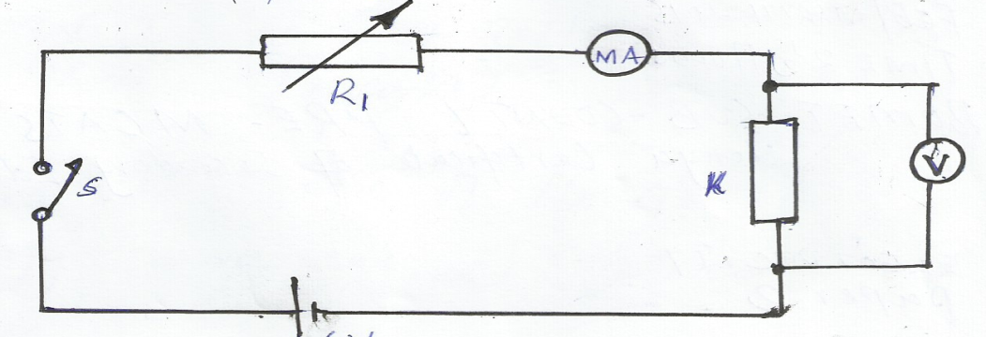Figure 1
- Close the switch S
- Adjust the potentiometer for the ammeter to obtain current values in table1 and in each case record the corresponding voltage values. (7 ½ marks)
Table1
Current (I) | 40 | 100 | 200 | 240 | 260
Voltage (V)
$$V/I$$
- Calculate the values of $V/I$ and record them in the spaces provided in the table
- Use the value in the table to draw a graph of voltage against current (5 ½ marks)
- Determine the slope of the graph (2marks)
- From the graph determine the voltage when the current is I=160mA (1mark)
- State the purpose of the experiment (4marks)

EXERCISE 2
- Use the tools and materials provided to make the bracket show in the figure 2. (20marks)
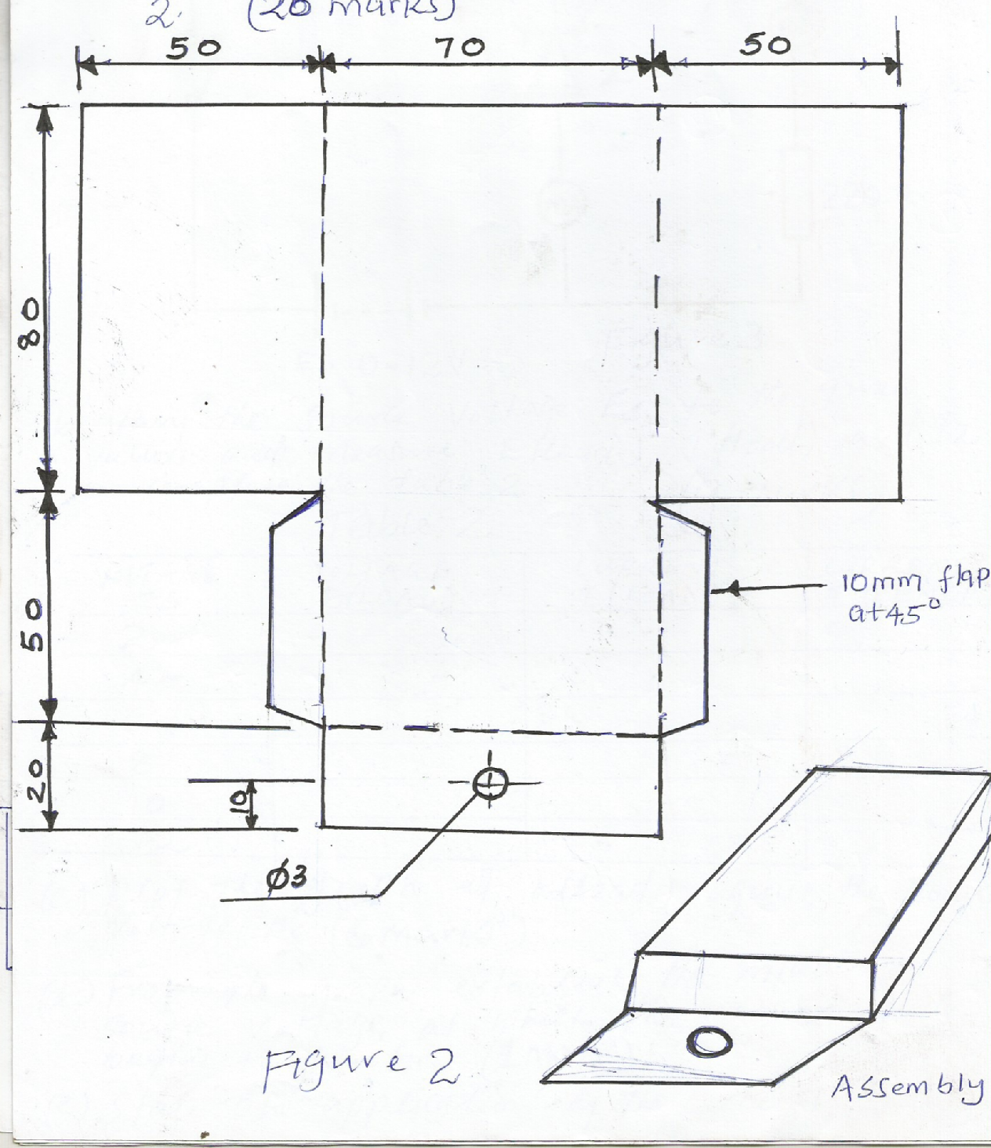
Figure 2
Assembly
10mm flap at 45⁰

EXERCISE 3
- (a) Use the component and equipment provided to connect the circuit in figure 3. (3marks)
Z
47Ω

220Ω
Es 0-12V
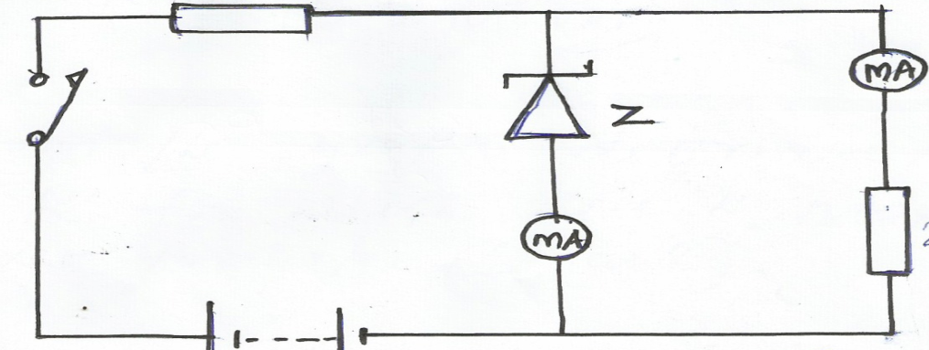

Figure 3
(b) Vary the source voltage ES to the given values and measures E (load), and IZ to complete the table 2.
Table 2 (9marks)
Voltage ES | Voltage E (load) | Current load I (load) | Current I (zener)
2
4
6
8
10
12

(c) Plot the graph of E (load ) against the source voltage ES (6marks)

(d) From the graph establish the minimum source voltage at which the zener diode begins to function (1mark)
(e) State one application of the circuit (1mark)

EXERCISE 4

- Fig 4 shows a block diagram of the electronic circuit provided (K)
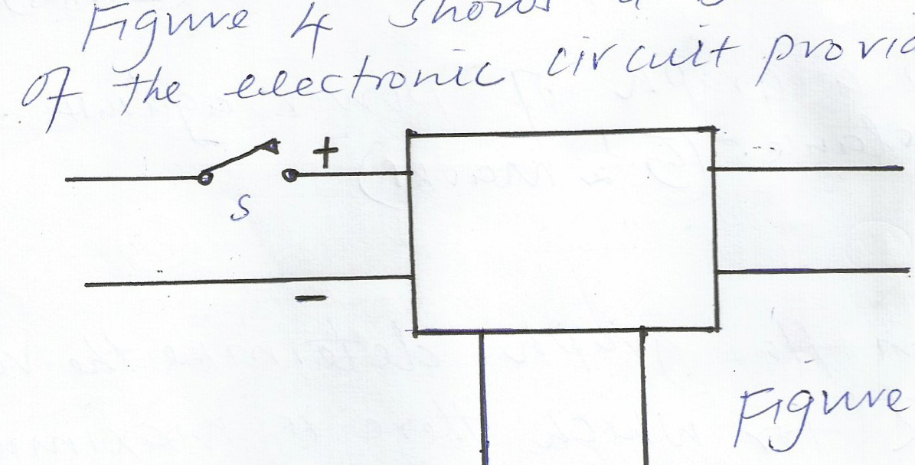

S
A B
X

Y

Figure 4
Perform the following task:
- With the switch S open, connect the circuit to D.C power source. Let the examiner check your work
(1mark)
(b) Set the potentiometer to 0Ω as measured with the ohmmeter. Select a value of resistor shown in the
table 3 and in each case do the following:
(i) Connect each resistor between terminals A and B (2 ½ marks)
(ii) Close the switch, measure the voltage and record in the table 3. (5marks)
Resistors Ω | VR | P=VR ²/_{R}
56
220
470
680
1000

(iii) Calculate the power dissipated by each resistor and complete the table. (5marks)

(iv) Draw a graph of power against resistance (5 ½ marks)

(v) From the graph determine the value of R which there is maximum power transfer (1mark)

EXERCISE 5
- Use the components and equipments to connect the circuit illustrated in figure 5. Let the examiner see your work. (2 ½ marks)
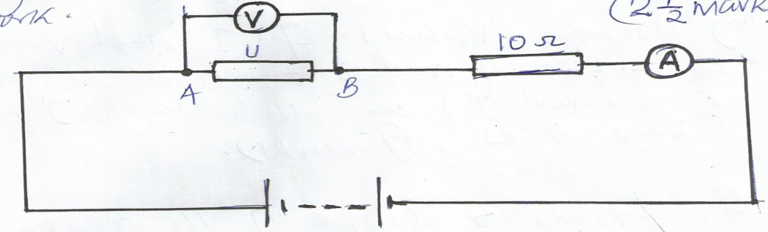

10Ω
0 – 12V
A
B

Perform the following tasks
- Switch on the power supply
- Adjust the power supply to obtain each of the voltage values across (U) as shown in the table 4 and in each case, record the corresponding current. (5marks)

V | 0.2 | 0.4 | 0.5 | 0.6 | 0.7 | 0.8 | 0.9 | 1.0
I

- Switch off the power and reverse the connection of U
- Adjust the power supply to obtain each of the voltage across U as shown in table 5 and in each case record the corresponding current (5marks)
- Use the values of I and V from the tables 4 and 5 to draw the graph of current (I) against voltage (v) on the same axes (7marks)
- From the share of the graph identify components U (¹/₂ mark)

