FRENCH
Paper 1
2 ¾ hours

INTRODUCTIONS
- Write your name and your index number in the spaces above
- Sign and write the date of examination in the space provided above
- This paper consists of three section I, II and II
- In section I you have five minutes to read through the questions before the test starts. Before answering the questions you will listen to several recorded passages on a tape. For each passage you will answer questions as indicated to you on tape.
- In section II you will listen to recorded materials once and start writing during the second listening.
- In section III, choose one composition from question I and from question 2
- Answer al question in spaces provided
- This paper consists of 7 printed pages.
- Candidates should check the question paper to ascertain that all pages are printed as indicated and that no question is missing.
For examiner’s use only.

Section | Maximum score | Candidates’ score
I | 15
II | 05
III | 25

Total score
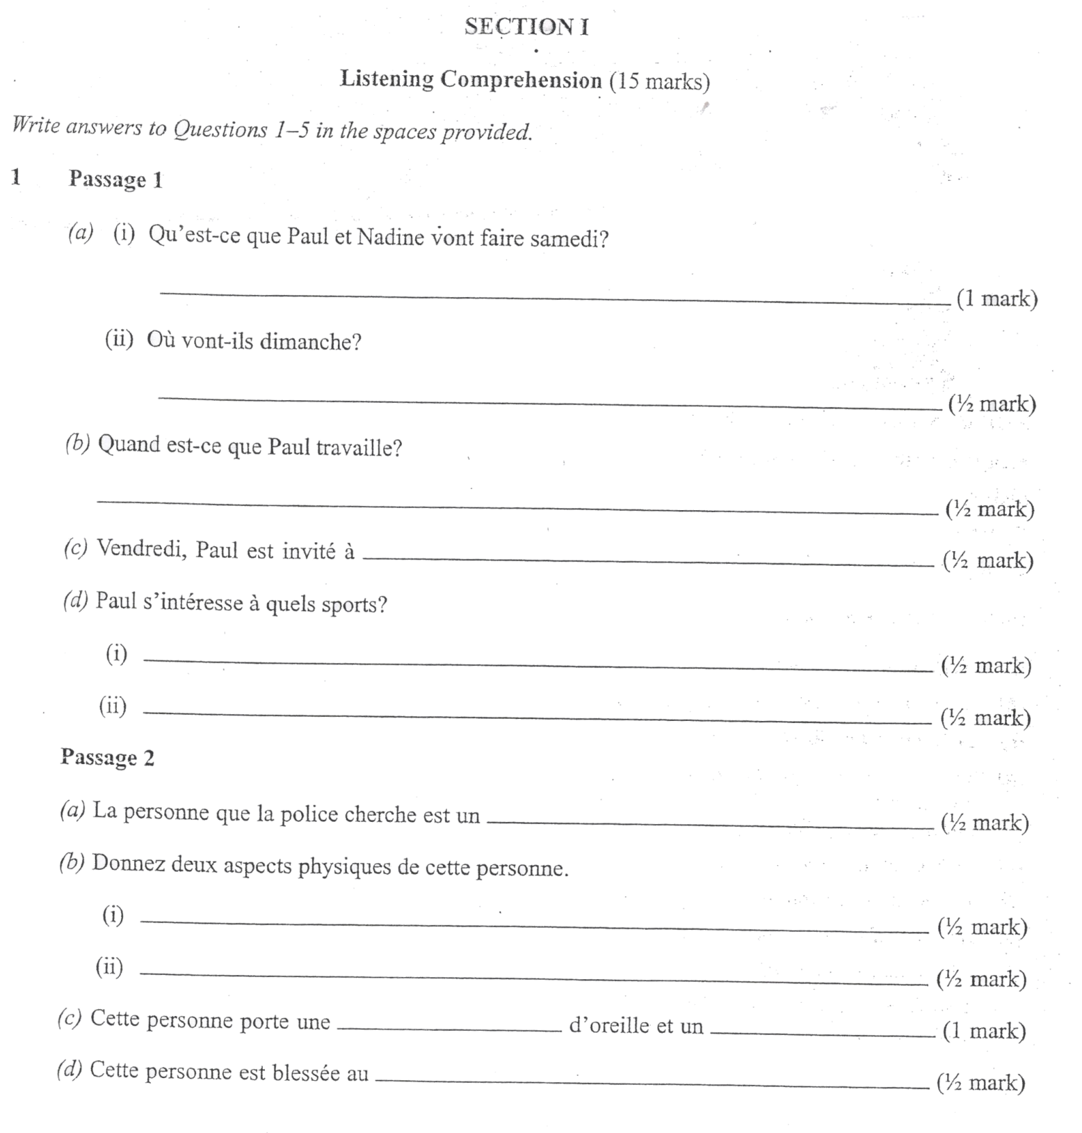

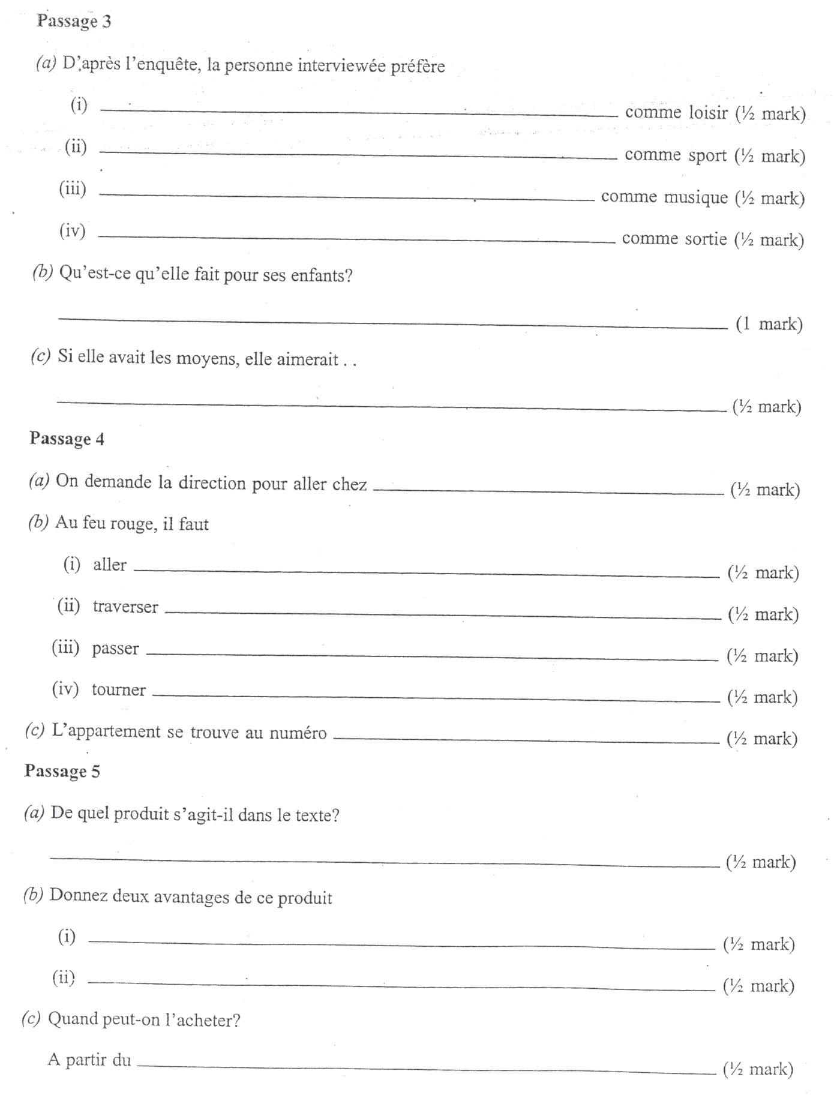

COMPOSITION
Write your two compositions in the pages provided.
- In 120-150 words write in French.

Either
- vous passez vos vacannes chez votre tante et vous avez beaucoup de problems avec sa famille.
Ecrivez une lettre a votre pere pour lui expliqur votre situation.

OR
- vous estes a L’hopital après un accident de route. Ecrivez une lettre a votre ami senegalais(e)
pour Lui Parler de votre experience.

- Write in French a composition of 150-180 words on

Either
- L’annee derniere, vous etes arrive(s) dans une ouun village pour la premiere fois.
Quelles ont ete vos impressions?

OR
- Begins us follows.
J’ai commence L’ecole primaire

