312/2
GEOGRAPHY
PAPER 2
TIME: 2 ¾ HOURS

MACHAKOS COUNTY KCSE TRIAL AND PRACTICE EXAM 2015

Kenya Certificate of Secondary Education (K.C.SE)

312/2
GEOGRAPHY
PAPER 2
TIME: 2 ¾ HOURS

INSTRUCTIONS TO CANDIDATES:
- This paper has two sections A and B
- Answer All questions in Section
- In section B answer question 6 and any other two questions.
- All answers must be written in the answer booklet provided.
- Candidates should answer the questions in English
- This paper consists of 3 printed pages. Candidates should check to ascertain that all pages are printed as indicated and that no questions are missing.

A special Performance Improvement Project
By His Excellency Dr. Alfred Mutua
Sponsored by the County Government of Machakos

SECTION A: (25 Marks)
Answer all the questions in this section (a)

- Use the map of Lake Victoria below to answer question (a)
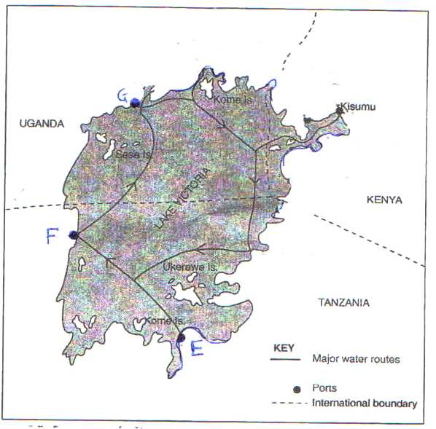

(a) Name the lake ports marked E, F and G. (3 marks)
(b) State two reasons why the use of waterways from Kisumu to other lake ports has tremendously
declined. (2 marks)
2. Give four reasons why the use of solar energy is becoming popular and widespread in Kenya (4 marks)
3. (a) Name two types of underground mining apart from deep shaft mining. (2 marks)
(b) State two problems associated with deep shaft mining. (2 marks)
4. (a) State three reasons why the government encourages Afforestation programmes in the country.
(3 marks)
5. (a) Identify the three main functional zones of an ideal urban centre. (3 marks)
(b) Outline four differences between the functions of Kisumu town and Nairobi City. (4 marks)

SECTION B:
Answer question 6 and any other two questions in these sections.

6. The table below shows the values in terms of billions US Dollars of Kenya’s import and export
between the years 2003 and 2008. Use it to answer question (a) (i) and (ii).

VALUE OF KENYA’S IMPORTS AND EXPORTS
YEARS | VALUE IN BILLIONS US DOLLARS
 | IMPORTS | EXPORTS
2003 | 3.00 | 2.10
2004 | 3.70 | 2.50
2005 | 4.10 | 2.58
2006 | 5.10 | 3.17
2007 | 6.60 | 3.60
2008 | 8.54 | 4.10
TOTAL | 31.04 | 18.05

(a) i) Calculate the balance of payment in the year 2008. (2 marks)
ii) Using a scale of 1 cm to represent 1 billion, draw a simple comparative bar graph based on the
data above. (8 marks)
iii) State four reasons why Kenya’s exports are generally low. (4 marks)
(b) i) List three major imports to Kenya from Japan. (3 marks)
ii) Explain four measures the Kenya government is taking to reduce the unfavourable balance of
trade. (8 marks)
7. (a) i) Name two species of coffee grown in Kenya. (2 marks)
ii) Explain how the following factors favour coffer growing in the central Highlands of Kenya.
  - High Altitude; (2 marks)
  - High Population. (2 marks)
(b) i) Explain three ways in which government promotes coffee growing in Kenya. (6 marks)
ii) Compare coffee growing in Kenya and Brazil under the following.
  - Marketing; (2 marks)
  - Climatic hazards; (2 marks)
(c) Suppose you carried out a field study on a coffee plantation;
i) State three problems facing coffee farmers you are likely to observe during the field study.
(3 marks)
ii) Give two methods you would use to collect data other than observation. (2 marks)
iii) In what two ways will you advice farmers to avert the problems identified in (c) (i) above?
(4 marks)
8. The pyramid below represents the population structure of a developed country. Use it to answer
question (a).
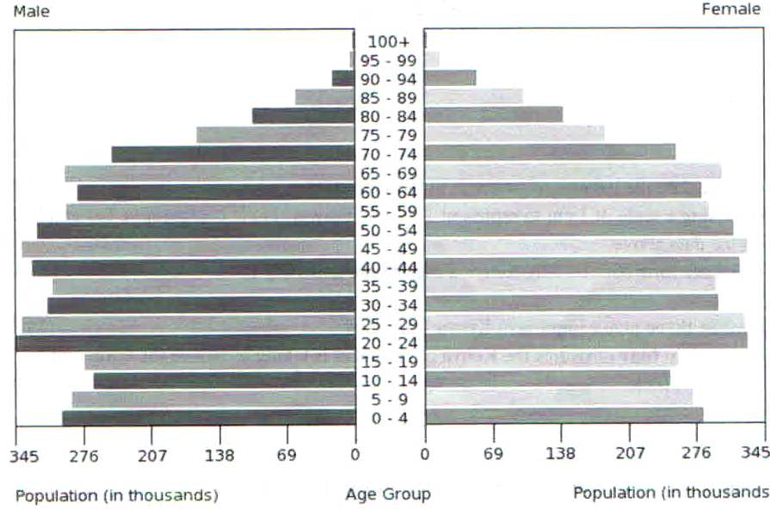

(a) Describe the characteristics of the population represented by the pyramid. (5 marks)
(b) i) Name two documents from where the information above may have been obtained other than
census reports. (2 marks)
ii) State four reasons why it is important for a country to carry out a population census. (4 marks)
(c) Explain four consequences of slow population growth rate to a country. (8 marks)
(d) Explain three economic factors that influence population distribution in East Africa. (6marks)
9. (a) i) What is domestic tourism? (2marks)
ii) State four reasons why the government is encouraging domestic tourism. (4marks)
(b) i) Apart from establishing national parks and game reserves, outline four ways in which wildlife is
being conserved in Kenya. (4 marks)
ii) State three reasons why national parks and game reserves have been established in Kenya.
(3 marks)
(c) Explain three ways in which the Masai Mara game reserves benefits the local Maasai community.
(6marks)
(d) Explain three ways in which the future of tourism can be improved in Kenya. (6 marks)
10. (a) i) What is industrialization ? (2 marks)
ii) State three reasons why some industries consider regular supply of water as the main reason for
their location. (3 marks)
(b) Outline four similarities between Jua Kali industry in Kenya and cottage industry in India.
(4 marks)
(c) Explain three factors that have influenced the location of iron and steel industry in the Ruhr
region of Germany in the 19th century. (6 marks)
(d) You intend to carry out a field study of a heavy manufacturing industry;
i) State three effects of the industry on the environment you are likely to observe. (3 marks)
ii) Design a working programme (schedule) you would use during the day of study. (4 marks)
iii) State three reasons why it is important to prepare a working programme (schedule) for the
study. (3 marks)

