312/1
GEOGRAPHY
PAPER 1.
JULY, 2015
TIME: 2 ¾ Hours
STAREHE GIRLS’ CENTRE
KCSE MOCK EXAMINATION
FORM FOUR
INSTRUCTIONS TO CANDIDATES
- Answer all the questions in section A
- In Section B answer question 6 and any other two questions.
- Answer section A and each question attempted in Section B on a separate answer sheet.
- This paper consists of 4 printed pages.
- Students should check the question paper to ensure that all pages are printed as indicated and that no questions are missing

SECTIONA
Answer ALL the questions in this section.

1 Give two theories that explain the evolution of the solar system. (2marks)
2. ( a) The diagram below shows a wet and dry bulb thermometer.

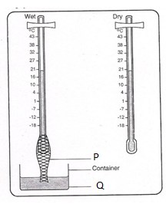

Name the parts marked P and Q (2marks)
(b) Describe how the instrument is used to measure humidity. (3marks)

(c)State three characteristics of Mediterranean climate. (3marks)

3 (a) State two factors that influence the differences in salinity of the ocean (2marks)

(b) Give three characteristics of aria coast. (3marks)

4 (a) Name two types of plate tectonic boundaries (2marks)

(b)State three reasons why it is necessary to study plate tectonics theory. (2marks)

5 State five factors that influence glacial deposition. (5marks)

SECTION B
Answer question 6 and any other TWO questions from this section.

6. Study the map of Migwani1:50000(sheet 151/1) provided and answer the following questions.

(a) (i) Give the six figure grid reference of Itoloni dam (2marks)

(ii) What is the position of Muanzoa outcrop rock using longitudes and latitudes? (2marks)

(b)(i)Measure the distance of the All weather road (bound surface) from Thitani to Migwani shops. (2marks)

(ii) Citing evidence give three types of settlement patterns in the area covered by the map. (3marks)

(c)(i) Using a vertical scale of 1cm to represent40metres, draw across-section along Northing 80 from Easting 04 to Easting 10. (3mark)
On it mark and label the following: (3marks)
- A river.
- Vegetation
- A hill
(ii) Calculate the vertical exaggeration of the cross-section. (2marks)

(d)State three characteristics of the long profile of River Vinda. (3marks)

(e) Describe the relief of the area covered by the map. (5marks)

7 (a) Name three major deserts found on the western coast of continents of the world. (3marks)

(b) (i) State three factors that have influence the action of water in the desert areas. (3 marks)

(ii) Differentiate between pediments and Pedi plains. (3marks)

c) Use the diagram below to answer the questions that follow
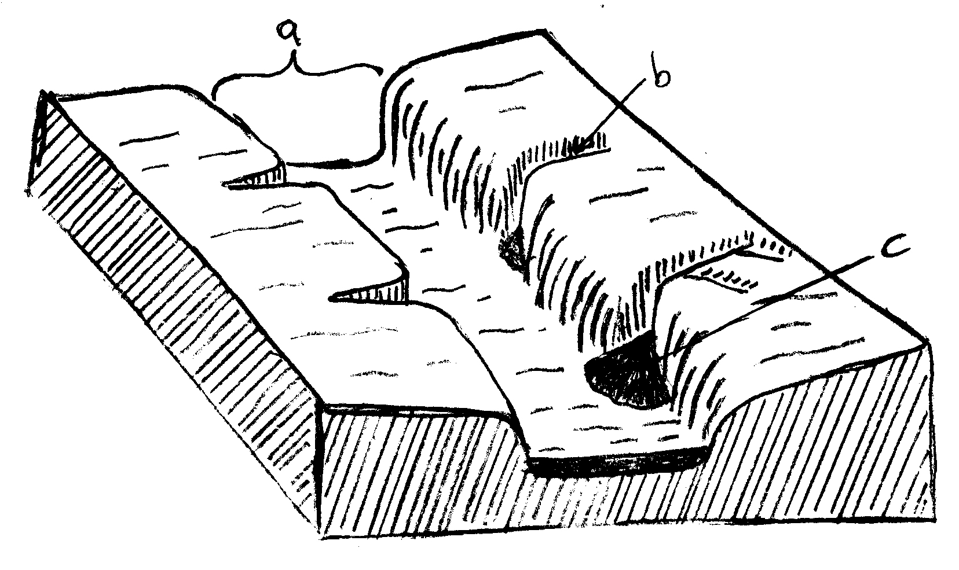

(i)Name the features marked a and b associated with water action in deserts. (2 marks)

(ii)Describe how feature c is formed (4 marks)

(iii)Draw a simple diagram of a barchans labeling all parts. (4 marks)

(d)Explain three ways in which desert features are of significances to human activities. (6marks)

8 (a)(i) What is a fault? (1 mark)

(ii)Apart from the Rift valley name three features resulting from faulting. (3 marks)

( iii) With the aid of diagrams, describe how compression forces may have led to the formation of the Great Rift Valley. (6 marks)

(b)Explain three effects of faulting on drainage of an area. (6 marks)

(c)You are required to carry out a field study on faulted landscape in an area.
( i)State two hypotheses of your study (2 marks)
(ii) State three methods of collecting data you would use. (3 marks)
(iii) Give three follow-up activities you would undertake after the study. (3 marks)

9(a) State three physical characteristics of minerals. (3 marks)

(b) (i)What is a rock? (2 marks)

(ii)Name two examples of intrusive igneous rocks. (2 marks)

(iii)Describe two ways in which metamorphic rocks are formed. (4 marks)

(c)(i) Name two processes of slow mass wasting. (2 marks)

(ii)Explain how the following factors enhance the nature and movement of material down slope.
- Vegetation (2marks)
- The angle of slope (2 marks)
(iii) Describe crystal growth process of weathering (4marks)

(d) State four characteristics of latosol soils. (4 marks)

10. (a) (i) Give three effects of river rejuvenation. (3 marks)
(ii) Differentiate between antecedent and superimposed drainage systems. (4 marks)

(b)With the aid of a diagram, describe the formation river braids. (5 marks)

(c) (i) What is a lake? (2 marks)
(ii) Name two moraine dammed lakes in the world. (2marks)

(d) (i)Using well-labeled diagram, explain how lagoonal lake is formed (5marks)
(ii)Citing examples, state four economic importances of lakes in Kenya. (4marks)

THIS IS THE LAST PRINTED PAGE

