441/2
HOME SCIENCE
CLOTHING CONSTRUCTION
PAPER 2
PRACTICALS

TIME: 2 ½ HOURS

Kenya Certificate of Secondary Education (K.C.S.E.)

441/2
Home Science
Paper 2
2 ½ hours

INSTRUCTIONS TO CANDIDATES
- This paper consists of two printed pages
- Candidates should check the question paper to ascertain that all pages are printed as indicated and that no question is missing.

A pattern of girl’s skirt has been provided. You are advised to study the sketches, instruction and the layout carefully before you begin the test.
MATERIAL PROVIDED.
- Pattern pieces for the girl’s skirt
- Skirt front
- Skirt back
- Front skirt yoke
- Pocket.
- Waist band
- 120cm embroidery thread.
- Plain light weight cotton fabric 50cm long by 95cm wide.
- Sewing thread to match the fabric
- One large envelope.

THE TEST
Using the materials provided, cut out and make the RIGHT HALF of the girl’s skirt to show the following processes.
- Preparation and attachment of the front skirt yoke to the skirt front using overlaid seam. Neaten using overcast stitches (8marks)
- Preparation and attachment of the in seam pocket. Do not neaten the pocket bag. (4marks)
- Join the side seam using open seam. (5marks)
- Preparation and attachment of the interfaced waist band. Slip hem the front skirt and hold the back skirt using long and short tacking. (9marks)
- Work letter ‘S’ using chain stitch. Use embroidery thread only. (4marks)

The Layout Not Drawn To Scale.

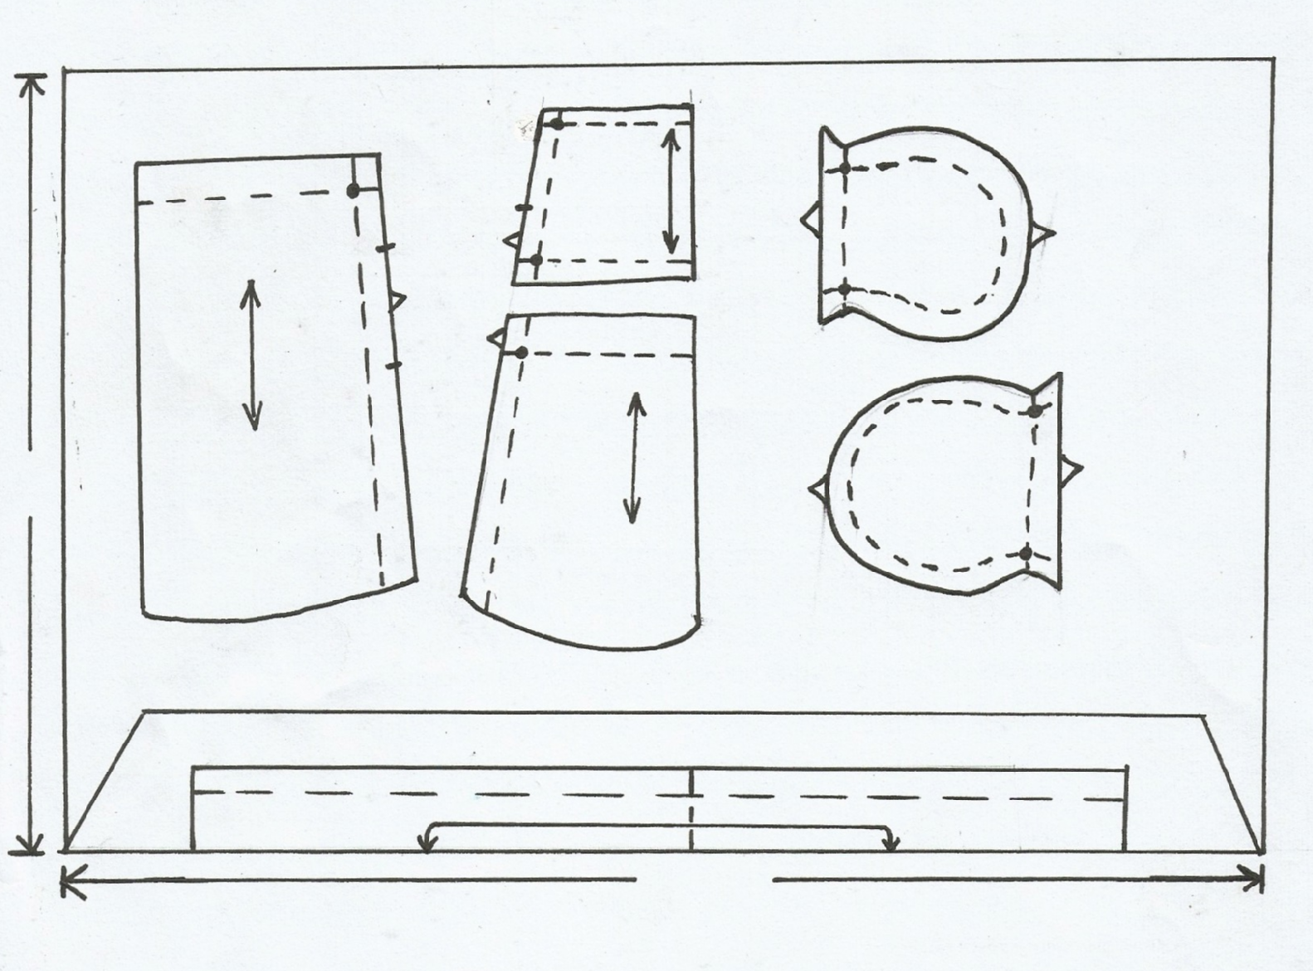
90 cm
50 cm
Selvedge
C
Front skirt
A
Front view

Back D
pocket cut 1
Front D
pocket cut 1
Front skirt
yoke

Back skirt B
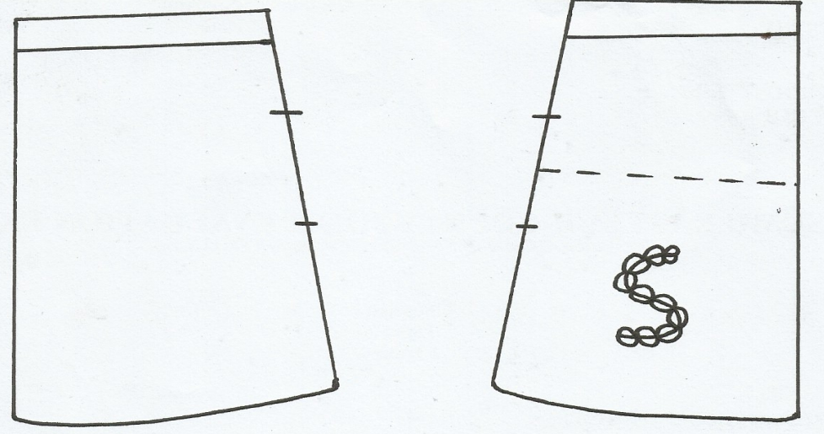
Back view

