Name……………………………………..………………….…Index No:……………………………………………..

School ………………………………………………………. Candidate’s Signature …………..…………………….
Date:……………………………………………………..

MUSIC
PAPER 3

TIME: 2 ½ HOURS

Kenya Certificate of Secondary Education (K.C.S.E.)

511/3
Music
Paper 3
2 ½ Hours

INSTRUCTIONS TO CANDIDATES

- Answer all questions in this paper
- In question 1 choose either (a) or (b)
- In question 4 choose any two of the questions numbered (a) (b) (c ) and (d)

SECTION A BASIC SKILLS
- EITHER (a) continue the following to make a melody of sixteen bars for voice introducing a duplet and syncopation. Modulate to the relative minor and add phrase mark (12marks)
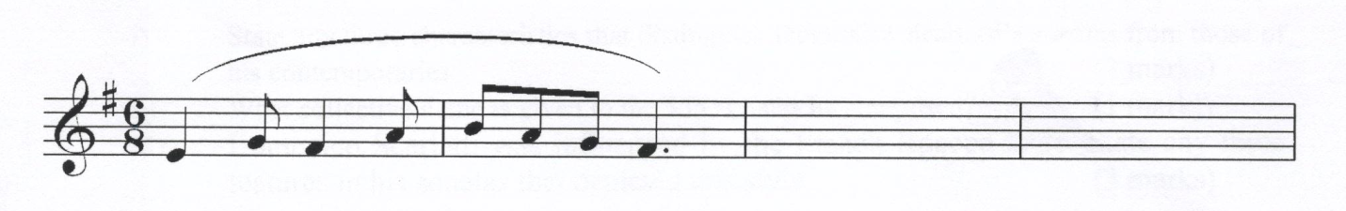OR (b) using staff notations write a tune to suit the following words. Add phrase mark.
Wakati wa kiangazi,mimea hukauka
Inyeshapo mvuanyingi,mashamba huaribika.

- Harmonize the following melody for Soprano, Alto, Tenor and Bass (SATB) choose appreciate chords from I, II, IV, V and VI. Use passing six four chord and
cadential six four. (20marks)
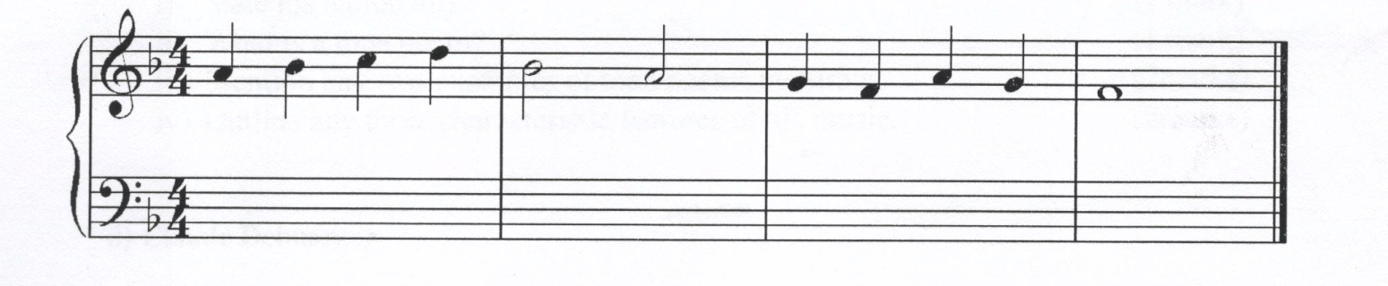HISTORY AND ANALYSIS (48 MARKS)
- AFRICAN MUSIC
- Identify any four factors that may influence traditional music (4marks)
..................................................................................................................................................................
..................................................................................................................................................................
..................................................................................................................................................................
..................................................................................................................................................................
- (i) Name any one occasion in which solo folk songs are used (1mark)
..................................................................................................................................................................
(ii) State two roles of solo folk songs in the occasion you have name d in (i) above. (2marks)
..................................................................................................................................................................
..................................................................................................................................................................
- Distinguish between Adeudeu and Pukan (2marks)
..................................................................................................................................................................
..................................................................................................................................................................
- Identify the roles of melodic idiophones in performance. (2marks)
..................................................................................................................................................................
..................................................................................................................................................................

- Identify community and occasion when the following dances were performed. (4marks)
(i)Enkipaata
..................................................................................................................................................................
..................................................................................................................................................................
(ii)Barabul
..................................................................................................................................................................
..................................................................................................................................................................
(iii)lokilet
..................................................................................................................................................................
..................................................................................................................................................................
(iv)Kibaata
..................................................................................................................................................................
..................................................................................................................................................................
- WESTERN MUSIC
Answer any two of question (a) (b) (c ) and (d)

(a)Domenico Scarlatti
(i) State any three characteristics that distinguish Domenico Scarlatti’s sonatas from those of his
contemporaries (3marks)
..................................................................................................................................................................
..................................................................................................................................................................
..................................................................................................................................................................
(ii) What collective name is given to the 555 sonatas he composed? (1mark)
..................................................................................................................................................................
(iii)Domenico Scarlatti was influenced by the French Rococo style. State any three features in his
sonatas that depicted this style (3marks)
..................................................................................................................................................................
..................................................................................................................................................................
..................................................................................................................................................................
(b)C.P.E Bach
(i) During which period of music did he live (1mark)
..................................................................................................................................................................
(ii) His work can be classified into two styles, state the styles (2marks)
..................................................................................................................................................................
..................................................................................................................................................................
(iii) Outline four contributions to music that he made (4marks)
..................................................................................................................................................................
..................................................................................................................................................................
..................................................................................................................................................................
..................................................................................................................................................................

(c )Richard Straus
(i)State his nationality (1mark)
..................................................................................................................................................................
(ii) What is a tone poem (1mark)
..................................................................................................................................................................
(iii) Mention any two examples of tone poem by Straus. (2marks)
..................................................................................................................................................................
..................................................................................................................................................................
(iv) Outline any three characteristics features of his music. (2marks)
..................................................................................................................................................................
..................................................................................................................................................................
(d)Claude Debussy
(i) Name his nationality. (1mark)
..................................................................................................................................................................
(ii) Outline two characteristics Of Debussy’s music (2marks)
..................................................................................................................................................................
..................................................................................................................................................................
(iii) Classify the following works by Claude Debussy.
Pelleas et malisande
Syrinx flute
Prelude to the afternoon of a Faun
The Prodical song
Jeaux Moonlight
(iv) Which revolutionary aspect did Debussy use to treat his Harmony (1mark)
..................................................................................................................................................................
- PRESCRIBED AFRICAN MUSIC:
Nyatiti by ogwang lelo.
- With reference to recording; name and classify the instrument used. (1mark)
............................................................................................................................................................
............................................................................................................................................................
- State and briefly explain any three characteristics of African music that featured in the recording. (3marks)
............................................................................................................................................................
............................................................................................................................................................
.............................................................................................................................................................

- How has variation been created in reference to recording (3marks)
............................................................................................................................................................
........................................................................................................................................................................................................................................................................................................................
- Differentiate between the middle and the final section in terms of the role of the voice. (1mark)
............................................................................................................................................................
- PRISCRIBED WESTERN MUSIC:
Antonio Vilvaldi: Gloria
SECTION C: GENERAL MUSIC KNOWLEDGE (20MARKS)
- (a) What a piano (1mark)
..................................................................................................................................................................

(b) When was the piano invented and by who. (2marks)
..................................................................................................................................................................
..................................................................................................................................................................
(c )Define the following musical terms (5marks)
- Ostinato……………………………………………………………………………………………………………………………
- Composer…………………………………………………………………………………………………………………………
- Ululation…………………………………………………………………………………………………………………………..
- Mass………………………………………………………………………………………………………………………………….
- Polyrythmic………………………………………………………………………………………………………………………
(d) Briefly describe the following musical forms (12marks)
(i) Sonata Form
..................................................................................................................................................................
..................................................................................................................................................................
..................................................................................................................................................................
..................................................................................................................................................................
..................................................................................................................................................................
..................................................................................................................................................................
..................................................................................................................................................................
..................................................................................................................................................................
(ii)Ternary
..................................................................................................................................................................
..................................................................................................................................................................
..................................................................................................................................................................
..................................................................................................................................................................
..................................................................................................................................................................
..................................................................................................................................................................
..................................................................................................................................................................
..................................................................................................................................................................
(iii) Minuet and trio
..................................................................................................................................................................
..................................................................................................................................................................
..................................................................................................................................................................
..................................................................................................................................................................
..................................................................................................................................................................
..................................................................................................................................................................
..................................................................................................................................................................
..................................................................................................................................................................

