Name: ……………………….……………………… Index No: ……………………..……………………….

Candidates signature: ……………..…………….……

Date: ……………………….…………..……………...
449/1
DRAWING AND DESIGN
PAPER 1
TIME 2 ½ Hours.

MACHAKOS COUNTY KCSE TRIAL AND PRACTICE EXAM 2015

Kenya Certificate of Secondary Education (K.C.S.E)

449/1
DRAWING AND DESIGN
PAPER 1

Instructions to candidates
- You should have the following materials for this examination:
Drawing instruments
3 sheets of A3 drawing papers.
Scale rule
- This paper consists of three sections: A, B and C
- Answer all questions in section A and B and any two questions in section C.
- Questions in section A must be answered on the answer sheet provided.
- Questions in section A, B and C should be answered on the A3 sheets of drawing papers.
- All dimensions are in millimeters unless otherwise stated.
- Candidates may be penalized for not following instructions given in this paper.
- This paper consists of 12 printed pages.
- Candidates should check the question paper to ascertain that all the pages are printed as indicated and that no question is missing.
- Candidates should answer the questions in English.

A special Performance Improvement Project
By His Excellency Dr. Alfred Mutua
Sponsored by the County Government of Machakos

SECTION A (50MARKS)
Answer all five questions in this section in the spaces provided

1. a) Give the following information regarding parastatal organizations in Kenya with respect to:
(i) Ownership (1mark)
………………………………………………………………………………………………………………………………………………………………………………………………………………………………………………………………………………………………………………………………………………………………………
(ii) Management. (1mark)
………………………………………………………………………………………………………………………………………………………………………………………………………………………………………………………………………………………………………………………………………………………………………
(iii) Services (1mark)
………………………………………………………………………………………………………………………………………………………………………………………………………………………………………………………………………………………………………………………………………………………………………
b) Describe four main steps involved in design process. (4marks)
………………………………………………………………………………………………………………………………………………………………………………………………………………………………………………………………………………………………………………………………………………………………………………………………………………………………………………………………………………………………………………………………………………………………………………………………………………………………………………………………………………………………………………………………………………
2. a) i) State one reason for using different types of lines in drawing. (1mark)
………………………………………………………………………………………………………………………………………………………………………………………………………………………………………………
ii) Explain one use of each of the following lines. (1mark)

………………………………………………………………………………………………………………………………………………………………………………………………………………………………………………

………………………………………………………………………………………………………………………………………………………………………………………………………………………………………………

b) Outline six advantages of using computers in drawing. (3marks)
………………………………………………………………………………………………………………………………………………………………………………………………………………………………………………………………………………………………………………………………………………………………………
………………………………………………………………………………………………………………………………………………………………………………………………………………………………………………………………………………………………………………………………………………………………………
3. a) State one disadvantage of using each of the following items to hold paper on the drawing board .
(i) Masking tape. (1mark)
………………………………………………………………………………………………………………………………………………………………………………………………………………………………………………………………………………………………………………………………………………………………………
(ii) Thumb pins (1mark)
………………………………………………………………………………………………………………………………………………………………………………………………………………………………………………………………………………………………………………………………………………………………………
b) Describe each of the following manufactured boards.
(i) Plywood (1mark)
………………………………………………………………………………………………………………………………………………………………………………………………………………………………………………………………………………………………………………………………………………………………………
(ii) Chipboard (1mark)
………………………………………………………………………………………………………………………………………………………………………………………………………………………………………………………………………………………………………………………………………………………………………
(iii) Block board (1mark)
………………………………………………………………………………………………………………………………………………………………………………………………………………………………………………………………………………………………………………………………………………………………………

4. Figure 1 shows a template drawn full size.
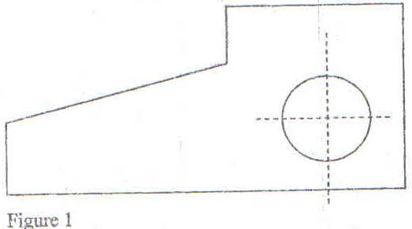

Measure and dimension the hole and angle of the slanting face. (2marks)
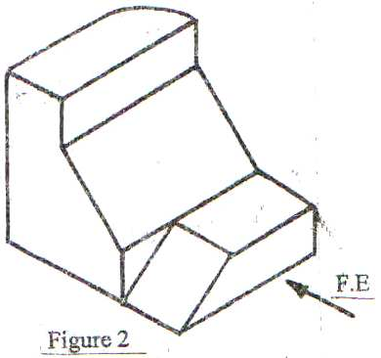
5. Figure 2 shows a pictorial view of a block.

Using third angle projection, sketch in good proportion the orthographic views of the block. (6marks)

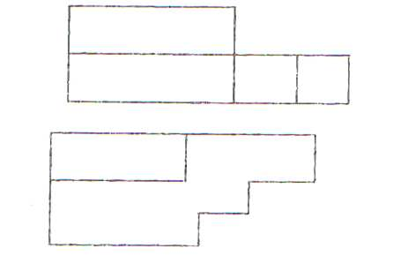
6. Figure 3 shows two views of a block drawn in first angle projection. In good proportionality sketch the block in oblique projection. (6marks)

Figure 3

7. Construct an internal common tangent to the circle given in figure 4.
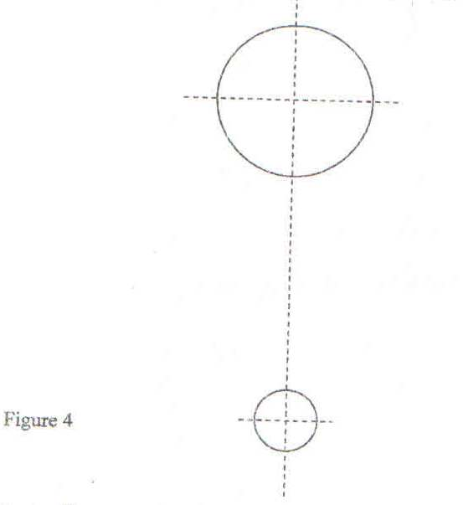

(7marks)

8. The following lines were drawn using different scale.
a) A B
b) C D
Determine the distance represented by each line using the given scale. (3marks)
i) Line AB if the scale used is 1:2
………………………………………………………………………………………………………………………………………………………………………………………………………………………………………………………………………………………………………………………………………………………………………
ii) Line CD if the scale used is 2:1
………………………………………………………………………………………………………………………………………………………………………………………………………………………………………………………………………………………………………………………………………………………………………

9. A right square pyramid is truncated along X-X and Y –Y as shown in figure 5.
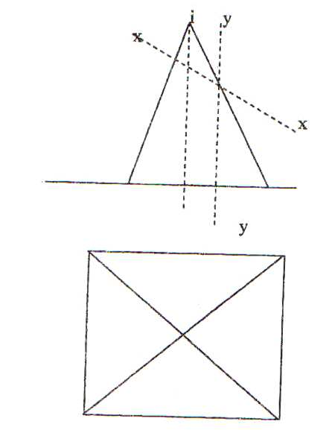

Figure 5
Complete the plan (4marks)

10. Figure 6 shows two views of a shaped block drawn in first angle projection. Sketch the third view by projecting from the given views. (5marks)
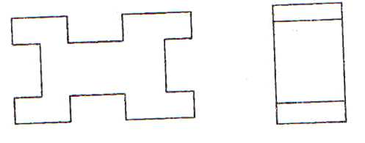

SECTION B (20MARKS)
This question is compulsory.
11. Figure 7 shows parts of a machined component drawn in first angle projection.
Assemble the parts and draw the following:
a) Sectional front elevation through the cutting plane F-F.
b) The plan.
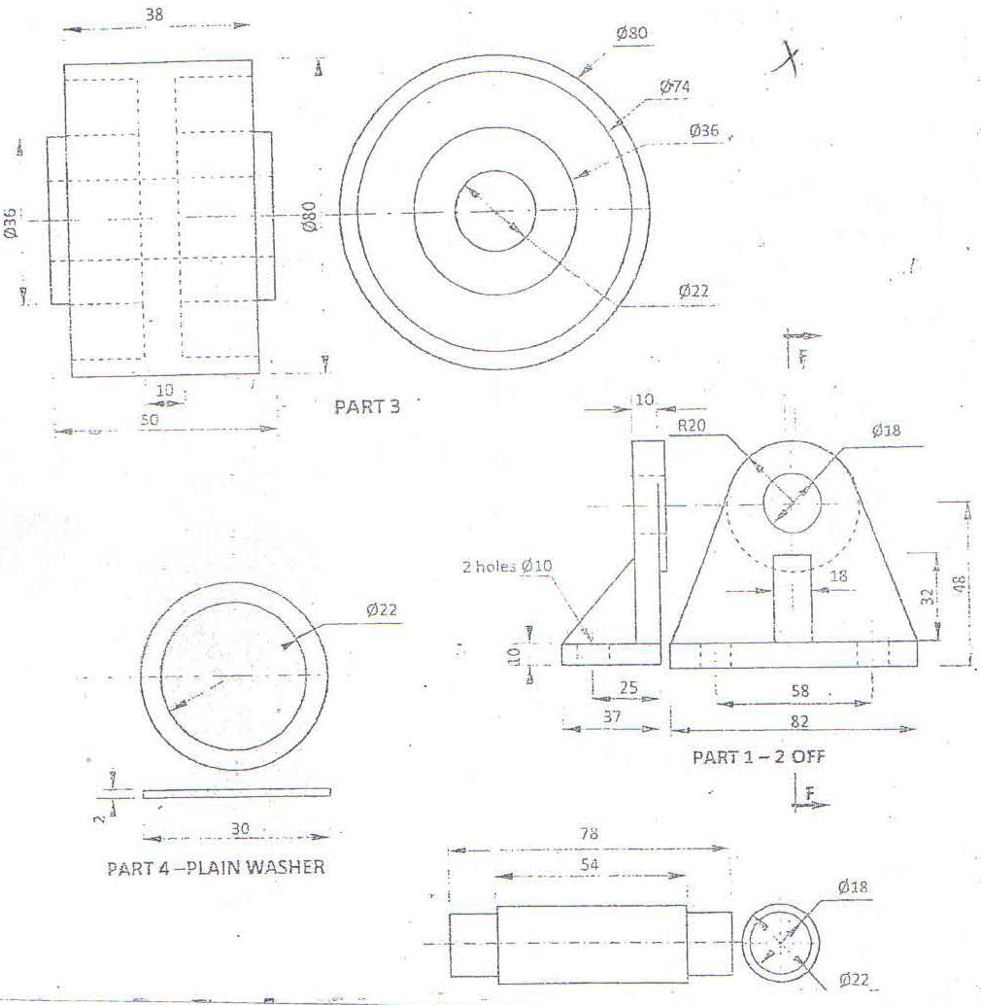

SECTION C (30MKS)
Answer any two questions from this section
12. Figure 8 shows the three orthographic views of a machined block drawn in first angle projection.
Draw full size, the isometric view of the block taking corner X as the lowest point. (15marks)

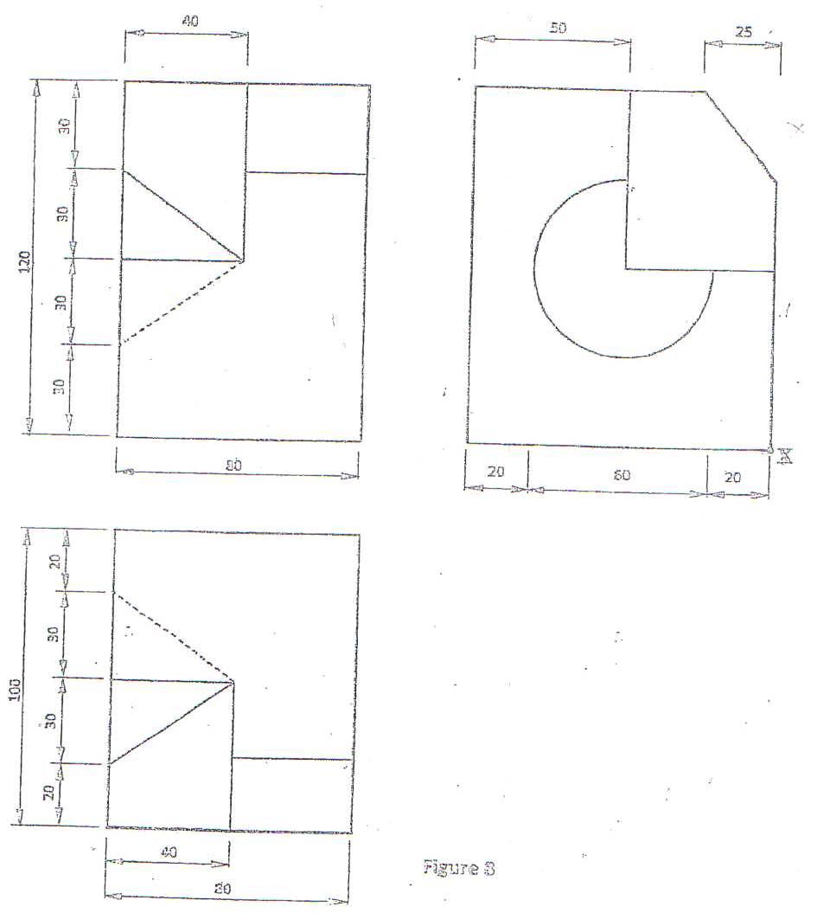
Figure 8
X

13. In the mechanism shown in figure 9, the crank EF rotates about centre E while GH oscillates about G.
Plot the locus of point P for one complete revolution of EF. (15marks)

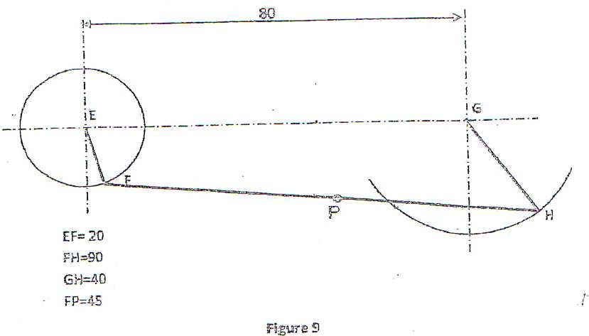

Figure 9

14. Figure 10 shows a branch pipe A connected to a conical shaped base of a chimney B.
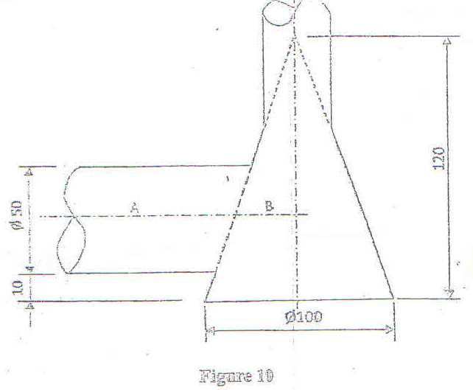

Figure 10

Draw the curves of interpenetration between the pipe and the conical base in:
- Plan
- Elevation (15marks)

