NAME _____________________________________ INDEX NO. _______________

SCHOOL _____________________________________ SIGNATURE _______________
DATE _______________
232/2
PHYSICS
PAPER 2
(THEORY)
JULY/AUGUST, 2015
TIME: 2 HOURS

232/2
PHYSICS
PAPER 2
(THEORY)
TIME: 2 HOURS

INSTRUCTIONS
- Write your name, school, index no, signature and date in the spaces provided above.
- The paper consists of two sections, Section A and B.
- Answer ALL the questions in section A and B in the spaces provided.
- ALL answers and working MUST be clearly shown.
- Mathematical tables and electronic calculators may be used.

FOR EXAMINER’S USE
SECTION | question | maximum score | Candidate’s score
A | 1−12 | 25
B | 13 | 11
 | 14 | 12
 | 15 | 09
 | 16 | 12
 | 17 | 11
 | Total | 80

This paper consists of 12 printed pages
Candidates should check to ensure that all pages are printed as indicated and no questions are missing

SECTION A (25 MARKS)
Answer ALL the questions in this section.
- The figure below shows the image in front of a mirror M.

Figure 1

By ray diagram construction, locate the position of the object. (2 marks)
- A negatively charged rod is brought near the cap of a leaf electroscope. The cap is then earthed momentarily by touching with the finger. Finally the rod is withdrawn. State and explain the observation made. (2 marks)
_________________________________________________________________________________________________________________________________________________________________________________________________________________________________________________________
- A boy observes his face in a concave mirror of focal length 100cm. If the mirror is 80cm away, state one characteristic of the image observed. (1 mark)
______________________________________________________________________________________________________________________________________________________________________
- The coil of an electric motor is usually wound on a soft iron armature. State two purposes by this armature. (2 marks)
_________________________________________________________________________________________________________________________________________________________________________________________________________________________________________________________
- A student stands at a distance 400m from a wall and claps two pieces of wood. After the first clap the student claps whenever an echo is heard from the wall. Another student starts a stopwatch at the first clap and stops it after the twentieth clap. The stopwatch records a time of 50 seconds. Find the speed of sound. (3 marks)
_______________________________________________________________________________________________________________________________________________________________________________________________________________________________________________________________________________________________________________________________________________________________________________________________________________________________
- The figure 2 below shows a displacement time graph for a wave motion.
Figure 2
Displacement (mm)
Time (s)
What is the frequency of the wave? (2 marks)
____________________________________________________________________________________________________________________________________________________________________________________________________________________________________________________________________________________________________________________________________________
- Figure 3 below shows an incomplete circuit diagram for a half-wave rectification of an AC voltage.
Figure 3
- Complete the diagram by inserting a diode at X so that the output terminals are positive and negative as shown. (1 mark)
- On the axis provided below, sketch a graph showing how the output voltage varies with time. (1 mark)
Time (s)
Voltage (V)

Figure 4

- Figure 5 below shows a series of wave fronts one wavelength apart approaching a gap between barriers in ripple tank.

Figure 5

On the same diagram, show what happens when the waves pass through the gap. (1 mark)
- Explain briefly how free electrons are produced in an X-ray tube. (1 mark)
_________________________________________________________________________________________________________________________________________________________________________________________________________________________________________________________
- A bulb is rated 100W, 240V. At what rate would it dissipate energy if it is connected to a 220V supply? (3 marks)
_______________________________________________________________________________________________________________________________________________________________________________________________________________________________________________________________________________________________________________________________________________________________________________________________________________________________
- One method of producing a weak magnet is to hold a steel rod in the North-South direction and then hammer it continuously for some time. Using the domain theory of magnetism, explain how this method works. (2 marks)
________________________________________________________________________________________________________________________________________________________________________________________________________________________________________________________
- Figure 7 below shows a motor connected to a magnetic switch called a relay operated by an ordinary switch S₁. Use the information in the figure to answer the questions that follows.
Figure 7
- Explain how the relay switches on the motor when S₁ is closed. (3 marks)
____________________________________________________________________________________________________________________________________________________________________________________________________________________________________________________________________________________________________________________________________________
- State with a reason the effect on the motor if the iron core is replaced with a steel core and switch S₁is put on and then off. (1 mark)
_________________________________________________________________________________________________________________________________________________________________________________________________________________________________________________________

SECTION B (55 MARKS)
Answer ALL the questions in the spaces provided
- A transformer has 500 turns in both its primary and its secondary coils. It is connected to a 240V mains supply. There are 4 possible connections to the secondary, labelled W, X, Y and Z on the figure below.
Between W and X there are 300 turns
Between X and Y there are 175 turns
Between Y and Z there are 25 turns
- A person wishes to run a 12V electric bell using the transformer. Between which two of the labelled terminals should the bell be connected? (show your working) (3 marks)
____________________________________________________________________________________________________________________________________________________________________________________________________________________________________________________________________________________________________________________________________________________________________________________________________________________________________________________________________________________________________________________________________________________________________________________________________
- State the voltage between terminals W and Z. (1 mark)
______________________________________________________________________________________________________________________________________________________________________
- State the name given to the part labelled P and the material from which it is made. (2 marks)
Name_____________________________________________________________________________
Material __________________________________________________________________________
- Why are the coils normally made of copper wire? (1 mark)
______________________________________________________________________________________________________________________________________________________________________

- An 8kW heater used a total of 1.5 hours a day. Calculate the cost of using this heater for a month of 30 days if the cost of an electrical unit is Ksh. 2.40 (3 marks)
_____________________________________________________________________________________________________________________________________________________________________________________________________________________________________________________________________________________________________________________________________________________________________________________________________________________________________________________________________________________________________________________________________________________________________________________________________
- State one difference between a step up transformer and an induction coil. (1 mark)
_________________________________________________________________________________________________________________________________________________________________________________________________________________________________________________________
- a) The figure below represents a cathode ray oscilloscope (C.R.O)
- Name the parts labelled A and B. (2 marks)
A______________________________________________________________________________
B______________________________________________________________________________
- What are the functions of parts labelled C and D? (2 marks)
C______________________________________________________________________________
D______________________________________________________________________________
- Explain how electrons are produced . (1 mark)
_________________________________________________________________________________________________________________________________________________________________________________________________________________________________________________________
- Give a reason why the tube is evacuated. (1 mark)
______________________________________________________________________________________________________________________________________________________________________

b) The potential between the anode and the cathode of an X-ray tube is 80kv. Calculate;
- The energy of an electron accelerated in the tube. (Electronic charge e = 1.6 x 10⁻¹⁹ C) (3 marks)
__________________________________________________________________________________________________________________________________________________________________________________________________________________________________________________________________________________________________________________________________________________________________________________________________________________________________________________________________________________________________________________
- The velocity of electrons in the tube. (Mass of an electron = 9.11 x 10⁻³¹kg ) (3 marks)
__________________________________________________________________________________________________________________________________________________________________________________________________________________________________________________________________________________________________________________________________________________________________________________________________________________________________________________________________________________________________________________
- a) The figure below shows a ultra-violet light striking a polished zinc plate on a negatively charged gold leaf electroscope.
Explain the following observation.
- The leaf of the electroscope falls. (2 marks)
_________________________________________________________________________________________________________________________________________________________________________________________________________________________________________________________
- When the same experiment was repeated with a positively charged electroscope the leaf did no fall. (2 marks)
_________________________________________________________________________________________________________________________________________________________________________________________________________________________________________________________
b) State one factor which determines the speed of photoelectrons emitted by a metal surface. (1 mark)
______________________________________________________________________________________________________________________________________________________________________

c) The graph below shows the plotting of stopping potential against frequency of radiation directed on a clean metal surface.
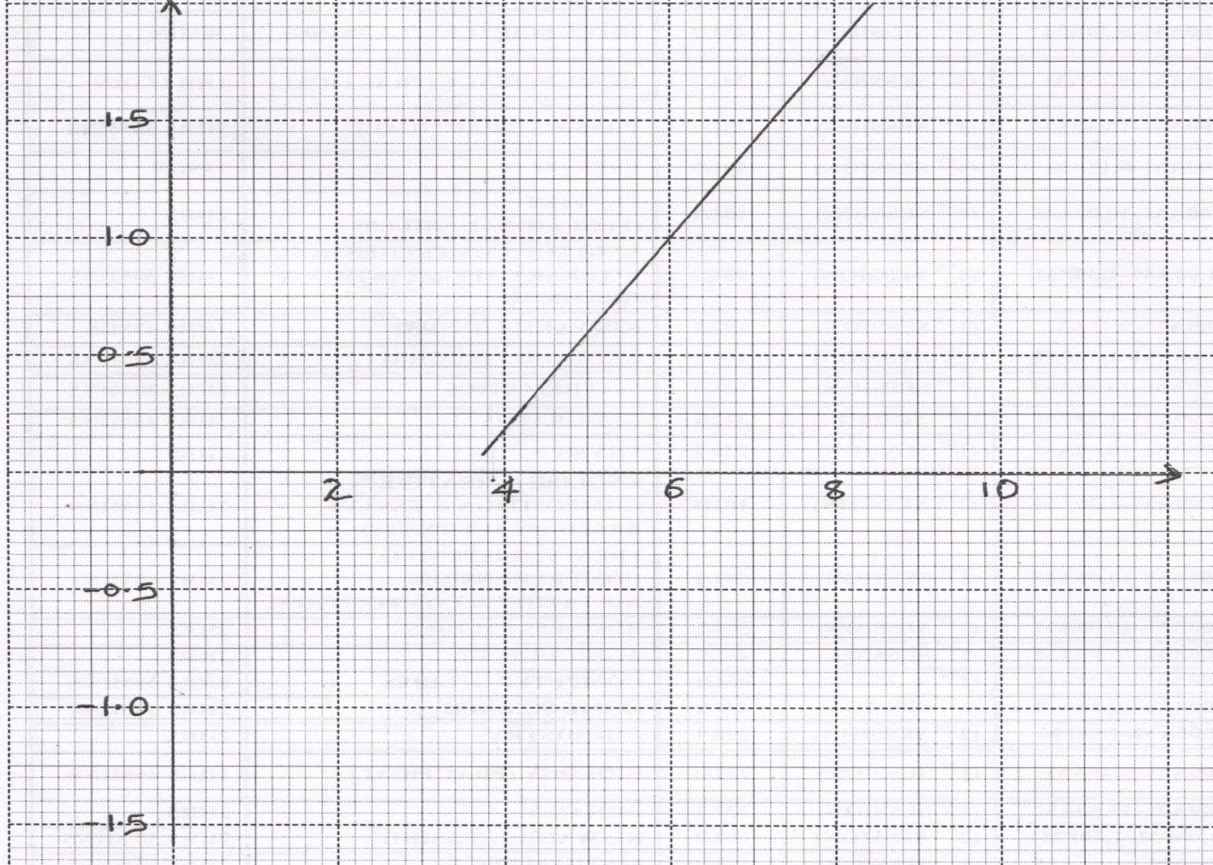
Stopping Potential, V
Frequency ($×$ 10¹⁴Hz)
From the graph determine;
- Threshold frequency of the metal. (2 marks)
_______________________________________________________________________________________________________________________________________________________________________________________________________________________________________________________________________________________________________________________________________________________________________________________________________________________________
- Planks constant (Use e = 1.6 x10⁻¹⁹ C). (2 marks)
__________________________________________________________________________________________________________________________________________________________________________________________________________________________________________________________________________________________________________________________________________________________________________________________________________________________________________________________________________________________________________________

- a) The diagram below shows part of a section of a house wiring system.
- What name is given to the circuit C? (1 mark)
___________________________________________________________________________________
- What name is given to the cables A and B? (2 marks)
______________________________________________________________________________________________________________________________________________________________________
- What name is given to the device labelled S and T? (1 mark)
___________________________________________________________________________________
- State the purpose of the device named in (iii) above. (1 mark)
______________________________________________________________________________________________________________________________________________________________________
- Why is the device S and T connected to B and not A? (1 mark)
______________________________________________________________________________________________________________________________________________________________________
- Why is earthing necessary in some circuits? (1 mark)
______________________________________________________________________________________________________________________________________________________________________
b) The figure below shows the inside of an electric plug wired for use on a 240V, 1kW mains electric heater.
Complete the table below. (5 marks)
 | Name of wire | Colour of insulation
X | Earth
Y
Z

- a) State the conditions necessary for total number of internal reflection to occur. (2 marks)
_________________________________________________________________________________________________________________________________________________________________________________________________________________________________________________________
b) The figure below shows a ray of light incident on the boundary between two media 1 and 2 at an angle θ.
θ
(1)
(2)

Show that the refractive index for a ray of light travelling from medium 1 and medium 2 is given by ŋ = $\frac{1}{\sin{}}$ (3 marks)
__________________________________________________________________________________________________________________________________________________________________________________________________________________________________________________________________________________________________________________________________________________________________________________________________________________________________________________________________________________________________________________
- The figure below shows a ray of light incidence on one face of a block of ice of refractive index 1.31 and totally reflected at the adjacent face.
Φ
x
θ
Determine:
- Angle θ (2 marks)
____________________________________________________________________________________________________________________________________________________________________________________________________________________________________________________________________________________________________________________________________________
- Angle x (2 marks)
____________________________________________________________________________________________________________________________________________________________________________________________________________________________________________________________________________________________________________________________________________
- Angle θ, the greatest angle for which the total internal reflection is possible. (2 marks)
_________________________________________________________________________________________________________________________________________________________________________________________________________________________________________________________

