Name: …………………………………………………………… Index No.:……………………................
School.: …………………………………………………………. Candidate’s Sign:……………………...
Date:…..……………..…………………………….........................

443/1
AGRICULTURE
PAPER 1
JULY/AUGUST - 2015
TIME: 2 HOURS

TRANS-NZOIA COUNTY JOINT EVALUATION EXAM – 2015
Kenya Certificate of Secondary Education (K.C.S.E)

AGRICULTURE
PAPER 1
2 HOURS

INSTRUCTIONS TO THE CANDIDATES

- Write your name, index number, and school in the spaces provided above.
- Sign and write the date of Examination in the spaces provided above
- This paper consists of three sections;- A, B and C.
- Answer all questions in section A and B.
- All answers should be written in spaces provided
For Examiner’s Use Only:-
SECTION | QUESTION | MAXIMUM SCORE | CANDIDATE’S SCORE
A | 1 – 18 | 30
B | 19 – 22 | 20
C | 23 – 25 | 20
 |  | 20
 | Total Score | 90

This paper consists of 8 printed pages.
Candidates should check the question paper to ascertain that all pages are printed as indicated.
And that no questions are missing.

SECTION A: (30 MARKS)
Answer all questions in this section.
1. State two field practices carried out to maintain an optimum plant population. (1 mk)
2. State four factors that affect the rooting of cuttings in tea and sugar cane. (2 mks)
3. Give two ways of controlling damping off in vegetable nursery. (1 mk)
4. Give two examples of the types of products experienced in product- product relationship. (1 mk)
5. (a) State two roles of the element magnesium in crop growth. (1 mk)
(b) List any six important soil micro-nutrients to crops. (3 mks)
6. Name four materials required during the budding in crop production. (2 mks)
7. Give four roles of micro-organisms in the soil that are beneficial to crops. (2 mks)
8. Define the following terms as used in crop production.
(i) Economic injury level. (1 mk)
(ii) Integrated pest management. (1 mk)
9. Give a reason for carrying out each of the following practices in tomato nursery.
(i) Pricking out. (1 mk)
(ii) Hardening off (1 mk)
10. State four qualities of good farm record. (2 mks)
11. Distinguish between shifting cultivation and nomadic pastoralism. (2 mks)
12. List two advantages of tissue culture. (4 mks)
13. Outline four practices that can be applied to increase light intensity to crops. (2 mks)
14. State one importance of each of the following crops.
(i) Sweet Potatoes (½ mk)
(ii) Ground nuts (½ mk)
(iii) Tobacco (½ mk)
(iv) Maize (½ mk)
15. Name two types of inventory records. (2 mks).
SECTION B (20 MARKS)
Answer all questions in this section
16. The diagram below illustrates crop pests.

(a) Identify the pests labelled K, L, M and N. (4 mks)
(b) Which of the pests above commonly attacks seedlings in the nursery? (1 mk)
(c) State the damage caused by pest labelled L in crops. (1 mk)
17. Alfa farm bought the following on credit from Betan Agro-vet on 6-03-2005.
- 15 bags of chick marsh, 60 kg each 1,200/=
- 20 bags of maize germ, 50 kg each at 300/=
- 17 bags of D.A.P. fertilizer, 50 kg each at 1,400/=
- 40 bags wheat seeds, 3 kg at 300/= per bag.
- 9 sickles at 300/= per sickle
(a) Use the diagram below to complete purchase orders below.
Alfa Farm Purchase Order
P.O. BOX 102, KITALE No. 5691
Date 6/3/2005
To Beta Agro-vet
P.O. Box 69 KITALE
Please supply us with the following;
ITEM | PARTICULARS | QUANTITY
1
2
3
4
5
Ordered by _____________________________ Signature ________________
Authorized by ____________________________Signature _______________
(2 ½ mks)
(b) Calculate the value of each item purchased and total value of the order. (2 ½ mks)
18. Diagram G and H shows weeds.
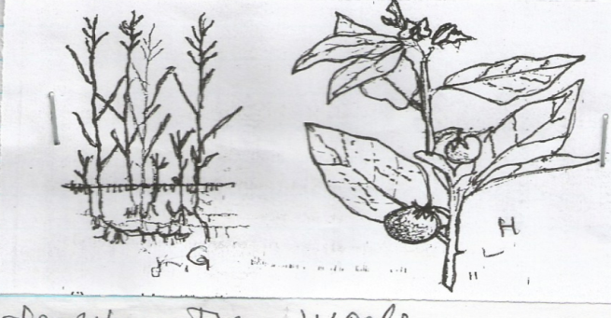

H
G

(a) Identify the weeds. (2 mks)
G - ……………………………………………………
H - …………………………………………………….
(b) State two economic importance of the weed shown in diagram G. (2 mks)
(c) Why is it difficult to control the weed in diagram G.? (1 mk)
19. Study a section of the diagram of soil conservation practices shown below then answer the questions
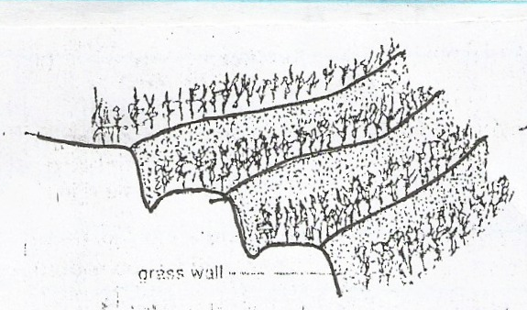
that follow.

Grass wall

- Identify any two soil conservation practices on the diagram, other than grass wall. (2 mks)
- Explain any two ways in which the grass wall helps to conserve soil. (2 mks)
SECTION C (40 MARKS)
Answer two questions in this section.
20. (a) State four methods of preparing planting materials in readiness for planting. (4 mks)
(b) Explain four factors which determine the scale of production in extensive and intensive farming.
(8 mks)
(c) State eight practices carried out to ensure field hygiene. (8 mks)
21. (a) State six advantages of a mixed pasture. (6 mks)
(b) Explain five roles of trees in soil and water conservation. (10 mks)
(c) State four conditions that should be observed when harvesting to ensure that cotton picked is of
high quality. (4 mks)
22. The following information was extracted from the farm records of Kiriamburi Farm as at
31-12- 2012
Sale of poultry 5,000
Sale of milk 6,000
Telephone bill 1,000
Purchase of feeds 2,500
Purchase of calves 3,000
Purchase of lambs 2,800
Sale of goats 5,000
Closing valuation 150,000
Rent 2,000
Casual Labour 2,500
Sale of cereals 12,000
Opening valuation 140,000
Machinery depreciation 500
Interest on loan 400
Purchase of chicks 800
Sale of sukumawiki 500
- Prepare a Profit and Loss Account for Kiriamburi Farm using the above information. (10 mks)
- Explain the role of Agricultural Co-operatives in Kenya. (10 mks)

