Name: …………………………………………………………… Index No.:……………………................
School.: …………………………………………………………. Candidate’s Sign:……………………...
Date:…..……………..…………………………….........................

443/2
AGRICULTURE
PAPER 2
JULY/AUGUST - 2015
TIME: 2 HOURS

TRANS-NZOIA COUNTY JOINT EVALUATION EXAM – 2015
Kenya Certificate of Secondary Education (K.C.S.E)

AGRICULTURE
PAPER 2
2 HOURS

INSTRUCTIONS TO THE CANDIDATES

- Write your name, index number, and school in the spaces provided above.
- Sign and write the date of Examination in the spaces provided above
- This paper consists of three sections;- A, B and C.
- Answer all questions in section A and B.
- All answers should be written in spaces provided
For Examiner’s Use Only:-
SECTION | QUESTION | MAXIMUM SCORE | CANDIDATE’S SCORE
A | 1 – 18 | 30
B | 19 – 22 | 20
C | 23 – 25 | 20
 |  | 20
 | Total Score | 90

This paper consists of 8 printed pages.
Candidates should check the question paper to ascertain that all pages are printed as indicated.
And that no questions are missing.

SECTION A: (30 MARKS)
Answer all the questions in this section in the spaces provided.
1. State four practices that should be carried out on wooden fencing post to make them last. (2 mks)
(i)………………………………………………………………………………………………………..
(ii) ………………………………………………………………………………………………………
(iii) ……………………………………………………………………………………………………...
(iv) ……………………………………………………………………………………………………...
2. Give two harmful effects of kids (melophagus orinus) in sheep. (1 mk)
(i)………………………………………………………………………………………………………..
(ii) ………………………………………………………………………………………………………
3. State four construction features necessary in a fish pond. (2 mks)
(i)………………………………………………………………………………………………………..
(ii) ………………………………………………………………………………………………………
(iii) ……………………………………………………………………………………………………...
(iv) ……………………………………………………………………………………………………...
4. List two appropriate hand tools needed to finish off the handle of a fork jembe. (1 mk)
(i)………………………………………………………………………………………………………..
(ii) ………………………………………………………………………………………………………
5. List four routes through which pathogens can enter the body of an animal. (2 mks)
(i)………………………………………………………………………………………………………..
(ii) ………………………………………………………………………………………………………
(iii) ……………………………………………………………………………………………………...
(iv) ……………………………………………………………………………………………………...
6. Name two functions of the crop in the digestive system of chicken. (1 mk)
(i)………………………………………………………………………………………………………..
(ii) ………………………………………………………………………………………………………
7. State two reasons why proper nutrition is important in animals’ health. (2 mks) (i)………………………………………………………………………………………………………..
(ii) ………………………………………………………………………………………………………
8. Give four functions of vitamins in livestock production. (2 mks)
(i)………………………………………………………………………………………………………..
(ii) ………………………………………………………………………………………………………
(iii) ……………………………………………………………………………………………………...
(iv) ……………………………………………………………………………………………………...
9. Give three reasons why honey harvesting should be discouraged at night. (1½ mks)
(i)………………………………………………………………………………………………………..
(ii) ………………………………………………………………………………………………………
(iii) ……………………………………………………………………………………………………...
10. (a) Name the causal organism of fowl typhoid. (1 mk)
…………………………………………………………………………………………………………..
(b) List three signs on a carcass which shows that an animal died of Anthrax. (1 ½ mks)
………………………………………………………………………………………………………
……………………………………………………………………………………………………..
11. Differentiate between cropping and harvesting in fish farming. (1 mk)
…………………………………………………………………………………………………………
…………………………………………………………………………………………………………..
12. Give four characteristics of a good site for a bee hive. (2 mks)
(i)………………………………………………………………………………………………………..
(ii) ………………………………………………………………………………………………………
(iii) ……………………………………………………………………………………………………...
(iv) ……………………………………………………………………………………………………...
13. Distinguish between inbreeding and line breeding as used in livestock production. (2 mks)
…………………………………………………………………………………………………………
…………………………………………………………………………………………………………..
14. State two maintenance requirements of a jack plane. (1 mk)
(i)………………………………………………………………………………………………………..
(ii) ………………………………………………………………………………………………………
15. (a) Give two features of a good laying nest. (1 mk)
…………………………………………………………………………………………………………
…………………………………………………………………………………………………………
(b) State two reasons why a young calf should feed on colostrum during first few days. (1 mk)
(i)………………………………………………………………………………………………………..
(ii) ………………………………………………………………………………………………………
16. State two reasons why calcium and phosphorus are important in the diet of young livestock. (1mk)
(i)………………………………………………………………………………………………………..
(ii) ………………………………………………………………………………………………………
17. State four factors that determine the depth and size of a foundation in a farm building. (1 ½ mks)
(i)………………………………………………………………………………………………………..
(ii) ………………………………………………………………………………………………………
(iii) ……………………………………………………………………………………………………...
(iv) ……………………………………………………………………………………………………
18. State four abnormalities of eggs that can be detected during egg candling. (2mks)
(i)………………………………………………………………………………………………………..
(ii) ………………………………………………………………………………………………………
(iii)………………………………………………………………………………………………………
(iv)………………………………………………………………………………………………………

SECTION B (20 MARKS)
Answer all the questions in the section in the spaces provided.
19. The diagram below shows the petrol fuel system of a tractor engine. Study it carefully and answer
the questions that follow:
D
Engine block
Exhaust pipe
Primary filter
Fuel tank
Throtile valve
C
A
B

- Name the parts labeled A, B, C and D. (2 mks)
A …………………………………………………………………….
B………………………………………………………………………
C ……………………………………………………………………….
D ……………………………………………………………….............
- State the functions of the parts labeled A, C, and D. (3 mks)
A ……………………………………………………………………………………………………
C ……………………………………………………………………………………………………
D ……………………………………………………………………………………………………
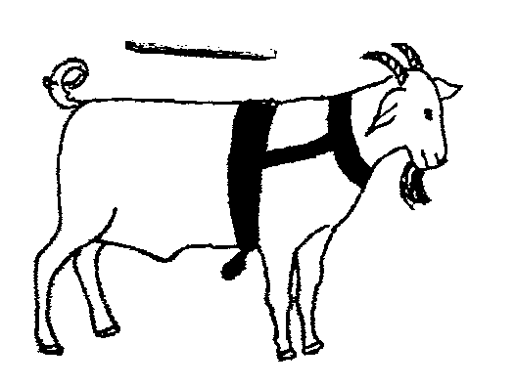
20. The diagram below illustrates a breeding management practices

- Identify the practice. (1 mk)
………………………………………………………………………………………………………
- Give two reasons for carrying out this practice. (2 mks)
(i)……………………………………………………………………………………………………
(ii) …………………………………………………………………………………………………..
- State two causes of infertility in farm animals. (2 mks)
(i)……………………………………………………………………………………………………
(ii) …………………………………………………………………………………………………..
21. The diagram below illustrates a method of identification in livestock production. Study the diagram
and answer the questions that follow:
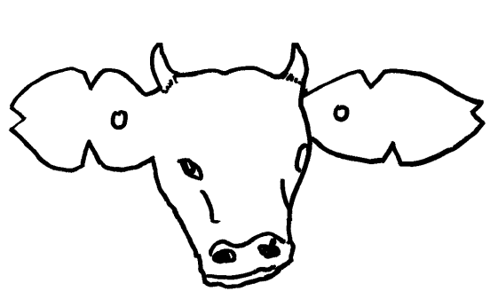
5
5
2
2
3
3

- Name the type of identification illustrated in the diagram. (1 mk)
………………………………………………………………………………………………………
- Give the identification number of the animal illustrated in the diagram. (1 mk)
………………………………………………………………………………………………………
- Using the diagram, illustrate how you can identify animal numbers 24 and 36 using the method above (draw and label). (2 mks)
24 36

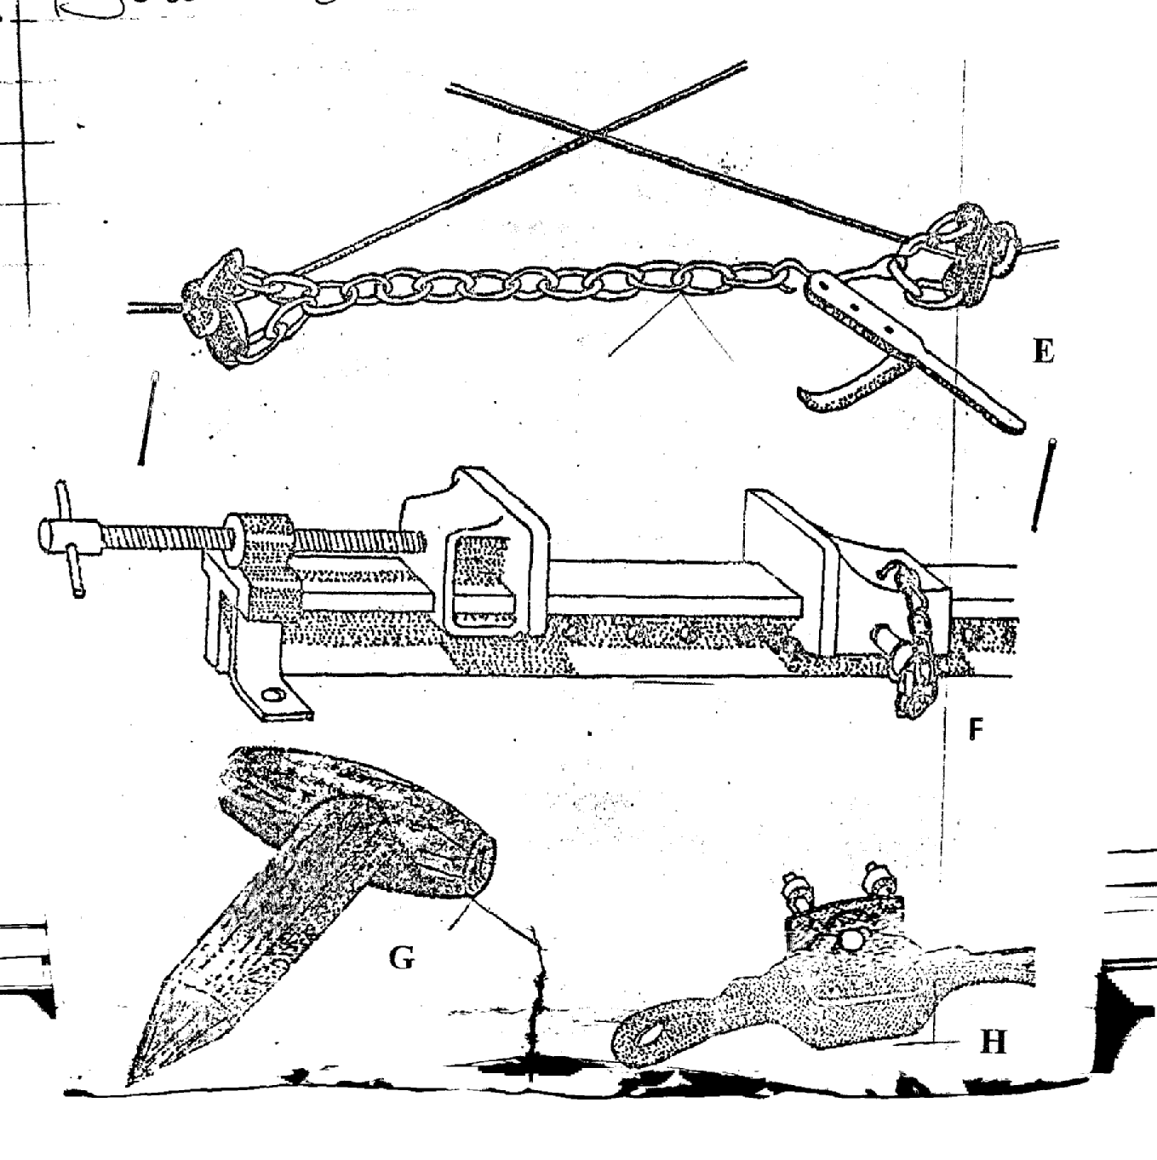
22. Below are illustrations of farm tools.

- Identify the farm tools labelled E, F, G and H. (2 mks)
E …………………………………………………………
F …………………………………………………………
G …………………………………………………….......
H …………………………………………………………
- State the use of tools labelled E, F and G (3 mks)
E ………………………………………………………………………………………………….
F …………………………………………………………………………………………………….
G ……………………………………………………………………………………………………
- Give one maintenance practice of the tool labelled F. (1 mk)
………………………………………………………………………………………………………

SECTION C: (40 MARKS)
Answer any two questions from this section on the spaces provided.
23. (a) Describe ten components of a plunge dip for cattle. (10 mks)
(b) Give four predisposing factors of foot rot in sheep. (4 mks)
(c) State and explain six methods of controlling internal parasites in livestock. (6 mks)
24. (a) Describe mastitis under the following sub-headings.
(i) Animals affected (2 mks)
(ii) Pre-disposing factors (4 mks)
(iii) Symptoms of attack (4 mks)
(b) Describe the preparation done before farrowing in pigs. (10 mks)

25. (a) Describe hand milking in a diary cow. (11 mks)
(b) Describe body conformation features of beef cattle. (4 mks)
(c) Describe five factors which affect quantity of honey. (5 mks)
…………………………………………………………………………………………………………..
…………………………………………………………………………………………………………..
…………………………………………………………………………………………………………..
…………………………………………………………………………………………………………..
…………………………………………………………………………………………………………..
…………………………………………………………………………………………………………..
…………………………………………………………………………………………………………..
…………………………………………………………………………………………………………..
…………………………………………………………………………………………………………..
…………………………………………………………………………………………………………..
…………………………………………………………………………………………………………..
…………………………………………………………………………………………………………..
…………………………………………………………………………………………………………..
…………………………………………………………………………………………………………..
…………………………………………………………………………………………………………..
…………………………………………………………………………………………………………..
…………………………………………………………………………………………………………..
…………………………………………………………………………………………………………..
…………………………………………………………………………………………………………..
…………………………………………………………………………………………………………..
…………………………………………………………………………………………………………..
…………………………………………………………………………………………………………..
…………………………………………………………………………………………………………..
…………………………………………………………………………………………………………..
…………………………………………………………………………………………………………..
…………………………………………………………………………………………………………..
…………………………………………………………………………………………………………..
…………………………………………………………………………………………………………..
…………………………………………………………………………………………………………..
…………………………………………………………………………………………………………..
…………………………………………………………………………………………………………..
…………………………………………………………………………………………………………..
…………………………………………………………………………………………………………..
…………………………………………………………………………………………………………..
…………………………………………………………………………………………………………..
…………………………………………………………………………………………………………..
…………………………………………………………………………………………………………..
…………………………………………………………………………………………………………..
…………………………………………………………………………………………………………..
…………………………………………………………………………………………………………..
…………………………………………………………………………………………………………..
…………………………………………………………………………………………………………..
…………………………………………………………………………………………………………..
…………………………………………………………………………………………………………..
…………………………………………………………………………………………………………..
…………………………………………………………………………………………………………..
…………………………………………………………………………………………………………..
…………………………………………………………………………………………………………..
…………………………………………………………………………………………………………..
…………………………………………………………………………………………………………..
…………………………………………………………………………………………………………..
…………………………………………………………………………………………………………..
…………………………………………………………………………………………………………..
…………………………………………………………………………………………………………..
…………………………………………………………………………………………………………..
…………………………………………………………………………………………………………..
…………………………………………………………………………………………………………..
…………………………………………………………………………………………………………..
…………………………………………………………………………………………………………..
…………………………………………………………………………………………………………..
…………………………………………………………………………………………………………..
…………………………………………………………………………………………………………..
…………………………………………………………………………………………………………..
…………………………………………………………………………………………………………..
…………………………………………………………………………………………………………..
…………………………………………………………………………………………………………..
…………………………………………………………………………………………………………..
…………………………………………………………………………………………………………..

