Name…………………………………………………………………… ADM………...……
CLASS……………….. SIGN………………… DATE………………

231/1
BIOLOGY THEORY
MARCH/APRIL 2015
2 HOURS

MOKASA JOINT EXAMINATION 2015
(Kenya Certificate of Secondary Education)
BIOLOGY THEORY
Instructions
- Write your name, class and admission number in the space provided above.
- Write the date of the examination and sign in the space provided above.
- Answer all the questions in the spaces provided.
- You will be penalized for wrong spelling especially technical terms.

For Examiner’s Use Only
Question | Maximum Score | Candidate’s Score
1-27 | 80

This paper consists of 10 printed pages.
Candidates should check the question paper to ascertain that all the pages are printed as indicated and no questions are missing.
- State two characteristics of living organisms that are specific to plants. (2marks)
…………………………………………………………………………………………………………………………………………………………………………………………………………………………………………………………………………………………………………………………………………………………………………………………………………………………………………..
- State one use for each of the following apparatus in the study of living organisms.
- Pooter. (1mark)
………………………………………………………………………………………………………
- Bait trap. (1mark)
………………………………………………………………………………………………………
- (a) Name two tissues in plants which are thickened with lignin. (2marks)
……………………………………………………………………………………………………………………………………………………………………………………………………………………..
(b) How is support attained in herbaceous plants? (1mark)
……………………………………………………………………………………………………………………………………………………………………………………………………………………
- The diagram below represents a cell as seen under an electron microscope.
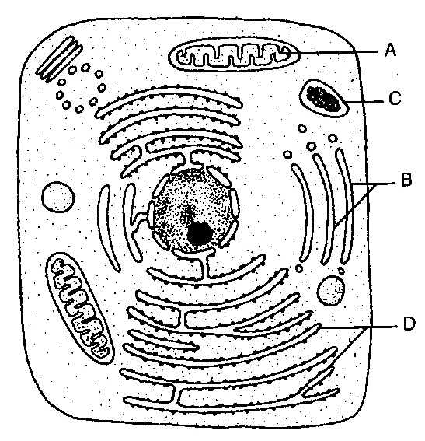
- Identify the parts labeled A and D. (2marks)
- A ………………………………………………………………………………………..
- D ………………………………………………………………………………………..

- State the function of the structures found on the part labeled D. (1marks)
……………………………………………………………………………………………………....
- a) Using a microscope, a student counted 55 cells across a field of view whose diameter was 6000µm. Calculate the average length of the cells. Show your working. (2marks)

- State the function of the following parts of a light microscope
- Fine adjustment knob. (1mark)
…………………………………………………………………………………………..
- Condenser (1mark)
…………………………………………………………………………………………..
- (a) Name the fluid that is produced by sebaceous glands. (1mark)
…………………………………………………………………………………………………………
(b) What is the role of sweat on the human skin? (2marks)
………………………………………………………………………………………………………………………………………………………………………………………………………………………………………………………………………………………………………………………………
- What is the importance of the following in an ecosystem? (2marks)
- Decomposers
………………………………………………………………………………………………………………………………………………………………………………………………………………
- Predation
………………………………………………………………………………………………………………………………………………………………………………………………………………
- (a) State two functions of bile juice in the digestion of food. (2marks)
…………………………………………………………………………………………………………………………………………………………………………………………………………………………………………………………………………..……………………………………………………
(b) How does substrate concentration affect the rate of enzyme action? (1mark)
……………………………………………………………………………………………………………………………………………………………………………………………………………………..
- Name the features that increase the surface area of small intestines. (2marks)
……………………………………………………………………………………………………………………………………………………………………………………………………………………………..…………………………………………………………………………………………………
- Describe what happens during the light stage of photosynthesis. (3marks)
………………………………………………………………………………………………………………………………………………………………………………………………………………………………………………………………………………………………………………………………
…………………………………………………………………………………………………………..
- (a) Define the following terms. (2marks)
- Population
……………………………………………………………………………………………………………………………………………………………………………………………………………………………………………………………………………..…………………………………………………
- Community
………………………………………………………………………………………………………………………………………………………………………………………………………………………………………………………………………………………..………………………………………
(b) Name a method that could be used to estimate the population size of the following organisms.
- Fish in a pond. (1mark)
…………………………………………………………………………………………………..
- Black jack in a garden. (1mark)
…………………………………………………………………………………………………..
- (a) What is meant by the term allele? (1mark)
……………………………………………………………………………………………………………………………………………………………………………………………………………………..
(b) Explain how the following occur during gene mutation.
(i) Deletion. (1mark)
……………………………………………………………………………………………………………………………………………………………………………………………………………………..
(ii) Inversion. (1mark)
……………………………………………………………………………………………………………………………………………………………………………………………………………………..
(c) What is a test-cross? (1mark)
………………………………………………………………………………………………………………………………………………………………………………………………………………………………………………………………………………………………………………………………
- Explain what happens when there is oxygen debt in human muscles. (2marks)
…………………………………………………………………………………………………………………………………………………………………………………………………………………………………………………………………………………………………………………………………………………………………………………………………………………………………………..
- The diagram below shows a transverse section of a plant organ.
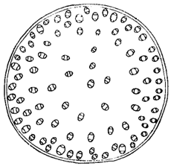
- Name the class to which the plant organ was obtained. (1mark)
………………………………………………………………………………………………………
- Give a reason for your answer in (a) above. (1mark)
………………………………………………………………………………………………………………………………………………………………………………………………………………
- Giving a reason in each case, name the class to which each of the following organisms belong: (4marks)
Pea plant
…………………………………………………………………………………………………………..
Reason
……………………………………………………………………………………………………………………………………………………………………………………………………………………..
Bat
…………………………………………………………………………………………………………
Reason
…………………………………………………………………………………………………………
- (a) Name the causative agents of the following diseases in humans. (2marks)
Typhoid
…………………………………………………………………………………………………………
Amoebic dysentery
…………………………………………………………………………………………………………..
(b) Name the disease in humans caused by Plasmodium falciparum. (1mark)
…………………………………………………………………………………………………………..
- State three differences between Chilopoda and Diplopoda. (3marks)
………………………………………………………………………………………………………………………………………………………………………………………………………………………………………………………………………………………………………………………………………………………………………………………………………………………………………………………………………………………………………………………………………………………………………………………………………………………………………………………………………………………………………………………………………………………………………………………………………………………………………………………………………………………………………………………………………………………………………………………………………………………………………………………………………………………………………………………………………………………………………………………………………………………………………………………………………………………………………………………………..
- What are the limitations of fossil records as evidence of organic evolution? (1mark)
………………………………………………………………………………………………………………………………………………………………………………………………………………………………………………………………………………………………………………………………..
- The diagram below represents a member of the kingdom Animalia.
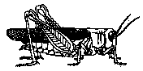
- Name the phylum to which the organism belongs. (1mark)
…………………………………………………………………………………………………..
- Using observable features in the diagram, give three reasons for the answer in (i) above. (3marks)
…………………………………………………………………………………………………………………………………………………………………………………………………………………………………………………………………………………………………………………………………………………………………………………………………………
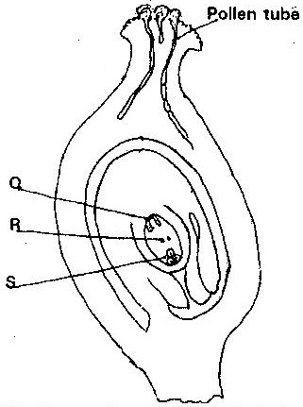
- The diagram below shows a stage during fertilization in plants.

- Name the parts labeled Q and R. (2marks)
Q ……………………………………………………………………………………………………
R ……………………………………………………………………………………………………
- State the function of the pollen tube. (1mark)
………………………………………………………………………………………………………………………………………………………………………………………………………………
- On the diagram, label the micropyle. (1mark)
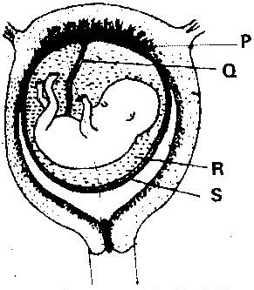
- The diagram below represents a human foetus in a uterus.

- Name the types of blood vessels found in the structure labeled Q. (2marks)
………………………………………………………………………………………………………………………………………………………………………………………………………………
- Name two features that enable the structure labeled P carry out its function. (2marks)
………………………………………………………………………………………………………………………………………………………………………………………………………………
- Name the type of skeleton that makes up each of the following animals. (3marks)
- Cockroach
………………………………………………………………………………………………………
- Bird
………………………………………………………………………………………………………
- Earthworm
………………………………………………………………………………………………………
- (a) Highlight two survival values of tropic response. (2marks)
…………………………………………………………………………………………………………………………………………………………………………………………………………………………………………………………………………………………………………………………………………………………………………………………………………………………………………..
(b) What is a klinostat? (1mark)
………………………………………………………………………………………………………………………………………………………………………………………………………………………………………………………………………………………………………………………………..
- Name:-
- The pressure sensitive swellings at the base of some leaves and petals which through loss or gain of turgidity bring about nastic movements. (1mark)
………………………………………………………………………………………………………
- The structure in cockroach used for detecting stimuli. (1mark)
………………………………………………………………………………………………………
- The growth movement of part of plants in response to a unidirectional external stimulus. (1mark)
………………………………………………………………………………………………………
- The diagram below shows a transverse section of a leaf. Study it carefully then answer the questions that follow.
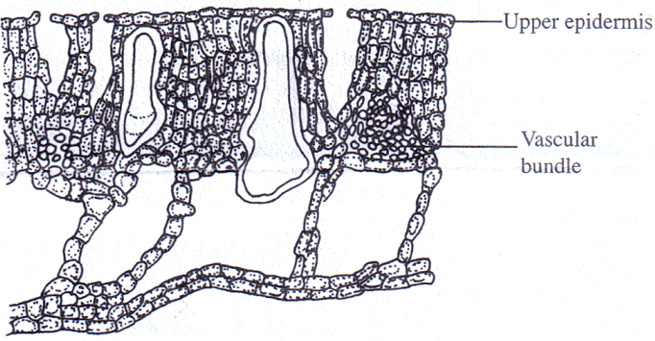
- Name the habitat of the plant from which the leaf was obtained. (1mark)
………………………………………………………………………………………………………
- Give two reasons for your answer in (a) above. (2marks)
………………………………………………………………………………………………………………………………………………………………………………………………………………………………………………………………………………………………………………………………………………………………………………………………………………………………
- (a) Name the gaseous exchange surface in insects. (1mark)
…………………………………………………………………………………………………………..
(b) How is the surface named in (a) above suited to its function. (2marks)
…………………………………………………………………………………………………………………………………………………………………………………………………………………………………………………………………………………………………………………………………………………………………………………………………………………………………………..
- Most carbon (IV) oxide is transported from tissues to the lungs within the red blood cells and not in the blood plasma. Give two advantages of this mode of transport. (2marks)
…………………………………………………………………………………………………………………………………………………………………………………………………………………………………………………………………………………………………………………………………………………………………………………………………………………………………………

