Name ……………………………………………………….. Index. No. ………………………...

Candidate’s Sign …………………………

Date ………………………………………

231/2
Biology
Paper 2
(Theory)
MARCH/APRIL 2015
Time: 2 Hours

MOKASA JOINT EVALUATION EXAMINATION
Kenya Certificate of Secondary Education
231/2
BIOLOGY
Paper 2
(Theory)
March/April 2015
2 Hours

- Write your name, Index Number in the spaces provided above
- Write the date of examination in the space provided above
- Answer ALL the questions in section A in the spaces provided below each question in the question paper
- In section B, answer question 6(Compulsory) and either question 7 or 8

FOR EXAMINER’S USE ONLY

Section | Question | Maximum Score | Candidate’s Score
A
B
 | TOTAL

SECTION A:

1. a) Define the following terms
(i) Stimulus (1 mark)
.....................................................................................................................................................
.....................................................................................................................................................
.....................................................................................................................................................
(ii) Taxis (1 mark)
.....................................................................................................................................................
.....................................................................................................................................................
.....................................................................................................................................................
b) A student uprooted a seedling of Bryophylum and left it to lie on the ground. After a few days the seedling has assumed a growth curvature shown in the diagram below.

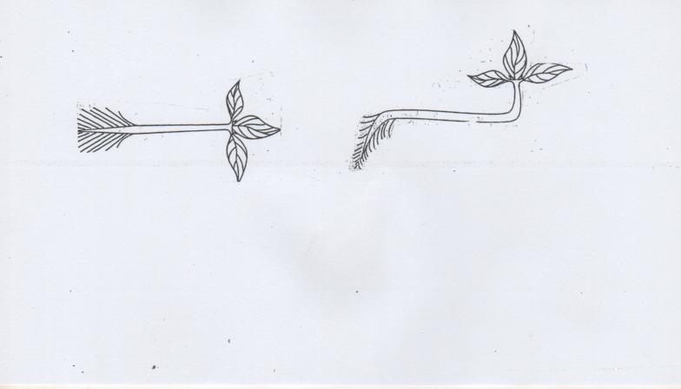

At the start of the experiment At the end of the experiment

- Account for the growth curvature observed in parts (4 marks)
A and B
.....................................................................................................................................................
.....................................................................................................................................................
Part A
.....................................................................................................................................................
.....................................................................................................................................................
Part B
.....................................................................................................................................................
.....................................................................................................................................................
c) State two survival values of taxis to organisms (2 marks)
.....................................................................................................................................................
.....................................................................................................................................................
.....................................................................................................................................................
.....................................................................................................................................................
2. A cross between a black bull and a white cow produces a calf with black and white spots.
a) Work out the possible genotypes of a calf resulting from a cross between a black bull and a white cow. (4 marks)
.....................................................................................................................................................
.....................................................................................................................................................
.....................................................................................................................................................
.....................................................................................................................................................
.....................................................................................................................................................
.....................................................................................................................................................

b) State the reason why the calf had black and white spots (1 mark)
.....................................................................................................................................................
.....................................................................................................................................................
c) What is meant by the term allele? (1 mark)
.....................................................................................................................................................
.....................................................................................................................................................
d) State two characteristics of an individual with Down’s syndrome (2 marks)
.....................................................................................................................................................
.....................................................................................................................................................
.....................................................................................................................................................
.....................................................................................................................................................

3. An experiment was set up as shown below by a biology class.

A B

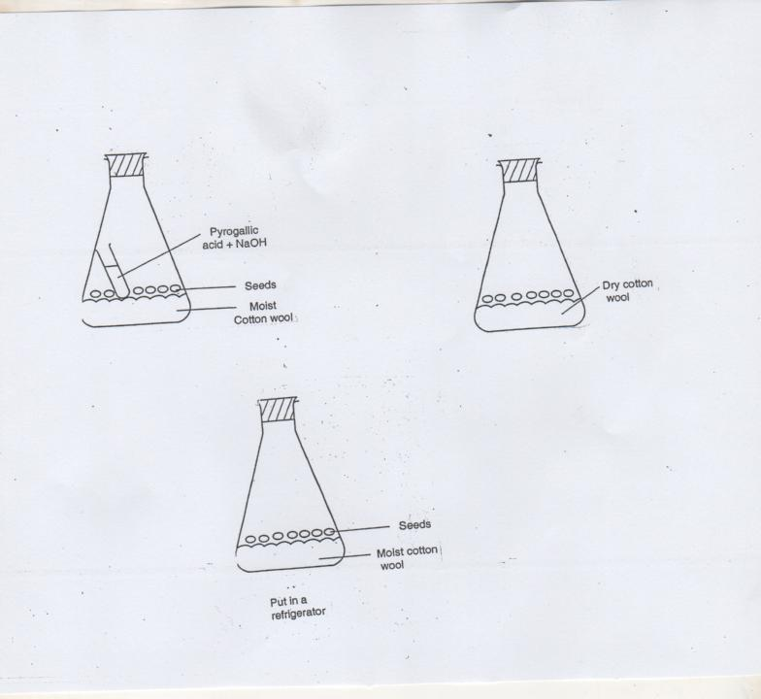

C

- What is the role of pyrogallic acid in sodium hydroxide in flask A? (1 mark)
.....................................................................................................................................................
.....................................................................................................................................................
- What conditions were being investigated in flasks A, B and C? (3 marks)
A ..............................................................................................................................................
B ...............................................................................................................................................
C ................................................................................................................................................
- Suppose the dry cotton wool in flask B was replaced with a moist cotton and set-up left for five days, give and account for the observation made (2 marks)
.....................................................................................................................................................
.....................................................................................................................................................
- State the inhibitory roles of gibberelic acid in plants (2 marks)
.....................................................................................................................................................
.....................................................................................................................................................
4. a) Distinguish the following terms as used in animal nutrition
(i) Dentition and dental formula (1 mark)
.....................................................................................................................................................
.....................................................................................................................................................
.....................................................................................................................................................
.....................................................................................................................................................
- Homodont and heterodont dentition (1 mark)
.....................................................................................................................................................
.....................................................................................................................................................
.....................................................................................................................................................
.....................................................................................................................................................
b) State two functions of the ileum (2 marks)
.....................................................................................................................................................
.....................................................................................................................................................
.....................................................................................................................................................
c) Explain how the chloroplast is adapted to its function (4 marks)
.....................................................................................................................................................
.....................................................................................................................................................
.....................................................................................................................................................
.....................................................................................................................................................
.....................................................................................................................................................
.....................................................................................................................................................
5. Proteins are present in a balanced diet. They are broken down into amino acids and excess cannot be stored in the body. Its metabolism is as shown below.

Excess amino acids

S

Non-nitrogen Urea
Organic compound

Process T

Carbon(IV) oxide + Removal from the body

- Describe how urea is transported to the site of removal from the body (2 marks)
.....................................................................................................................................................
.....................................................................................................................................................
- Name the process Sand T, stating the organ in which each occurs (4 marks)

Process | Name | Organ
S
T

- Give four uses of amino acids in the body (2 marks)

.....................................................................................................................................................
.....................................................................................................................................................
.....................................................................................................................................................
...................................................................................................................................................

SECTION B

Answer question 6 (Compulsory) in the spaces provided and either question 7 or 8 in the spaces provided after question 8.

6. In an experiment, Tradescantia plants with purple leaves were kept in the dark for about 1 hour, strips of leaves approximately 5mm by 12mm from this plants were then cut and floated with lower epidermis on experimental solution in petri dishes. The dishes were then placed in light and temperature kept at 20°C. After 5 minutes a leaf strip was removed from each experimental solution, quickly blotted dry and the percentage number of open stomata was found after counting under the microscope. The procedure was repeated with other strips from the same experimental solutions at intervals of 10 minutes. The results are as shown in the table below.

Time in minute, floating on solution | 5 | 15 | 25 | 35 | 45 | 55
% open stomata in KCl solution (150mm) | 0 | 0 | 20 | 76 | 82 | 86
% open stomata in NaCl solution (150mm) | 0 | 0 | 6 | 22 | 42 | 45

- Plot graphs using the same axis and suitable scale for the percentage of open stomata against time for treatment in each of the solutions, potassium chloride and sodium chloride. (7 marks)

- Why was it necessary to keep the plant in the dark for a period of time before the experiment? (1 mark)
.....................................................................................................................................................
.....................................................................................................................................................
- Using the graphs you have plotted give possible explanations for the behaviour of the guard cells during this experiment (6 marks)
.....................................................................................................................................................
.....................................................................................................................................................
.....................................................................................................................................................
.....................................................................................................................................................
.....................................................................................................................................................
.....................................................................................................................................................
.....................................................................................................................................................
.....................................................................................................................................................
.....................................................................................................................................................
.....................................................................................................................................................
- What would happen if the experiment was carried out in the dark (1 mark)
.....................................................................................................................................................
.....................................................................................................................................................
- With respect to leaf structure only, state five ways in which plants living in arid areas minimize excessive water loss. (5 marks)
.....................................................................................................................................................
.....................................................................................................................................................
.....................................................................................................................................................
.....................................................................................................................................................
.....................................................................................................................................................
.....................................................................................................................................................
.....................................................................................................................................................
.....................................................................................................................................................
.....................................................................................................................................................
.....................................................................................................................................................
7. a) State four precautions to be observed when collecting specimens. (4 marks)
.....................................................................................................................................................
.....................................................................................................................................................
.....................................................................................................................................................
.....................................................................................................................................................
.....................................................................................................................................................
.....................................................................................................................................................
.....................................................................................................................................................
.....................................................................................................................................................
b) Explain how the various activities of man have caused soil pollution (16 marks)

.....................................................................................................................................................
.....................................................................................................................................................
.....................................................................................................................................................
.....................................................................................................................................................
.....................................................................................................................................................
.....................................................................................................................................................
.....................................................................................................................................................
.....................................................................................................................................................
.....................................................................................................................................................
.....................................................................................................................................................
.....................................................................................................................................................
.....................................................................................................................................................
.....................................................................................................................................................
.....................................................................................................................................................
.....................................................................................................................................................
.....................................................................................................................................................
.....................................................................................................................................................
.....................................................................................................................................................
.....................................................................................................................................................
.....................................................................................................................................................
.....................................................................................................................................................
.....................................................................................................................................................
.....................................................................................................................................................
....................................................................................................................................................
8. a) State the various ways in which energy is utilized in living organisms (6 marks)
.....................................................................................................................................................
.....................................................................................................................................................
.....................................................................................................................................................
.....................................................................................................................................................
.....................................................................................................................................................
.....................................................................................................................................................
.....................................................................................................................................................
.....................................................................................................................................................
.....................................................................................................................................................
.....................................................................................................................................................
.....................................................................................................................................................
.....................................................................................................................................................
b) Describe the process of fertilization and implantation of the zygote in mammals
(14 mks)
.....................................................................................................................................................
.....................................................................................................................................................
.....................................................................................................................................................
.....................................................................................................................................................
.....................................................................................................................................................
.....................................................................................................................................................
.....................................................................................................................................................
.....................................................................................................................................................
.....................................................................................................................................................
.....................................................................................................................................................
.....................................................................................................................................................
.....................................................................................................................................................
.....................................................................................................................................................
.....................................................................................................................................................
.....................................................................................................................................................
.....................................................................................................................................................
.....................................................................................................................................................
.....................................................................................................................................................
.....................................................................................................................................................
.....................................................................................................................................................
.....................................................................................................................................................
.....................................................................................................................................................
.....................................................................................................................................................
.....................................................................................................................................................
.....................................................................................................................................................
.....................................................................................................................................................
.....................................................................................................................................................
.....................................................................................................................................................
.....................................................................................................................................................
.....................................................................................................................................................
.....................................................................................................................................................
.....................................................................................................................................................
.....................................................................................................................................................
.....................................................................................................................................................
.....................................................................................................................................................
.....................................................................................................................................................
.....................................................................................................................................................

