Name: …………………………………………………………… Index No.:……………………................
School: …………………………………………………………. Candidate’s Sign:……………………...
Date:…..……………..…………………………….........................

231/1
BIOLOGY
PAPER 1
(THEORY)
JULY/AUGUST - 2015
TIME: 2 HOURS

TRANS-NZOIA COUNTY JOINT EVALUATION EXAM – 2015
Kenya Certificate of Secondary Education (K.C.S.E)

BIOLOGY
PAPER 1
2 HOURS

INSTRUCTIONS TO THE CANDIDATES
- Write your name and index number in the spaces provided above.
- Sign and write the date of examination in the spaces provided.
- Answer all questions in the spaces provided in the question paper.
- Additional pages must not be inserted.

For Examiner’s Use Only:-
QUESTION | MAXIMUM SCORE | CANDIDATE’S SCORE
1 - 28 | 80

This paper consists of 8 printed pages.
Candidates should check the question paper to ascertain that all pages are printed as indicated.
And that no questions are missing.

1. (a) Explain the importance of gradual release of heat energy in a cell during respiration. (1 mk)
…………………………………………………………………………………………………………..
…………………………………………………………………………………………………………..
(b) Name the products of glycolysis. (2 mks)
…………………………………………………………………………………………………………..
…………………………………………………………………………………………………………..
…………………………………………………………………………………………………………...
2. (a) Differentiate between essential and non-essential amino acids. (2 mk)
…………………………………………………………………………………………………………..
…………………………………………………………………………………………………………..
…………………………………………………………………………………………………………..
………………………………………………………………………………………………...................
(b) Name two constituents of food that are absorbed without digestion. (2 mks)
…………………………………………………………………………………………………………..
…………………………………………………………………………………………………………..
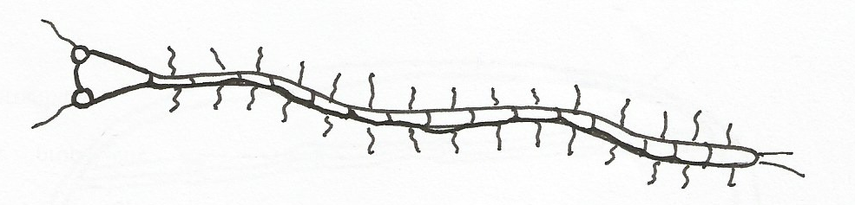
3. Study the diagram below.

- Identify the class to which the organism belongs. (1 mk)
…………………………………………………………………………………………………………..
- Give a reason for your answer in (a) above. (1 mk)
…………………………………………………………………………………………………………..
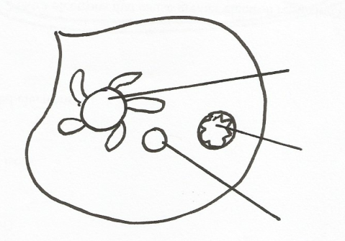
4. The diagram below shows a process in amoeba.

Contractile Vacuole

Nucleus

- State the habitat of the organism. (1 mk)
…………………………………………………………………………………………………………..
- Explain how the contractile vacuole functions in the organism drawn above. (2 mks)
……………………………………………………………………………………………………..........
…………………………………………………………………………………………………………..
5. The illustration below shows a type of chromosomal mutation. Use it to answer the questions that
follow:
X X
X
X
X
X
Parent Cell
1st meiotic division
2nd meiotic division

- Identify the type of chromosomal mutation illustrated above. (1 mk)
………………………………………………………………………………………………………
- Name one disorder in humans caused by the above named chromosomal mutation characterized by presence of an extra chromosome on chromosome number 21. (1 mk)
………………………………………………………………………………………………………
- (i) What is polyploidy? (1 mk)
………………………………………………………………………………………………………
………………………………………………………………………………………………………
………………………………………………………………………………………………………
(ii) State one beneficial effect of polyploidy in plants. (1 mk)
………………………………………………………………………………………………………
6. The diagram below shows and organelle in a plant cell.
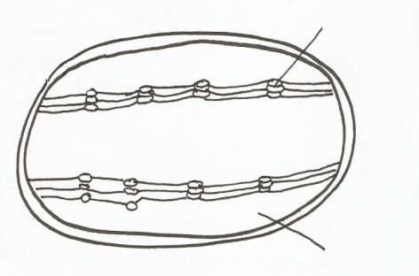
R
P

- Identify the organelle. (1 mk)
………………………………………………………………………………………………………
- (i) Name the structure labelled P. (1 mk)
………………………………………………………………………………………………………
(ii) Write a word equation of the reaction taking place in R. (1 mk)
………………………………………………………………………………………………………

7. The flippers of whales and fins of fish adapt these organisms to aquatic habitat.
(a) Name the evolutionary process that may have given rise to these structures. (1 mk)
…………………………………………………………………………………………………………..
…………………………………………………………………………………………………………
(b) What is the name given to such structures? (1 mk)
………………………………………………………………………………………………………
- In the view of modern genetics, explain why the Lamarckian theory is unacceptable. (1mk)
………………………………………………………………………………………………………
8. What characteristics of living organisms is represented by the following:-
(a) A cat producing kittens. (1 mk)
……………………………………………………………………………………………………….
(b) A girl dropping a hot pan. (1 mk)
………………………………………………………………………………………………………
9. (a) Name the strengthening tissue found in woody plants deposited with;
(i) Cellulose and Pectin. (1 mk)
………………………………………………………………………………………………….
(ii)Lignin (1mk)
…………………………………………………………………………………………………
(b) State a reason why xylem vessels are regarded to be more efficient in transport of water and
dissolved mineral salts up the plant than the tracheids. (1 mk)
………………………………………………………………………………………………………
………………………………………………………………………………………………………
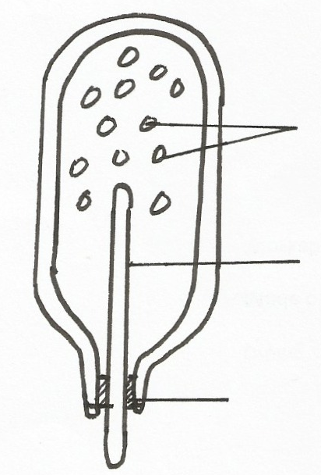
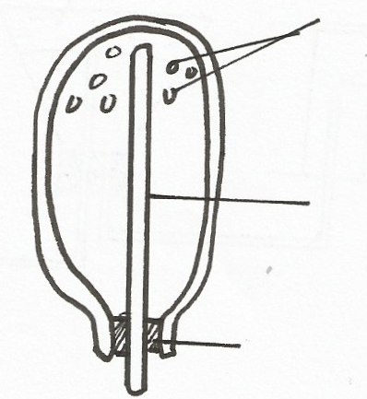
10. Form 2 students set up an experiment as shown below.
Soaked beans seeds
Wet cotton wool
Thermometer
Thermometer
Dry beans seeds
Dry cotton wool

SET UP A SET UP B

- State the aim of their experiment. (1 mk)
……………………………………………………………………………………………………
………………………………………………………………………………………………………
- State one observation made in set up A after some times. (1 mk)
………………………………………………………………………………………………………
- Account for the observation made in B above. (2 mks)
………………………………………………………………………………………………………………………………………………………………………………………………………………
- What is the role of set up B? (1 mk)
………………………………………………………………………………………………………
11. The diagram below shows a bone of the hind limb. Study it and answer the questions that follow:-

Z
R
Q

- Name the bone. (1 mk)
……………………………………………………………………………………………
- Name the parts labelled Q and R. (2 mks)
Q …………………………………………………………………………………………….
R ……………………………………………………………………………………………
- Name the structure that articulates with the part labelled Z and the joint formed. (2 mks)
Structure …………………………………………………………………
Joint ………………………………………………………………………
12. (a) What is peristalisis?. (1 mk)
………………………………………………………………………………………………………
(b) State one component in the animal diet which promotes peristalisis. (1 mk)
………………………………………………………………………………………………………
13. State a characteristic of Red blood cells which enables them to squeeze through blood capillaries.
(1 mk)
…………………………………………………………………………………………………………..
…………………………………………………………………………………………………………..

14. The diagram below illustrates the behavior of a red blood cell when placed in solution X.

Solution X

Process A

- Suggest the nature of solution X. (1 mk)
……………………………………………………………………………………………………
- Name process A. (1 mk)
……………………………………………………………………………………………………
- Account for the appearance of the red blood cell. (3 mks)
………………………………………………………………………………………………………………………………………………………………………………………………………………………………………………………………………………………………………………………
………………………………………………………………………………………………………
15. The table below shows the percentage composition of carbon (IV) oxide and oxygen in inhaled and
exhaled air.

Gases | Inhaled air | Exhaled air
Oxygen | 20% | 17%
Carbon (iv) oxide | 0.04% | 4.0%
- Explain the differences in percentages of the two gases in inhaled and exhaled air.
(i) Oxygen (2 mks)
………………………………………………………………………………………………………………………………………………………………………………………………………………………………………………………………………………………………………………………(ii) Carbon (iv) oxide (2 mks)
……………………………………………………………………………………………………………………………………………………………………………………………………………………………………………………………………………………………………………………....
16. State the functions of the following parts of the mammalian ear.
(i) Tympanic membrane (1 mk)
…………………………………………………………………………………………………………
(ii) Eustachian tube (1 mk)
…………………………………………………………………………………………………………

(iii) Vestibular apparatus (1 mk)
…………………………………………………………………………………………………………..
17. What is parthenocarpy? (1 mk)
…………………………………………………………………………………………………………..
18. Differentiate between interspecific and intraspecific competition. (2 mks)
…………………………………………………………………………………………………………..
…………………………………………………………………………………………………………..
…………………………………………………………………………………………………………..
…………………………………………………………………………………………………………..
19. (a) What is organic evolution? (1 mk)
…………………………………………………………………………………………………………..
- List three limitations of fossil records as an evidence of organic evolution. (3 mks)
………………………………………………………………………………………………………………………………………………………………………………………………………………
………………………………………………………………………………………………………
20. Name the type of response shown by:-
(a) Leaves of Mimosa pudica when they fold after being touched. (1 mk)
……………………………………………………………………………………………………….
(b) Euglena when it swims towards light. (1 mk)
………………………………………………………………………………………………………
21. Name the micro-organism found in the root nodules of leguminous plants. (1 mk)
…………………………………………………………………………………………………………..
22. In a certain bird species black colour of feather is dominant over white colour. A heterozygous black
bird was crossed with a homozygous white bird.
- State the genotype of the two parents.
(Use letter B to represent gene for black colour and b for white colour). (2 mks)
………………………………………………………………………………………………………………………………………………………………………………………………………………
………………………………………………………………………………………………………………………………………………………………………………………………………………
………………………………………………………………………………………………………………………………………………………………………………………………………………
- Using the genetic crosses work out the F₁ generation. (4 mks)
…………………………………………………………………………………………………………………………………………………………………………………………………………………..…………………………………………………………………………………………………………..……………………………………………………………………………………………
……………..………………………………………………………………………………………
………..……………………………………………………………………………………………
………..……………………………………………………………………………………………
………..……………………………………………………………………………………………
23. (a) Name the hard body covering found in organisms in phylum Arthropoda. (1 mk)
………………………………………………………………………………………………………
(b) State three uses of the structure named in (a) above. (3 mks)
………………………………………………………………………………………………………
………………………………………………………………………………………………………..
………………………………………………………………………………………………………
24. State two organelles absent in members of kingdom Monera but present in members of kingdom
Protoctista. (2 mks)
…………………………………………………………………………………………………………..
…………………………………………………………………………………………………………..
25. Name the substance produced during anaerobic respiration in animals and state why it should be got
rid of immediately. (2 mks)
Substance ……………………………………………………………………………………………….
Reason ………………………………………………………………………………………………….
26. What is the significance of chiasma formation during meiotic cell division. (1 mk)
…………………………………………………………………………………………………………..
…………………………………………………………………………………………………………..
27. Distinguish between continuous and discontinuous variation. (2 mks)
…………………………………………………………………………………………………………..
…………………………………………………………………………………………………………..
……………..……………………………………………………………………………………………
28. State how the palisade cell is specialized to carry out its function. (1 mk)
…………………………………………………………………………………………………………..

