Name……………………………………………………………………… Index No…………………….
School…………………………………………………………………….. Sign………………………….
Date………………………….

231/2
BIOLOGY
(THEORY)
PAPER 2
JULY / AUGUST – 2012
TIME: 2 HOURS

KISII SOUTH DISTRICT JOINT EVALUATION -2012
Kenya Certificate of Secondary Education (K.C.S.E)
231/2
BIOLOGY
(THEORY)
PAPER 2
JULY / AUGUST – 2012
TIME: 2 HOURS

INSTRUCTIONS TO CANDIDATES:-
• Write your name and index number in the spaces provided above.
• This paper consists of two sections; A and B.
• Answer all the questions in Section A in the spaces provided.
• In section B, answer question 6 (compulsory) and either question 7 or 8 in the spaces provided after question 8.

FOR EXAMINER’S USE ONLY:-
Section | Question | Maximum score | Candidates score
A | 1  2  3  4  5 | 08  08  08  08  08
B | 6  7  8 | 20  20  20
TOTAL | SCORE | 80

This paper consists of 8 Printed pages. Candidates should check the question paper to ensure that all the Papers are printed as indicated and no questions are missing.
SECTION A (40MARKS)
Answer ALL questions in this section in the spaces provided.

1. A freshly obtained dandelion stem measuring 5cm long was split lengthwise to obtain two similar pieces. The pieces were placed in solutions of different concentrations in Petri dishes for 20 minutes. The appearance after 20 minutes is as shown.
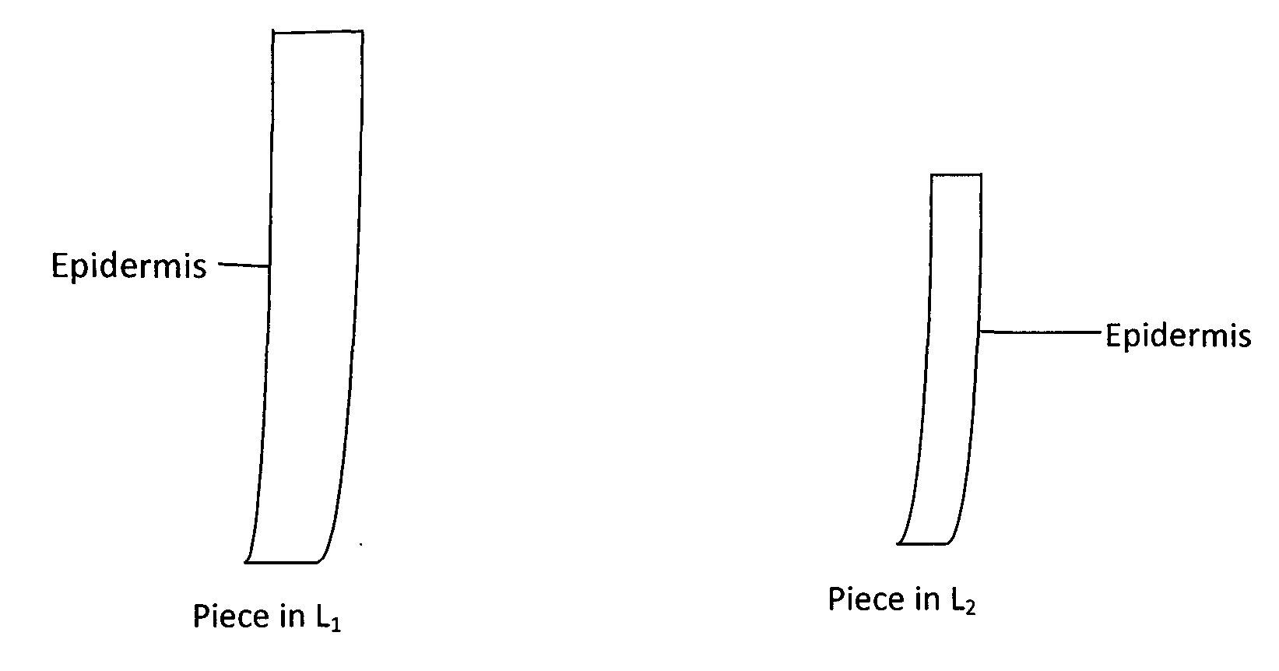
(a) Account for the appearance of the pieces in solutions L1 and L2 (6mks)
L₁
………………………………………………………………………………………………………………………………………………………………………………………………………………
………………………………………………………………………………………………………………………………………………………………………………………………………………
L₂
………………………………………………………………………………………………………………………………………………………………………………………………………………
………………………………………………………………………………………………………………………………………………………………………………………………………………
(b) State the significance of biological process involved in the experiment. (2mks)
………………………………………………………………………………………………………………………………………………………………………………………………………………
………………………………………………………………………………………………………………………………………………………………………………………………………………
2. (a) Give three reasons in each case why support is necessary in
(i) Plants (3mks)
………………………………………………………………………………………………………………………………………………………………………………………………………………
………………………………………………………………………………………………………………………………………………………………………………………………………………………………………………………………………………………………………………………
………………………………………………………………………………………………………
(ii) Animals (3mks)
………………………………………………………………………………………………………………………………………………………………………………………………………………
………………………………………………………………………………………………………………………………………………………………………………………………………………………………………………………………………………………………………………………
………………………………………………………………………………………………………
(b) Why is movement necessary in animals? (2mks)
(i)
………………………………………………………………………………………………………………………………………………………………………………………………………………
(ii)
………………………………………………………………………………………………………………………………………………………………………………………………………………
3. In maize the gene for purple colour is dominant to the gene for white colour. A pure
bleeding maize plant with purple grains was crossed with a heterozygous plant.
(a)
(i) Using letter G to represent the gene for purple colour, work out the
genotypic ratio of the offspring. (5mks)
………………………………………………………………………………………………………………………………………………………………………………………………………………
………………………………………………………………………………………………………………………………………………………………………………………………………………
………………………………………………………………………………………………………………………………………………………………………………………………………………
(ii) State the phenotype of the offspring. (lmk)
………………………………………………………………………………………………………………………………………………………………………………………………………………
(b) What is genetic engineering? (lmk)
………………………………………………………………………………………………………………………………………………………………………………………………………………
………………………………………………………………………………………………………………………………………………………………………………………………………………
(c) What is meant by hybrid vigour? (lmk)
………………………………………………………………………………………………………………………………………………………………………………………………………………
………………………………………………………………………………………………………………………………………………………………………………………………………………

4. (a) Distinguish between pyramid of numbers and pyramid of biomass. (2mks)
………………………………………………………………………………………………………………………………………………………………………………………………………………
………………………………………………………………………………………………………………………………………………………………………………………………………………
(b) Give three reasons for loss of energy from one trophic level to another in a food
chain. (3mks)
………………………………………………………………………………………………………………………………………………………………………………………………………………
………………………………………………………………………………………………………………………………………………………………………………………………………………
………………………………………………………………………………………………………………………………………………………………………………………………………………
(c) Describe how the belt transect can be used in estimating the population of a
shrub in a grassland. (3mks)
………………………………………………………………………………………………………………………………………………………………………………………………………………
………………………………………………………………………………………………………………………………………………………………………………………………………………
………………………………………………………………………………………………………………………………………………………………………………………………………………
5. (a) What is meant by the terms?
(i) Epigynous flower? (lmk)
………………………………………………………………………………………………………………………………………………………………………………………………………………
(ii) Staminate flower? (lmk)
………………………………………………………………………………………………………………………………………………………………………………………………………………
(b) Name the essential parts of a flower. (2mks)
………………………………………………………………………………………………………………………………………………………………………………………………………………
(c) How are the male parts of a wind pollinated flower adapted to their functions? (4mks)
………………………………………………………………………………………………………………………………………………………………………………………………………………
………………………………………………………………………………………………………………………………………………………………………………………………………………
………………………………………………………………………………………………………………………………………………………………………………………………………………

SECTION B (4OMARKS)
Answer question 6 (compulsory) in the spaces provided and either question 7 or 8 in the spaces provided after question 8.
6. In an experiment to determine the effect of ringing on the concentration of sugar in phloem, a ring of bark from the stem of a tree was cut and removed. The amount of sugar in grams per 16cm³ piece of bark above the ring was measured over a 24hour period. Sugar was also measured in the bark of a similar stem of a tree which was not ringed. The results are shown in the table below.

Time of the day | Amount of sugar in grams per | 16cm³ piece of bank
 | Normal stem | Ringed stem
0645 | 0.78 | 0.87
0945 | 0.80 | 0.91
1245 | 0.81 | 1.01
1545 | 0.80 | 1.04
1845 | 0.77 | 1.00
2145 | 0.73 | 0.95
0045 | 0.65 | 0.88

(a) Using the same axes, plot a graph of the amount of sugar against time. (6mks)

(b) At what time was the amount of sugar highest in the-:
(i) Ringed stem. (lmk)
………………………………………………………………………………………………………
(ii) Normal stem. (lmk)
………………………………………………………………………………………………………
(c) How much sugar would be in the ringed stem if it was measured at 0345 hours? (lmk)
………………………………………………………………………………………………………
(d) Give reasons why there was sugar in the stems of both trees at 0645 hours. (2mks)
………………………………………………………………………………………………………
………………………………………………………………………………………………………
(e) Account for the shape of the graph for the tree ringed stem between
(i). 0645 hours and 1545 hours (3mks)
………………………………………………………………………………………………………
………………………………………………………………………………………………………
………………………………………………………………………………………………………
(ii) 1545 hours and 0045 hours (2mks)
………………………………………………………………………………………………………
………………………………………………………………………………………………………
(f) Name the structures in the phloem that are involved in the translocation of
sugars. (2mks)
………………………………………………………………………………………………………
………………………………………………………………………………………………………
(g) Other than sugars name two compounds that are translocated in phloem. (2mks)
………………………………………………………………………………………………………
………………………………………………………………………………………………………
7. (a) State four characteristics of gaseous exchange surfaces. (4mks)
(b) Describe the mechanism of gaseous exchange in a mammal. (l6mks)
8. (a) What is meant by the term digestion? (2mks)
(b) Explain the role of bile in the digestion of food. (4mks)
(c) Describe the digestion of protein in the human body. (l4mks)
………………………………………………………………………………………………………………………………………………………………………………………………………………
………………………………………………………………………………………………………………………………………………………………………………………………………………
………………………………………………………………………………………………………………………………………………………………………………………………………………
………………………………………………………………………………………………………………………………………………………………………………………………………………
……………………………………………………………………………………………………………………………………………………………………………………………………………………………………………………………………………………………………………………………………………………………………………………………………………………………
………………………………………………………………………………………………………………………………………………………………………………………………………………
………………………………………………………………………………………………………………………………………………………………………………………………………………
………………………………………………………………………………………………………………………………………………………………………………………………………………
………………………………………………………………………………………………………………………………………………………………………………………………………………
………………………………………………………………………………………………………………………………………………………………………………………………………………
………………………………………………………………………………………………………………………………………………………………………………………………………………
………………………………………………………………………………………………………………………………………………………………………………………………………………
………………………………………………………………………………………………………………………………………………………………………………………………………………
………………………………………………………………………………………………………………………………………………………………………………………………………………
………………………………………………………………………………………………………………………………………………………………………………………………………………
………………………………………………………………………………………………………………………………………………………………………………………………………………
………………………………………………………………………………………………………………………………………………………………………………………………………………
………………………………………………………………………………………………………………………………………………………………………………………………………………
………………………………………………………………………………………………………………………………………………………………………………………………………………
………………………………………………………………………………………………………………………………………………………………………………………………………………
………………………………………………………………………………………………………………………………………………………………………………………………………………
………………………………………………………………………………………………………………………………………………………………………………………………………………
END

