233/2
CHEMISTRY PAPER 2
(Theory)
PRE-MOCK 1 - MARCH 2015
TIME: 2 HRS

NAME: …………………………………………………………………INDEX:……………….

CLASS:………………………………….. DATE:……………SIGN:…………………

INSTRUCTIONS
- Write your name and index number in the spaces provided.
- Answer all questions in the spaces provided.
- Mathematical tables and calculators may be used.
- All working must be clearly shown.

EXAMINERS USE

QUESTION | MAX SCORE | CANDIDATES SCORE
1 | 14
2 | 15
3 | 16
4 | 11
5 | 05
6 | 11
7 | 08
Total | 80

- (a) Calculate the oxidation number of chromium Cr (H₂O)₆³⁺ (2 mks)
……………………………………………………………………………………………….
……………………………………………………………………………………………….
……………………………………………………………………………………………….
……………………………………………………………………………………………….
……………………………………………………………………………………………….
(b) The table below shows the standard reduction potentials for four half-cell. Study it and
answer the questions that follow:

Half reaction | E⁰ (volts)
Au³⁺ + 3e Au _{(s)} | +1.50
Cu⁺ + e ⁻ Cu _{(s)} | -0.52
Pb²⁺ + 2e⁻ Pb_{(s)} | -0.13
Fe²⁺ + 2e⁻ Fe_{(s)} | -0.44
Cr³⁺ + Cr_{(s)} Cr_{(s)} | -0.74
Al³⁺ + 3e⁻ Al_{(s)} | -1.66
Mg²⁺ 2e⁻ Mg_{(s)} | -2.37
Rb⁺ + e⁻ Rb_{(s)} | -2.98

- Identify the strongest reducing agent. (1 mk)

……………………………………………………………………………………………….
- Write the equation for the redox reaction which takes place between (Cu / Cu⁺) and (Al/Al³⁺). (1 mk)

- Draw the cell obtained in (ii) above. (3 mks)

- Calculate the emf for the cell above. (2 mks)

(c) A current of 2.75 A is measured during recharging with an external potential of 2.0 V using Cd²⁺_{(aq)} solution. After 5 minutes charging, how many moles of Cadnium will be redeposited. Hence calculate the mass redeposited. (Cd = 112, F = 96500C). (3 mks)

……………………………………………………………………………………………….
……………………………………………………………………………………………….
……………………………………………………………………………………………….
……………………………………………………………………………………………….
……………………………………………………………………………………………….
……………………………………………………………………………………………….
……………………………………………………………………………………………….
……………………………………………………………………………………………….
……………………………………………………………………………………………….
(d) State two uses of electrolysis (2 mks)

……………………………………………………………………………………………….
……………………………………………………………………………………………….
……………………………………………………………………………………………….
……………………………………………………………………………………………….
- Petrol (octane) a long hydrocarbon alkane can be converted to ethane and hydrogen gas mixtures as follows.

C₈H_{18 (l)} 4 C₂H_{4 (g)} + H_{2 (g)}

- What do we call the process by which the products are obtained from octane? (1 mk)

……………………………………………………………………………………………….

- Unleaded fuel is now widely used and has to be used in modern cars fitted with catalytic converters. State the merits of unleaded petrol. (1 mk)

……………………………………………………………………………………………….
……………………………………………………………………………………………….
- Study the scheme given below and answer the questions that follows:

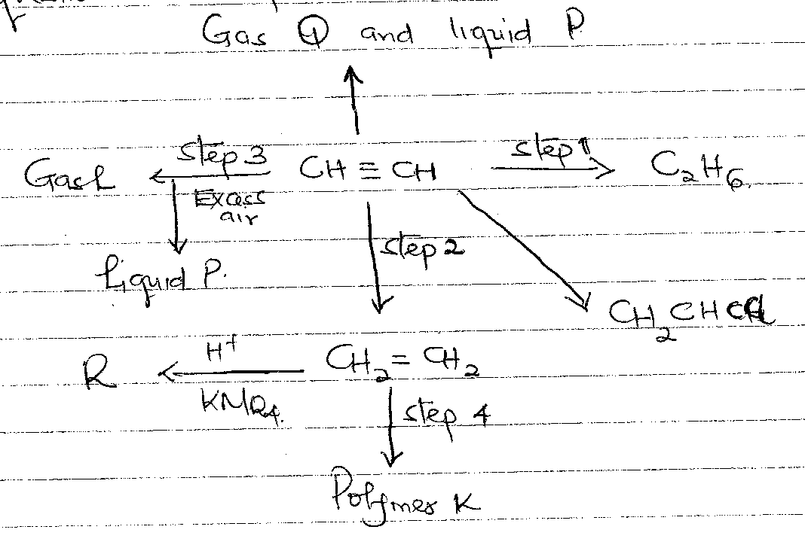
- Name the reagents used in: (4 mks)

Step 1…………………………………………………………………………………
Step 2…………………………………………………………………………………
Step 3…………………………………………………………………………………
Step 4…………………………………………………………………………………

- Identify substance. (3 mks)

L………………………………………………………………………………………
P………………………………………………………………………………………
Q………………………………………………………………………………………
N………………………………………………………………………………………
K………………………………………………………………………………………
R………………………………………………………………………………………
- Draw the structural formula of:
R (1 mk)

K (1 mk)

- Ethanol from glucose can be converted to ethane as shown below:

- Name the process that takes place in 1. (1 mk)
……………………………………………………………………………………………..
- Name the reagent used in step 2. (1 mk)
………………………………………………………………………………………………
- Compound A and B have the same molecular formulae C₃H₆O₂. Compound A liberates carbon iv oxide on addition of sodium carbonate while compound B doesn’t. Compound B has a sweet smell. Draw the possible structures of: (2 mks)
- A

- B

- (i) (a) Write the chemical name for rust. (1 mk)

(b) State any two ways of preventing rusting. (2 mks)

………………………………………………………………………………………………
………………………………………………………………………………………………
(c) Give a reason why vehicles based in Mombasa rust faster than those based in
Limuru. (1 mk)

………………………………………………………………………………………………
………………………………………………………………………………………………
(d) Oxygen to obtained by fractional distillation of liquid air. Name two other gases
which are obtained during the distillation. (1 mk)

………………………………………………………………………………………………
………………………………………………………………………………………………
(ii) In an experiment to determine the solubility of sodium chloride, 5cm³ of a saturated solution of sodium chloride of mass 5.35g were placed in a volumetric flask and diluted to a total of 250 cm³. 25 cm³ of the dilute solution reacted completely with 24cm³ of 0.1 moldm³ silver nitrate solution. Calculate:

- Moles of silver nitrate in 24cm³ of solution. (1 mk)

- Moles of sodium chloride to 25cm³ of solution. (1 mk)

- Moles of sodium chloride in 250 cm³ of solution. (1 mk)

- Mass of sodium chloride in 5 cm³ of the original saturated sodium chloride solution
(1 mk)

- Solubility of sodium chloride. (1 mk)

- The apparatus below was used to investigate the effect of dry hydrogen gas on hot lead (II) oxide.
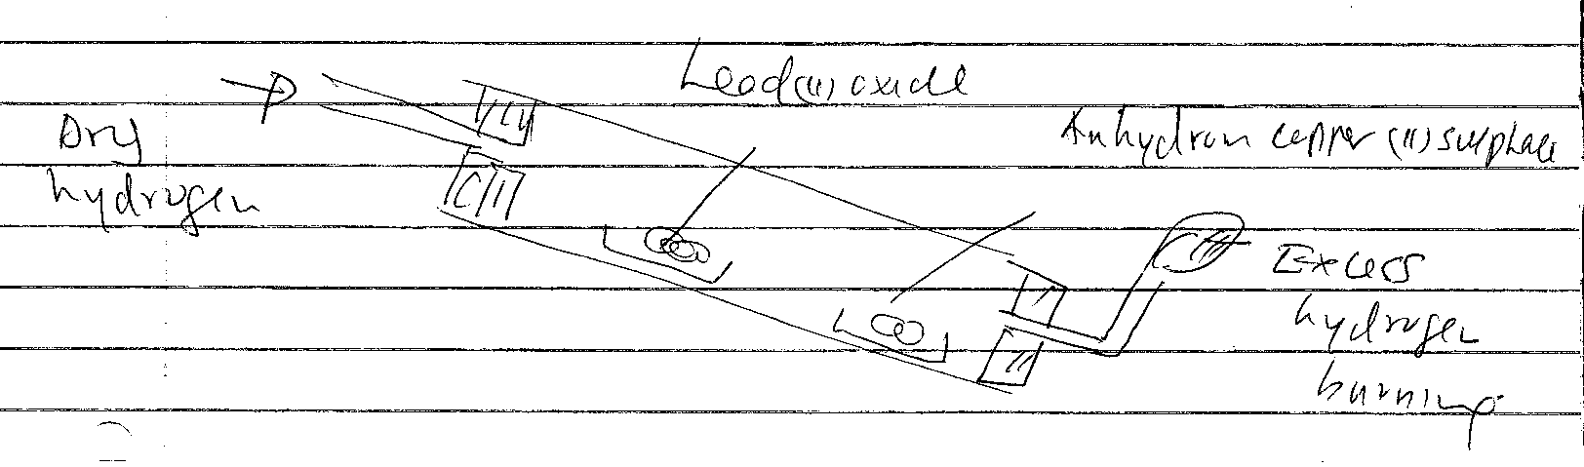
- What is observed in the combustion tube at the end of the experiment? (2 mks)

………………………………………………………………………………………………
………………………………………………………………………………………………
………………………………………………………………………………………………
………………………………………………………………………………………………
- Write an equation for the reaction between hydrogen gas and lead (II) oxide. (1 mk)

- Why should the tube be slanting? (1 mk)

………………………………………………………………………………………………
………………………………………………………………………………………………
- State any 2 precautions to be observed when doing this experiment. (2 mks)

………………………………………………………………………………………………
………………………………………………………………………………………………
………………………………………………………………………………………………
………………………………………………………………………………………………

- The table below shows volumes of nitrogen (IV) oxide gas produced when different volumes of 1M nitric (V) acid were reacted with 2.07g of lead at room temperature.

Volume of 1M nutirc (V) acid | Volume of nitrogen (IV) oxide gas (cm³)
5 | 60
15 | 180
25 | 300
35 | 420
45 | 480
55 | 480

- Give a reason why nitric (IV) is not used to prepare hydrogen gas. (1 mk)

………………………………………………………………………………………………
………………………………………………………………………………………………
- On the grid provided plot a graph of the volume of the gas produced against the volume of the gas produced against the volume of the acid. (3 mks)

- Use your graphs to determine:
- Volume of nitrogen (IV) oxide produced when 30 cm³ of 1M nitric (V) acid were reacted with 2.07g of lead. (1 mk)

- Volume of 1M nitric (V) acid that would react completely with one mole of lead. (1 mk)

- Calculate the number of moles of:
- 1M nitric (V) acid that reacted with one mole of lead. (1 mk)

- Nitrogen (IV) oxide produced when one mole of lead reacted with excess nitric (V) acid. (Molar gas volume = 2400 cm) (1 mk)

- Use the answers to d above and write the equation for the reaction between lead and nitric(V) acid. (1 mk)

- Explain how the rate of the reaction between lead and nitric (V) acid would be affected if the temperature of the reaction mixture was raised. (2 mks)

………………………………………………………………………………………………
………………………………………………………………………………………………
………………………………………………………………………………………………
………………………………………………………………………………………………
- (a) When ammonia gas is passed through copper (II) sulphate solution a blue precipitate is
formed which dissolves to give a deep blue solution. Write an ionic equation for the
formation of:
(i) The blue precipitate (1 mk)

(ii) the deep blue precipitate. (1 mk)

(b) Aluminum oxide is amphoteric.

(a) Explain the term amphoteric. (1 mk)

………………………………………………………………………………………………
………………………………………………………………………………………………
(b) Name and give the formula of other two amphorteric oxides. (2 mks)

………………………………………………………………………………………………
………………………………………………………………………………………………
………………………………………………………………………………………………
………………………………………………………………………………………………

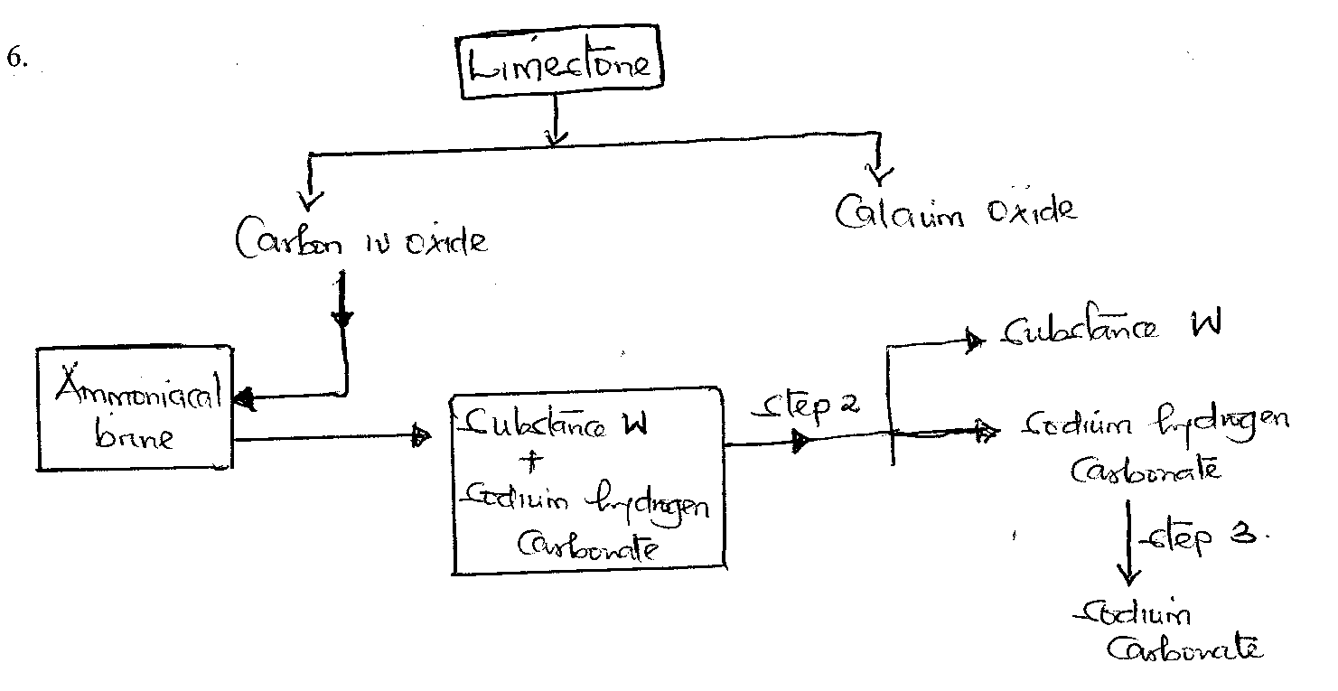

- What is the chemical name for limestone. (1 mk)

………………………………………………………………………………………………
- Identify substances: (2 mks)

- X - ………………………………………………………………………………
- W - ………………………………………………………………………………
- Name the process taking place in: (2 mks)

- Step II………………………………………………………………………………
- Step III……………………………………………………………………………..
- Write a chemical equation for the reaction of:
- Leading to formation of substances W and sodium hydrogen carbonate. (1 mk)

- Taking place in step (III). (1 mk)

- Carbon (V) oxide and ammonia are required during the solvay process. Write equation to show how ammonia is recycled. (1 mk)

- Name the other product of solvay process and state one use of it. (1 mk)

………………………………………………………………………………………………
- State two uses of sodium carbonate. (2 mks)

………………………………………………………………………………………………
………………………………………………………………………………………………
………………………………………………………………………………………………
………………………………………………………………………………………………
- The grid below represents past of the periodic table. Study it and answer the questions.

 |  |  |  | B |  |  | C
K | F |  | D |  |  | E | A | Y
 | G

- Identify the family name to which element F and G belong. (1 mk)

………………………………………………………………………………………………
………………………………………………………………………………………………
- Name the type of bond formed when C and F react. (1 mk)
………………………………………………………………………………………………
- Write the formulae of the oxide formed when D reacts with oxygen. (1 mk)

- What type of oxide is formed in (c) above. (1 mk)
………………………………………………………………………………………………
- Compare the atomic radii of F and D. Explain. (2 mks)
………………………………………………………………………………………………
………………………………………………………………………………………………
………………………………………………………………………………………………
………………………………………………………………………………………………
- Element F burns in air to form two products. Write 2 equations for the two products formed.

- State two uses of element K and its compounds. (2 mks)

………………………………………………………………………………………………
………………………………………………………………………………………………
………………………………………………………………………………………………
………………………………………………………………………………………………

