Name: …………………………………………………………… Index No.:……………………................
School: …………………………………………………………. Candidate’s Sign:……………………...
Date:…..……………..…………………………….........................

233/1
CHEMISTRY
(THEORY)
PAPER 1
JULY/AUGUST - 2015
TIME: 2 HOURS

TRANS-NZOIA COUNTY JOINT EVALUATION EXAM – 2015
Kenya Certificate of Secondary Education (K.C.S.E)

CHEMISTRY
PAPER 1
2 HOURS

INSTRUCTIONS TO THE CANDIDATES
- Write your name and index number in the spaces provided above.
- Sign and write the date of examination in the spaces provided.
- Answer all questions in the spaces provided.
- Mathematical table and silent electronic calculators may be used.
- All workings must clearly be shown where necessary.

For Examiner’s Use Only:-
QUESTION | MAXIMUM SCORE | CANDIDATE’S SCORE
1 – 28 | 80

This paper consists of 8 printed pages.
Candidates should check the question paper to ascertain that all pages are printed as indicated.
And that no questions are missing

1. A wooden splint was slipped through a region of a particular flame in the laboratory and was burnt as
shown in the diagram below.
Unburnt part

Burnt part

- Name the type of flame the splint was slipped through. (1 mk)
……………………………………………………………………………………………….
- Explain why the splint was burnt the way is shown in the diagram. (2 mks)
………………………………………………………………………………………………
………………………………………………………………………………………………
2. (a) State Gay Lussac’s law. (1 mk)
………………………………………………………………………………...........................
…………………………………………………………………………………………………
- 10 cm³ of a gaseous hydrocarbon, C₂H_{x} required 30 cm³ of oxygen for complete combustion. If
steam and 20 cm³ of carbon (IV) oxide gas were produced, what is the value of x? (2 mks)
………………………………………………………………………………………………………
………………………………………………………………………………………………………
……………………………………………………………………………………………………….
3. The diagram below shows the set-up used to burn hydrogen and collect the product.
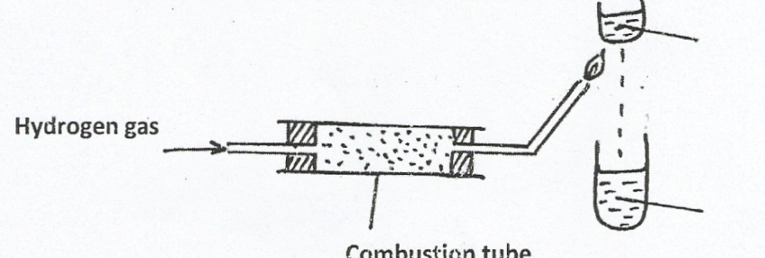
Cold water
Colourless liquid
Combustion tube packed with fused CaCl₂
Hydrogen gas

- Why is hydrogen not readily used as a fuel? (1 mk)
………………………………………………………………………………………………..
- (i) State the precaution that must be taken before igniting the hydrogen. (1 mk)
………………………………………………………………………………………………….
(ii) State two uses of hydrogen gas. (1 mk
…………………………………………………………………………………………………..
…………………………………………………………………………………………………..
4. (a) Define the term solubility. (1 mk)
…………………………………………………………………………………………………...
(b)The following were the results obtained in an experiment to determine solubility of Potassium
Nitrate at room temperature.
Mass of evaporating dish = 14.32 g
Mass of evaporating dish + saturated solution = 35.70 g
Mass of evaporating dish + salt (residue) = 18.60 g
Calculate the solubility of Potassium Nitrate from the specimen results. (2 mks)

5. The electron arrangement of ions X³⁺ and Y²⁻ are 2. 8 and 2 . 8. 8 respectively.
(a) To which groups does X and Y belong to. (1 mk)
X………………………………………..……, Y………………..………………………………
(b) State the atomic numbers of X and Y. (1 mk)
X…………………………………….…………, Y………………………………………………
(c) Write a formula of compound formed when Y and X reacts. (1 mk)
…………………………………………………………………………………………………….
6. 50 cm³ of Carbon (IV) Oxide diffuses through a porous plate in 15 seconds. Calculate the time taken
by 75 cm³ Nitrogen (IV) Oxide to diffuse through the same plate under similar conditions.
(C = 12, O= 16, N = 14) (3 mks)

7. (a) Name the following organic compound (1 mk)
CH₃
⏐
CH₃⎯ CH₂ ⎯ C⎯CH₂⎯CH₂⎯CH₃ …………………………………………………….
⏐
CH₃
(b) Draw and name any two isomers of C₄H₁₀ (2 mks)

8. Hydrogen sulphide gas is bubbled into two solutions of metallic nitrate as represented in the flow
chart below.
Blue solution
Brown solution
Black solid W
Green solution Q
Hydrogen
Sulphide

- Identify the cation present in:
(i) Blue solution (1 mk)
…………………………………………………………………………………………….
(ii) Brown solution. (1 mk)
……………………………………………………………………………………………..
(b) Write an ionic equation for the formation of black solid W. (1 mk)
……………………………………………………………………………………………….
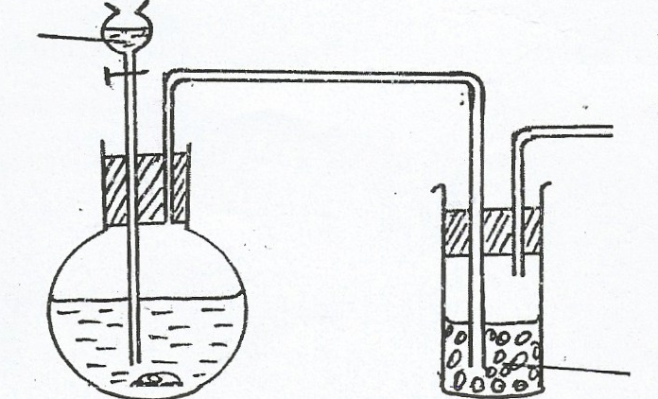
9. The set-up below was used to prepare dry sample of Oxygen gas
Water
J

Solid H

- (i) Complete the diagram to show how the gas was collected (1 mk)
(ii) Identify the following (1 mk)
I. Solid H
……………………………………………………………………………………………….
II. Solid J
……………………………………………………………………………………………..
- Write an equation for the reaction that occurred in the flask between solid H and water. (1 mk)
………………………………………………………………………………………………….
10. The table below gives the melting points of oxides of elements in period 3. Study it and answer the questions that follow.
Formula of oxide | Na₂O | MgO | Al₂O₃ | SiO₂ | P₄O₁₀ | SO₃
Melting point (⁰c) | 1190 | 3080 | 2050 | 1730 | 560 | -73

- Identify the compound in the above table that will dissolve in dilute hydrochloric acid and dilute sodium hydroxide. (1 mk)
……………………………………………………………………………………………………..
- Explain the difference in melting points of MgO and P₄O₁₀. (2 mks)
……………………………………………………………………………………………………
……………………………………………………………………………………………………..
11. Calcium carbonate decomposes on heating producing a gaseous product and a residue. What volume
of gaseous product at s.t.p is produced from 2.5 g of the carbonate.
(Ca = 40.00 C = 12.0 = 16.0, molar gas volume at s.t.p = 22400 cm³) (3 mks)
………….....................................................................................................................................
......................................................................................................................................................
…………………………………………………………………………………………………..
……………………………………………………………………………………………………
12. Magnesium hydroxide is used as a medication to relieve stomach acidity.
(a) Write a balanced chemical equation for the reaction that occurs in the stomach when one takes in
the medicine. (1 mk)
…………………………………………………………………………………………………………..
(b) What type of reaction takes place in the stomach after taking the medicine. (1 mk)
………………………………………………………………………………………………
- Sodium hydroxide cannot be used for the same purpose. Explain. (1 mk)
………………………………………………………………………………………………..
13. (a) Distinguish between nuclear fusion and fission. (2 mks)
……………………………………………………………………………………………………
……………………………………………………………………………………………………..
- Complete the nuclear equation below.
²³⁰Th ²³⁰ Pa + ____ (1 mk)
⁹⁰ ⁹¹
- Copper – 64 has half – life of 12.8 days. What mass of copper – 64 will remain after 51.2 days starting with 20 g of the isotope? (1 mk)
……………………………………………………………………………………………………..
…………………………………………………………………………………………………….
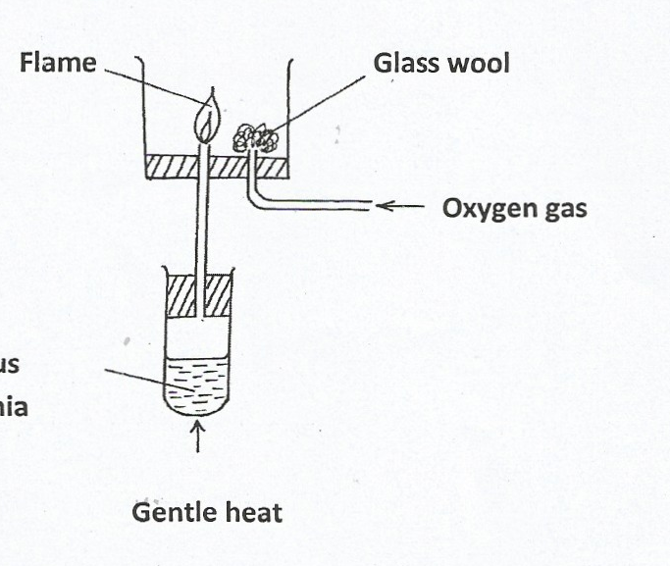
14. Study the diagram below and answer the questions that follow:
Oxygen gas
Flame
Aqueous ammonia
Gentle heat
Glass wool

- Why is aqueous ammonia warmed gently? (1 mk)
…………………………………………………………………………………………………
- What is the colour of the flame? (1 mk)
…………………………………………………………………………………………………..
- Write an equation for the reaction that produces the flame. (1 mk)
………………………………………………………………………………………………..
15. The following is an organic compound represented as CH₃CH₂COOCH₂CH₃
(i) Draw and name the organic acid and alkanol used in making the compound. (2 mks)

(ii) Name the organic compound and the gas formed when the alkanol in (i) above is reacted with
Potassium.. (1 mk)
…………………………………………………………………………………………………
……………………………………………………………………………………………………..
16. Use the information below to answer the question that follows.
Ca_{(s)} + _{½} O_{2(g )} CaO_{(s)} ; ΔH = 635KJmol⁻
C_{(s)} +O_{2(g)} CO_{2(g)}; ΔH = -394 KJMol⁻
Ca_{(s)} + C_{(s)} +$3/2$O_{2(g)} CaCO_{3(s)} ΔH = -1207 KJmol⁻
Calculate the enthalpy change for the reaction. (3 mks)

17. Study the information in the table below and answer the questions that follow. A mixture contains
three solids, aluminum sulphate sugar, and camphor. The solubility of these solids in different liquids is shown in the table below.
Solid | Water | Alcohol | Ether
Aluminium sulphate | Soluble | Insoluble | Insoluble
Sugar | Soluble | Soluble | Insoluble
Camphor | Insoluble | Soluble | Very soluble

Describe how you would obtain a solid sample of sugar from the mixture. (3 mks)
………………………………………………………………………………………………………
………………………………………………………………………………………………………
……………………………………………………………………………………………………….
18. The curve below represent the changes in the concentrations of substance E and F with time in the
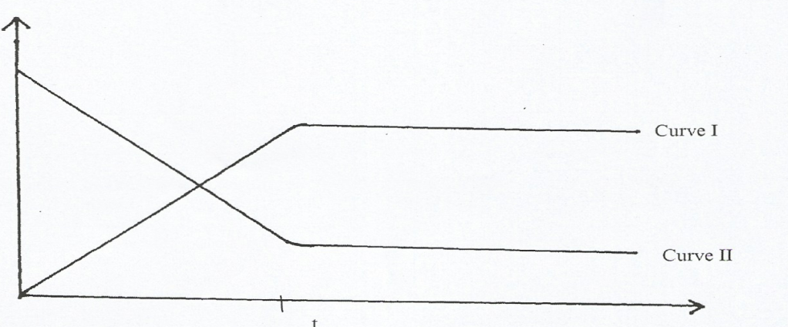
reaction. E_{(g)} F_{(g)}
Curve I
Curve II
t
Time (sec)
Concentration mole / dm³

- Which curve represents the changes in the concentration of substance F? Give a reason.(2 mks)
…………………………………………………………………………………………………….
…………………………………………………………………………………………………….
- Give a reason for the shapes of the curves after time (t) minutes. (1 mk)
………………………………………………………………………………………………….
19. Reagent bottles labelled H₂SO_{4(aq)}, K₂CO_{3(aq)} and NaCl_{(aq)} had labels accidentally removed. A packet of blue litmus paper is lying near a long with a rack of test-tubes, without using any other material, explain how you would go about labeling the bottles correctly. (3 mks)
…………………………………………………………………………………………………………
………………………………………………………………………………………………………
………………………………………………………………………………………………………….
20. Some sodium chloride was found to be contaminated with Copper (II) oxide. Describe how a sample
of sodium chloride can be separated from the mixture. (2 mks)
……………………………………………………………………………………………………….
……………………………………………………………………………………………………….
21. Describe how you can distinguish a solution of sodium sulphite from a solution of sodium sulphate
in the laboratory. (3 mks)
…………………………………………………………………………………………………………
…………………………………………………………………………………………………………..
……………………………………………………………………………………………………………
22. The grid below represents part of periodic table. Study it and answer the questions that follow. The
letters given do not represent the actual symbols of the elements.
 |  |  |  |  |  |  | P
 | Q |  | R |  | S |  |  | T

- Write an equation of the reaction taking place when Q and P react. (1 mk)
…………………………………………………………………………………………………..
- State one use of element T. (1 mk)
…………………………………………………………………………………………………
23. The diagram below shows some steps used in the manufacture of sodium carbonate by the Solvay
process.
Ammonia
Ammonium
chloride
Concentrated
Sodium chloride
Step 1
CO_{2 (g)}
Carbonator
Substance D
Step III
Sodium
Carbonate
Sodium
Carbonate
Step II

- Name substance D (1 mk)
………………………………………………………………………………………………..
(b) What process takes place in. (2 mks) i.) Step II …………………………………………………………………………
ii.) Step III ……………………………………………………………………….
24. Describe how you would prepare crystals of sodium nitrate starting with 200 cm³ of 2M sodium hydroxide. (3 mks)
………………………………………………………………………………………………………..…………………………………………………………………………………………………………..…………………………………………………………………………………………………………..…
25. Use the information below to answer the questions that follow:
Q_{(s)}/ Q²⁺_{(aq)} E⁰ = -0.76V
R_{(s)}/ R²⁺_{(aq)} E⁰ = + 034V
- Write the cell equation for the cell. (1 mk)

- Calculate the Emf value for the cell. (1 mk)

- State two application of electrolysis. (1 mk)
………………………………………………………………………………………………………
………………………………………………………………………………………………………
26. (a) Aluminium chloride sublimes. Explain. (1 mk)
………………………………………………………………………………………………………...
…………………………………………………………………………………………………………..
- Aluminium is a reactive metal yet utensils made of aluminium do not corrode easily. Explain.
……………………………………………………………………………………………..(1 mk)
…..…………………………………………………………………………………………………
27. The diagram below shows industrial manufacture of hydrochloric acid.
Water
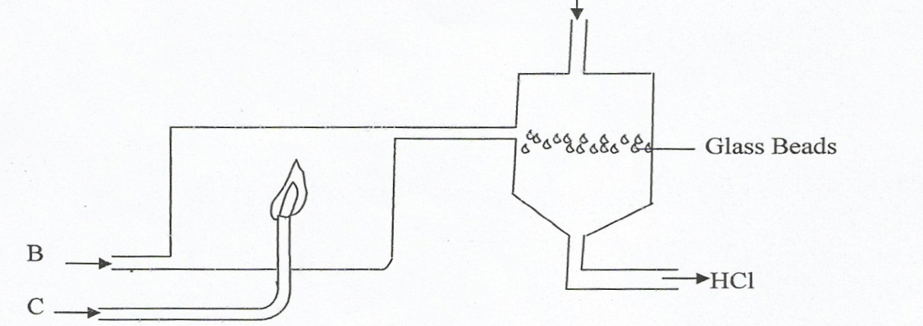

Glass Beads

HCl _{(aq)}
- Name the substance: (2 mks)
A …………………………………………..,B ……………………………………………….
- State the effect of the above plant on the environment. (1 mk)
……………………………………………………………………………………………………
28. When excess ammonia solution is added to copper (II) ions a deep blue solution is formed.
Write the formulae of the complex ion formed. (1 mk)
……………………………………………………………………………………………………
……………………………………………………………………………………………………

