**Name: ……………………………………………………………** **Index No.:……………………................**

**School: …………………………………………………………. Candidate’s Sign:……………………...**

**Date:…..……………..…………………………….........................**

**233/2**

**CHEMISTRY**

**PAPER 2**

**(THEORY)**

**JULY/AUGUST - 2015**

**TIME: 2 HOURS**

**TRANS-NZOIA COUNTY JOINT EVALUATION EXAM – 2015**

***Kenya Certificate of Secondary Education (K.C.S.E)***

**CHEMISTRY**

**PAPER 2**

**2 HOURS**

**INSTRUCTIONS TO THE CANDIDATES**

* Write your ***name*** and ***index* *number*** in the spaces provided above.
* ***Sign*** and write the ***date*** of examination in the spaces provided.
* Answer ***all*** questions in the spaces provided.
* KNEC mathematical table and silent non-programmable electronic calculators may be used.
* All workings ***must*** be clearly shown where necessary.
* Candidates should answer the questions in ***English*.**

**For Examiner’s Use Only:-**

|  |  |  |
| --- | --- | --- |
| **QUESTION** | **MAXIMUM SCORE** | **CANDIDATE’S SCORE** |
| 1 | 12 |  |
| 2 | 10 |  |
| 3 | 13 |  |
| 4 | 11 |  |
| 5 | 11 |  |
| 6 | 11 |  |
| 7 | 12 |  |
| **Total** | **80** |  |

*This paper consists of 8 printed pages.*

*Candidates should check the question paper to ascertain that all pages are printed as indicated.*

*And that no questions are missing.*

**1**. (a) The information below relates to element N, P, Q, R and S. Study it and use it to answer the

questions that follow. The letters are not the actual symbols of the elements.

|  |  |  |  |  |
| --- | --- | --- | --- | --- |
| Element | Atomic radius (mm) | Ionic radius (mm) | Formula of oxide | Melting point of oxide |
| N  P  Q  R  S | 0.364  0.830  0.592  0.381  0.762 | 0.421  0.711  0.485  0.446  0.676 | N2O  PO2  Q2O3  R2O5  SO | -119  837  1466  242  1054 |

(i) Name the elements that are metal. Give a reason. (2 mks)

…………………………………………………………………………………………………………..

…………………………………………………………………………………………………………..

(ii) Compare the melting points of the oxides of S and R in terms of structure and bonding. (2 mks)

………………………………………………………………………………………………………..

…………………………………………………………………………………………………………..

(iii) Name the pair of elements that would react most vigorously with each other? Explain. (2 mks)

…………………………………………………………………………………………………………..

…………………………………………………………………………………………………………..

(b) The table below has information about chlorides of elements in period 3 of the periodic table:

sodium to sulphur.

|  |  |  |  |  |  |
| --- | --- | --- | --- | --- | --- |
| **Chloride** | NaCl | MgCl2 | AlCl3 | SiCl4 | PCl5 |
| **Melting point (0C)** | 801 | 712 | Sublimes at 183 | -70 | -80 |

1. What are the possible PH values of the solutions formed when the following chlorides are dissolved in water? Explain.

MgCl2  (1 mk)

…………………………………………………………………………………………………..

AlCl3 (1 mk)

…………………………………………………………………………………………………..

(c) The molecular formula of Aluminium chloride is Al2Cl6. Draw the structural

(not dot and cross diagram) of Aluminium chloride indicating clearly the different types of bonds

present. (2 mks)

(d) Using dot **(.)** and cross **(x)**, draw a diagram to show bonding in sodium chloride.

***(Na = 11, Cl = 17)*** (2 mks)

**2.** Sulphuric (IV) acid can be prepared using hydrogen sulphide as shown in flow chart below. Study it

and answer the questions that follow.

DRY HYDROGEN SULPHIDE

**SOLID C**

**BURNERS**

**OLEUM**

**AIR**

**CHAMBER D**

**ABSORPTION TOWER**

**GAS A**

**SULPHUR IV OXIDE**

**LIQUID B**

1. Identify:
2. Gas **A**: …………………………………………………………………… (1 mk)
3. Liquid **B**: …………………………………………………………………. (1 mk)
4. (i) What function does solid C play in the chamber **D**? ( 1mk)

………………………………………………………………………………………………………

(ii) Write an equation for the reaction in chamber **D**. (1 mk)

………………………………………………………………………………………………………

1. Explain the observations made if hydrogen sulphide gas is bubbled through copper (II) nitrate solution.? (2 mks)

………………………………………………………………………………………………………………………………………………………………………………………………………………

1. Write an ionic equation for the confirmatory test for hydrogen sulphide gas. (1 mk)

………………………………………………………………………………………………………

1. Write a chemical equation to show the formation of concentrated Sulphuric (VI) acid from the oleum. (1 mk)

………………………………………………………………………………………………………

1. Explain why in contact process SO3 gas is not directly dissolved in water to make concentrated sulphuric (VI) acid. (2 mks)

………………………………………………………………………………………………………

………………………………………………………………………………………………………

**3**. (a) Write the formula of the complex ion formed in each of the following reactions below.

(i) Lead metal dissolves in hot alkaline solution. (1 mk)

………………………………………………………………………………………………………

(ii) Zinc hydroxide dissolves in excess ammonia solution. (1 mk)

………………………………………………………………………………………………………

(b) Give the name of each of the processes described below which takes place when the salts are

exposed to air for some time

(i) Anhydrous Copper (II) Sulphate becomes wet. (1 mk)

………………………………………………………………………………………………………

(ii) Iron (III) chloride forms an aqueous solution. (1 mk)

………………………………………………………………………………………………………

(iii) Fresh crystals of sodium carbonate decahydrate become covered with a white powder of

solution carbonate monohydrate. (1 mk)

………………………………………………………………………………………………………

(c) From the redox below:

Cr2O2-7(aq) + 3SO2-3 (aq) + 8H+ (aq) 2Cr3+(aq) +3SO42-(aq) + 4H2O(l)

1. Give the reduction half equation. (1 mk)

………………………………………………………………………………………………………

(ii) State and explain the observation made when a solution of sodium hydroxide is added to the

equilibrium mixture above. (2 mks)

………………………………………………………………………………………………………

………………………………………………………………………………………………………

………………………………………………………………………………………………………

(d) A certain hydrate salt has the following composition by mass. Iron 20.2%, sulphur 11.5%, water

45.5% and the rest oxygen. Its relative formula mass is 278.

(i) Determine the formula of the hydrated salt. ***(Fe= 56, S = 52, O = 16, H = 1)*** (3 mks)

………………………………………………………………………………………………………

………………………………………………………………………………………………………

………………………………………………………………………………………………………

(ii) 6.95 g of the hydrated salt were dissolved in distilled water and the total volume made to 250 cm3

of solution. Calculate the concentration of the salt solution. (2 mk)

………………………………………………………………………………………………………

………………………………………………………………………………………………………

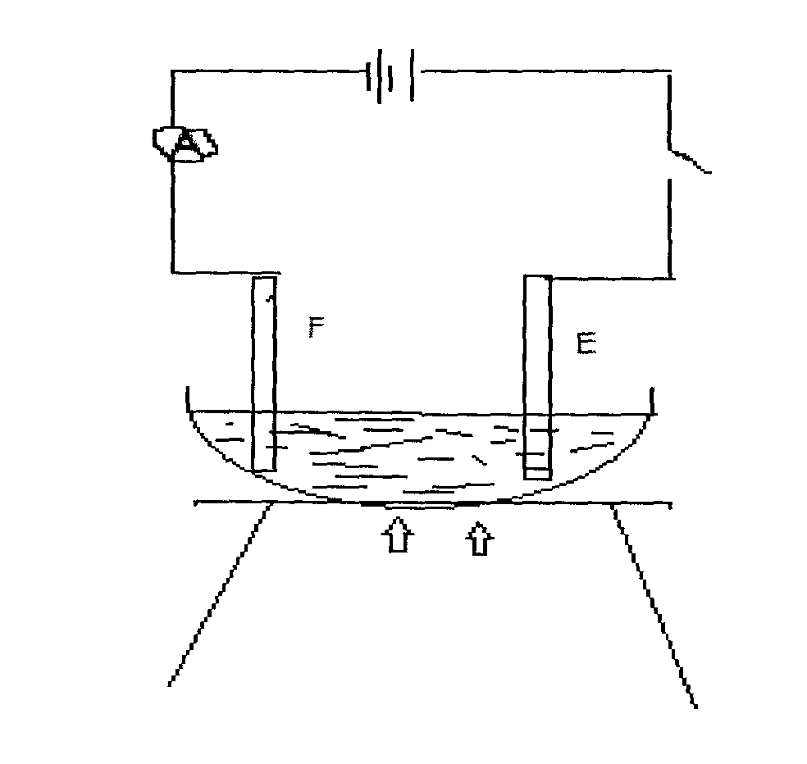**4**. You are provided with the diagram below. Use it to answer the questions below.

**Bulb**

**F**

**E**

**PbBr2**

1. Identify electrodes **E, F** (1 mk)

**E**……………………………………………………………………………………..

**F** ………………………………………………………………………………………

1. (i) Give **two** elements that are the most appropriate to be used as electrodes. (1 mk)

………………………………………………………………………………………………………

………………………………………………………………………………………………………

(ii) Explain your answer in b (i) (1 mk)

……………………………………………………………………………………………………….

………………………………………………………………………………………………………..

1. (i) State the observation made on the bulb when Lead (II) bromide is heated and the electric

current was switched on. (1 mk)

………………………………………………………………………………………………………

(ii) Explain your answer in c (i). (1 mk)

………………………………………………………………………………………………………

………………………………………………………………………………………………………

1. (i) Arrange the following anions in the order of increasing ease of discharge during electrolysis:

, OH-, SO42- , I-, Cl-, Br-  (2 mks)

………………………………………………………………………………………………………

(ii) Dilute Copper (II) sulphate solution was electrolysed using copper electrodes. Write an Ionic

equation to show the reaction occurring at the: (2 mks)

Anode: ………………………………………………………………………………………….

Cathode: ………………………………………………………………………………………...

1. An electric current of 2.5 amperes was passed through molten Lead (II) Bromide for 40 minutes. Calculatethe volume of bromine vapour that would be produced.

***(Faraday’s constant = 96,500 coulombs, molar volumes = 24.0dm3)***  (3 mks)

……………………………………………………………………………………………………………………………………………………………………………………………………………………………………………………………………………………………………………………

**5**. Study the flow chart below and use it answer the questions below.

**SILICON (IV) OXIDE**

**COMPRESSED AIR**

**SILICATES**

**USES:**

**MAKING ELECTRICAL CABLES**

**MAKING COINS**

**MAKING SOLDERING WIRE**

**HOT AIR**

**SLAG**

**Ore**

**CuFeS2**

**Crusher**

**MIXING CHAMBER**

**ROASTING FURNACE 1**

**SMELTING FURNACE**

**ROASTING FURNACE 2**

**MOLTEN METAL**

**PURIFICATION**

**OIL**

**WATER**

1. Identify the process described by the flow chart. (1 mk)

………………………………………………………………………………………………………

1. Explain why the ore is crushed. (1 mk)

………………………………………………………………………………………………………

1. Which process occurs in mixing chamber? (1 mk)

………………………………………………………………………………………………………

1. Explain the use of: (3 mks)

I. Water…………………………………………………………………………………………

………….………………………………………………………………………………….

II. Oil ..…………………………………………………………………………………………

………..……………………………………………………………………………………

III. Compressed air………………………………………………………………………………

………………………………………………………………………………………………..

(e) Write down an equation for the formation of slag. (1 mk)

……………………………………………………………………………………………………….

(f) Identify the cations present where the metal is being purified. (1 mk)

……………………………………………………………………………………………………….

(g) (i) Draw a diagram of a set-up used for electrolytic purification of copper. (2 mks)

(ii) A green rocky material is suspected to be malachite, CuCO3. Cu(OH)2.

Describe how the presence of copper can be confirmed. (2 mks)

………………………………………………………………………………………………… …………………………………………………………………………………………………

………………………………………………………………………………………………….

**6**. (a) State Hess’s law. (1 mk)

………………………………………………………………………………………………………

(b) Distinguish between **hydration** **energy** and **lattice energy**. (1 mk)

………………………………………………………………………………………………………

………………………………………………………………………………………………………

(c) An experiment was done using magnesium ribbon and dilute hydrochloric acid of different

concentrations. The time needed to produce 25 cm3 of the gas for every experiment was recorded

in the table below.

|  |  |  |  |  |  |  |  |  |
| --- | --- | --- | --- | --- | --- | --- | --- | --- |
| Conc. Of HCl (mol/Litre) | 2.0 | 1.75 | 1.50 | 1.25 | 1.00 | 0.75 | 0.50 | 0.25 |
| Time in Sec. (s) | 8.8 | 10.0 | 11.7 | 13.5 | 17.5 | 22.7 | 35.7 | 70.00 |
| (s-1) |  |  |  |  |  |  |  |  |

(i) Complete the table above. (2 mks)

(ii) Plot a graph of rate $1/{time}$ against concentration. (3 mks)

(iii) Determine from your graph the concentration needed to produce 25 cm3 of hydrogen gas, when

time is 15 seconds. (1 mk)

………………………………………………………………………………………………………

(d) The diagram below shows an energy level diagram for the formation of magnesium chloride.

Study it and answer the questions that follow.

Mg2+(g) + 2Cl-(g)

HH

Hk

MgCl2(s)

Hl

Mg2+(aq) + 2Cl-(aq)

Energy (KJ)

Reaction path

(i) State the enthalpy changes represented by the letters **H, J** and **K.** (1 ½ mks)

**H** …………………………………………… ……………………………………….

**J** ………………………………………………………………………………………

**K** ………………………………………………………………………………………

(ii) What is the relationship between ΔHH, ΔHJ and ΔHK. (½ mk)

………………………………………………………………………………………………………

(iii) Calculate the enthalpy change ΔHH given that ΔHJ = 2484Jmol- and ΔHK = -2659 KJmol (1 mk)

…………………………………………………………………………………………………………..

…………………………………………………………………………………………………………..

**7**. (a) Name any **two** factors that will affect the properties of a polymer. (2 mks)

…………………………………………………………………………………………………………..

…………………………………………………………………………………………………………..

(b) Polythene bags litter every city and villages across Kenya. State **two** approaches that can be used

to solve the problem of disposing polymers. (2 mks)

…………………………………………………………………………………………………………..

…………………………………………………………………………………………………………..

(c) Name the following compounds.

(i) HCOOCH2CH2CH3……………………………………………………………………….. (1 mk)

(ii) (CH3CH2COO)2Ca………………………………………………………………….. …… (1 mk)

(d) The scheme below relates to organic compounds. Study it and use it to answer the questions that

follow.

(1 ½ mks)

H H

| |

* C— C—

| |

CH3 H

**KMnO4/H+**

**W**

**O**

**Y**

**NaOH**

**U**

**NaOH/HEAT**

**NaOH(aq)**

**Na(s)**

**M**

**Na2CO3(S)**

**CH3CH2COONa**

**CH3CH2OH**

**W**

CH3CH= CH2

CH3CH2CH2OH

CH3CH2COOH

CH3CH2COOCH2CH3 **X**

Gas Q

CH3CH2COONa

CH3CH3 **V**

CH3CH2Cl

CH3CH2CH3

Gas P

**Z**

(i) Name:

I. Gas **P** ……………………………………………………………………………

II. Gas **Q** …………………………………………………………………………….

III. Substance **J** ………………………………………………………………………

(ii) Give the structural formula of **T** (½ mk)

…………………………………………………………………………………………………………..

(iii) State **one** common physical property of substance **N**. (½ mk)

…………………………………………………………………………………………………………..

(iv) Write down the equation for the reaction represented by step **U**. (½ mk)

…………………………………………………………………………………………………………..

1. A mixture of ethane, oxygen and nitrogen were ignited. On cooling the residue gas occupied

58 cm3 and when shaken with aqueous alkali the volume was reduced to 32 cm3. A further

18 cm3 of the product was absorbed by alkaline pyrogallol. Calculate the composition of the

original mixture. ***(NB:- Alkaline pyrogallol absorbs oxygen).*** (3 mks)

…………………………………………………………………………………………………………

…………………………………………………………………………………………………………..

…………………………………………………………………………………………………………..