**NAME:……………………………………………………… INDEX NO:…………………………**

**SCHOOL:………………………………………………….. DATE:……………………………….**

**SIGN:………………………………..**

**232/2**

**PHYSICS**

**PAPER 2**

**(THEORY)**

**JULY/AUGUST - 2012**

**TIME: 2 HOURS**

**BORABU-MASABA DISTRICTS JOINT EVALUATION TEST– 2012**

***Kenya Certificate of Secondary Education (K.C.S.E)***

**INSTRUCTIONS TO CANDIDATES**

1. Write your name and index number in the spaces provided at the top of this page.

2. Sign and write the date of examination in the spaces provided above.

3. This paper consists of TWO sections: A and B

4. Answer ALL the questions in the sections A and B in the spaces provided.

5. ALL working MUST be clearly shown.

6. Non-programmable silent electronic calculators and KNEC mathematical tables may be used.

**FOR EXAMINERS USE ONLY.**

|  |  |  |  |
| --- | --- | --- | --- |
| **SECTION** | **QUESTIONS** | **MAXIMUM SCORE** | **CANDIDATE’S SCORE** |
| A | 1 – 14 | 25 |  |
| B | 15 | 12 |  |
| **16** | **12** |  |
| **17** | **11** |  |
| **18** | **09** |  |
| **19** | **11** |  |
| **Total Score** |  | **80** |  |

*This paper consists of 12 printed pages.*

*Candidates should check the question paper to ensure that all pages are printed as indicated and that no questions are missing.*

**Section A (25 marks)**

1. Give one difference between luminous and non-luminous sources of light. (1mk)

.............................................................................................................................................................

.............................................................................................................................................................

2. **Figure 1** shows a circuit contains a battery of cells V. a 3Afuse F, a switch Sand two

identical lamps L1 and L2. A current of 2A flows through lamp L2 when the switch is open.

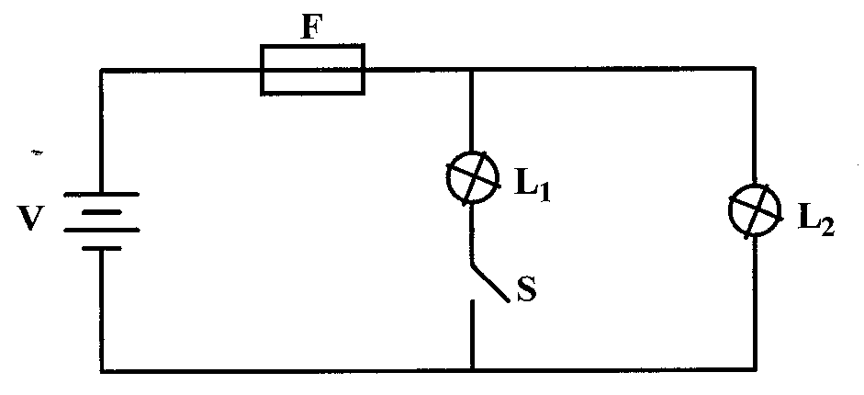

Figure 1

Explain why the fuse may blow when the switch is closed. (2mks)

.............................................................................................................................................................

.............................................................................................................................................................

.............................................................................................................................................................

.............................................................................................................................................................

3. When a negatively charged rod is brought near the cap of a leaf electroscope, the leaf rises. Explain this observation, (2mks)

.............................................................................................................................................................

.............................................................................................................................................................

.............................................................................................................................................................

.............................................................................................................................................................

4. **Figure 2** represents a displacement-time graph for a wave.

Figure 2

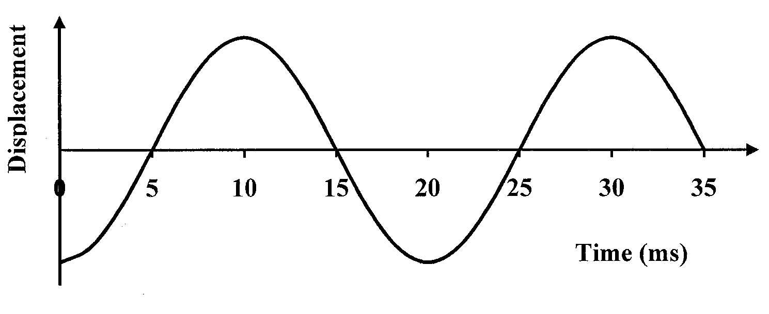

Determine the frequency of the wave. (2mks)

.............................................................................................................................................................

.............................................................................................................................................................

.............................................................................................................................................................

.............................................................................................................................................................

5. The reception of radio signals in a valley is better than the reception of TV signals in

the same valley. Explain this observation. (2mks)

.............................................................................................................................................................

.............................................................................................................................................................

.............................................................................................................................................................

.............................................................................................................................................................

6. In an experiment to determine the focal length of a concave mirror, magnification M was determined for various image distances v. Figure 3 shows a graph of magnification M against image distance v for the results from the experiment.

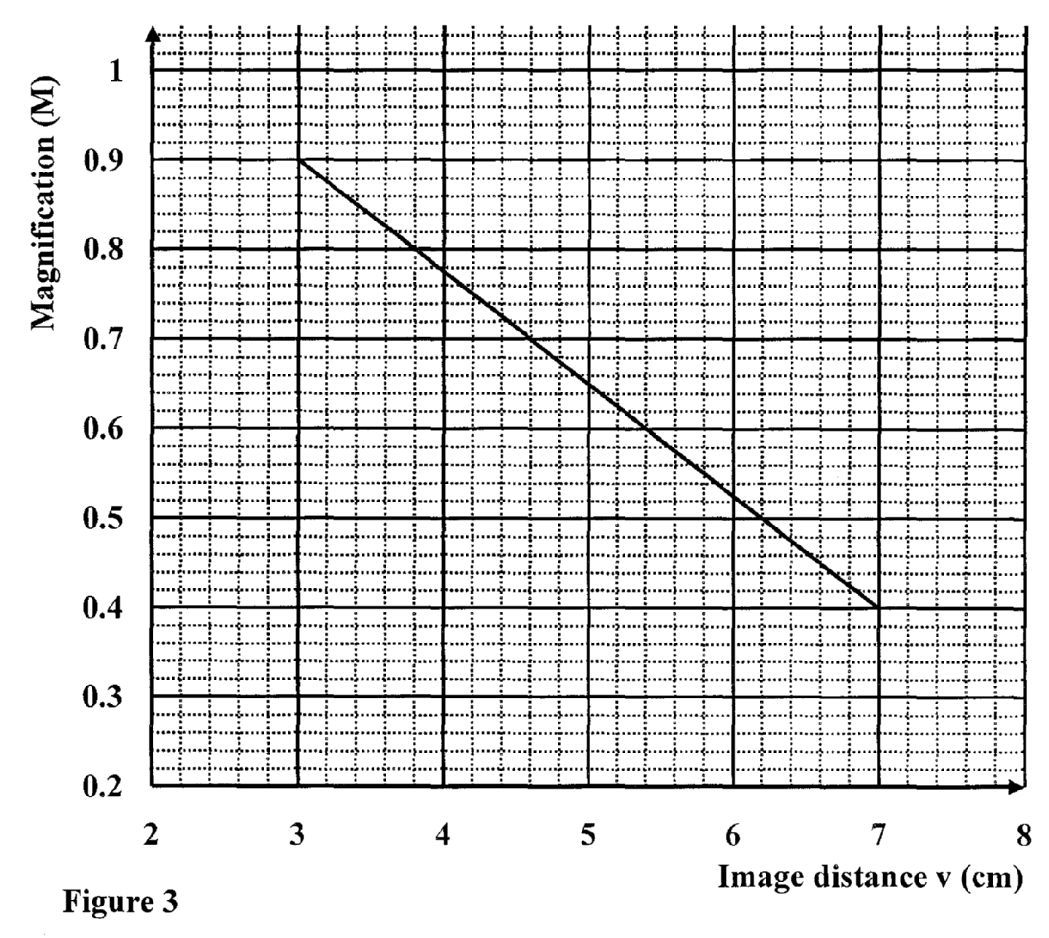

Given that M = 1 , determine the focal length f of the mirror. (3mks)

.............................................................................................................................................................

.............................................................................................................................................................

.............................................................................................................................................................

.............................................................................................................................................................

7. A hair dryer is rated 2500W, 240V. Determine its resistance. (2mks)

.............................................................................................................................................................

.............................................................................................................................................................

8. **Figure 4** shows the magnetic field pattern round a current-carrying conductor. Indicate on the

conductor the direction of the current. (1mk)

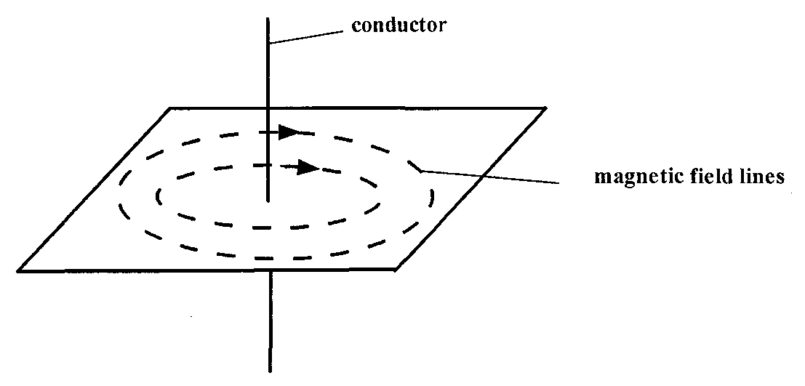

Figure 4

9. Why is repulsion the sure test for a magnet? (1mk)

.............................................................................................................................................................

.............................................................................................................................................................

10. **Figure 5** shows a ray of light incident on an air bubble which is inside water,

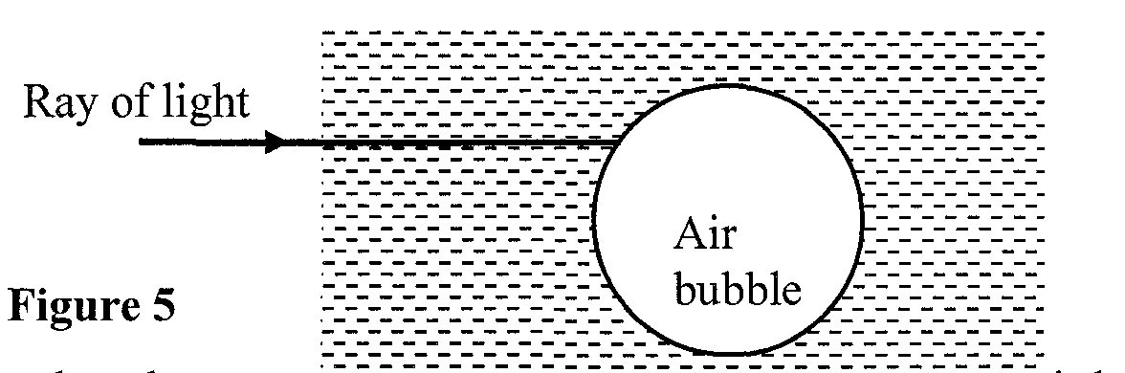

Complete the ray to show the path it follows through the air bubble. (1mk)

11. Explain how polarization of a cell increases the cell’s internal resistance. (2mks)

.............................................................................................................................................................

.............................................................................................................................................................

12. Figure 6 a loop of conductor wire moving parallel to a uniform magnetic field B

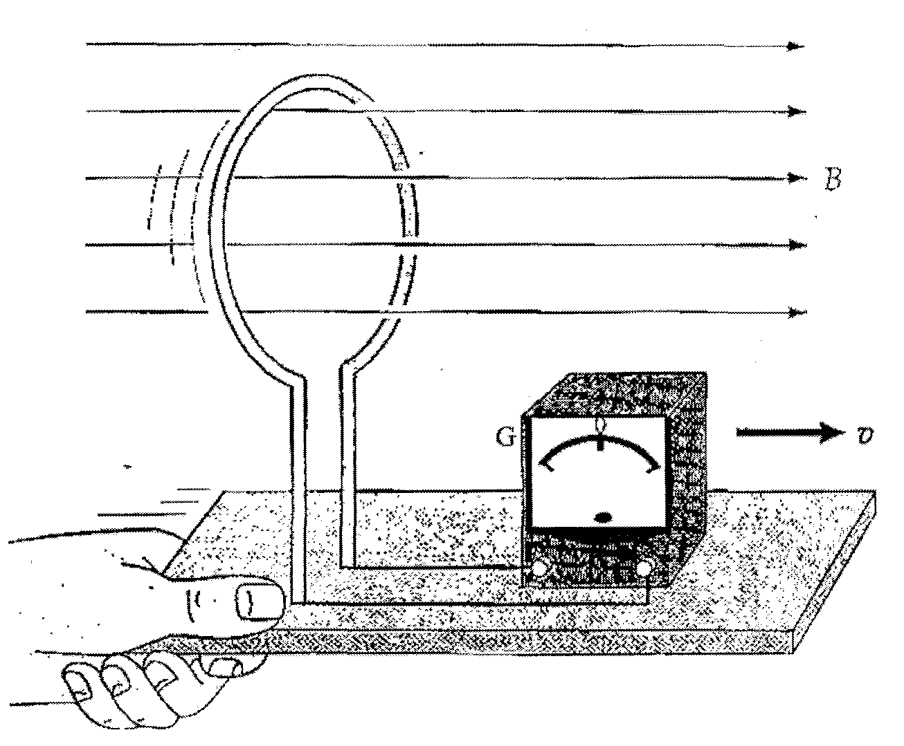

(i) Sketch on the galvanometer the pointer showing the pointer reading. (1mk)

(ii) Give the correct explanation of the reading you have sketched. (2mks)

.............................................................................................................................................................

.............................................................................................................................................................

.............................................................................................................................................................

.............................................................................................................................................................

13. Using the variation of resistance with temperature, differentiate between a conductor and a

semiconductor. (1mk)

.............................................................................................................................................................

.............................................................................................................................................................

.............................................................................................................................................................

.............................................................................................................................................................

14. A cell of internal resistance O.5 is in a circuit containing a 10 resistor. A current

of 2A flows in the circuit. Determine the emf of the cell. (2mks)

.............................................................................................................................................................

.............................................................................................................................................................

.............................................................................................................................................................

.............................................................................................................................................................

**Section B (55 marks)**

15. a) **Figure 7** shows a photocell used in a set-up for a burglar alarm.

Figure 7

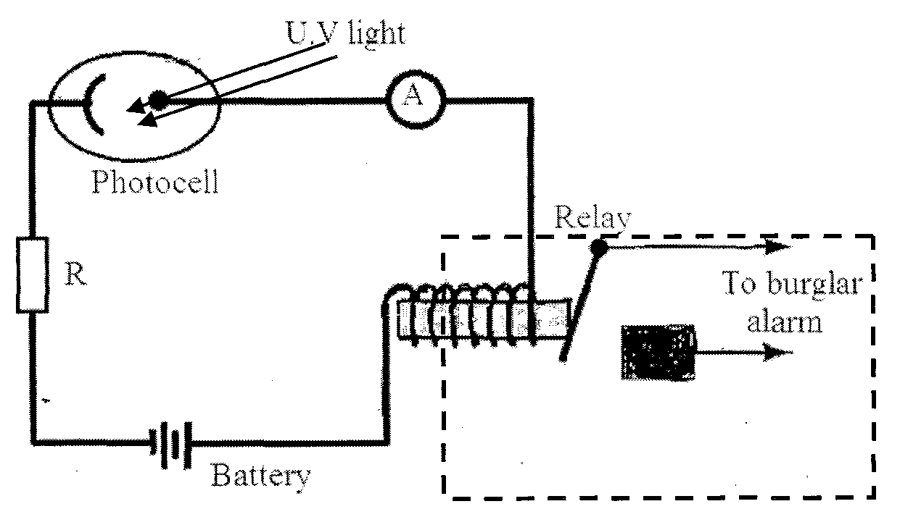

(i) Give a reason why the photocell is usually evacuated. (1mk)

.............................................................................................................................................................

.............................................................................................................................................................

(ii) State the function of the resistor R in this circuit. (1mk)

.............................................................................................................................................................

.............................................................................................................................................................

(iii) Explain why a particular radiation such as ultra-violet light is used to strike

a given cathode surface. (2mks)

.............................................................................................................................................................

.............................................................................................................................................................

.............................................................................................................................................................

.............................................................................................................................................................

(iv) Explain how the set-up in **figure 7** can be used as a burglar alarm. (3mks)

.............................................................................................................................................................

.............................................................................................................................................................

.............................................................................................................................................................

.............................................................................................................................................................

.............................................................................................................................................................

.............................................................................................................................................................

b) Light of frequency 5.50 x 1014 Hz. is incident on a surface whose work function is 2.5 eV.

(i) Determine the energy of a photon of the light in eV.

(Take h = 6.63 x 10-34Js and 1 eV = 1.6 x 10-19J) (3mks)

.............................................................................................................................................................

.............................................................................................................................................................

.............................................................................................................................................................

.............................................................................................................................................................

(ii) Will photoelectric emission occur? Explain. (2mks)

.............................................................................................................................................................

.............................................................................................................................................................

.............................................................................................................................................................

.............................................................................................................................................................

16. a) What is meant by the following terms:

(i) radioactive decay? (1mk)

.............................................................................................................................................................

.............................................................................................................................................................

(ii) half-life? (1mk)

.............................................................................................................................................................

.............................................................................................................................................................

b) A Geiger-Muller (GM) tube and a scaler are used to measure the decay rate from a radioactive sample. The results are shown in table 1. The background radiation is

included in the table. The background count rate is 25 counts per minute.

**Table 1**

|  |  |  |  |  |  |  |
| --- | --- | --- | --- | --- | --- | --- |
| Time (hours) | 0 | 1 | 2 | 3 | 4 | 5 |
| Count rate (counts/minute) | 440 | 265 | 165 | 105 | 75 | 55 |
| Actual count rate from sample (count/minute) |  |  |  |  |  |  |

(i) Complete the table to show the actual count rate from the radioactive

sample. (2mks)

(ii) Plot a graph of the actual count rate (y – axis) against time. (5mks)



(iii) From the graph determine the half-life of the radioactive sample. (3mks)

.............................................................................................................................................................

.............................................................................................................................................................

.............................................................................................................................................................

.............................................................................................................................................................

17. a) Name two properties common to both X-rays and gamma rays. (2mks)

.............................................................................................................................................................

.............................................................................................................................................................

.............................................................................................................................................................

.............................................................................................................................................................

b) **Figure 8** shows an X-ray tube.

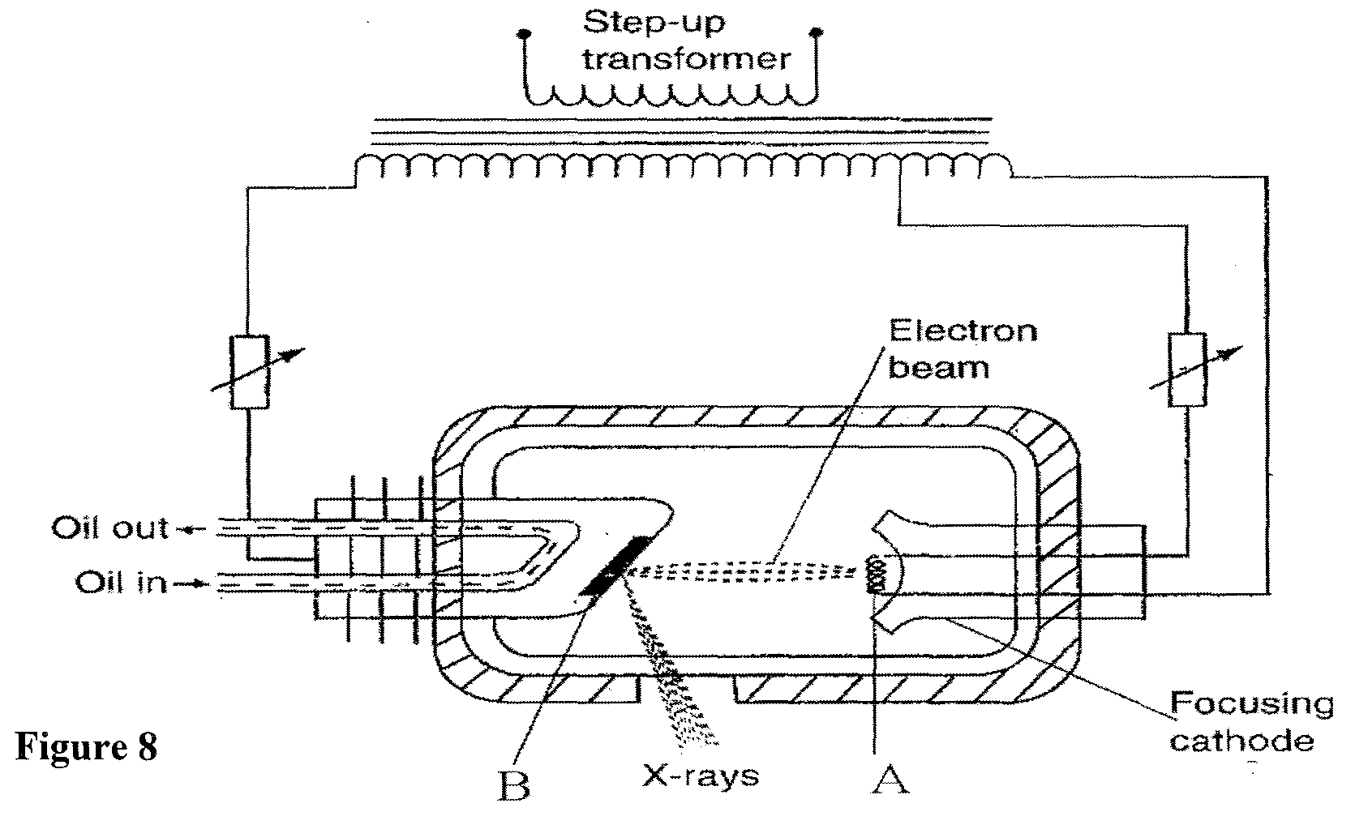

(i) Name the parts labelled A and B (2mks)

A ...............................................................................................

B................................................................................................

(ii) State the function each of the parts you have named in (i) (2mks)

A ..............................................................................................

B................................................................................................

(iii) In the X-ray tube the voltage between the cathode and anode is more than

50 000V. Give a reason for this. (1mk)

.............................................................................................................................................................

.............................................................................................................................................................

c) An X-ray tube operates with a potential difference of 150 kV between the cathode

and the anode. Only 0.5% of the kinetic energy of each electron is converted into

X-rays. (Take electronic charge, e = 1.6 x 10-19C)

Determine the maximum:

(i) kinetic energy of each electron. (2mks)

.............................................................................................................................................................

.............................................................................................................................................................

.............................................................................................................................................................

.............................................................................................................................................................

(ii) energy of the X-rays (2mks)

.............................................................................................................................................................

.............................................................................................................................................................

.............................................................................................................................................................

.............................................................................................................................................................

18. a) Is it safe to stay in a car during a lightning storm? Explain. (2mks)

.............................................................................................................................................................

.............................................................................................................................................................

b) **Figure 9** shows a circuit consisting of a 6V cell, a 200 resistor, a 20 F

capacitor and a switch S1 connected in series. Another 200 resistor and

Switch S2 are connected in parallel to the capacitor.

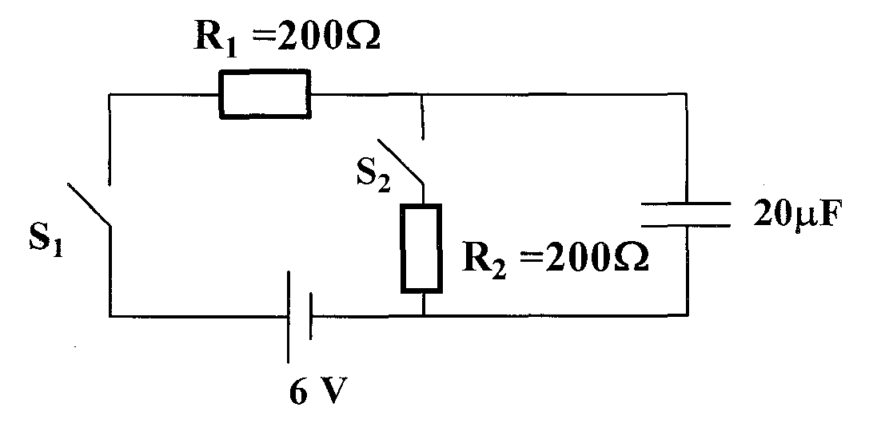

Figure 9

(i) On axes provided sketch graphs showing how the voltage VR across resistor R1 and the voltage VC across the capacitor vary with time when switch S1 is closed and switch S2 remains open. (2mks)

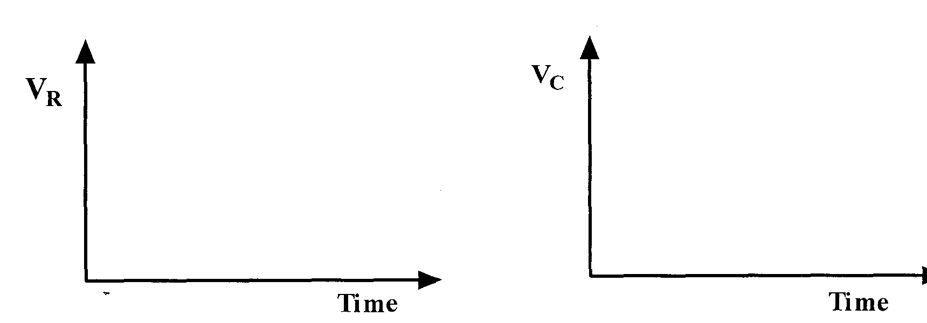

(ii) What is the maximum voltage across the capacitor when fully charged? (1mk)

.............................................................................................................................................................

.............................................................................................................................................................

(iii) Determine the maximum charge on the capacitor. (2mks)

.............................................................................................................................................................

.............................................................................................................................................................

c) Lightning conductors are installed on tall buildings to protect them from damage by lightning. The lightning conductor does this in two ways. Explain (2mks)

.............................................................................................................................................................

.............................................................................................................................................................

.............................................................................................................................................................

.............................................................................................................................................................

19. a) (i) The speed of sound at the top mount Kenya is less than the speed of sound at

Mombasa. Explain this observation. (2mks)

.............................................................................................................................................................

.............................................................................................................................................................

.............................................................................................................................................................

.............................................................................................................................................................

(ii) A girl stands 120 m away from a high wall. She claps two blocks of wood at a constant rate such that 40 claps are made in 30 seconds. If each clap coincides

with the echo of the one before, determine the speed of sound. (3mks)

.............................................................................................................................................................

.............................................................................................................................................................

.............................................................................................................................................................

.............................................................................................................................................................

b) **Figure 10** shows an object and its image formed on a screen by a thin lens.

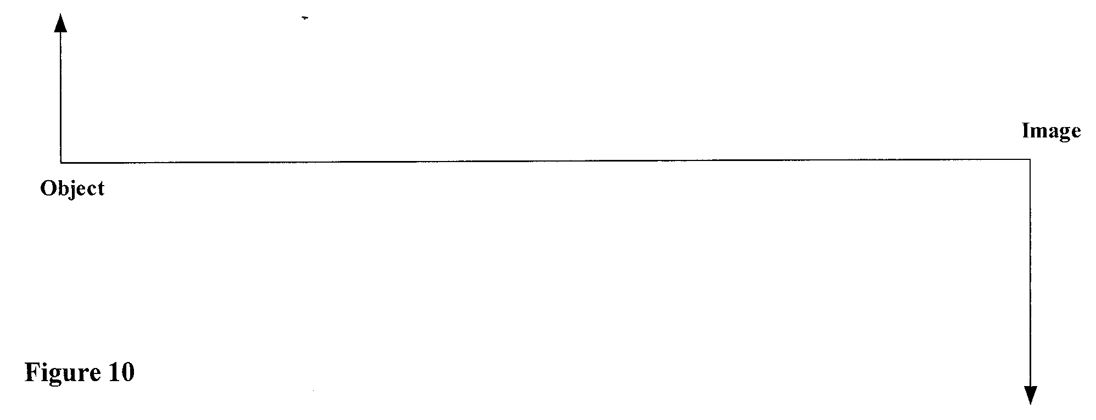

By using appropriate rays complete the diagram to show the position of:

(i) the lens. (2mks)

(ii) the two principal foci. (3mks)

c) State one use of the cathode ray oscilloscope. (1mk)

.............................................................................................................................................................

.............................................................................................................................................................

End