**Name: ……………………………………………………………** **Index No.:……………………................**

**School: …………………………………………………………. Candidate’s Sign:……………………...**

**Date:…..……………..…………………………….........................**

**232/2**

**PHYSICS**

**PAPER 2**

**JULY/AUGUST - 2015**

**TIME: 2 HOURS**

**TRANS-NZOIA COUNTY JOINT EVALUATION EXAM – 2015**

***Kenya Certificate of Secondary Education (K.C.S.E)***

**PHYSICS**

**PAPER 2**

**2 HOURS**

**INSTRUCTIONS TO THE CANDIDATES**

* Write your ***name*** and ***index* *number*** in the spaces provided above.
* ***Sign*** and write the ***date*** of examination in the spaces provided.
* This paper consists of ***two*** *sections*, ***A*** *and* ***B***.
* Answer ***all*** the questions in section **A** and **B** in the spaces provided.
* ***All*** workings ***must*** be clearly shown.
* Mathematical table and silent non programmable electronic calculators may be used.
* Candidates should answer the questions in ***English.***

**For Examiner’s Use Only:-**

|  |  |  |  |
| --- | --- | --- | --- |
| **SECTION** | **QUESTION** | **MAXIMUM SCORE** | **CANDIDATE’S SCORE** |
| A | 1 – 13 | 25 |  |
| B | 14 | 10 |  |
| 15 | 12 |  |
| 16 | 13 |  |
| 17 | 09 |  |
| 18 | 11 |  |
| **TOTAL SCORE** | | **80** |  |

*This paper consists of 8 printed pages.*

*Candidates should check the question paper to ascertain that all pages are printed as indicated.*

*And that no questions are missing.*

**SECTION I: (25 MARKS)**

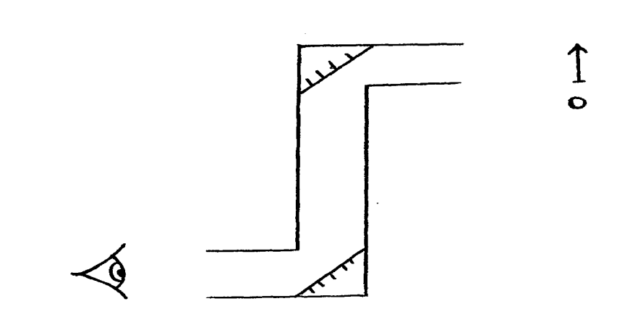***Answer all questions from this section.***

**1**. .

Fig. 1

Wanyonyi used the above apparatus to observe a concert in a crowded theatre. Complete the ray

diagram to show the final image position. (1 mk)

**2**. Polarisation is a defect of a simple cell. State how it reduces the current produced. (1 mk)

…………………………………………………………………………………………………………

…………………………………………………………………………………………………………

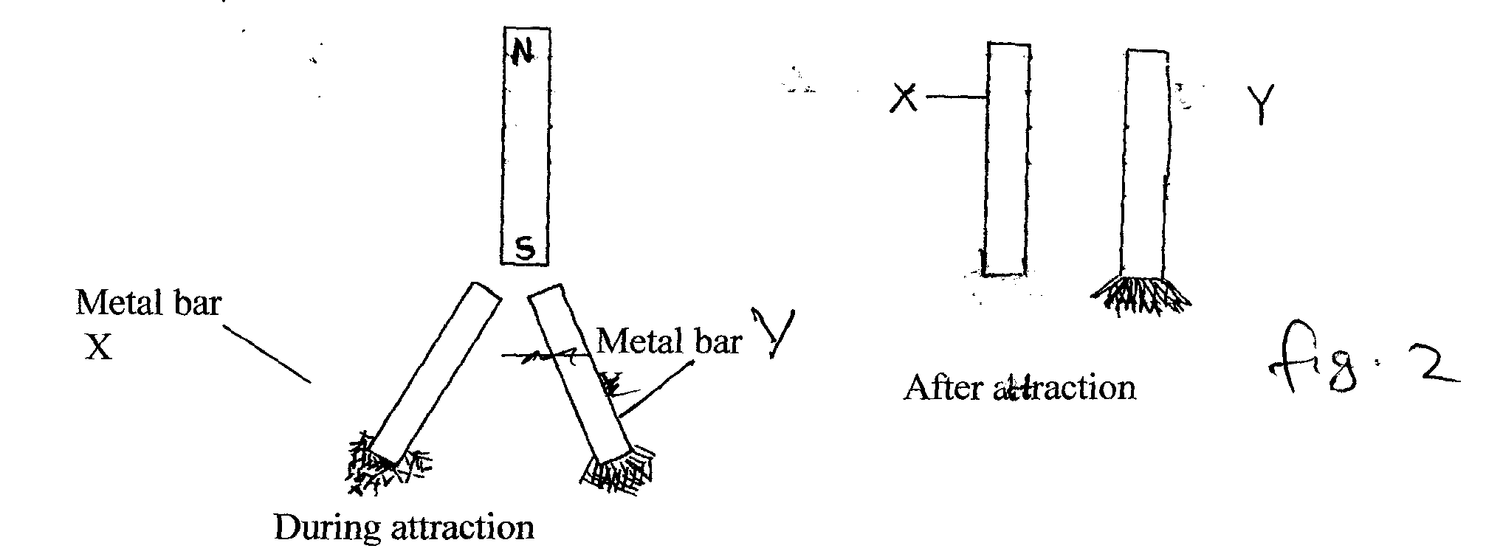**3**. The figure 2 below shows a simple experiment using a permanent magnet and two metal bars **X** and **Y**.

**Y**

**X**

**N**

.

**S**

**Metal bar X**

**Metal bar Y**

Fig. 2

**After attraction**

**During attraction**

State, with reason, which bar is a soft magnetic material. (2 mks)

…………………………………………………………………………………………………………

…………………………………………………………………………………………………………

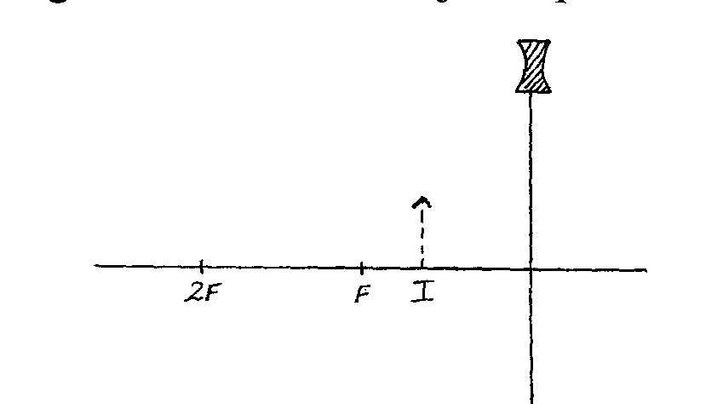**4**. The figure 3 below shows the image formed when an object is placed in front of a concave lens.

**F I**

**2F**

Fig. 3

Using suitable rays locate the position of the object. (2 mks)

**5**. Sketch the magnetic field pattern between the two poles of the magnet shown below. The wire carrying current is in between the poles. (1 mk)

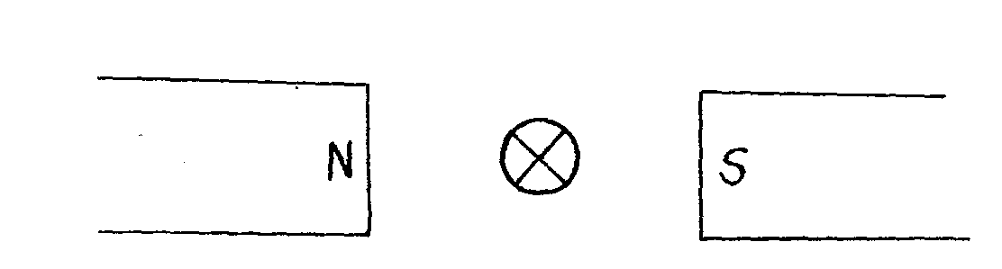

**S**

**N**

Fig. 4

**6**. The figure 5 below shows a displacement time graph for a wave.

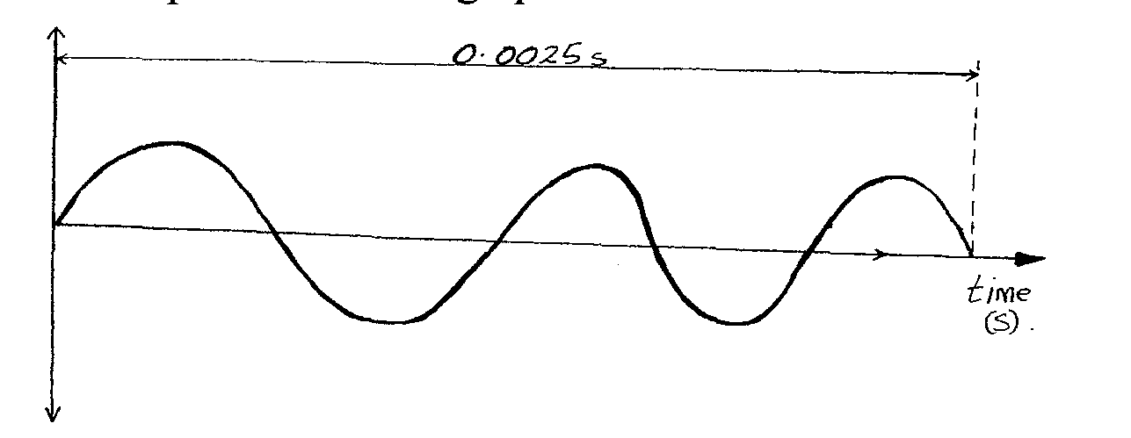

**0.0025s**

**time (s)**

Fig. 5

Determine the frequency of the wave. (3 mks)

…………………………………………………………………………………………………………

…………………………………………………………………………………………………………

…………………………………………………………………………………………………………

**7**. A mine worker stands between two vertical cliffs 500m from the nearest cliff. The cliffs are **x** metres apart. Every time he strikes the rocks, he hears the echoes. The first one comes after **2.5.s** while the other comes **3s** later. Calculate the distance between the cliffs. (3 mks)

…………………………………………………………………………………………………………

…………………………………………………………………………………………………………

………………………………………………………………………………………………………….

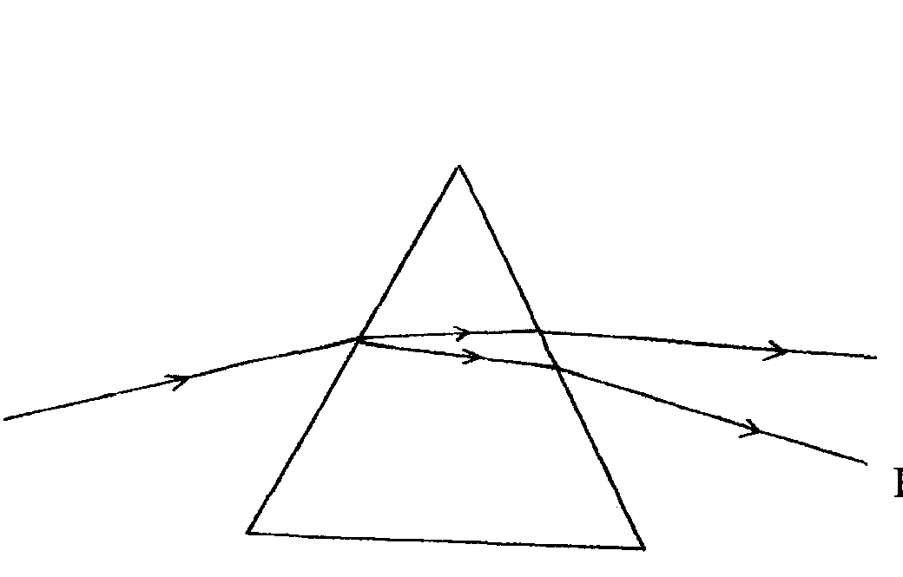**8**. The figure 6 below shows how white light behaves when it is incident on a glass prism.

**A**

**B**

**White light**

Fig. 6

Explain why it splits to different colours between **A** and **B**. (2 mks)

…………………………………………………………………………………………………………

…………………………………………………………………………………………………………

…………………………………………………………………………………………………………..

**9**. Determine the total energy in the following arrangement of capacitors. (3 mks)

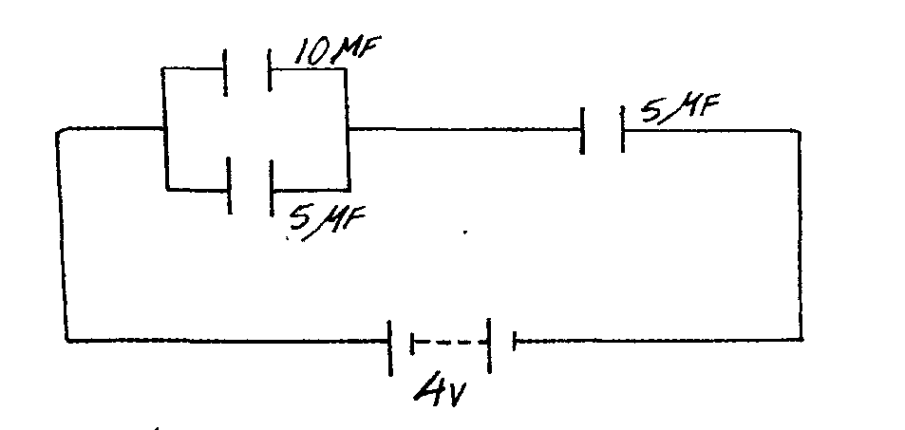

**5μF**

**5μF**

**4V**

**10μF**

Fig. 7

…………………………………………………………………………………………………………

…………………………………………………………………………………………………………

…………………………………………………………………………………………………………

**10**. When a sharp point of a pin is held in a bare hand and brought near a cap of a positively charged electroscope the leaf collapses. Explain this observation. (2 mks)

…………………………………………………………………………………………………………

…………………………………………………………………………………………………………

**11**. Two resistors are placed in the gaps of the metre bridge as shown in the figure 8.below

Fig. 8

**Q**

**X**

**Y**

**P**

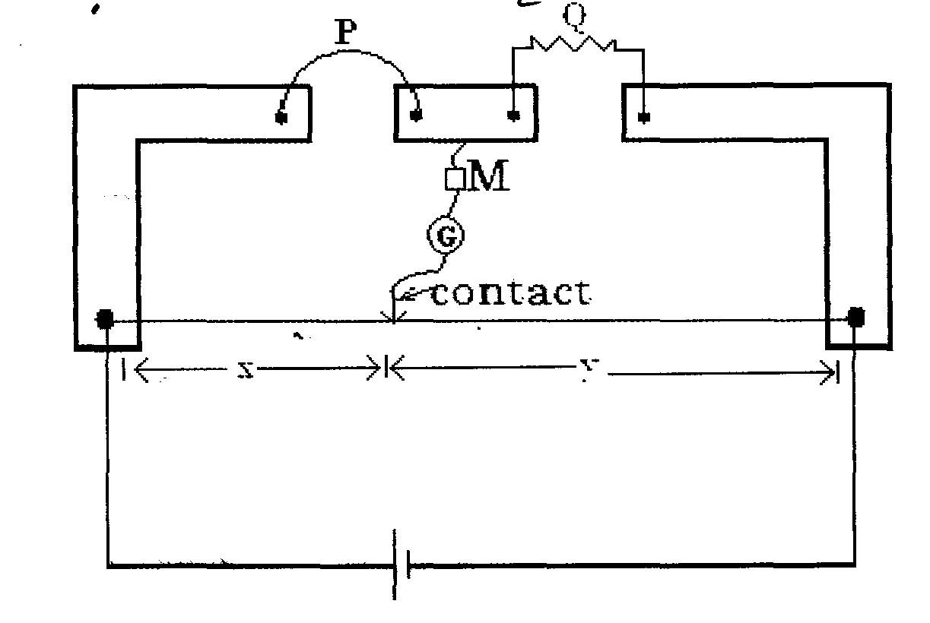

A balance point is found when the movable contact touches the meter bridge wire at a distance of

**x = 35.5 cm**. If **Q** is a resistor of 10 ohms; when the balance point **y = 15.5 cm**,

find the valueof the resistor **P**. (2 mks)

…………………………………………………………………………………………………………

…………………………………………………………………………………………………………

**12**. The minimum frequency of radiation necessary to cause photoelectric effect on a certain metal

surface is **9.06 x 1014HZ.**

Determine the work function of the metal. ***(Take plank’s constant, h = 6.63x 10-34Js)*** (3 mks)

…………………………………………………………………………………………………………

…………………………………………………………………………………………………………

…………………………………………………………………………………………………………

**13**. Define half-life of a radioactive material. (1 mk)

…………………………………………………………………………………………………………

………………………………………………………………………………………………………….

**SECTION II: (55 MARKS)**

***Answer all questions from this section***

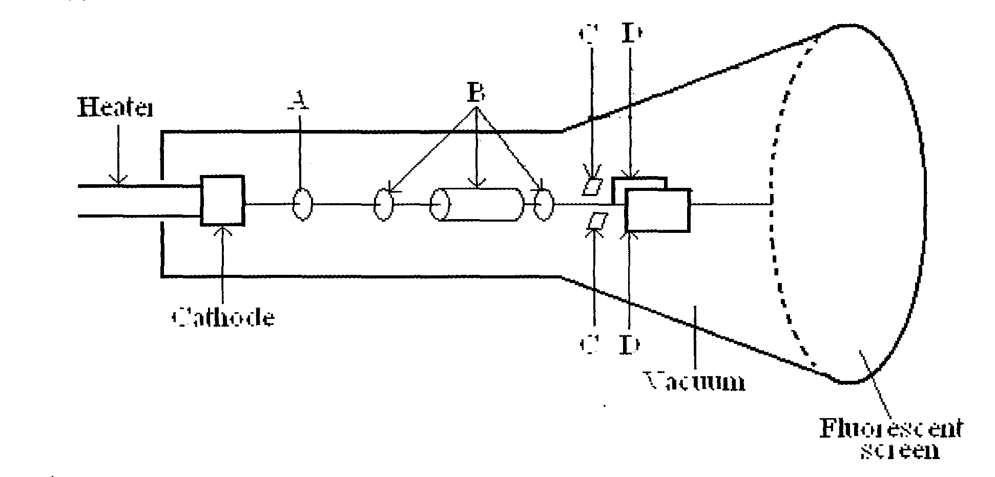**14**. (a) The figure 9 represents cathode ray oscilloscope (CRO)

**Cathode**

**Vacuum**

**C D**

**C D**

Fig. 9

**Heater**

**B D**

**A D**

**Fluorescent screen**

1. Name the parts labelled **A** and **B**  (2 mks)

**A**………………………………………………………………………….

**B** …………………………………………………………………………..

1. Whatare the functions of the parts labelled **C** and **D**? (2 mks)

**C**…………………………………………………………………………………………………….

**D** ……………………………………………………………………………………………………

1. Explainhow the electrons are produced. (2 mks)

………………………………………………………………………………………………………………………………………………………………………………………………………………

1. Giveareason why the tube is evacuated. (1 mk)

………………………………………………………………………………………………………

1. The work function of a tungsten is 7.2 x 10-19J. Calculate the wavelength of the light photon that is capable of first removing an electron from the tungsten surface. (3 mks)

………………………………………………………………………………………………………

………………………………………………………………………………………………………

………………………………………………………………………………………………………

**15**. (a) The graph below shows the relationship between $1/u$ for $1/v$ for a converging lens where u and v

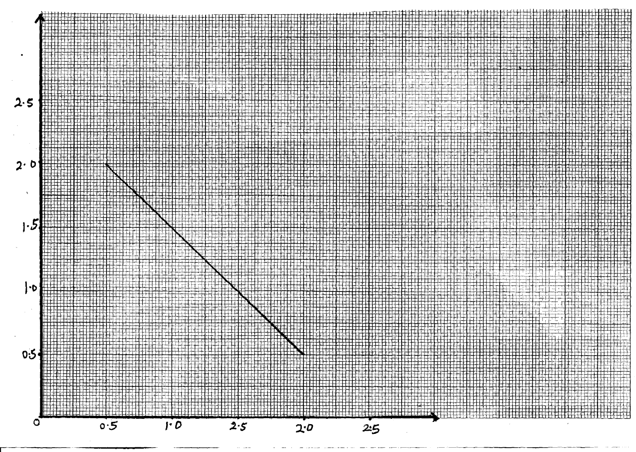 are the object and image distances respectively.

**1 x 10-2 (cm-1)**

**u**

**0.5 1.0 2.5 2.0 2.5**

**2.5**

**2.0**

**1.5**

**1.0**

**0.5**

**0**



From the graph, determine the focal length f, of the lens. (3 mks)

…………………………………………………………………………………………………

…………………………………………………………………………………………………

…………………………………………………………………………………………………

b) State **two** conditions necessary for total internal reflection to occur. (2 mks)

…………………………………………………………………………………………………

…………………………………………………………………………………………………

c) The figure 10 below shows the path of a ray of light passing through a rectangular block of

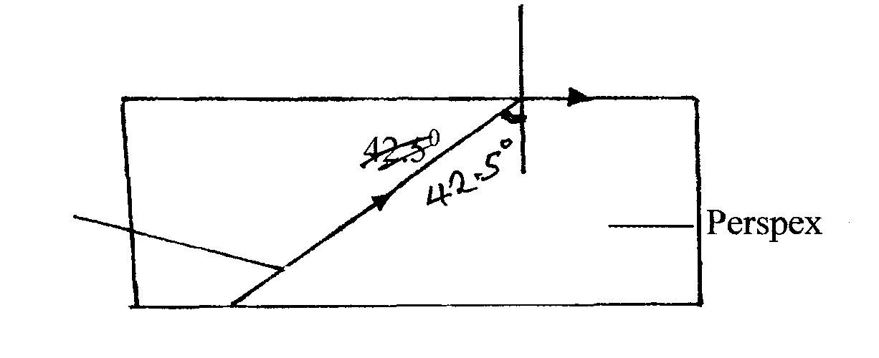 Perspex placed in air.

**Ray of light**

**Perspex**

Fig.10

(i) Calculate the refractive index of Perspex. (3 mks)

…………………………………………………………………………………………………

…………………………………………………………………………………………………

…………………………………………………………………………………………………

(ii) A ray of light now travels from a transparent medium of refractive index 2.4 into the

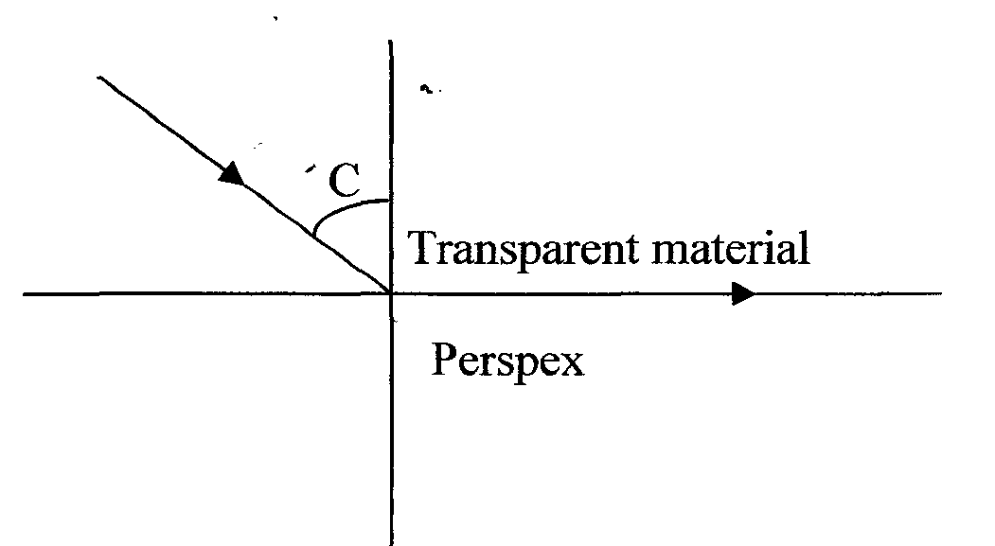 Perspex as shown below in figure 11.

Fig. 11

Calculate the critical angle C. (3 mks)

…………………………………………………………………………………………………

…………………………………………………………………………………………………

…………………………………………………………………………………………………

**16**. a) An x-ray tube operating at a potential difference of 50K V has a tube current of 20mA.

Calculate :-

i) The electric power input. (2 mks)

…………………………………………………………………………………………………

…………………………………………………………………………………………………

ii) The number of electrons hitting the target per second. (2 mks)

…………………………………………………………………………………………………

…………………………………………………………………………………………………

iii) The velocity of the electrons when they hit the target. (3 mks)

…………………………………………………………………………………………………

…………………………………………………………………………………………………

…………………………………………………………………………………………………

…………………………………………………………………………………………………

(iv) If only 5% of the energy of the electrons is converted to x – rays.

Estimate the quantity of heat produced per second. (2 mks)

…………………………………………………………………………………………………

…………………………………………………………………………………………………

v) Find the x – ray power output. (2 mks)

…………………………………………………………………………………………………

…………………………………………………………………………………………………

…………………………………………………………………………………………………

**17**. (a) In an experiment to observe interference of light waves a double slit placed close to the

source as shown in figure 12 below

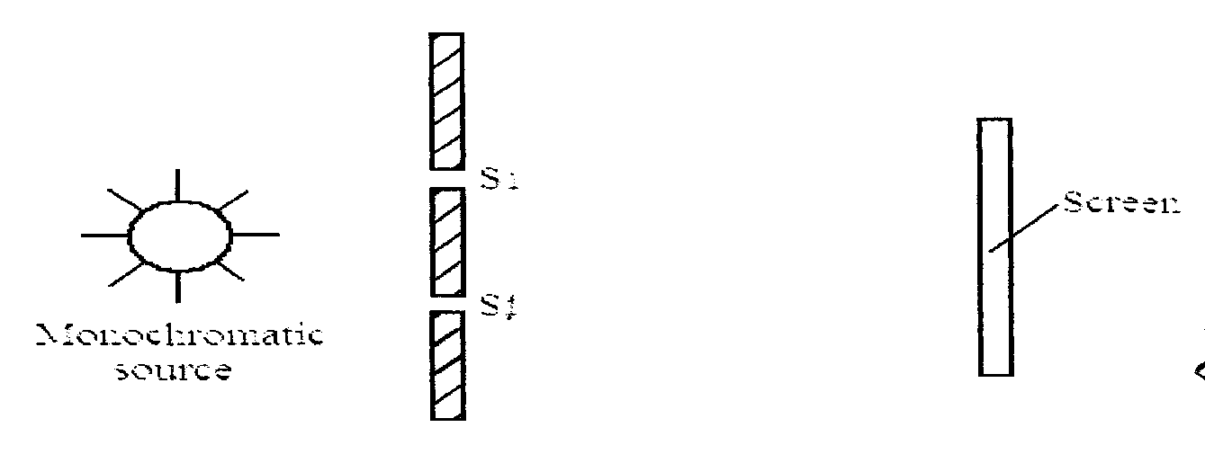

Fig. 12

**S­1**

**S­1**

**S­1**

**S­1**

**Monochromatic source**

**Screen**

(i) What is monochromatic source. (1 mk)

…………………………………………………………………………………………………

(ii) State the function of the double screen. (1 mk)

…………………………………………………………………………………………………

(iii) Briefly describe what is observed on the screen (2 mks)

…………………………………………………………………………………………………

…………………………………………………………………………………………………

b) Briefly explain what is observed on the screen when:-

(i) The separation S1 S2 is reduced. (1 mk)

…………………………………………………………………………………………………

…………………………………………………………………………………………………

(ii) White light source is used in place of monochromatic source. (1 mk)

…………………………………………………………………………………………………

…………………………………………………………………………………………………

c) Explain briefly how a p – type semi- conductor may be made from a pure semi-conductor

material. (3 mks)

…………………………………………………………………………………………………

…………………………………………………………………………………………………

…………………………………………………………………………………………………

d) Draw circuit diagrams to distinguish between forward and reverse bias of a p-n junction diode. (2 mks)

**18**. (a) State the **Lenz’s law** of electro-magnetic induction. (1 mk) …………………………………………………………………………………………………………..

(b) In figure 13 below the bar magnetic is moved out of the coil.

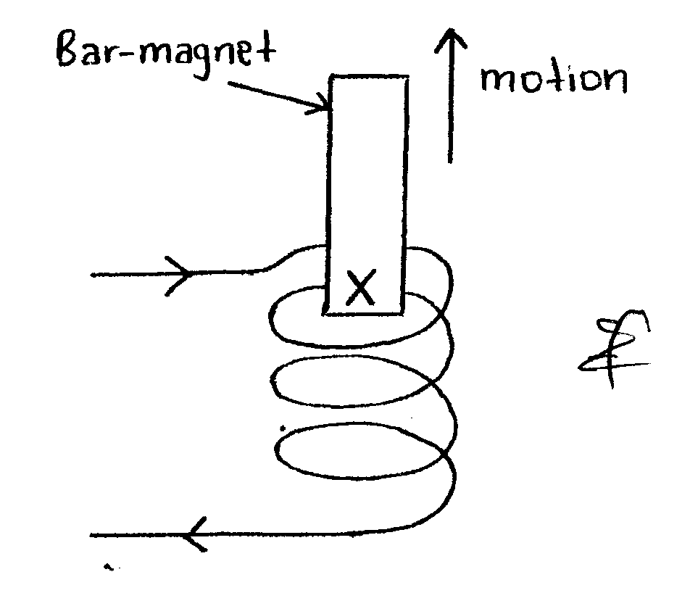

**Bar magnet**

**X**

Fig. 13

(i) If a current I is induced in the coil in the direction shown. What is the polarity of the end X

of the magnet? (1 mk)

…………………………………………………………………………………………………

(ii) Explain briefly the sources of electrical energy in the circuit. (1 mk)

…………………………………………………………………………………………………

…………………………………………………………………………………………………

(c) A hydro-electrical power station produces 500 KW at a voltage of 10 KV. The voltage is

then stepped up to 150 KV and the power is transmitted through cables of resistance 200Ω to

a step down transformer in a substation. Assuming that both transformers are 100%

efficient.

**Determine**

(i) The current produced by the generator. (2 mks)

…………………………………………………………………………………………………

…………………………………………………………………………………………………

(ii) The current that flows through the transmission cables. (2 mks)

…………………………………………………………………………………………………

…………………………………………………………………………………………………

(iii) The voltage drop across the transmission cables. (2 mks)

…………………………………………………………………………………………………

…………………………………………………………………………………………………

(iv) The power loss during transmission. (2 mks)

…………………………………………………………………………………………………

…………………………………………………………………………………………………