Name: …………………………………………………………… Index No.:……………………................
School: …………………………………………………………. Candidate’s Sign:……………………...
Date:…..……………………………….
232/3
PHYSICS
PRACTICAL
PAPER 3
JULY/AUGUST - 2015
TIME: 2 ½ HOURS

TRANS-NZOIA COUNTY JOINT EVALUATION EXAM – 2015
Kenya Certificate of Secondary Education (K.C.S.E)

PHYSICS
PAPER 3
2 ½ HOURS
INSTRUCTIONS TO THE CANDIDATES:
- Write your name, index number, sign and date in spaces provided above
- Answer all the questions in section I and II in the spaces provided in the question paper.
- You are supposed to spend the first 15 minutes of the 2 ½ hours allowed for this paper reading the whole
paper carefully before commencing your work.
- Marks are given for a clear record of the observations actually made, their suitability, accuracy and the use made of them.
- Candidates are advised to record their observations as soon as they are made.
- Non-programmable silent electronic calculators and KNEC mathematical tables may be used.
For Examiner’s Use Only:-
QUESTION 1: PART I
 | V | Vi | vii | viii  a b | ix | Total
Maximum Score | 4 | 5 | 3 | 1 1 | 2
Candidate’s Score
PART II
 | A | b vi | b vii | b viii | Total
Maximum Score | 1 | 1 | 1 | 1
Candidate’s Score
QUESTION 2: PART 1
 | a i | a iv | B | c i | c ii | c iii | Total
Maximum Score | 1 | 5 | 5 | 2 | 1 | 2
Candidate’s Score
PART 1I
 | B | C | d i | d ii | e | f | Total
Maximum Score | ½ | ½ | ½ | ½ | 1 | 1
Candidate’s Score
GRAND TOTAL

This paper consists of 8 printed pages.
Candidates should check the question paper to ascertain that all pages are printed as indicated.
And that no questions are missing.

- You are provided with the following apparatus:
- Candle
- A plane mirror
- Lens holder
- 4 optical pins
- Metre Rule
- A soft board
- Cross wire
- A piece of cellotape
- Screen
- 2 White plain sheets of paper
- Vernier calipers (To be shared)
- 4 office pins
- A glass block
- Protractor

PART I
Proceed as follows:-
i) Arrange the apparatus as shown in the fig. 1 below.
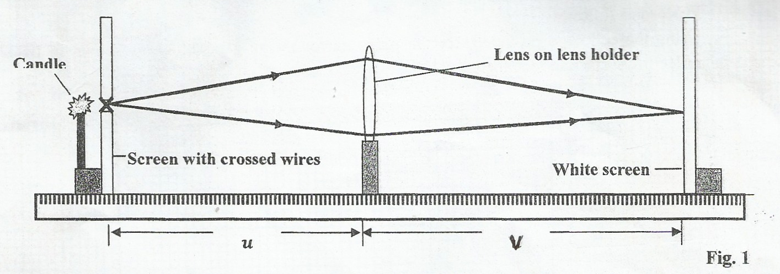
Lens on lens holder
Candle

White screen

v
u andle
ii) Place the cross – wire before the lens so that u = 28 cm. The lit candle should be placed close to the
cross-wire.
iii) Adjust the position of the screen until a sharp image is cast on the screen.
iv) Measure and record the image distance, v in the table 1.
v) Repeat the same procedure for the other values in the table.
u (cm) | 28 | 30 | 32 | 34 | 36 | 38
v (cm)
m = $\frac{v}{u}$

vi) Plot a graph of u (y-axis) against v

vii) By finding the slope, use the equation m = $\frac{v}{f}$ - 1 to determine the focal length f of the lens.
(3 mks)

viii) Use the vernier calipers to measure:
- Thickness (T) of the lens = ……………………………………… cm (1 mk)
- The diameter (D) of the lens = …………………………………….. cm (1 mk)
ix) Determine the angle α given that $\sin{ =\frac{D}{4f}}$ (2 mks)
…………..……………………………………………………………………………………………….
………..………………………………………………………………………………………………..
…………………………………………………………………………………………………………..
PART II
Proceed as follows:
Using the cellotape provided, fix the plane mirror to the glass block as shown in fig. 2. The
reflecting surface to face the glass block.
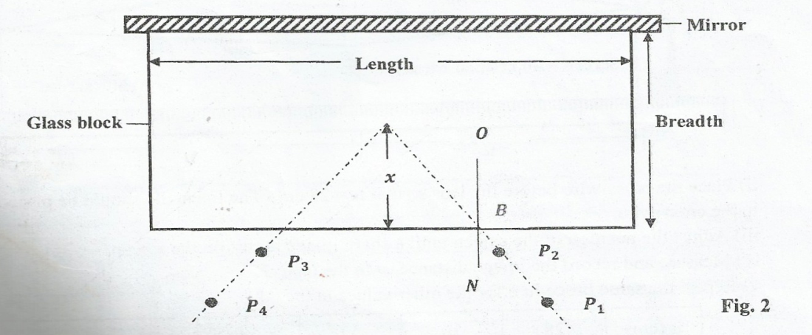
Mirror
Length
Fig 2
O
Glass block
Breadth
C
x
B
N
P₃
P₄
P₁
P₂
- Measure the breadth, b of the glass block. (1 mk)
b = …………………………………………………………………………………..……
- (i) With the use of the office pins, secure firmly a white plain paper on the board and place
the block together with attached mirror
ii) Draw the outline of the glass block together with the mirror.
iii) Remove the block and the mirror and draw a normal at B somewhere a quarter- way the
length of the outline you drew in (iii) above. Draw two different rays AB incident at B.
The incident rays should make angles 10⁰ and 40⁰.
Replace the glass block together with the attached mirror so as to exactly fit the outline
in (iii).
iv) Place the pins P₁ and P₂ along the 10⁰ line. Locate the images of pins P₁ and P₂ as they
appear by non- parallax (the images of the pins appear to be in a straight line when
viewed through the glass block)
v) Place the pins P₃ and P₄ so that the images of pins P₁ and P₂ are not seen.
vi) Remove the glass block together with the attached mirror from the outline and produce
the lines joining P₁ to P₂ and P3 to P₄ so that they intersect at C.

Measure and record the distance x in the table below.
NB: It may be necessary to draw another outline so as to avoid congestion of
construction line
Table 2
Angle i⁰ | 10⁰ | 40⁰
Distance x (cm)

(1mk)
vii) Calculate the average x_{avg} of the values of x in the table above. (1 mk)
x_{avg} = …………………………………………………………………………..
viii Determine the refractive index of the glass block using the formula. (1 mk)
Refractive index, of glass η = b
x_{avg}
………………………………………………………………………………………..
……………………………………………………………...........................................
………………………………………………………………………………………..
QUESTION 2
PART 1
2. You are provided with following:-
- Seven connecting wires
- A jockey
- A cell holder
- A new dry cell
- A voltmeter
- Nichrome wire labelled AB and attached on a millimetre scale.
Proceed as follows:
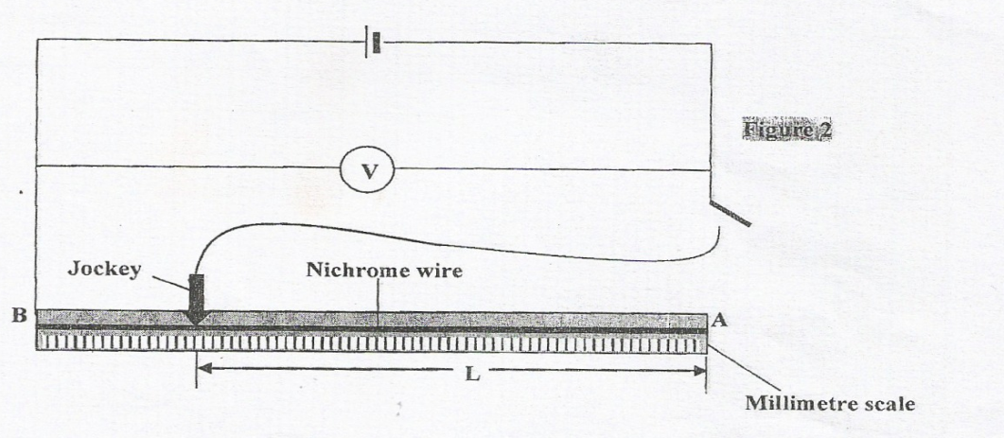
Set up the circuit as shown below in figure 2.

V

Nichrome wire
Jockey
L
Millimetre scale
Fig. 2
- i) Place the jokey on AB so that the length marked L is 90 cm. Open the switch and record the voltmeter reading V₁ (1 mk)
V₁ ………………………………………………………..V
Precaution: The switch should be left open when the readings are not being taken.
ii) Now, close the switch and note the new reading of the voltmeter, V₂ when L = 90 cm
and record this value in table 2 below
iii) Repeat part (ii) for other values of L in table 2.
iv) Complete the table for the values of V where V = (V₁ – V₂)
- Plot a graph of $\frac{1}{V}$ (y – axis) against L. (5 mks)
Table 3
L(cm) | 90 | 80 | 70 | 60 | 50 | 40
V₂ (Volts)
V = (V₁ – V₂) (Volts)
$\frac{1}{v}$ (V⁻¹)
(5 mks)

- The relationship between V and L is given by the equation.
WL = 12 - 1 where R and W are constants
100 R V
Use your graph to determine:
i) The slope S of the graph. (2 mks)
………………………………………………………………………………………………………………………………………………………………………………………………
………………………………………………………………………………………………………………………………………………………………………………………………
ii) The value of W. (1 mk)
………………………………………………………………………………………………………………………………………………………………………………………………
iii) The value of R (2 mks)
………………………………………………………………………………………………………………………………………………………………………………………………
PART II
You are provided with the following:
- Boiling tube
- 1000 ml beaker
- Sand in a small beaker
- Vernier calipers (to be shared)
- A weighing balance (to be shared)
- Metre rule / a half metre rule / 30 cm rule/ 15cm rule
- Spatula and water
Proceed as follows:
a)Set up the apparatus as shown in the figure below by adding sand into the boiling tube until the boiling tube just floats upright.
200ml beaker
Boiling tube
Water
Sand
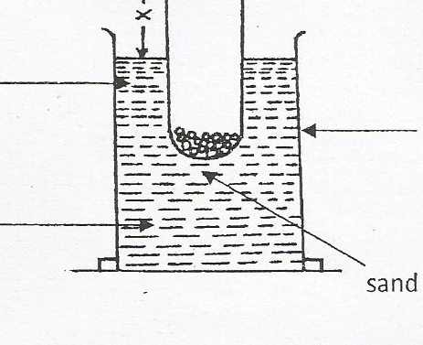

b) Measure the length x (½ mk)
x = …………………………………………. cms

c) Measure the whole length of the test tube y. (½ mk)
y = …………………………………………… cm
d) Determine the external diameter of the test tube using the vernier caliper.
i) External diameter = …………………………………. cm (½ mk)
ii) External radius, r = …………………………………… cm (½ mk)
e) Measure the mass of the test tube and its contents.
Mass, M = ………………………………………………. g (1 mk)
f) Determine the density of water given that:
p = 7M
22r² (y – x) (1 mk)

