NAME: ……………………………………………………INDEX NO: ……………………..……………
CANDIDATE’S SIGNATURE:………………………….
DATE: ……………….………………

443/1
AGRICULTURE
PAPER 1

TIME: 2 HOURS

Kenya Certificate of Secondary Education (K.C.S.E)

443/1
AGRICULTURE 1
PAPER 1
MARCH/APRIL 2015

TIME: 2 HOURS

INSTRUCTIONS TO CANDIDATES:
- Write your name and index number in the spaces provided.
- Sign and write the date of examination in the spaces provided
- This paper consists of three section A,B and C
- Answer all the questions in section A and B
- Answer any two questions in section C
- All the questions should answered in the spaces provided
FOR EXAMINER’S USE ONLY
SECTION | QUESTIONS | MAX SCORE | CANDIDATES SCORE
A | 1-16 | 30
B | 17-20 | 20
C | 21-23 | 20
 | TOTAL | 90

This paper consists of 8 printed pages.
Candidates should check the question paper to ascertain all the pages are printed as indicated
And no questions are missing.
SECTION A (30MARKS)
Answer all questions in this section the spaces provided

- State any human factors which influence agricultural production. (2mks)
………………………………………………………………………………………………………
………………………………………………………………………………………………………
- Give four reasons for carrying out minimum tillage. (2mks)

………………………………………………………………………………………………………
………………………………………………………………………………………………………
………………………………………………………………………………………………………
………………………………………………………………………………………………………
- State two deficiency symptoms of sulphur. (1mk)
………………………………………………………………………………………………………
………………………………………………………………………………………………………
………………………………………………………………………………………………………
- State four factors that contribute to land fragmentation in Kenya before 1955 (2mks)
………………………………………………………………………………………………………
………………………………………………………………………………………………………
………………………………………………………………………………………………………
………………………………………………………………………………………………………
- Give two reasons how each of the following climatic factors influence agriculture
- Low rainfall (1mk)
………………………………………………………………………………………………………
………………………………………………………………………………………………………
- High temperature (1mk)
………………………………………………………………………………………………………
……………………………………………………………………………………………………
- State four benefits of a deep soil profile to crop production 2mks)
………………………………………………………………………………………………………
………………………………………………………………………………………………………
………………………………………………………………………………………………………
………………………………………………………………………………………………………
- State two reasons for using certified seeds in crop production. (1mk)
………………………………………………………………………………………………………
………………………………………………………………………………………………………
………………………………………………………………………………………………………
………………………………………………………………………………………………………

- Identify foeur reasons for earthing up in crops. (2mks)
………………………………………………………………………………………………………
………………………………………………………………………………………………………
………………………………………………………………………………………………………
………………………………………………………………………………………………………
- State two processes of rock weathering. (1mk)
………………………………………………………………………………………………………
………………………………………………………………………………………………………
- State four reasons why timely weed control is advisable in crop production. (2mks)
………………………………………………………………………………………………………
………………………………………………………………………………………………………
………………………………………………………………………………………………………
………………………………………………………………………………………………………
- (a) Define the term land reform. (1mk)
………………………………………………………………………………………………………
………………………………………………………………………………………………………
(b)Give three methods of land reform practised in Kenya. ( 1 ½ mks)
………………………………………………………………………………………………………
………………………………………………………………………………………………………
………………………………………………………………………………………………………
- a) Define the term “economic Injury level’ of a crop. (1mk)
………………………………………………………………………………………………………
………………………………………………………………………………………………………
b) Give two way by which pesticides kill crop parts. (1mk)
………………………………………………………………………………………………………
………………………………………………………………………………………………………
c) State four disadvantages of chemical pest control in crop production. (2mks)
………………………………………………………………………………………………………
………………………………………………………………………………………………………
………………………………………………………………………………………………………
………………………………………………………………………………………………………

- State four roles of additives in silage making. (2mks)
………………………………………………………………………………………………………
………………………………………………………………………………………………………
………………………………………………………………………………………………………
………………………………………………………………………………………………………

- Give four reasons for planting crop at the correct spacing. (2mks)
………………………………………………………………………………………………………
………………………………………………………………………………………………………
………………………………………………………………………………………………………
………………………………………………………………………………………………………

- Give four advantages of boardcasting as a method of planting. (2mks)
………………………………………………………………………………………………………
………………………………………………………………………………………………………
………………………………………………………………………………………………………
………………………………………………………………………………………………………

- State a reason for chitting in crop production. ( ½ mks)
………………………………………………………………………………………………………
………………………………………………………………………………………………………

SECTION B (20 MARKS)
Answer ALL the questions in this section in the spaces provided.

- The diagrams below show an experiment set up using different types of soil and observation is made
after 24 hours. Study and answer the questions that follow.
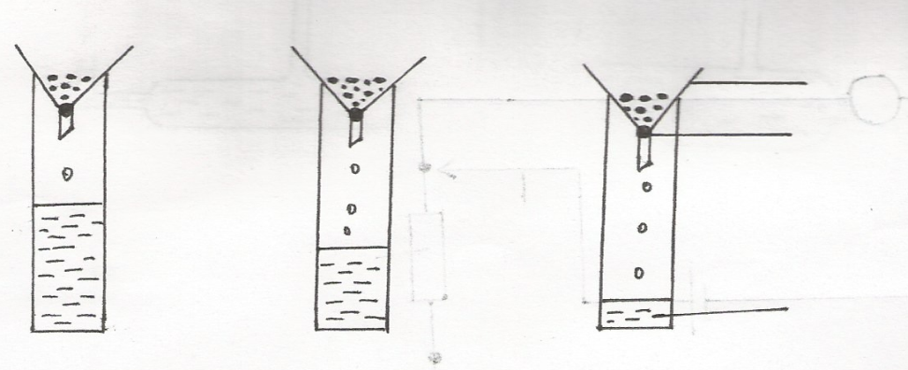
funnel
C
B
A

Cotton wool

Water drained

- What is the experiment set up designed to study. (1mk)
………………………………………………………………………………………………………
………………………………………………………………………………………………………
- Name the three soil types. ( 1 ½ mks)
………………………………………………………………………………………………………
………………………………………………………………………………………………………

- State how the farmer can improve the structure of soil A (1mk)
………………………………………………………………………………………………………
………………………………………………………………………………………………………
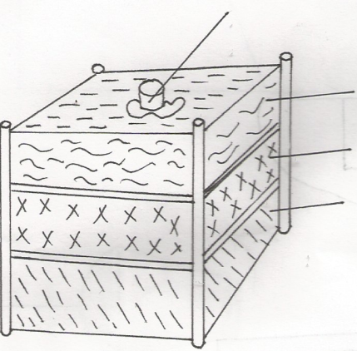
- The diagram below illustrates the preparation of compost manure. Study it carefully and answer the
T
question that follow.
R
P
Q

(a) Identify the layer labeled P,Q and R above
P……………………………………………………………………. (1mk)
Q……………………………………………………………………. (1mk)
R………………………………………………………………….. (1mk)
(b) State one use of the layer labeled P and part T
P……………………………………………………………………………………. ( ½ mk)
T…………………………………………………………………………………….. ( ½ mk)
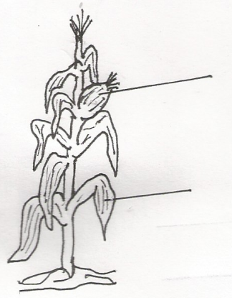
- Study the crop illustrated in the diagram and answer the questions that follow.

C1

C2

- Name the insect pest which attack the part labelled C1 and one disease that attacks part labelled C2. (3mks)
…………………………………………………………………………………………………….
…………………………………………………………………………………………………….
- Give one reason why it is advisable to apply a straight nitrogenous fertilizer to the above crop at
height of 30-45 cm (1mk)
…………………………………………………………………………………………………….
…………………………………………………………………………………………………….
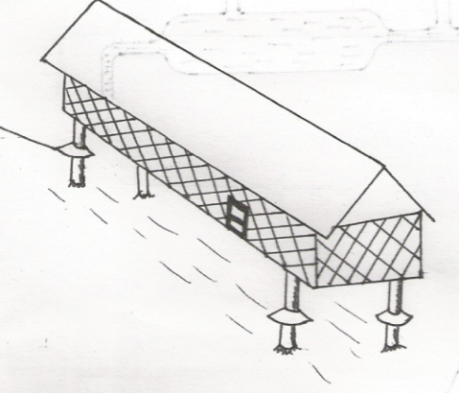
(b) Below is a diagram of a grain store
H

i)Name the part labelled H. (1mk)
…………………………………………………………………………………………………….
…………………………………………………………………………………………………….
ii)State two maintenance practices that should be carried out on the store before storing a crop. (2mks)
…………………………………………………………………………………………………….
…………………………………………………………………………………………………….
iii) Why is it important to have some open spaces on the walls of the store (1mk)
…………………………………………………………………………………………………….
…………………………………………………………………………………………………….
- The diagram below illustrates a method of crop propogation.
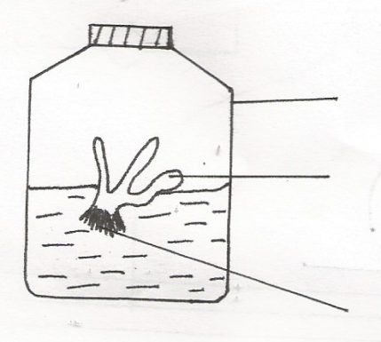
Propagule
Glass jar

Developing roots
- Identify the method of propagation ( ½ mk)
…………………………………………………………………………………………………….
…………………………………………………………………………………………………….
- Name a common crop propagated through the method . ( ½ mk)
…………………………………………………………………………………………………….
…………………………………………………………………………………………………….
(iii)Name three advantages of this method. (3mks)
…………………………………………………………………………………………………….
……………………………………………………………………………………………………

SECTION C (40 MARKS)
Answer any two questions on the space provided
21. (a) Describe how biotic factors affect livestock production. (12mks)
b) Describe how edaphic factors influence crop production. (8mks)

22.(a) Explain reasons that may lead to pasture failure during establishment. (10mks)
(b) Describe the production of cabbage seedling under the following subheadings.
(i) Nursery establishment. (6mks)
(ii) Management of seedling up to transplanting. (4mks)
- a) State and explain five types of soil erosion (10mks)
b) Discuss five factors that influence soil erosion (10mks)
…………………………………………………………………………………………………….
…………………………………………………………………………………………………….
…………………………………………………………………………………………………….
…………………………………………………………………………………………………….
…………………………………………………………………………………………………….
…………………………………………………………………………………………………….
…………………………………………………………………………………………………….
…………………………………………………………………………………………………….
…………………………………………………………………………………………………….
…………………………………………………………………………………………………….
…………………………………………………………………………………………………….
…………………………………………………………………………………………………….
…………………………………………………………………………………………………….
…………………………………………………………………………………………………….
…………………………………………………………………………………………………….
…………………………………………………………………………………………………….
…………………………………………………………………………………………………….
…………………………………………………………………………………………………….
…………………………………………………………………………………………………….
…………………………………………………………………………………………………….
…………………………………………………………………………………………………….
…………………………………………………………………………………………………….
…………………………………………………………………………………………………….
…………………………………………………………………………………………………….
…………………………………………………………………………………………………….
…………………………………………………………………………………………………….
…………………………………………………………………………………………………….
…………………………………………………………………………………………………….
…………………………………………………………………………………………………….
…………………………………………………………………………………………………….
…………………………………………………………………………………………………….
…………………………………………………………………………………………………….
…………………………………………………………………………………………………….
…………………………………………………………………………………………………….
…………………………………………………………………………………………………….
…………………………………………………………………………………………………….
…………………………………………………………………………………………………….
…………………………………………………………………………………………………….
…………………………………………………………………………………………………….
…………………………………………………………………………………………………….
…………………………………………………………………………………………………….
…………………………………………………………………………………………………….
…………………………………………………………………………………………………….
…………………………………………………………………………………………………….
…………………………………………………………………………………………………….
…………………………………………………………………………………………………….
…………………………………………………………………………………………………….
…………………………………………………………………………………………………….
…………………………………………………………………………………………………….
…………………………………………………………………………………………………….
…………………………………………………………………………………………………….
…………………………………………………………………………………………………….
…………………………………………………………………………………………………….
…………………………………………………………………………………………………….
…………………………………………………………………………………………………….
…………………………………………………………………………………………………….
…………………………………………………………………………………………………….
…………………………………………………………………………………………………….
…………………………………………………………………………………………………….
…………………………………………………………………………………………………….
…………………………………………………………………………………………………….
…………………………………………………………………………………………………….
…………………………………………………………………………………………………….
…………………………………………………………………………………………………….
…………………………………………………………………………………………………….
…………………………………………………………………………………………………….
…………………………………………………………………………………………………….

