Name: …………………………………………………………Index No: ……………………..……………
Candidate’s Signature:……………………………….
Date: ……………….……………….…

443/2
AGRICULTURE
PAPER 2

TIME: 2 HOURS

Kenya Certificate of Secondary Education (K.C.S.E)

44//2
Agriculture 2
Paper 2
2 hours

INSTRUCTIONS TO CANDIDATES:
- Write your name and index number in the spaces provided.
- Sign and write the date of examination in the spaces provided
- This paper consists of three section A,B and C
- Answer all questions in section B and C
- Answer any two questions in section C
- All the questions should answered in the spaces provided
FOR EXAMINERS USE ONLY
SECTION | QUESTIONS | MAX SCORE | CANDIDATES SCORE
A | 1-16 | 30
B | 17-20 | 20
C  TOTAL | 21-23 | 20
 |  | 20
 |  | 90

This paper consists of 8 printed pages. Candidates should check to ascertain that all pages are printed as indicated and that no questions are missing.

SECTION A. (30 MARKS)

Answer ALL the questions in the spaces provided.

1. Name a breed of pig which has the following characteristics: black body with a white patch in the
shoulders. (1 mark)
…………………………………………………..………………………………………………………………..
……………………………………………………….………………………………………………………….
2. State four aims of livestock breeding. (2 marks)
…………………………………………………..………………………………………………………………..
……………………………………………………….………………………………………………………….
…………………………………………………..………………………………………………………………..
……………………………………………………….………………………………………………………….
3. State four ways of controlling tsetse flies (2 marks)
…………………………………………………..………………………………………………………………..
……………………………………………………….………………………………………………………….
…………………………………………………..………………………………………………………………..
……………………………………………………….………………………………………………………….
4. Identify three different ways by which farmers can apply accaricides when controlling ticks in
livestock. (1 ½ mks)
…………………………………………………..………………………………………………………………..
……………………………………………………….………………………………………………………….
5. a) What name is given where hind legs comes out first during parturition. (1 mk)
…………………………………………………..………………………………………………………………..
……………………………………………………….………………………………………………………….
b) Give four factors that would affect digestibility of food in livestock. (2mks)
…………………………………………………..………………………………………………………………..
……………………………………………………….………………………………………………………….
…………………………………………………..………………………………………………………………..
……………………………………………………….………………………………………………………….
6. Differentiate between prepotency and prolificacy as used in selection of breeding stock (2marks)
…………………………………………………..………………………………………………………………..
……………………………………………………….………………………………………………………….
7. List four routes through which pathogens can enter the body of an animal (2 marks)
…………………………………………………..………………………………………………………………..
……………………………………………………….………………………………………………………….
…………………………………………………..………………………………………………………………..
……………………………………………………….………………………………………………………….

8. Name four causes of pecking and cannibalism (2 marks)
…………………………………………………..………………………………………………………………..
……………………………………………………….………………………………………………………….
…………………………………………………..………………………………………………………………..
……………………………………………………….………………………………………………………….
9. State the use of the following plumbing tools (2 marks)
a. Stock and die
…………………………………………………..………………………………………………………………..
……………………………………………………….………………………………………………………….
b. Pipe wrench
…………………………………………………..………………………………………………………………..
……………………………………………………….………………………………………………………….
10. Name two functions of the crop in the digestive system of chicken. (1mark)
…………………………………………………..………………………………………………………………..
……………………………………………………….………………………………………………………….
11. State how the following practices can be used to control livestock diseases
(a) Quarantine (1 mark)
…………………………………………………..………………………………………………………………..
……………………………………………………….………………………………………………………….
(b) Prophylactic measures (1 mark)
…………………………………………………..………………………………………………………………..
……………………………………………………….………………………………………………………….
12. List the three methods that dairy farmers can use in out breeding. (1 ½ mks)
…………………………………………………..………………………………………………………………..
……………………………………………………….………………………………………………………….
…………………………………………………..………………………………………………………………..
……………………………………………………….………………………………………………………….
13. Identify four different ways by which vaccines can be administered to farm livestock. (2mks)
…………………………………………………..………………………………………………………………..
……………………………………………………….………………………………………………………….
…………………………………………………..………………………………………………………………..
……………………………………………………….………………………………………………………….
14. State two reasons why proper nutrition is important in animal’s health. (2 marks)
…………………………………………………..………………………………………………………………..
……………………………………………………….………………………………………………………….
…………………………………………………..………………………………………………………………..
……………………………………………………….………………………………………………………….
15. Why are die following conditions maintained during artificial incubation of eggs in poultry
Production. (2 marks)
(a) Proper ventilation
…………………………………………………..………………………………………………………………..
……………………………………………………….………………………………………………………….
(b) Relative humidity at 60%
…………………………………………………..………………………………………………………………..
……………………………………………………….………………………………………………………….
16. List any four farm structures that are necessary for holding dairy animals. (2 marks)
…………………………………………………..………………………………………………………………..
……………………………………………………….………………………………………………………….
…………………………………………………..………………………………………………………………..
……………………………………………………….………………………………………………………….

SECTION B. (20 MARKS)
Answer ALL the questions in the spaces provided.
17. The illustration below shows the major parts of a tractor ignition system. Study it carefully and answer the questions that follow.
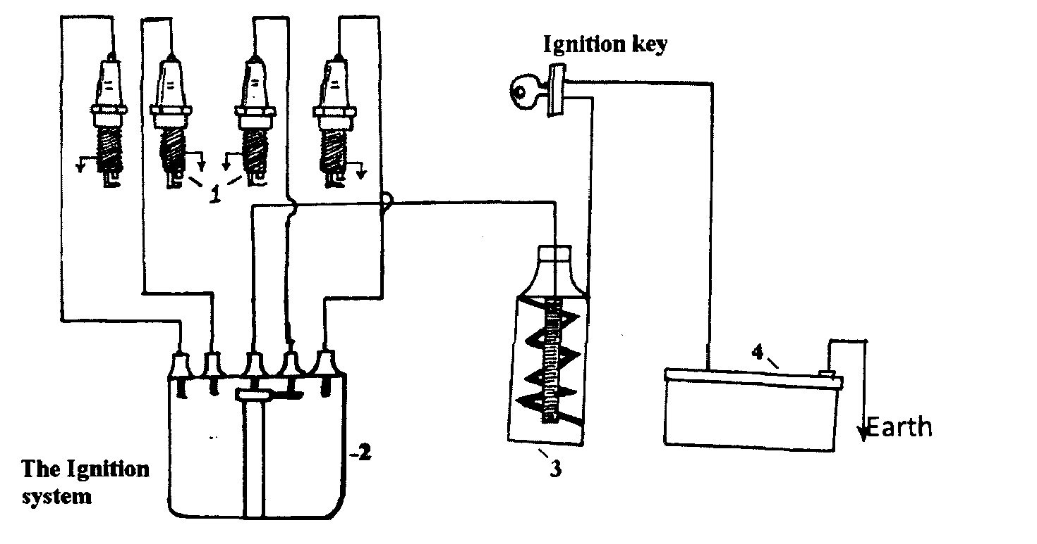

a) What are the functions of the parts of the system labeled 1, 2, and 3? (3mks)
1 ……………………………………………………….………………………………………………………….
2 ……………………………………………………….………………………………………………………….
3 ……………………………………………………….………………………………………………………….
c) State the maintenance practices that should be carried out on the ignition system of a tractor. (3mks)
……………………………………………………….………………………………………………………….
……………………………………………………….………………………………………………………….
……………………………………………………….………………………………………………………….

18. The diagram below shows a plunge dip.
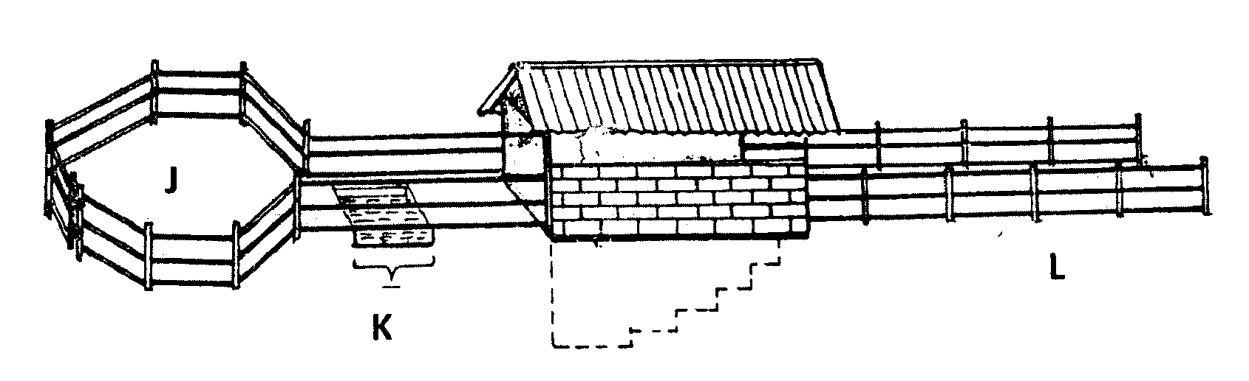

(a) State one use of each of the parts of the dip labeled J, K and L (3 marks)
J………………………………………………………………………………………
K……………………………………………………………………………………..
L ……………………………………………………………………………………..
(b) State two precautions a farmer should take on the dip wash to ensure effective dipping. (2marks)
……………………………………………………….………………………………………………………….
……………………………………………………….………………………………………………………….
(c) State two uses of the roof of the dip. (1 mark)
……………………………………………………….………………………………………………………….
……………………………………………………….………………………………………………………….
19. You are provided with the following feed stuffs.
• Maize meal
• Blood meal
Assume that maize meal contains 8% crude protein and blood meal contains 28% crude protein. Calculate the quantity of maize meal and blood meal that should be mixed to make 200kg of feed
containing 16% crude protein. Use Pearson square method. (4 marks)

20. Outline four structural requirements of a deep litter house (4 marks)
……………………………………………………….………………………………………………………….
……………………………………………………….………………………………………………………….
……………………………………………………….………………………………………………………….
……………………………………………………….………………………………………………………….

SECTION C. (40 MARKS)
Answer only TWO questions from this section in the spaces provided after question 21.
21. a) Explain the factors considered when selecting materials for constructing a calf pen. (10marks)
b) Describe the general methods of controlling livestock diseases. (10 marks)
22. a) Describe the uses of farm fences. (l0mks)
b) State and explain six methods of controlling internal parasites in livestock (6marks)
(c) State four disadvantages of natural mating as a method of breeding in dairy cattle production
(4 mks)
23. (a) Outline ten daily maintenance practices that should be carried out on a farm tractor. (10 marks)
(b) Describe the body conformation features of beef cattle (4 marks)
(c) Outline six causes of stress to a flock of layers. (6 marks)
……………………………………………………….………………………………………………………….
……………………………………………………….………………………………………………………….
……………………………………………………….………………………………………………………….
……………………………………………………….………………………………………………………….
……………………………………………………….………………………………………………………….
……………………………………………………….………………………………………………………….
……………………………………………………….………………………………………………………….
……………………………………………………….………………………………………………………….
……………………………………………………….………………………………………………………….
……………………………………………………….………………………………………………………….
……………………………………………………….………………………………………………………….
……………………………………………………….………………………………………………………….
……………………………………………………….………………………………………………………….
……………………………………………………….………………………………………………………….
……………………………………………………….………………………………………………………….
……………………………………………………….………………………………………………………….
……………………………………………………….………………………………………………………….
……………………………………………………….………………………………………………………….
……………………………………………………….………………………………………………………….
……………………………………………………….………………………………………………………….
……………………………………………………….………………………………………………………….
……………………………………………………….………………………………………………………….
……………………………………………………….………………………………………………………….
……………………………………………………….………………………………………………………….
……………………………………………………….………………………………………………………….
……………………………………………………….………………………………………………………….
……………………………………………………….………………………………………………………….
……………………………………………………….………………………………………………………….
……………………………………………………….………………………………………………………….
……………………………………………………….………………………………………………………….
……………………………………………………….………………………………………………………….
……………………………………………………….………………………………………………………….
……………………………………………………….………………………………………………………….
……………………………………………………….………………………………………………………….
……………………………………………………….………………………………………………………….
……………………………………………………….………………………………………………………….
……………………………………………………….………………………………………………………….
……………………………………………………….………………………………………………………….
……………………………………………………….………………………………………………………….
……………………………………………………….………………………………………………………….
……………………………………………………….………………………………………………………….
……………………………………………………….………………………………………………………….
……………………………………………………….………………………………………………………….
……………………………………………………….………………………………………………………….
……………………………………………………….………………………………………………………….
……………………………………………………….………………………………………………………….
……………………………………………………….………………………………………………………….
……………………………………………………….………………………………………………………….
……………………………………………………….………………………………………………………….
……………………………………………………….………………………………………………………….
……………………………………………………….………………………………………………………….
……………………………………………………….………………………………………………………….
……………………………………………………….………………………………………………………….
……………………………………………………….………………………………………………………….
……………………………………………………….………………………………………………………….
……………………………………………………….………………………………………………………….
……………………………………………………….………………………………………………………….
……………………………………………………….………………………………………………………….
……………………………………………………….………………………………………………………….
……………………………………………………….………………………………………………………….
……………………………………………………….………………………………………………………….
……………………………………………………….………………………………………………………….
……………………………………………………….………………………………………………………….
……………………………………………………….………………………………………………………….
……………………………………………………….………………………………………………………….
……………………………………………………….………………………………………………………….
……………………………………………………….………………………………………………………….
……………………………………………………….………………………………………………………….
……………………………………………………….………………………………………………………….
……………………………………………………….………………………………………………………….
……………………………………………………….………………………………………………………….
……………………………………………………….………………………………………………………….
……………………………………………………….………………………………………………………….
……………………………………………………….………………………………………………………….
……………………………………………………….………………………………………………………….
……………………………………………………….………………………………………………………….
……………………………………………………….………………………………………………………….
……………………………………………………….………………………………………………………….
……………………………………………………….………………………………………………………….
……………………………………………………….………………………………………………………….
……………………………………………………….………………………………………………………….
……………………………………………………….………………………………………………………….
……………………………………………………….………………………………………………………….
……………………………………………………….………………………………………………………….
……………………………………………………….………………………………………………………….
……………………………………………………….………………………………………………………….
……………………………………………………….………………………………………………………….
……………………………………………………….………………………………………………………….
……………………………………………………….………………………………………………………….
……………………………………………………….………………………………………………………….
……………………………………………………….………………………………………………………….
……………………………………………………….………………………………………………………….
……………………………………………………….………………………………………………………….
……………………………………………………….………………………………………………………….
……………………………………………………….………………………………………………………….
……………………………………………………….………………………………………………………….
……………………………………………………….………………………………………………………….
……………………………………………………….………………………………………………………….
……………………………………………………….………………………………………………………….
……………………………………………………….………………………………………………………….
……………………………………………………….………………………………………………………….
……………………………………………………….………………………………………………………….
……………………………………………………….………………………………………………………….
……………………………………………………….………………………………………………………….

