Name………………………………………………… ……………….…. Index No:………………………
School ………………………………………………………… Candidate’s Signature …………..………
Date: ………………………………
231/2
PAPER 2
BIOLOGY
(THEORY)

TIME: 2 HOURS

Kenya Certificate of Secondary Education (K.C.S.E.)
231/2
BIOLOGY
PAPER 2

TIME:-2 HOURS

INSTRUCTIONS TO CANDIDATES
- Write your name, Admission number and name of School in the spaces provided above
- Sign and write the date of examination in the spaces provided.
- This paper consists of sections A and B answer all questions in section A
- In section B answer question 6 compulsory and either question 7or 8 in the spaces provided after question 8
- Answer all the questions in the spaces provided.

FOR EXAMINERS USE ONLY
Section | Question | Maximum score | Candidate’s score
A | 1  2  3  4  5 | 8  8  8  8  8
B | 6  7  8 | 20  20  20
Total Score |  | 80

This paper consists of 10printed pages.
Candidates should check to ascertain that all pages are printed as indicated
and that no questions are missing.

- The equation below represents a process that take place in plants
6CO₂ + 6H₂O C6H₁₂O₆ + 6O₂
- Name the process (1mk)
……………………………………………………………………………………………………..…………………………………………………………………………………………………………..……
- State the condition necessary for the process to take place. (2mks)
……………………………………………………………………………………………………..…………………………………………………………………………………………………………..……
- State what happens to the end products of the process. (5mks)
……………………………………………………………………………………………………..…
………………………………………………………………………………………………………..
……………………………………………………………………………………………………..…
………………………………………………………………………………………………………..
……………………………………………………………………………………………………..…
………………………………………………………………………………………………………..
- The diagram below represents the lower jaw of a mammal
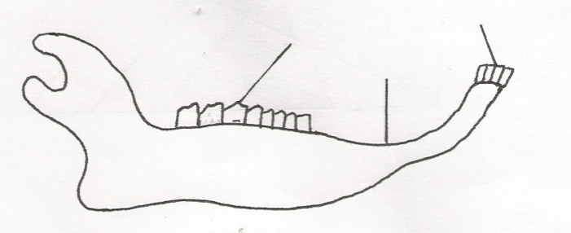
J
K
L

- Name the mode of nutrition of the mammal whose jaw is shown. (1mk)
……………………………………………………………………………………………………..
………………………………………………………………………………………………………
- State one structural and one functional difference between the teeth labelled J and L. (2mks)
……………………………………………………………………………………………………..…
………………………………………………………………………………………………………..
- (i) name the toothless gap labelled K (1mk)
……………………………………………………………………………………………………..
(ii) State the function of the gap (1mk)
……………………………………………………………………………………………………..…
………………………………………………………………………………………………………..
- Name the substance that is responsible for hardening of teeth. (1mk)
……………………………………………………………………………………………………..…
………………………………………………………………………………………………………..

- The diagram below represents a transverse section through a plant organ
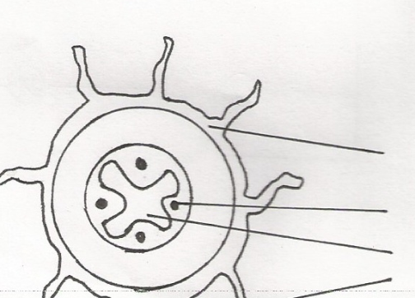

L
K
J
M

- From which plant organ was the section obtained? (1mk)
……………………………………………………………………………………………………..…
………………………………………………………………………………………………………..
- Give two reasons for your answer in a) above (2mks)
……………………………………………………………………………………………………..…
………………………………………………………………………………………………………..

- Name the parts labelled J K, and L. (3mks)
……………………………………………………………………………………………………..…
………………………………………………………………………………………………………..
- State two functions of the part labelled M.
……………………………………………………………………………………………………..…
………………………………………………………………………………………………………..
- (a) Name the causative agents of the following respiration disease. (2mks)
- Whooping cough
……………………………………………………………………………………………………..…
………………………………………………………………………………………………………..
- Pneumonia
……………………………………………………………………………………………………..…
……………………………………………………………………………………………………….. (b) Describe how oxygen in the alveolus reaches the red blood cells. (4mks)
……………………………………………………………………………………………………..…
………………………………………………………………………………………………………..
……………………………………………………………………………………………………..…
………………………………………………………………………………………………………..
……………………………………………………………………………………………………..…
………………………………………………………………………………………………………..

(c) how are pneumatophores adapted to their functions? (2mks)
……………………………………………………………………………………………………..…
………………………………………………………………………………………………………
- In an experiment disinfected soaked bean seed were put in a vacuum flask which was then fitted with a
thermometer as shown in the diagram below.
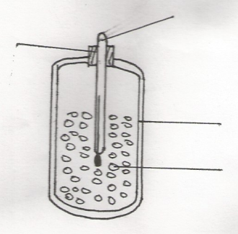
Vacuum flask
Thermometer
Cotton wool
Cotton wool

Disinfected soaked bean seed

The temperature readings were taken every morning for three consecutive days.
(a) Which process was being investigated. (1mk)
……………………………………………………………………………………………………..…
………………………………………………………………………………………………………..
(b)What were the expected results. (1mk)
……………………………………………………………………………………………………..…
………………………………………………………………………………………………………..
- Account for the answer in (b) (i) above (2mks)
……………………………………………………………………………………………………..…
………………………………………………………………………………………………………..
(c)Why were the seed disinfected? (2mks)
……………………………………………………………………………………………………..…
………………………………………………………………………………………………………..
(d) Why was a vacuum flask used in the set-up? (2mks)
………………………………………………………………………………………………………..
………………………………………………………………………………………………………..
(e)How would a control for this experiment be set? (2mks)
……………………………………………………………………………………………………..…
………………………………………………………………………………………………………..

- In the experiment to determine the effects of ringing on the concentration of sugar in phloem ring of bark
from the tern of a tree was cut and removed. The amount of sugar in grammes per 16cm3 piece of bark above the ring was measured over a 24 hour period.

Sugar was also measured in the bark of a similar stem of a tree which is not ringed. The results one
shown in the table below.

Time of the day | Amount of sugar in grammes per 6cm3 piece of bark
 | Normal stem | Ringed stem
0645  0945  1245  1545  1845  2145  0045 | 0.78  0.80  0.81  0.80  0.77  0.73  0.65 | 0.78  0.91  1.01  1.04  1.00  0.95  0.88

- Using the same axes, plot a graph of the amount of sugar against time. (6mks)

- At what time was the amount of sugar highest in the
(i)ringed stem (1mk)
……………………………………………………………………………………………………..…
………………………………………………………………………………………………………..
(ii) Normal stem (1mk)
……………………………………………………………………………………………………..…
………………………………………………………………………………………………………..
- How much sugar would be in the ringed stem if it was measured at 0345 hours (1mk)
……………………………………………………………………………………………………..…
……………………………………………………………………………………………………….
- Give reason why there was sugar in the stems of both trees at 0645hours (2mks)
……………………………………………………………………………………………………..…
………………………………………………………………………………………………………..

- Account for the shape of the graph for the tree with ringed stem between:
- 0645 hours and 1545 hours (3mks)
……………………………………………………………………………………………………..…
………………………………………………………………………………………………………..
……………………………………………………………………………………………………..…
………………………………………………………………………………………………………..

- 1545 hours and 0045 hours (2mks)
……………………………………………………………………………………………………..…
……………………………………………………………………………………………………….

- Name the structure in phloem that are involved in the translocation of sugars. (2mks)
……………………………………………………………………………………………………..…
………………………………………………………………………………………………………..
- Other than sugars name two compounds that are translocated in phloem. (2mks)
……………………………………………………………………………………………………..…
………………………………………………………………………………………………………..
7. Describe the role of the liver in homeostas in the human body. (20mks)
8. Describe causes and methods of controlling water pollution. (20mks)
……………………………………………………………………………………………………..…
………………………………………………………………………………………………………..
……………………………………………………………………………………………………..…
………………………………………………………………………………………………………..
……………………………………………………………………………………………………..…
………………………………………………………………………………………………………..
……………………………………………………………………………………………………..…
………………………………………………………………………………………………………..
……………………………………………………………………………………………………..…
………………………………………………………………………………………………………..
……………………………………………………………………………………………………..…
………………………………………………………………………………………………………..
……………………………………………………………………………………………………..…
………………………………………………………………………………………………………..
……………………………………………………………………………………………………..…
………………………………………………………………………………………………………..
……………………………………………………………………………………………………..…
………………………………………………………………………………………………………..
……………………………………………………………………………………………………..…
………………………………………………………………………………………………………..
……………………………………………………………………………………………………..…
………………………………………………………………………………………………………..
……………………………………………………………………………………………………..…
………………………………………………………………………………………………………..
……………………………………………………………………………………………………..…
………………………………………………………………………………………………………..
……………………………………………………………………………………………………..…
………………………………………………………………………………………………………..
……………………………………………………………………………………………………..…
………………………………………………………………………………………………………..
……………………………………………………………………………………………………..…
………………………………………………………………………………………………………..
……………………………………………………………………………………………………..…
………………………………………………………………………………………………………..
……………………………………………………………………………………………………..…
………………………………………………………………………………………………………..
……………………………………………………………………………………………………..…
………………………………………………………………………………………………………..
……………………………………………………………………………………………………..…
………………………………………………………………………………………………………..
……………………………………………………………………………………………………..…
………………………………………………………………………………………………………..
……………………………………………………………………………………………………..…
………………………………………………………………………………………………………..
……………………………………………………………………………………………………..…
………………………………………………………………………………………………………
..………………………………………………………………………………………………………
………………………………………………………………………………………………………..
……………………………………………………………………………………………………..…
………………………………………………………………………………………………………..
……………………………………………………………………………………………………..…
………………………………………………………………………………………………………..
……………………………………………………………………………………………………..…
………………………………………………………………………………………………………..
……………………………………………………………………………………………………..…
………………………………………………………………………………………………………..
……………………………………………………………………………………………………..…
………………………………………………………………………………………………………..
……………………………………………………………………………………………………..…
………………………………………………………………………………………………………..
……………………………………………………………………………………………………..…
………………………………………………………………………………………………………..
……………………………………………………………………………………………………..…
………………………………………………………………………………………………………..
……………………………………………………………………………………………………..…
………………………………………………………………………………………………………..
……………………………………………………………………………………………………..…
………………………………………………………………………………………………………..
……………………………………………………………………………………………………..…
………………………………………………………………………………………………………..
……………………………………………………………………………………………………..…
………………………………………………………………………………………………………..
……………………………………………………………………………………………………..…
………………………………………………………………………………………………………..
……………………………………………………………………………………………………..…
………………………………………………………………………………………………………..
……………………………………………………………………………………………………..…
………………………………………………………………………………………………………..
……………………………………………………………………………………………………..…
………………………………………………………………………………………………………..
……………………………………………………………………………………………………..…
………………………………………………………………………………………………………..
……………………………………………………………………………………………………..…
………………………………………………………………………………………………………..
……………………………………………………………………………………………………..…
………………………………………………………………………………………………………..
……………………………………………………………………………………………………..…
………………………………………………………………………………………………………..

