Name…………………………………… …………………………..………… Index No:………………………….

231/3 Candidate’s Signature …………..……………
BIOLOGY Date: …………………………
Paper 3
(Theory)

Time: 2 Hours

Kenya Certificate of Secondary Education (K.C.S.E.)

Biology
Paper 3
(Theory)
March/April 2015
Time: 2 ½ Hours

INSTRUCTIONS TO CANDIDATES

- Write your name and indexnumber in the spaces provided above
- Sign and write the date of examination in the spaces provided.
- Answer all the questions in the spaces provided.

For Examiners Use Only
Question | Maximum score | Candidate’s score
1 | 16
2 | 16
3 | 8
Total | 40

This paper consists of 4 printed pages.
Candidates should check to ascertain that all pages are printed as indicated
and that no questions are missing.

1. You are provided with specimen labelled D which is a piece of mammalian intestine.

The contents labelled Dl was squeezed from the lumen of specimen D. Add 3mls of distilled water and
shake the contents.

a) (i) Using the reagents provided test for the presence of starch, proteins and reducing sugars in the
intestinal contents. Record the procedures, observation, and conclusions in the table below.
[9mks]
FOODSUBSTANCE | PROCEDURE | OBSERVATION | CONCLUSION
Starch

Proteins
Reducing
sugars
(ii) Account for the results obtained in a(i) (3mks)
…………………………………………………………………………………………………..………
…………………………………………………………………………………………………..………
…………………………………………………………………………………………………..………
b) Specimen D was cut along its length to expose the inner surface
i. Feel the inner and outer surfaces of the specimen D
Record your observations.
Outer surface ……………………………………………………………………………………… [1mk]
Inner surface ……………………………………………………………………………………… [lmk]

ii. Account for the observations of the inner surface [2mks]

2.
a) Examine specimen M
Make a transverse section of specimen M.
(i) State the type of placentation in the specimen (lmk)
…………………………………………………………………………………………………..………
…………………………………………………………………………………………………..………
(ii) Make a labelled drawing of the transverse section of a specimen M (5mks)
…………………………………………………………………………………………………..………
…………………………………………………………………………………………………..………
…………………………………………………………………………………………………..………
…………………………………………………………………………………………………..………
…………………………………………………………………………………………………..………
…………………………………………………………………………………………………..………
(iii) State the magnification (lmk)
…………………………………………………………………………………………………..………
…………………………………………………………………………………………………..………
(iv) Name the agent of dispersal in specimen M (1mk)
…………………………………………………………………………………………………..………
…………………………………………………………………………………………………..………
(v) What observable features adapt M to the agent of dispersal named in (ii) above [2mks)
…………………………………………………………………………………………………..………
…………………………………………………………………………………………………..………
(b) Examine specimen N carefully using a handlens.
(i) Make a labelled drawing of the specimen (2mks).

(ii)Which group of plants posses such a root system. (1mk)
…………………………………………………………………………………………………..………
…………………………………………………………………………………………………..………
(iii) What special feature is possessed by the root system? (1mk)
…………………………………………………………………………………………………..………
…………………………………………………………………………………………………..………
(iv) State the roles of the feature named in (iii) above. (2mks)
…………………………………………………………………………………………………..………
…………………………………………………………………………………………………..………

3. During a visit to mescum student were shown ten specimens of invertebrates on display. The teacher
provided a dichotomus key to enable them to place each specimen on display into its taxonomic group.
Four of the ten specimens that were on display are shown in the photographs below
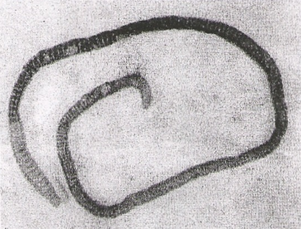
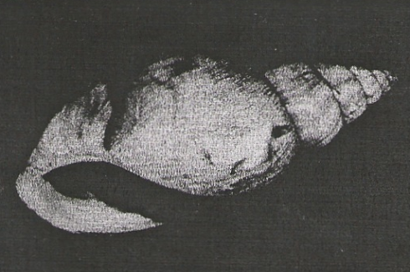
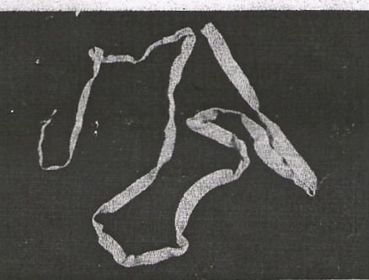

G
F
E

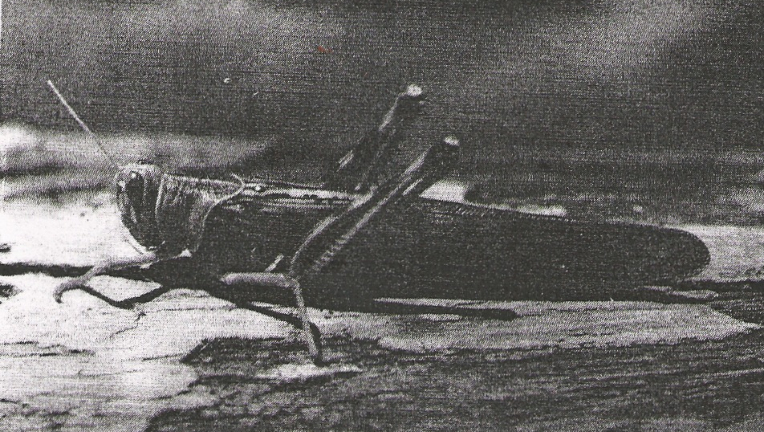

H

Dichotomous key

1 (a) Animal with flattened body…………………………………….. go to 9
(b) Animal with out flattened body………………………………… go to 2

2 (a) Animal with body in shell………………………………………. MOLLUSCA
(b)Animal with body not segmented……………………………….. go to 3

3. (a) Animal with segmented body………………………………….. go to 4
(b) Animal with body not segmented……………………………… NEMATODA
4.(a) Animal with jointed appendages………………………………… go to 6
(b) Animal without jointed appendages……………………………. go to 5

5. (a) Animal with long and cylindrical body………………………. ANNELIDA
(b) Animal with short stout body…………………………………. TREMATODA

6 (a) Animal with antennae………………………………………… go to 7
(b) animal without antennae……………………………….…….. go to 8

7 (a) Animal with one pair of antennae…………………………….. INSECTA
(b) Animal with more than one pair of antennae………………… CRUSTACEA

8. (a) Animal with pincer-like mouthparts………………………… ARACHINIDA
(b)Animal with sucking mouthparts…………………………….. ACARINA

9. Animal with long ribbon –like body……………………………. CESTODA
Animal with circular body……………………………………… CRINOIDEA

c). Use the dichotomous key to identify the taxonomic group of each the four organisms photographs.
In each case show in sequence the steps(e.g. la,2b,5a,lb) in the key that you follow to arrive at the
identity of each organism. (8mks)

Animal Steps followed Identify
E ……………………………… ………………………………
F ……………………………… ………………………………
G ……………………………… ………………………………
H ……………………………… ………………………………

