Name……………………………………………….Index No………………………………….………...…
School……………………………………….……..Candidate’s Sign …………………….…….………….
Date……………………………………………

233/1
CHEMISTRY
PAPER 1
THEORY

TIME: 2 HOURS

Kenya Certificate of Secondary Education (K.C.S.E)

CHEMISTRY 233/2
THEORY

TIME: 2 HOURS

INSTRUCTIONS TO CANDIDATES
- Write your Name, school ,Index number and date in the spaces provided
- Answer all the questions in the spaces provided
- Mathematic tables and the electronic calculators may be used
- All working must be clearly shown where necessary

FOR EXAMINERS USED ONLY
Question | Maximum score | Candidates score
1 - 28 | 80

This paper consists of 8 printed pages.
Candidates should check the question paper to ascertain all the pages are printed as indicated
And no questions are missing.

1. Study the table below and answer the questions that follow. The letters do not represent the actual
Symbols of the element.
Formula of ion | Electronic configuration
E²⁺ | 2
D⁻ | 2.8
Cl⁻ | 2.8.8
B³⁺ | 2.8
A²⁺ | 2.8

(a) Select elements found in:
(i) The same group (1 mark)
………………………………………………………………………………………………….
………………………………………………………………………………………………….
(ii) Period three (1 mark)
………………………………………………………………………………………………….
………………………………………………………………………………………………….
(iii) What is the family name given to the group number to which element B belongs (1 mark)
………………………………………………………………………………………………….
………………………………………………………………………………………………….
(b) With reasons compare the atomic radius of elements B and A. (2 marks)
………………………………………………………………………………………………….
………………………………………………………………………………………………….
(c) State two industrial uses of element B. (2 marks)
………………………………………………………………………………………………….
………………………………………………………………………………………………….
(d) With reasons, compare the reactivity of E and A. (2 marks)
………………………………………………………………………………………………….
………………………………………………………………………………………………….
(e) Write the formula of the compound formed when D and A react. (1 mark)
………………………………………………………………………………………………….
………………………………………………………………………………………………….
(b) What type of bond is formed when element E reacts with oxygen. Give a reason or your
answer. (2 marks)
………………………………………………………………………………………………….
………………………………………………………………………………………………….

2. Study the flow chart and information in the table below it and answer the questions that follow. The chart shows
how certain chemicals can be obtained from a sample of sea water.
Sea water

Solution P
Mixture of crystalline solids with solubility less than 50g per 100 of water

Chlorine gas
Element Q and R
Water
Solid T
Solid T
Salt X
Sodium carbonate solution

Solution W
Solution U
Barium chloride solution with nitric (V) acid

White precipitate V

Salt | MgSO₄ | CaSO₄ | Mgl₂ | CaCl₂ | KCl | NaCl | K₂SO₄ | KBr | Nal
Solubility g/10g water | 22 | 0.21 | 55 | 83 | 35 | 35.6 | 12 | 56 | 160

(a) (i) Write the formulae of two anions in solution W. (1 mark)
………………………………………………………………………………………………….
………………………………………………………………………………………………….
(ii) Identify elements Q and R (1 mark)
Q…………………………………………………………….
R……………………………………………………………
(iii) Write an ionic equation for the reaction which produces Q and R.
………………………………………………………………………………………………….
………………………………………………………………………………………………….
(iv) Name solid I and write the equation for the reaction which produces it.
Solid T ...................................................................................................................................... (1 mark)
Equation………………………………………………………………………………… ..(1 mark)
(v) Write the formulae of the precipitate V. (1 mark)
………………………………………………………………………………………………….
………………………………………………………………………………………………….

(vi) Name two salts present in solution W. (2 marks)
………………………………………………………………………………………………….
………………………………………………………………………………………………….
(b) Explain why sea water is not suitable for washing clothes. (2 marks)
………………………………………………………………………………………………….
………………………………………………………………………………………………….
(c) Explain why motor vehicles based in Mombasa rust much faster than those based in Nairobi. (1 mark)
………………………………………………………………………………………………….
………………………………………………………………………………………………….
3. The diagram below summarizes the results of a series of chemical reaction.
Acid solution B
Products E
Green yellow gas
water
Colourless gas A
Sodium chloride
Concentrated

sulphuric acid

Lead (II) nitrate
White precipitate D

Hydrogen sulphide

i) Name gas A (1 mark)
………………………………………………………………………………………………….
………………………………………………………………………………………………….
(ii)State how gas A can be tested. (1 mark)
………………………………………………………………………………………………….
………………………………………………………………………………………………….
(iii) Write the chemical equation for the formation of gas A. (1 mark)
………………………………………………………………………………………………….
………………………………………………………………………………………………….
(iv) What effect would solution B have on phenolphthalein indicator? (1 mark)
………………………………………………………………………………………………….
………………………………………………………………………………………………….
(v) Name reagent used to convert B to C. (1 mark)
………………………………………………………………………………………………….
………………………………………………………………………………………………….

(vi) Identify
(a) White precipitate D (1 mark)
………………………………………………………………………………………………….
………………………………………………………………………………………………….
(b) Products E (1 mark)
………………………………………………………………………………………………….
………………………………………………………………………………………………….
(vii) Write ionic equation for the formation of white precipitate D. (1 mark)
………………………………………………………………………………………………….
………………………………………………………………………………………………….
4. The diagram below represents a set up that was used to obtain dry nitrogen from air. Study it and answer
the questions that follow.
Combustion tube

Nitrogen gas

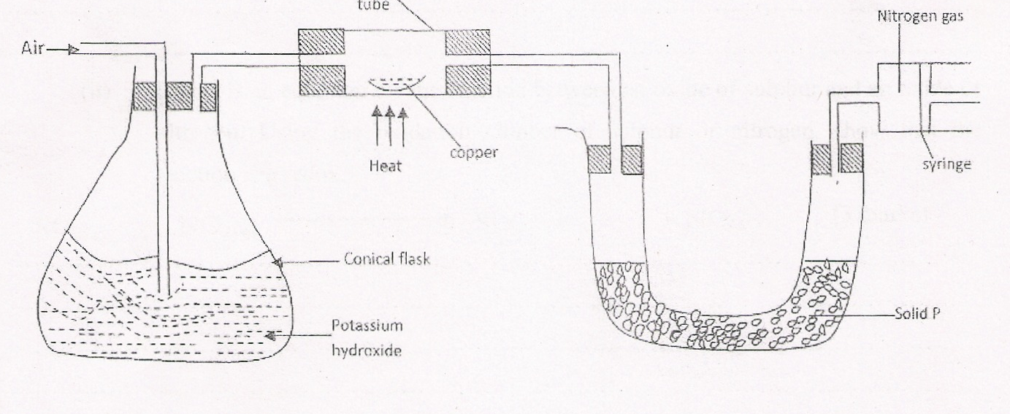
Syringe

Solid P

Air

Heat

Copper

Potassium
Hydroxide
Conical flask

(a) (i) Name solid P. (1 mark)
………………………………………………………………………………………………….
………………………………………………………………………………………………….
(ii) State the observations in the combustion tube. (1 mark)
………………………………………………………………………………………………….
………………………………………………………………………………………………….
(iii) Write down the equation occurring in the conical flask. (1 mark)
………………………………………………………………………………………………….
………………………………………………………………………………………………….
(iv) Explain why a high temperature is required for nitrogen to react with oxygen. (1 mark)
………………………………………………………………………………………………….
………………………………………………………………………………………………….

(v) How would the volume nitrogen gas collected in the syringe if magnesium turnings were
used in the combustion tube instead of zinc granules? Explain (2 marks)
………………………………………………………………………………………………….
………………………………………………………………………………………………….
(b) Nitrogen forms many compounds in which its oxidation states varies.
(i) What is meant by oxidation state? (1mark)
(ii) Below is an equation for the reaction between an oxide of sulphur and an oxide of nitrogen.
Using the oxidation number of sulphur or nitrogen, show that the reaction is a redox.

SO_{2(g)} + NO_{2(g)} SO_{3(g)} + NO_{(g)} (3 marks)
………………………………………………………………………………………………….
………………………………………………………………………………………………….
………………………………………………………………………………………………….
………………………………………………………………………………………………….
5. The apparatus below was used for preparation of hydrogen sulphide gas in the laboratory.
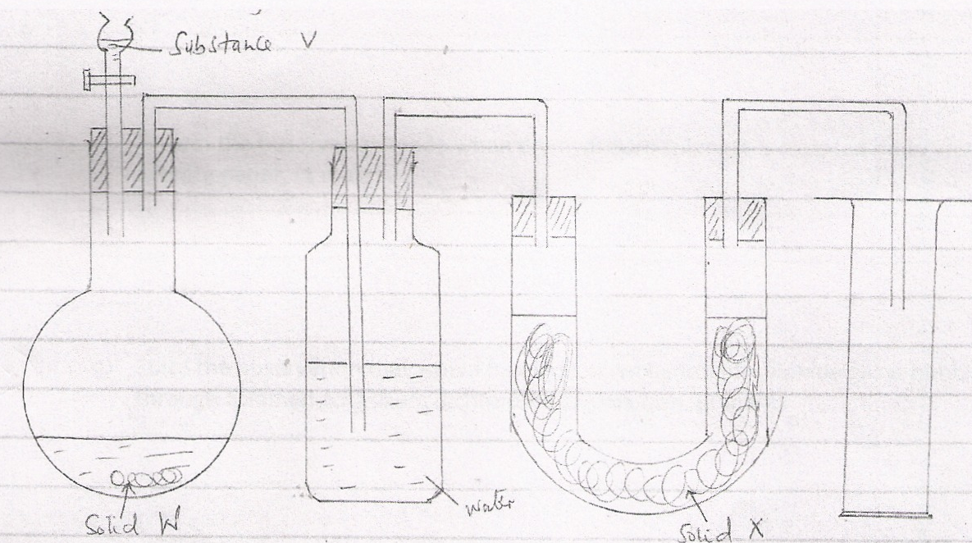

a) Name
a. Substance V ……………………………………………………… ( 1mark)
b. Solid W ………………………………………………………….. ( 1mark)
c. Solid X............................................................................................ ( 1mark)
b) Write an equation for the preparation of hydrogen sulphide. (1 mark)
………………………………………………………………………………………………….
………………………………………………………………………………………………….

c) What property of the gas enables it to be collected by the method shown in the diagram? (1 mark)
………………………………………………………………………………………………….
d) What is the purpose of the water in the second flask? (1 mark)
………………………………………………………………………………………………….
e) What precaution should be taken when preparing the gas? (1 mark)
………………………………………………………………………………………………….
f) Explain the observation made when dry hydrogen suiphide is exposed on to wet lead (ii)
acetate paper (1mark)
………………………………………………………………………………………………….
g) State the observation that would be made when hydrogen sulphide gas is bubbled acidified
potassium dichromate (vi) solution. (1 mark)
………………………………………………………………………………………………….
h) Explain why it is not advisable to dispose off hydrogen sulphide gas by burning. (1 mark)
………………………………………………………………………………………………….
………………………………………………………………………………………………….
6. (a) From an experiment, 25.0cm³ of hydrochloric acid required 20.0cm³ of 0.02M sodium carbonate
for a complete reaction. Calculate:
(i) The number of moles of sodium carbonate used. (1 mark)
………………………………………………………………………………………………….
………………………………………………………………………………………………….
(ii) The number of moles of hydrochloric acid used . (1mark)
………………………………………………………………………………………………….
………………………………………………………………………………………………….
(iii) The molarity of the acid. (1 mark)
………………………………………………………………………………………………….
………………………………………………………………………………………………….
(iv) Determine the concentration of the sulphuric (VI) acid solution in g/dm³. (3 marks)
(Na = 23,0 = 16, H = 1,5 = 32)

7. (a) (i) Apart from ethanol, name two liquid fuels. (1 mark)
………………………………………………………………………………………………….
………………………………………………………………………………………………….
(ii) State two factors that should be considered when choosing a fuel for cooking. (2 marks)
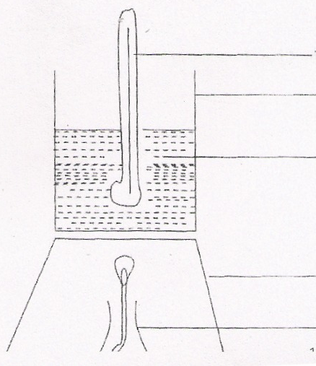
Lamp

Tripod stand

Water

Metallic container

Thermometer

During the experiment, the data given below was recorded.
Volume of water = 500cm³
Initial temperature of water = 25°C
Final temperature of water 46.5°C
Mass of ethanol + lamp before burning 125.5g
Mass of ethanol + lamp after burning = 124.0g
Calculate;
(i) Heat evolved during the experiment (Density of water = lg/cm³, specific heat capacity of
water = 4.2J/g/k. (3 marks)
………………………………………………………………………………………………….
………………………………………………………………………………………………….
………………………………………………………………………………………………….
………………………………………………………………………………………………….
(ii) Molar heat of combustion of ethanol (C 12.0, 0 = 16.0, H = 1.0) (2 marks)
………………………………………………………………………………………………….
………………………………………………………………………………………………….
(c) Write the equation for the complete combustion of ethanol. (1 mark)
………………………………………………………………………………………………….
………………………………………………………………………………………………….
(d) The experiment value of molar heat of combustion of ethanol obtained in (b) (ii) above is lower
than the theoretical value. Give two reasons for this variation. (2 marks)
………………………………………………………………………………………………….
………………………………………………………………………………………………….
(c) Why is the water in the container continuously stirred with thermometer? (1 mark)
………………………………………………………………………………………………….
………………………………………………………………………………………………….

