NAME………………………………………………………………INDEX NO ……………….…………
CANDIDATE’S SIGNATURE …………………………………
DATE: ……………………………….....
121/2
MATHEMATICS
PAPER 2

TIME: 2¹/₂ HOURS

Kenya Certificate of Secondary Education (K.C.S.E)
121/2
MATHEMATICS
PAPER 2
MARCH/APRIL 2015

TIME:2 ½ HOURS

INSTRUCTIONS TO THE CANDIDATES
- Write your name and index number in the spaces provided above
- This paper contains two sections; Section 1 and Section 11.
- Answer all the questions in section 1 and only five questions from Section 11
- All workings and answers must be written on the question paper in the spaces provided below each question.
- Marks may be given for correct working even if the answer is wrong.
- Non programmable silent electronic calculators and KNEC Mathematical tables may be used EXCEPT where stated otherwise
- Show all the steps in your calculations, giving your answers at each stage in the spaces below each question.
FOR EXAMINER’S USE ONLY
Section 1
Question | 1 | 2 | 3 | 4 | 5 | 6 | 7 | 8 | 9 | 10 | 11 | 12 | 13 | 14 | 15 | 16 | Total
Marks

Section 1I GRAND TOTAL
Question | 17 | 18 | 19 | 20 | 21 | 22 | 23 | 24 | Total
Marks

This paper consists of 13 printed pages.
Candidates should check the question paper to ascertain all the pages are printed as indicated
And no questions are missing.

SECTION I (50 MARKS ).
Answer All Questions from this section in the spaces provided

- Two similar cylindrical tins has base radii of 6 cm and 8 cm respectively. If the capacity of the larger tin is 2566cm3. Find the capacity of the small tin. (3mks)

- Simplify the expression ( 2mks)
2ab² _ 3ab – 2b²
4a² – b²

- Solve the inequality (3mks)
2x + 2 ≤ x + 5x + 2

- P varies jointly as q and R. When P = 6, Q = 9 and R = S. Find R when P = 24 and Q = 8. ( 3mks)

- In what ratio will coffee grade A costing sh 90 per kg be mixed with coffee grade B costing sh. 60 per kg so that a profit of 25% is realised by selling the mixture at sh. 80 per kg. (4mks)

- Determine the centre and radius of a circle represented by the equation 2x² + 2y +32= 0 (3mks)

- Find the distance between C ( 39ºN, 35ºE) and D( 39ºN, 135ºE) in nm ( 3mks)

- Solve the equation 2 log 15 – log x = log 5 + log ( x – 4) (4mks)

- A (0.1), B ( 2,1) C ( 4,3), show if they are collinear. (3mks)

- Make P the subject of the formular (3mks)

- Use matrix method to solve ( 4mks)
-5y + 4x – 13 = 0
8 + 2y = 3x

- Expand ( 2- 2x)5 upto x 3 . hence use your expansion to evaluate ( 2.04)⁵ ( 4mks)

- Solve for x (3mks)
Sin (3x – 120)º = - ³/₂

- Rationalise ( 3mks)

- The breadth and length of rectangle are given as 5.35 cm and 3.75. Find absolute error in perimeter.

- If the ratio x: y = 5: 3, determine the ration ( 2x-y) : (x+ y). (2mks)

SECTION B ( 50 MARKS)
Answer any five questions from the section in the spaces.

- The following distribution shows the masses to the nearest kg of 65animls in a certain farm.
Mass kg | 26-30 | 31-35 | 36-40 | 41-45 | 46-50 | 51-55
Frequency | 9 | 13 | 20 | 15 | 6 | 2

- On the grid provided draw the cumulative frequency curve for the given information. ( 5mks)

- Use the to find:
- Median mass (2mks)

- Quartile deviation (3mks)

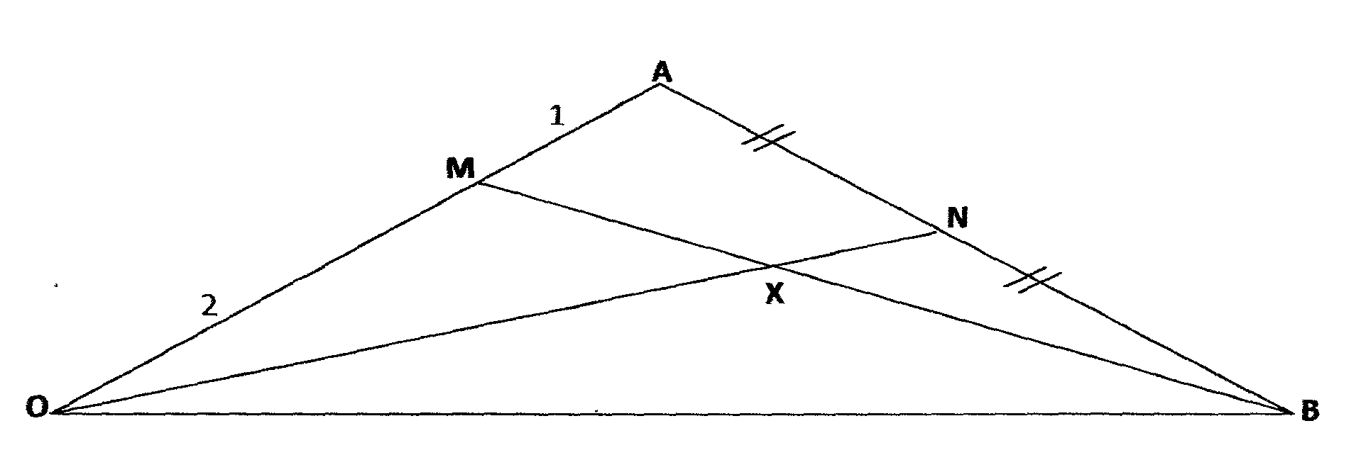

The diagram above shows triangle OAB in which N is the mid-points of AB and M is a point OA such that OM : MA = 2:1 lines ON and BM meet at X such that OX = hON and MX = kMb

- Given that OA = a and OB = b express AB, ON and BM in terms of a and b. ( 4mks)

- By expressing OX in two different ways, determine the values of h and k (6mks)

- The table below shows the rates at which income tax was charged in Kenya in a certain year.

Monthly taxable income (sh) Tax rate (%)
1 – 9840 10%
9841-18960 15%
18961 – 28080 20%
28,081- 37200 25%
37201 – 46320 30%
46321 – 55 440 35%
55441and above 40%

Kasule, a chief Executive officer earned monthly income as follows:

Kasule was Married and hence entitiled to a tax relief of sh 1280 per month
(a) Calculate
(i) His monthly income (2marks)

(b) In addition to income tax, the following deduction were also made from his monthly
Income
Loan= sh 1,085
NHIF= sh 1800
Service charge + sh 375
Determine
(i) PEYE (6marks)

(ii) Determine Kasule,s net Monthly salary (2marks)

20. Three quantities P, Q and R are such that P varies Directly as the square of 0 and inversely as the
square root of R
(a) Given that P=20 when Q.=5 and R=q, find P when Q=7 and R= 25 (4marks)

(b) If Q is increased by 20% and R decreased by 36%, Find the percentage change in 21. Given the
function y= 4-3x - x2, complete the table below (2marks)

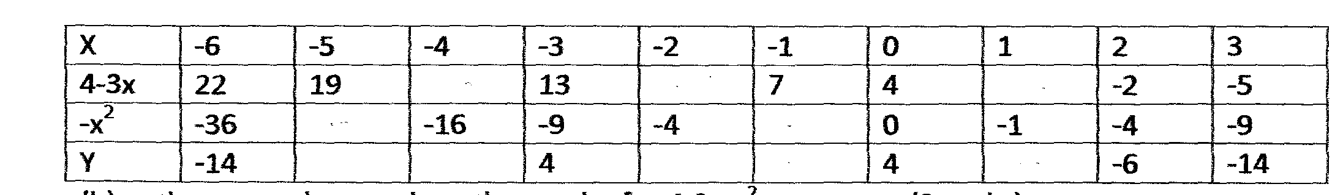

(b) On the squared paper draw the graph of y= 4-3 x - x (3marks)
(c) On the same grid draw the graph of y = x +2 (2marks)

(d) Use your graphs to solve the equations
(i) x² + 3x- 4 = 0 ( 1mark)

(ii) x²+ 4x - 2= 0 (1mark)

(iii) x²+ 4x - 2= 0 (1mark)

22. A school water reservoir is supplied with water by two pumps P and Q. The probability that
Pump P fails is ¹/₁₀ and the probability that pump Q fails is ¹/₅

(a) Draw a simple tree diagram to illustrate this information (2marks)

(b) Calculate the probability that:
(i) both pumps are working (2marks)

(ii) both pump are not working (2marks)

(iii)only one pump is working (2marks)

(iv) Atleast one pump is working. (2marks)

23. (a) Sanga goes to a shop and buys 4kg of rice at sh.90 per Kg, 3kg of sugar at sh. 60 per Kg and 5kg
of flour at sh.70 per Kg.
Fatuma buys 3Kg of rice, 5Kg of sugar and 6Kg of flour from the same shop.

(i) Express the above information in the form of two matrices. (2marks)

(ii) Find their total expenses (4marks)

(b) Given that P = and Q = find the matrix R if R= P⁻¹ Q. (4marks)

24. A radio dealer had planned to buy some radios from a wholesaler for sh 340,000. Before he could buy
them the Price of each radio was increased by sh. 300. He now discovers that he had planned to buy 30
radios less that he had planned to buy with the same amount of money. Determine the number of radios
he had originally planned to buy and the new price of each radio. (l0marks)

