Name…………………………………… …………………………. Index No:………………………….

233/1 Candidate’s Signature …………..……………
PHYSICS 1 Date: …………………………
PAPER 1
THEORY

TIME: 2 HOURS

Kenya Certificate of Secondary Education (K.C.S.E.)

232/1
PHYSICS
PAPER 1
2 HOURS

INSTRUCTIONS TO THE CANDIDATES:
- Write your name and index number in the spaces provided above.
- Answer all the questions both in section A and B in the spaces provided below each question
- All workings must be clearly shown; marks may be awarded for correct steps even if the answers are wrong.
- Mathematical tables and non programmable silent electronic calculators may be used.
(Take acceleration due to gravity g= 10ms⁻² Density of water 1g/m⁻³)
For examiners use only
SECTION | QUESTION | MAXIMUM SCORE | CANDIDATE’S SCORE
Section A | 1-13 | 25
Section B | 14 | 07
 | 15 | 10
 | 16 | 12
 | 17  18 | 10  09
 | 19 | 07
 | TOTAL | 80

This paper consists of 8 printed pages. Candidates should check to ascertain that all pages are printed as indicated and that no questions are missing.
SECTION A (25 MARKS)
- The micrometrer screw gauge shown in figure below was found to have an error of + 0.04
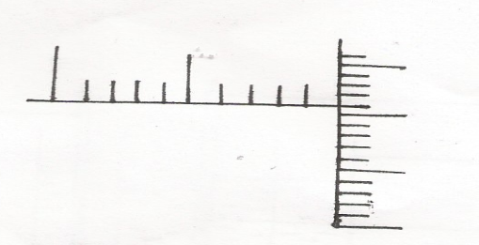
10
5
0
0
5
45

- What is zero error (1mk)
………………………………………………………………………………………………..
………………………………………………………………………………………………..
- Give the correct reading of the micrometer (1mk)
………………………………………………………………………………………………..
………………………………………………………………………………………………..
- State the principle involved when determining of the centre of gravity of regular lamina using a plumb line (1mk)
………………………………………………………………………………………………..
………………………………………………………………………………………………..
- A uniform metre rule of mass 200g is pivoted at the )cm mark, calculate the force which would be applied vertically upward at the 65cm mark to keep the rule horizontal. (3mks)
………………………………………………………………………………………………..
………………………………………………………………………………………………..
………………………………………………………………………………………………..
………………………………………………………………………………………………..
- Distinguish between the terms gravitational potential energy and elastic potential energy. (2mks)
………………………………………………………………………………………………..
………………………………………………………………………………………………..
………………………………………………………………………………………………..
- Describe a simple experiment to demostrate that the pressure in liquid increase with depth. (3mks)
………………………………………………………………………………………………..
………………………………………………………………………………………………..………………………………………………………………………………………………..………………
- State a situation where a body can move as a constant speed and yet it is accelerating. (1mk)
……………………………………………………………………………………..………………..
……………………………………………………………………………………..………………..

- An arrow of mass 100g is shot into a block of wood of mass 400g lying at rest on the smooth surface of an ice rink. If at the moment of impact the arrow is traveling horizontally at 15m/s. calculate the common velocity after the impact. (3mks)
………………………………………………………………………………………………..
………………………………………………………………………………………………..
………………………………………………………………………………………………..
………………………………………………………………………………………………..
- State two evidences that matter is made up of small particles (2mks)
………………………………………………………………………………………………..
………………………………………………………………………………………………..
- In a constant volume gas thermometer the gas pressure at 0ºC is 200mmHg and at 100ºC is 270mmHg. At what temperature is the pressure of the gas 214mmhg (2mks)
………………………………………………………………………………………………..
………………………………………………………………………………………………..
………………………………………………………………………………………………..
………………………………………………………………………………………………..
- Distinguish between conduction and convection (1mk)
………………………………………………………………………………………………..
………………………………………………………………………………………………..
- A pump forces 12kg of water through a hose every minute. If the water is being raised vertically through 20m and ejected at the nozzle at 10m/s, calculate the power of the pump. (3mks)
………………………………………………………………………………………………..
………………………………………………………………………………………………..
………………………………………………………………………………………………..
………………………………………………………………………………………………..
- Determine the manometer which will have the lowest level between P,Q and R in the figure below. Explain your answer. [assume the water is flowing continuously from the tap to the tap to the outlet.
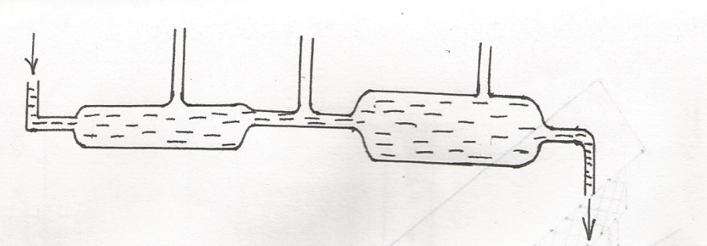
(2mks)
Q
R
P
In let

Out let

SECTION B (55 MARKS)
13. (a) A block of metal A having a mass 40kg requires a horizontal force of 100N to drag it with uniform
velocity along a horizontal surface
- Calculate the co-efficient of friction (3mks)

- Determine the force required to drag a similar block of metal B having a mass of 30kg along the same horizontal surface (3mks)

- If the two metal blocks A and B are connected with a tow bar and a force of 200N is applied to pull the two along the same surface, calculate
- The tension in the tow – bar (1mk)

- The acceleration (3mks)

- If the tow-bar is removed and the 40kg block of metal moves around a smooth path of radius 10m at a constant speed of 24m/s, calculate the centripetal force. (3mks)

- At the end of the circular path, the 40kg mass drops vertically in a trench 10m high and falls freely. Determine the time it takes to land at the bottom of the trench. (3mks)

- (a) The table of results below gives the temperature of wax in a tube as it is allowed to cool.
Time (min) | 0 | 1 | 2 | 3 | 4 | 5 | 6 | 7 | 8 | 9 | 10
Temp (ºC) | 84 | 61 | 41 | 39 | 39 | 39 | 39 | 37 | 30 | 25 | 2

- Plot the graph of temperature against time (5mks)

- What is the melting point of the wax. (1mk)
………………………………………………………………………………………………..…………………………………………………………………………………………
- Which of the two cools quickest near this melting point, the solid or the liquid wax?
(1mk)
………………………………………………………………………………………………..
………………………………………………………………………………………………..

- Which of the two has a greater specific heat capacity, the solid or the liquid?
Explain your answer. (2mks)
………………………………………………………………………………………………..
………………………………………………………………………………………………..

- (a) State the Archimedes principle (1mk)
………………………………………………………………………………………………..
………………………………………………………………………………………………..
- A block of length 15cm and uniform cross section area 9cm² is suspended from a spring balance and completely immersed in oil of density 0.8g/cm³. Given that the density of material or the block is 1.25g/cm³, determine
- The mass of the block. (2mks)

- The reading of the spring balance (2mks)

- The reading of the spring balance if the block was half immersed in the oil. (3mks)

- With the aid if a well labelled diagram. Describe an experiment to verify the Archimedes principle. (4mks)
………………………………………………………………………………………………..
………………………………………………………………………………………………..
………………………………………………………………………………………………..
………………………………………………………………………………………………..
- (a) The figure below shows the displacement – time graph of the motion of particle.
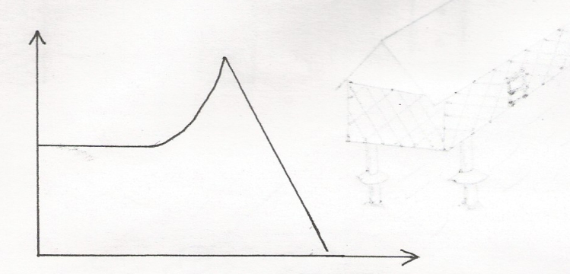
B
C

A
Displacement (M)
D

Time (s)

- State the nature of the motion of the particle between
- A and B (1mk)
………………………………………………………………………………………………..
………………………………………………………………………………………………..
- B and C (1mk)
………………………………………………………………………………………………..
………………………………………………………………………………………………..
- C and D (1mk)
………………………………………………………………………………………………..
………………………………………………………………………………………………..
- A ball is thrown horizontally from top of a vertical tower and strikes the ground at a point 50m from the bottom of the tower. Given that the height of the tower is 45m, determine the
- Time taken by the ball to hit the ground. (2mks)

- Initial horizontal velocity of the ball (2mks)

- Vertical velocity of the ball just before striking the ground. (2mks)
(take acceleration due to gravity g as 10m/s)

- The figure below shows a container with small holes at the holes at the bottom in which wet clothes have been put. When the container is whirled in air at high speed as shown, it is observed that the clothes dry faster.
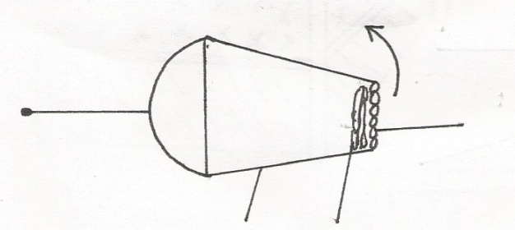
Container
Wet clothes
Holes
Rotation

- Explain how the rotation of the container causes the clothes to dry faster. (3mks)
………………………………………………………………………………………………..
………………………………………………………………………………………………..
………………………………………………………………………………………………..
………………………………………………………………………………………………..
- A glass block of mass 100g is placed in turn at various distance from the centre of the turn table which is rotating at a constant angular velocity. It is found that at a distance of 8 cm from the centre, the block just starts to slide off the table. If the force of frinction between the block and the table 0.4N, determine.
- The angular velocity of the table. (2mks)

- The force required to hold the block at a distance of 12cm from the centre of the table.
(3mks)

- A glass of mass 200g is now placed at a distance of 8.0cm from the centre or the table In (i) above, and the table rotated at the same angular velocity. State with a reason whether or not the block will slide. (2mks)

