Name…………………………………… …………………………..………… Index No:………………………….

232/3 Candidate’s Signature …………..……………
PHYSICS Date: …………………………
PAPER 3

TIME: 2 ½ HOURS

Kenya Certificate of Secondary Education (K.C.S.E.)
232/3
Physics
Paper 3

INSTRUCTIONS TO CANDIDATES:
- Write your name and index number in the spaces provided above.
- Sign and write the date of the examination in the spaces provided above.
- You are supposed to spend the first 15 minutes of the 2 ½ hours allowed for this paper reading the whole paper carefully.
- Marks are given for a clear record of the observation actually made, their suitability, accuracy and the use made of them.

For Examiners’ Use Only
Question 1 | b | c | d | f | g | (i) | j | k
Marks Score | 1 | 1 | 2 | 1 | 2 | 6 | 5 | 2
Candidate’s score

TOTAL
Question 2 | b | C | e | f | g(i) | g(ii)
Marks Score | 3 | 2 | 5 | 5 | 3 | 2
Candidate’s score

TOTAL

GRAND TOTAL

This paper consists of 6 printed pages. Candidates should check to ascertain that all pages are printed as indicated and that no questions are missing.

1. You are provided with the following apparatus
• one dry cell
• a voltmeter
• seven connecting wires (at least three with a crocodile clip on one end)
• a switch
• two standard resistors labeled X and Y
• one metre Nichrome wire mounted on millimeter scale Labeled R
• a jockey
Proceed as follows:
(a) Connect the apparatus as shown in figure one below
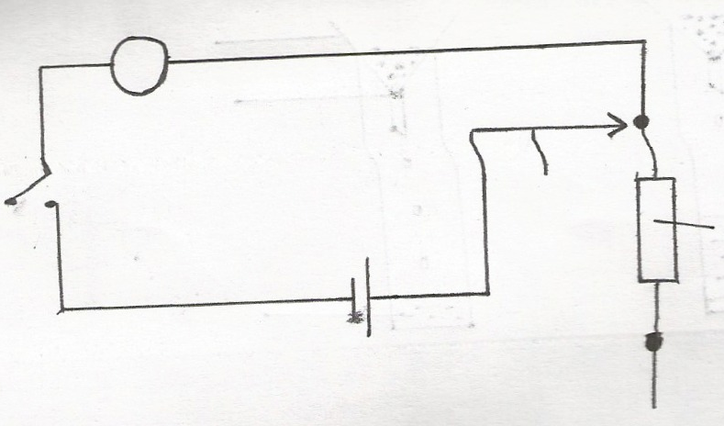

Fig 2
Fig 1
Resistor X

S
V
Cell
A
B

(b) Connect the jockey to A and close the switch S. Record the voltmeter reading
V_{l}=………………………………………………. (lmk)
(c) Repeat by connecting the jockey to B. Close the switch and record the voltmeter reading,
V₂= ………………………………………………. (lmk)
(d) Calculate Z1 from the formula Z1 = V1-V2 (2mks)
VI

(e) Connect the circuit as shown in figure 2 below
Y
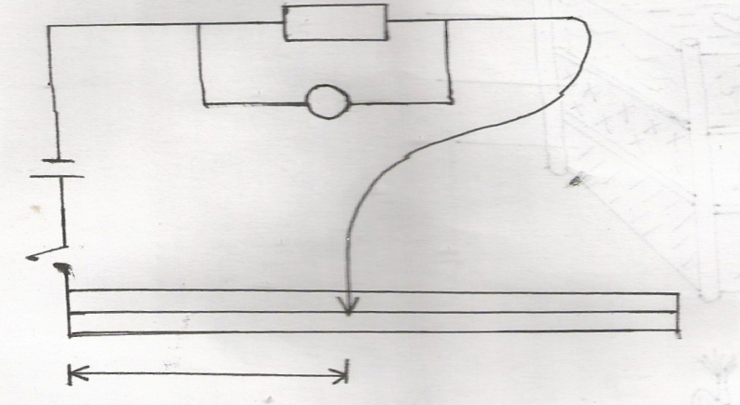
NIchromewire
Jockey
v
S
cell

A L B

(f) Connect the jockey to the end of the Nichrome wire at point A. close the switch S and record the voltmeter reading
V₃=……………………………………………………….. (1mk)
(g) Calculate Z2 using the formula Z₂ = V₁-V₃ (2mks)
V_{I}

(h) Calculate the length L, corresponding to the resistance R, using the formula L = kR where k= 10
( Fill the table below for the values L)
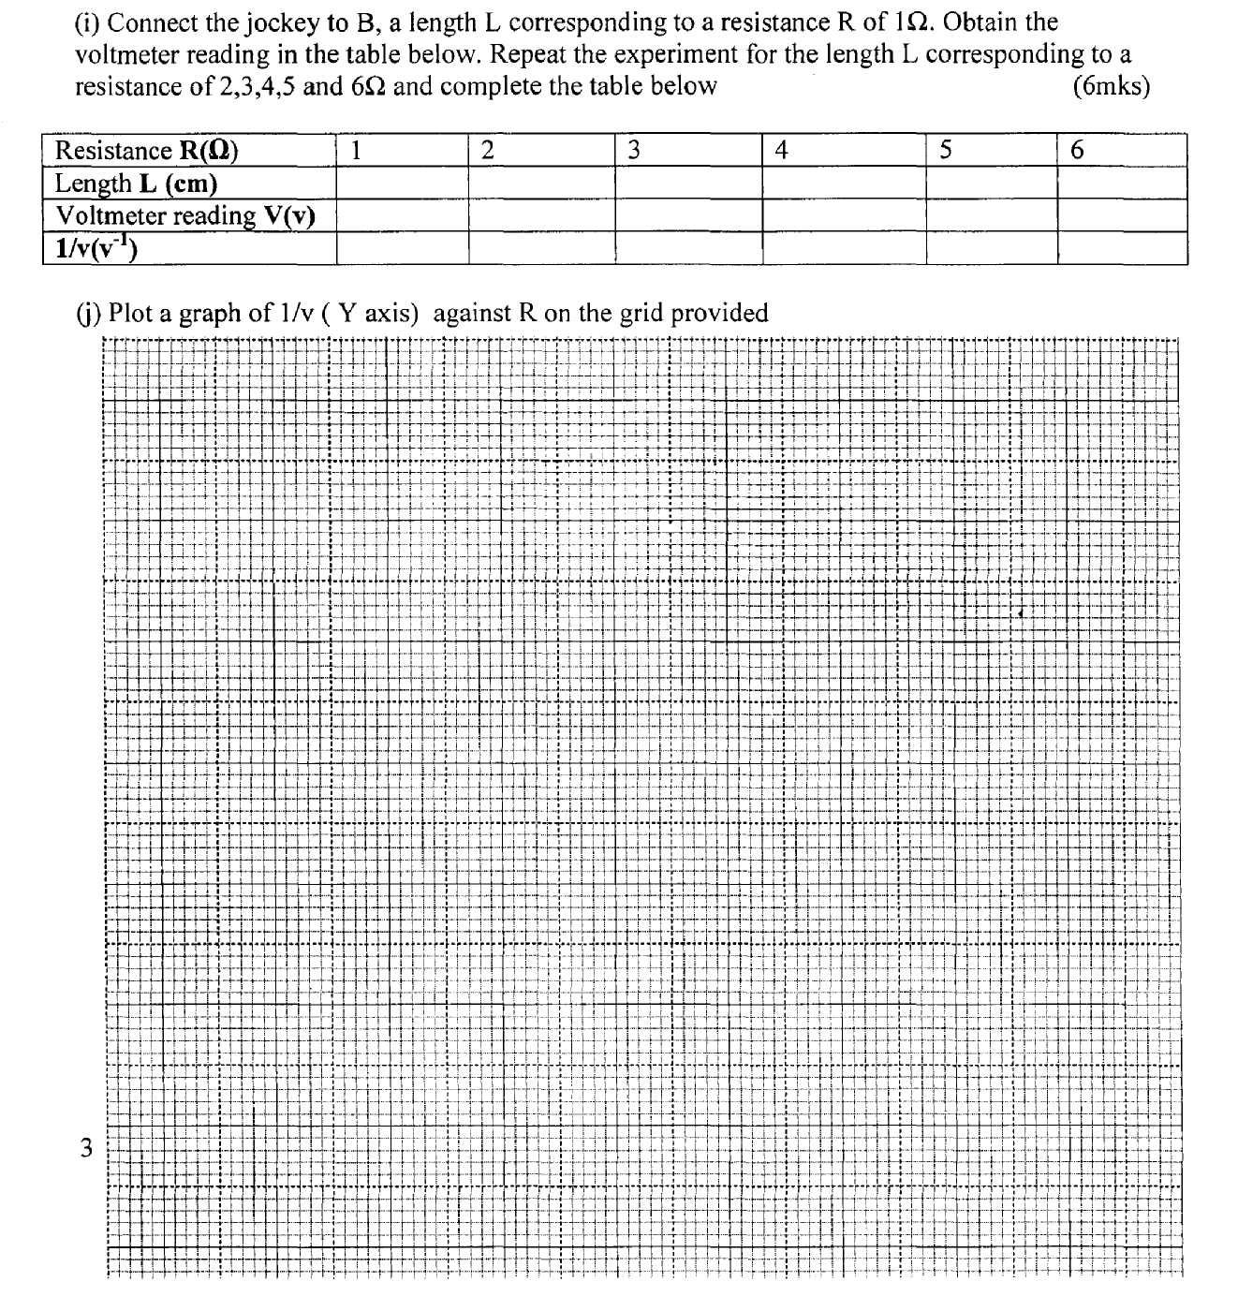

.

(k) The quantity M is given by M = 1/v when R = 0. Determine M. (2mks)

Q2. You are provided with the following
• a l00ml beaker (strictly glass)
• a 600mlbeaker (glass)
• 250m1 distilled water in a 250ml glass beaker
• 2 thermometers range -10°C to 110°C
• some distilled water in a wash bottle
• a measuring cylinder; (to be shared)
• some plasticine
• vernier calipers: (to be shared)
• a half metre rule;
• tripod stand and wire gauze
• tissue paper(to be shared)
• burner
• funnel
Proceed as follows
(a) Heat the water in the 250m1 glass beaker (ensure that the level of water is at 250m1 mark), until it boils.
N/B: As you wait for the water to get boiled, proceed to part (b) below.
(b) Using the Vernier. Measure the internal diameter d₁ and the external diameter d₂ of the l00ml beaker.
d₁=………………………………………………… cm (lmk)
d₂=………………………………………………. cm (lmk)
Determine the thickness x of the glass wall of the beaker given that
X = d₂- d₁
2
X=………………………………………………. cm (lmk)
(c) Using the measuring cylinder provided, pour 75m1 of cold water (from wash bottle) into the l00mI beaker.
Measure the height h of the water in the l00ml beaker
h=………………………………….. cm (lmk)
Determine the area A of the walls in contact with water, given that
A= πd1h
A=………………………………………………………. cm² (lmk)
(d) Use the plasticine provided to make a circular disc of about the same area as the bottom surface of the l00ml
beaker and 1cm thick. Place this disc at the bottom of the 600m1 beaker and place the l00ml beaker on it.

(e) Now using the tissue paper provided (to handle the hot beaker) and the funnel, pour the boiling water into the
600ml beaker (Use the funnel provided to make sure the hot water do not get into the small beaker .see fig 3 below.

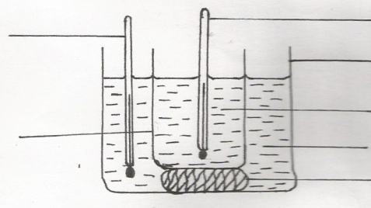
Thermometer T₁
Hot water
Cold water
Large beaker (600ml)
Thermometer T₂

Small beaker (100ml)
Plastine

Immediately place thermometer T₁ in the hot water and thermometer T₂ in the cold water and using the
thermometers stir gently until the temperature T_{i} of hot water is 72°C, measure temperature T₂ of cold water and
record in the table below. Obtain other values of T₂ when T₁ is as in the table below.
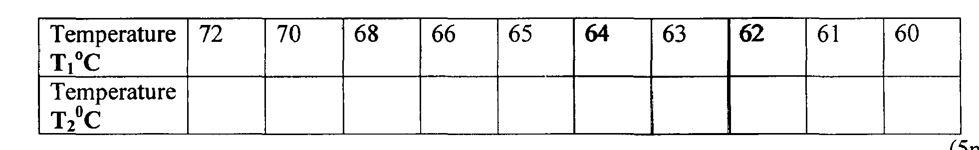

15mks

(f) Plot a graph of T2⁰c (y — axis) against T1⁰c (x — axis) (5mks)

(g) (i) Determine the slope of the graph at T₂= 45°C (3mks)

(ii) Determine the constant k, given that k = 315 SX
A (T₁ - T₂)
Where T1is the temperature of the hot water at T₂ = 45°C (2mks)

